Supplementary Material

# Supplementary Figures and Tables

## Supplementary Figures

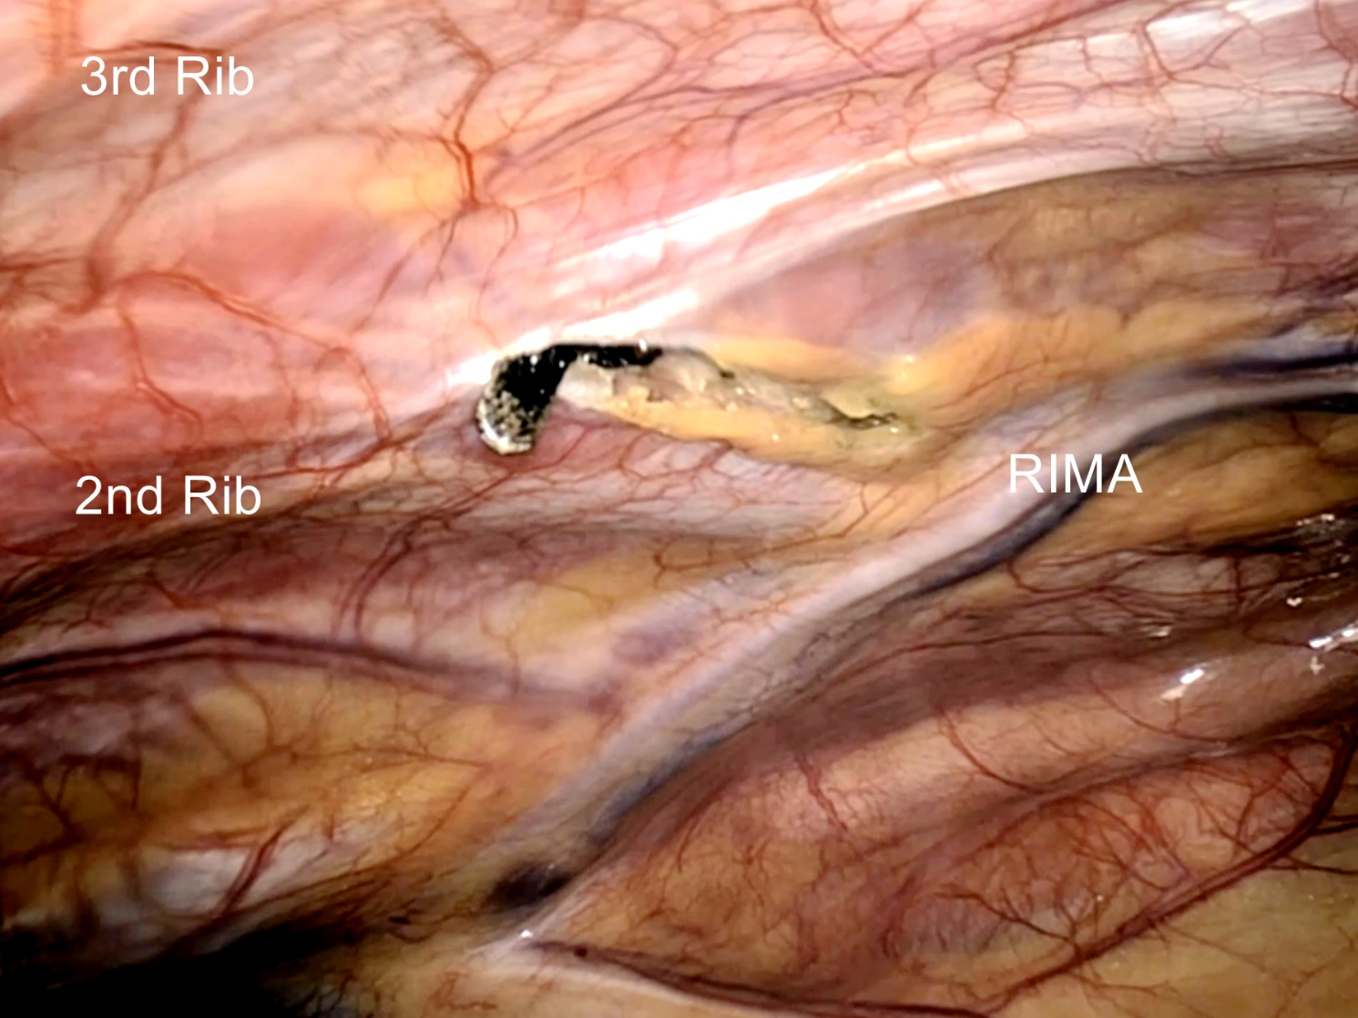

**Supplementary Figure 1.** Assist Port (Port 3) making under thoracoscopic guidance



**Supplementary Figure 2.** Surgical View of ASD Repair

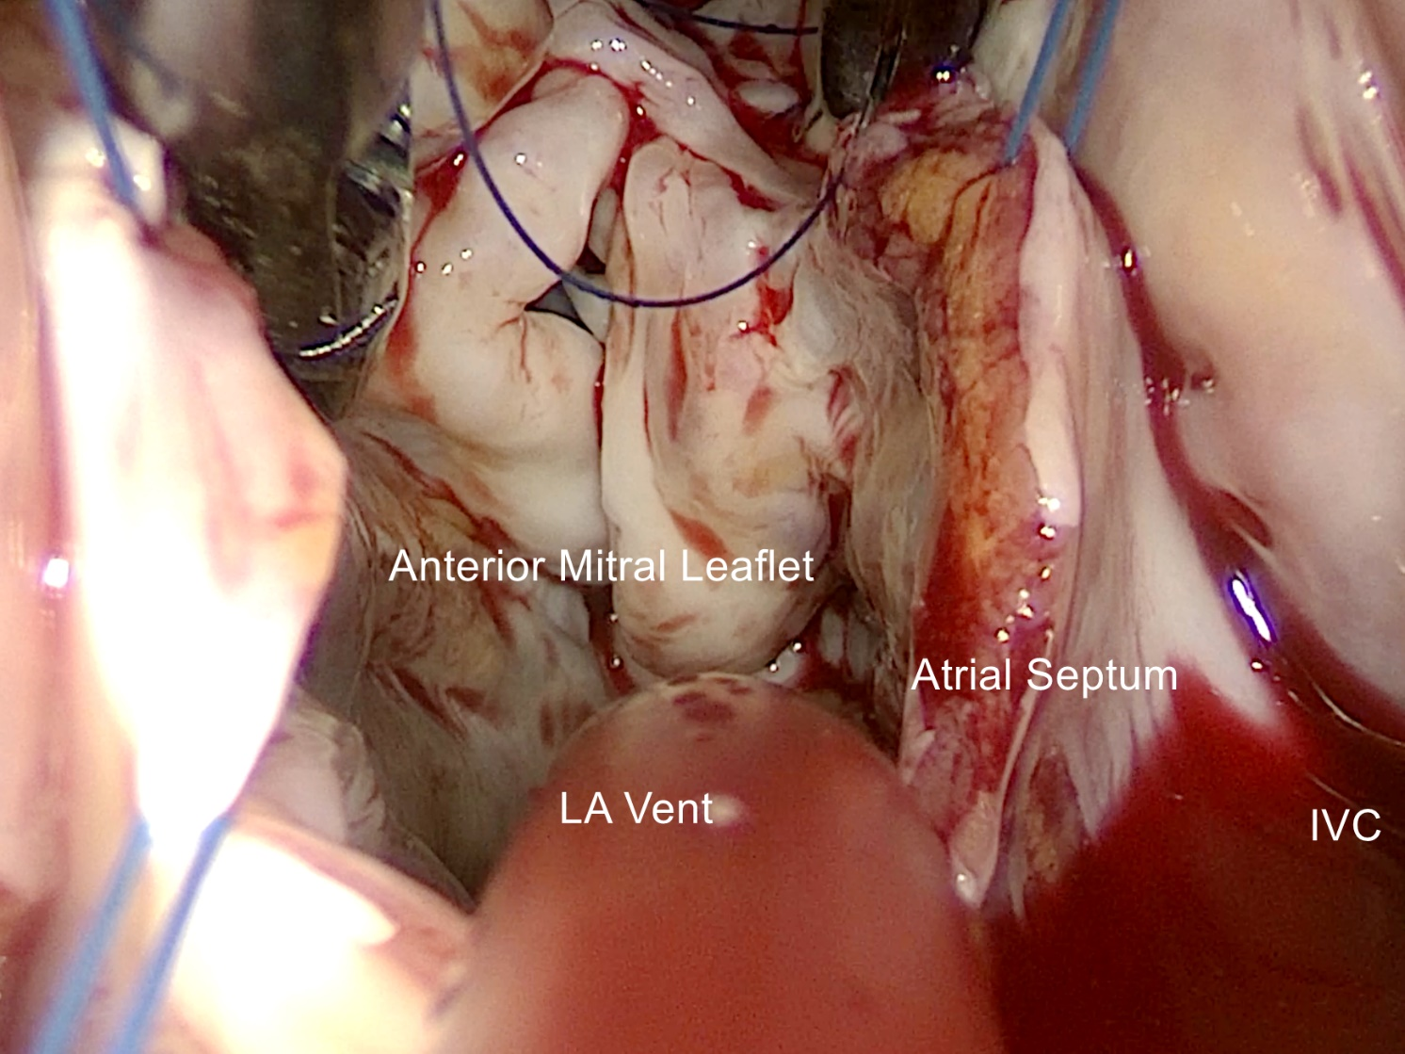

**Supplementary Figure 3.** Surgical View of PAVC Repair

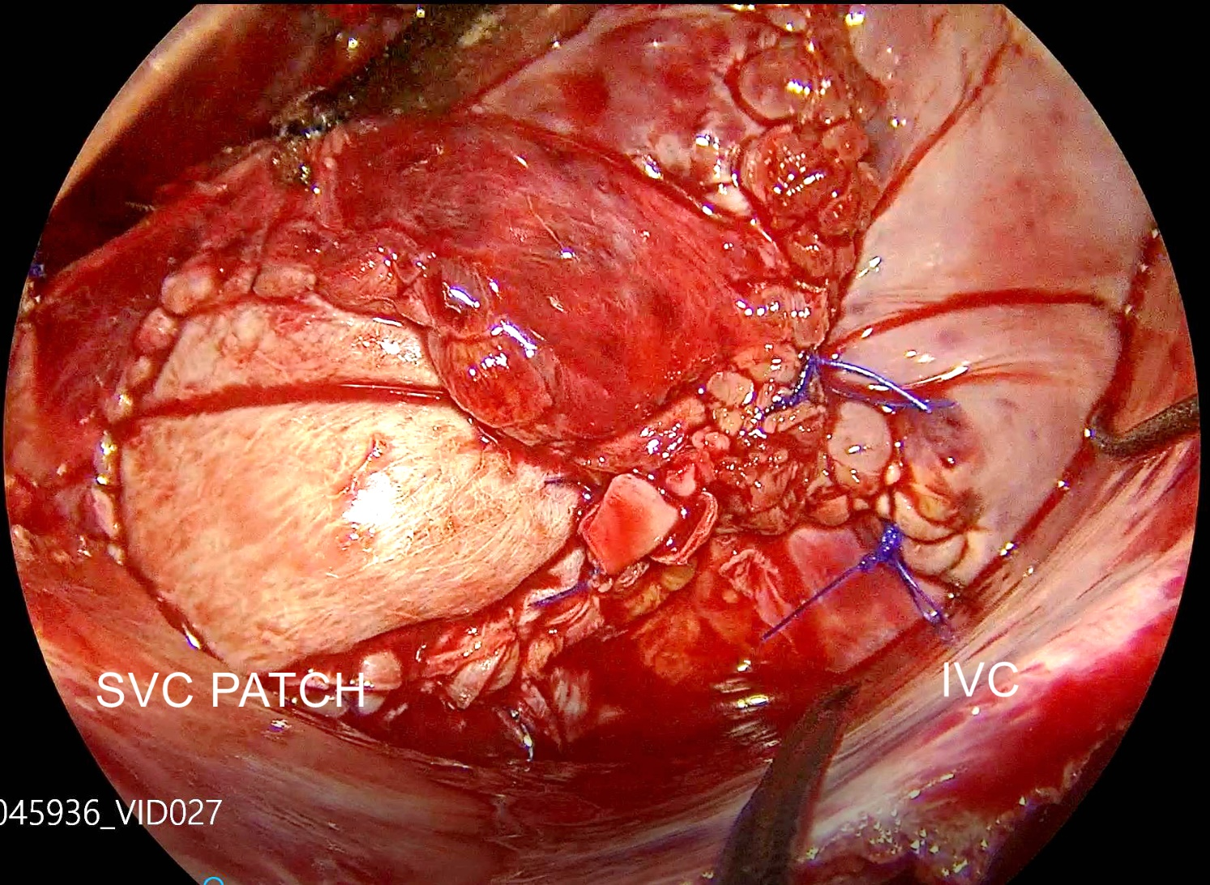

**Supplementary Figure 4.** Surgical View of PAPVC Repair

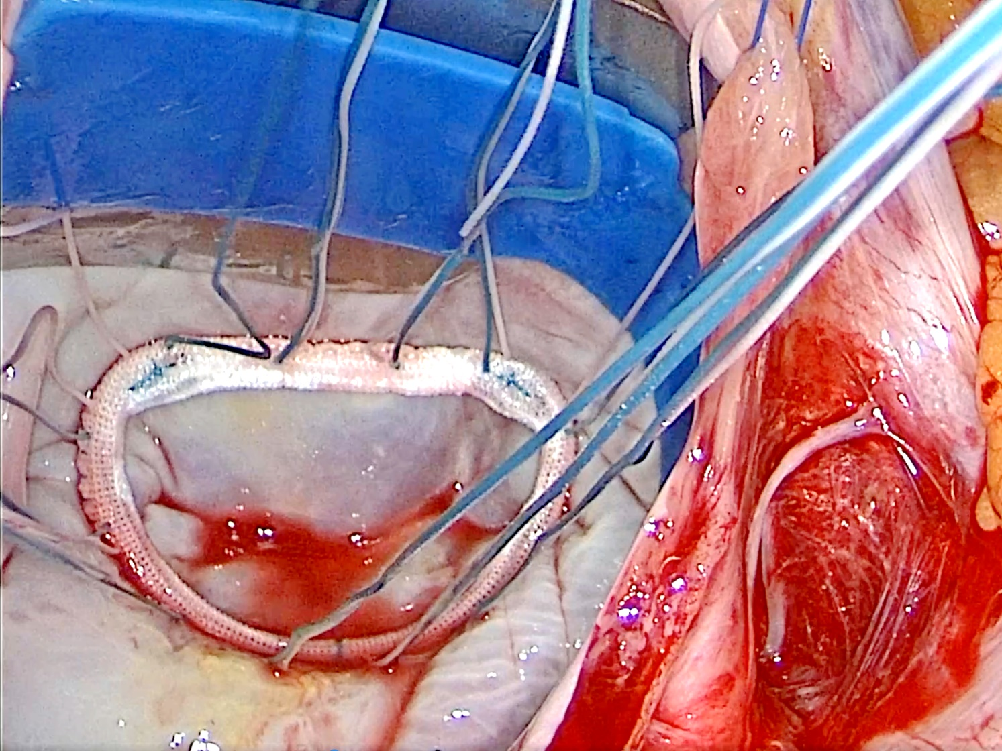

**Supplementary Figure 5.** Surgical View of Mitral Valve Repair

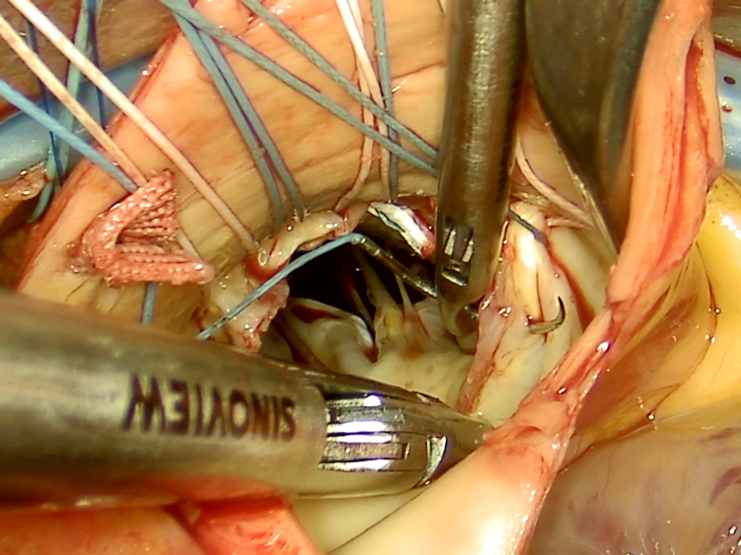

**Supplementary Figure 6.** Surgical View of Aortic Valve Replacement

**Supplementary Figure 1.** The figure legends are required to have the same font as the main text, 12 point normal Times New Roman, single spaced. Please use a single paragraph for each legend and prepare the figures keeping in mind the PDF layout.