Figure S1
Distribution of Global Executive Composite Scores in Sample 1 (a) and Sample 2 (b)
(a)
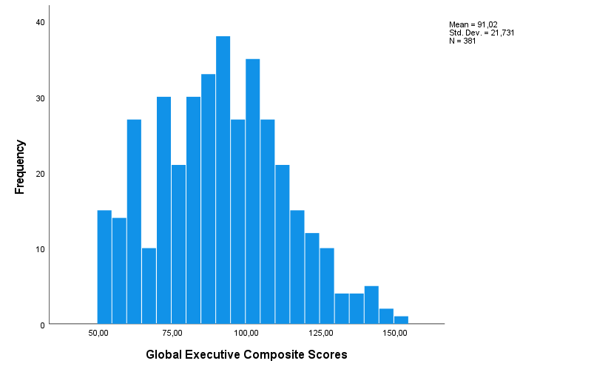
(b)
