Supplementary Material

**A novel exopolysaccharide-producing bacterium, *Pseudescherichia liriopis* sp. nov. isolated from *Liriope platyphylla*, enhances the growth of *Daucus carota* subsp. *sativus* under drought and salinity stress**

**Inhyup Kim1, Haejin Woo1, Geeta Chhetri1, Sunho Park1, and Taegun Seo1,\***

1Department of Life Science, Dongguk University-Seoul, Goyang 10326, Republic of Korea

**\* Correspondence:**

Corresponding Author: Taegun Seo

E-mail: [tseo@dongguk.edu](mailto:tseo@dongguk.edu)

Tel.: +82-31-961-5135

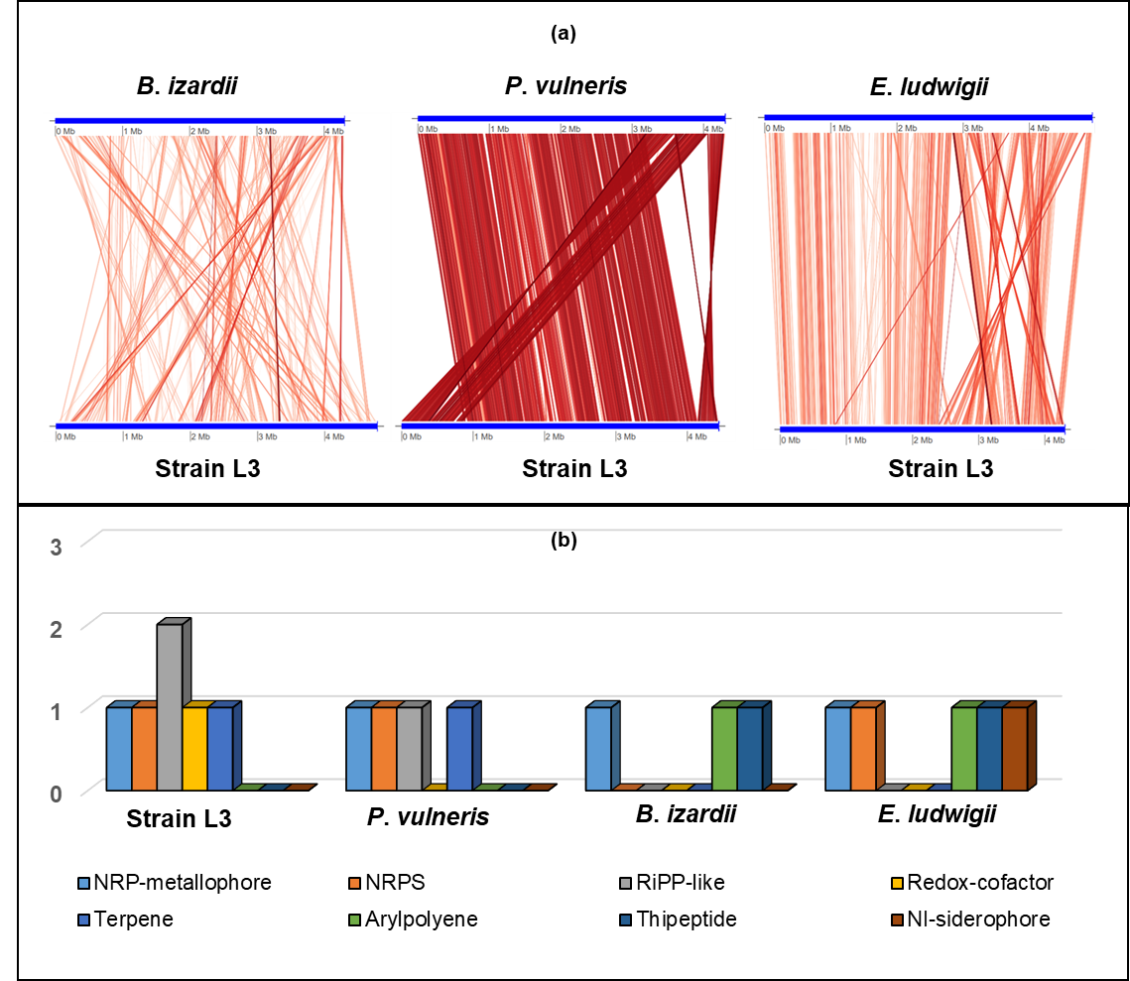

**Fig. S1.** (a) Illustration representing FastANI's workflow between the novel strain L3T genome and a phylogenetically close reference genome. (b) The results of antiSMASH show secondary metabolites of strain L3T and phylogenetically related species.

|  |  |  |  |
| --- | --- | --- | --- |
| **Bacterial strains** | **20%PEG** | **6% NaCl** | **EPS producing** |
| RP10 | – | – | + |
| RP14 | – | – | + |
| L1 | – | + | + |
| L3 | + | + | + |
| L8 | + | – | + |
| L10 | – | + | + |

**Table S1**. Qualitative analysis of six isolates for EPS production, PEG resistance, and NaCl resistance. RP10 = *Sphingomonas liriopis* RP10T, RP14 = *Mesorhizobium liriopis* RP14T, L1 = Rhizobium sp., L3 = *Pseudescherichia liriopis* L3T, L8 = *Lactilactobacillus sakei* subsp. *sakei* JCM 1157T, L10 = *Phyllobacterium* RBR8, + =positive, and – = negative.

|  |  |  |
| --- | --- | --- |
| **Characterization** | **1** | **2** |
| Range of growth |  |  |
| Temperature (°C) | 15–45 | 18–45 |
| NaCl (%, w/v) | 0–7 | 0–6 |
| pH | 4–13 | 5–13 |
| Hydrolysis of |  |  |
| L–Arginine | + | – |
| Genome accession number | JANKYC000000000 | UGGL00000000 |
| Genome size (bp) | 4,304,575 | 4,442,322 |
| Contigs | 10 | 2 |
| N50 | 2,389,350 | 4,427,509 |
| Total genes | 4131 | 4360 |
| Protein-coding genes | 3989 | 3809 |
| rRNAs (5S, 16S, 23S) | 5, 2, 2 | 8, 7, 7 |
| ncRNAs | 12 | 12 |
| tRNAs | 72 | 81 |
| Pseudo genes | 49 | 436 |
| DNA G+C content | 56.5* | 56.5* |

**Table S1.** Differentiating characteristics of strain L3T and other *Pseudescherichia* species. 1, L3T; 2, *Pseudescherichia vulneris* JCM 1688T. All dates are from this research. On the API 20NE strips, all strains were negative for hydrolysis of urea and gelatine and assimilation of caprate, adipate, trisodium citrate, and phenylacetic acid. All strains were positive for hydrolysis of *β*–galactosidase and aesculin; assimilation of D–glucose, D–mannose, L–arabinose, D–mannitol, D–maltose, *N*-acetyl-glucosamine, potassium gluconate, and malate. *, From whole genome sequencing for genomic sequences; +, Positive; –, Negative.

|  |  |  |
| --- | --- | --- |
| **Strains (NCBI genome accession number)** | **dDDH** | **ANI** |
| *Buttiauxella izardii* CCUG 35510T (QZWH00000000) | 19.9 | 75.9 |
| *Enterobacter ludwigii* EN-119T (JTLO00000000) | 22.4 | 79.5 |
| *Pseudescherichia vulneris* JCM 1688T | **55.1** | **93.9** |
| *Buttiauxella noackiae* ATCC 51607T (LXEO01000077) | 19.8 | 75.3 |
| *Citrobacter braakii* ATCC 51113T (UBGZ00000000) | 21.8 | 78.3 |
| *Citrobacter pasteurii* CIP 55.13T (QRDC00000000 | 23.1 | 80.3 |
| *Buttiauxella warmboldiae* CCUG 35512T (RPOH00000000) | 20.5 | 76.8 |
| *Enterobacter kobei* DSM 13645T (CP017181) | 23.6 | 79.8 |
| *Enterobacter chuandaensis* HD8830T (JAMFTT000000000) | 22.8 | 80 |
| *Citrobacter youngae* CCUG 30791T (RPOI00000000 | 21.8 | 78.1 |
| *Leclercia adecarboxylata* NBRC 102595T (BCNP01000062) | 22.9 | 79.9 |
| *Klebsiella spallanzanii* NCTC 11966T (UHJH00000000) | 22 | 78.6 |
| *Lelliottia jeotgali* PFL01T (CP018628) | 22.2 | 79.1 |
| *Enterobacter bugandensis* EB-247T (FYBI00000000) | 23 | 79.9 |
| *Enterobacter roggenkampii* EN-117T (CP017184) | 23.1 | 80.3 |
| *Kosakonia oryzendophytica* LMG 26432T (FYBE00000000) | 21.6 | 78.7 |
| *Lelliottia nimipressuralis* LMG 10245T (CICC 24156) | 22.4 | 79.5 |
| *Klebsiella huaxiensis* CCUG 15901T (WCHKI090001) | 22.2 | 78.3 |
| *Citrobacter freundii* HAMBI 1695T (BBMV00000000) | 21.7 | 80.3 |
| *Buttiauxella gaviniae* ATCC 51604T (LXEP01000074) | 19.7 | 75.4 |
| *Lelliottia amnigena* NBRC 105700T (BCNN00000000) | 21.5 | 78.5 |
| *Enterobacter sichuanensis* WCHECl1597T (POVL00000000) | 22.7 | 79.7 |
| *Citrobacter cronae* AwkT (JAMCOT00000000) | 21.8 | 78.4 |
| *Phytobacter ursingii* ATCC 27989T (JAWJAC000000000) | 21.7 | 78.5 |
| *Yokenella regensburgei* DSM 5079T (RBIZ00000000) | 22 | 79 |
| *Enterobacter cancerogenus* ATCC 33241T (FYBA00000000) | 22.8 | 79.8 |

**Table S2.** Phylogenetic tree-based DNA–DNA hybridization (dDDH) and average nucleotide identity (ANI) index for the genomes of 29 species.