Supplementary Materials
Establishment and validation of a predictive nomogram for central venous catheter-related thrombosis in cancer patients: a retrospective nested case-control study
Running title: Nomogram for thrombosis prediction

Xuexing Wang, Xiao Dai, Yuan He, Jie Chu, Yufeng Wang

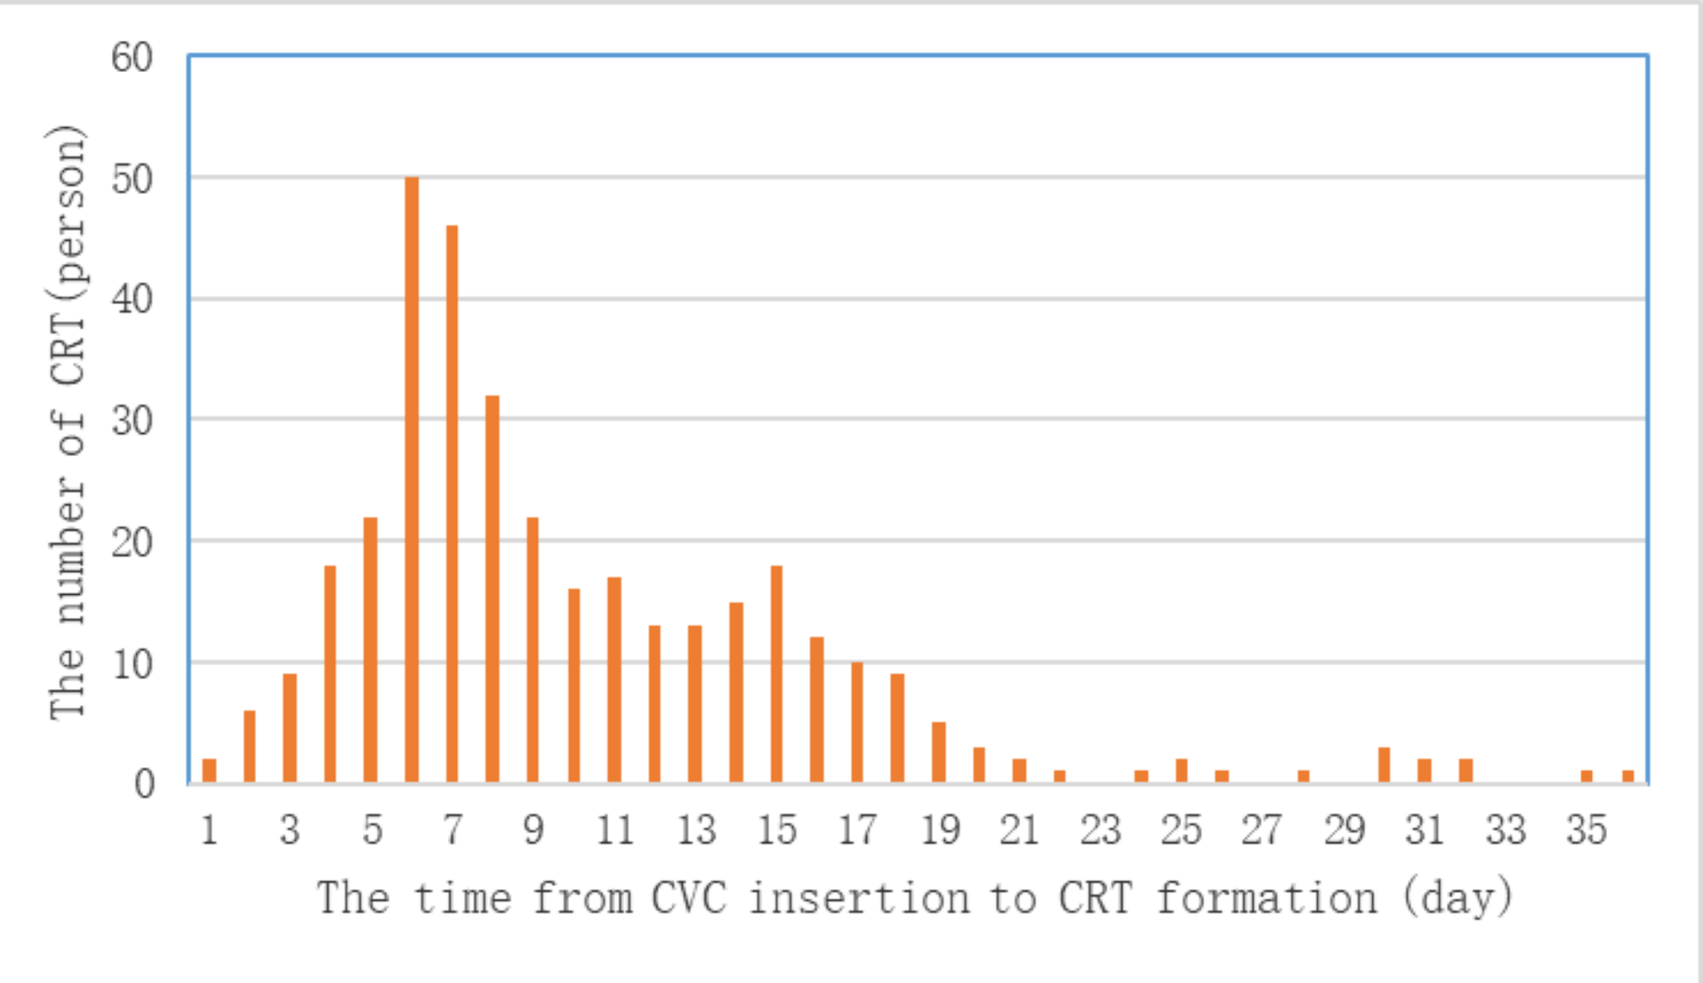
Figure S1. The time distribution between central venous catheter(CVC) insertion to the onset of thrombosis.
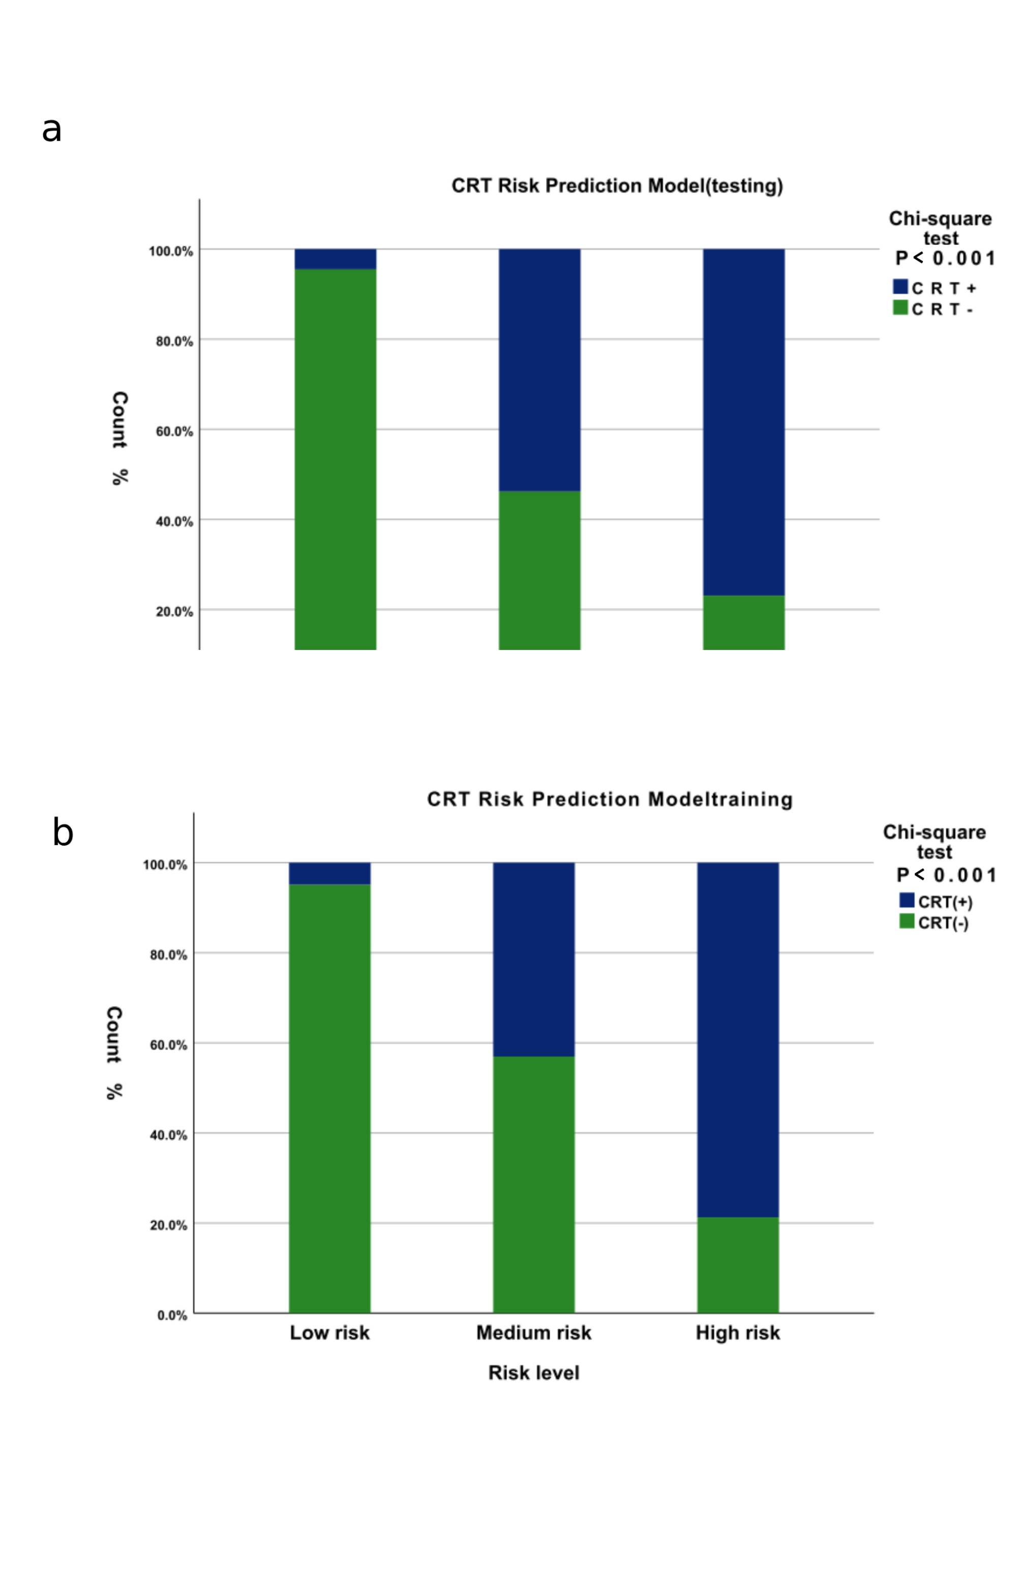
Figure S2. Comparing of actual incidence among patients with different risk for CRT. a). The training set. b). The Validation set.

Table S1. Variables assignments

Characteristics | Variables assignments
 | 0 | 1 | 2 | 3 | 4
CRT Status | Negative | Positive
Gender |  | Male | Female
Age(years) |  | ≤55 | >55
Number of CVC insertions |  | ≤2 | >2
Activity amount | Hardly | Frequently
History of chemotherapy | No | Yes
TNM stage |  | I | II | III | IV
KPS(points) |  | >80 | ≤80
BMI(kg/㎡) |  | ≤18.4 | 18.5-23.9 | 24.0-27.9 | ≥28
Smoking history | No | Yes
Drinking history | No | Yes
History of blood transfusion | No | Yes
Operation history | No | Yes
Co-infection | No | Yes
Hormone use | No | Yes
Hypertension | No | Yes
Diabetes mellitus | No | Yes
Hyperlipidemia | No | Yes
Thrombosis/Hypercoagulability history | No | Yes
RBC (10¹²/l) |  | <3.5 | 3.5-5.5 | >5.5
WBC (10⁹/l) |  | <4 | 4-10.0 | >10
PLT (10⁹/l) |  | <100 | 100-300 | >300
HGB (g/l) |  | <110 | ≥110
PT (s) |  | ≤12.1 | >12.1
INR |  | <0.84 | 0.84-1.06 | >1.06
APTT (s) |  | ≤31.3 | >31.3
TT |  | <14 | ≥14
FIB |  | <4 | ≥4
ATIII |  | ≤75 | >75
FDP |  | <5 | 5-10 | >10
D-Dimer(mg/l) |  | 0-0.55 | 0.56-1.00 | 1.01-2.00 | 2.01~3.00 (3.01-4.00=5, >4.00=6)
Albumin (g/l) |  | >40 | ≤40
Albumin/Globulin |  | ≤1.2 | >1.2
Total bilirubin |  | ≤17.1 | >17.1
Total cholesterol |  | <5.18 | ≥5.18
Fasting Blood Glucose |  | <6.11 | ≥6.11

Table S2. Demographic and clinical characteristics among all patients
Characteristic | Entire cohort  No. (%) | Training set (n=3284)  No. (%) | Validation set (n=1407)  No. (%) | P
Age (years) | 53.86±12.04 | 53.79±12.12 | 54.01±11.86 | 0.832
Gender |  |  |  | <0.001
Male | 1998(42.6) | 1140(34.7) | 858(61)
Female | 2693(57.4) | 2144(65.3) | 549(39)
TNM stage |  |  |  | 0.011
I | 1224(26.1) | 822(25.0) | 402(28.6)
II | 1121(23.9) | 769(23.4) | 352(25.0)
III | 978(20.8) | 703(21.4) | 275(19.5)
IV | 1369(29.2) | 990(30.1) | 378(26.9)
Type of cancer |  |  |  | 0.03
Genital cancers | 1597(34.0) | 1289(39.3) | 308(21.9)
Respiratory cancers | 1417(30.2) | 838(25.5) | 579(41.2)
Digestive cancers | 1081(23.0) | 753(22.9) | 328(23.3)
Head and neck system tumors | 212(4.5) | 158(4.8) | 54(3.8)
Motior system cancers | 65(1.4) | 52(1.6) | 13(0.9)
Other cancers* | 319(6.9) | 194(5.9) | 125(8.9)
Number of CVC insertions |  |  |  | <0.001
≤2 | 2126(45.3) | 1348(41) | 778(55.3)
>2 | 2565(54.7) | 1936(59) | 629(44.7)
Activity amount |  |  |  | 0.052
Hardly | 80(1.7) | 63(1.9) | 17(1.2)
Frequently | 4611(98.3) | 3229(98.1) | 1390(98.8)
History of chemotherapy |  |  |  | <0.001
No | 1057(22.5) | 656(20.0) | 401(28.5)
Yes | 3634(77.5) | 2628(80.0) | 1006(71.5)
Operation history |  |  |  | 0.144
No | 1865(39.8) | 1325(40.3) | 540(38.4)
Yes | 2825(60.2) | 1959(59.7) | 866(61.5)
History of blood transfusion
No | 4492(95.8) | 3110(94.7) | 1382(98.2) | <0.001
Yes | 199(4.2) | 174(5.3) | 25(1.8)
KPS
>80 points | 807(17.2) | 619(18.8) | 188(13.4) | <0.001
≤80 points | 3884(82.8) | 2665(81.2) | 1229(86.6)
BMI(kg/m²) |  |  |  | <0.001
<18.5 | 521(11.1) | 437(13.3) | 84(6.0)
18.5-23.99 | 2806(59.8) | 2003(61.0) | 803(57.1)
24.0-27.99 | 1088(23.2) | 674(20.5) | 4014(29.4)
≥28 | 276(5.9) | 170(5.2) | 106(7.5)
Smoking history |  |  |  | <0.001
No | 3410(72.7) | 2544(77.5) | 866(61.5)
Yes | 1281(27.3) | 740(22.5) | 541(38.5)
Drinking history |  |  |  | <0.001
No | 3911(83.4) | 2819(85.8) | 1092(77.6)
Yes | 780(16.6) | 465(14.2) | 315(22.4)
Co-infection
No | 4209(89.7) | 2914(88.7) | 1295(92.0) | <0.001
Yes | 482(10.3) | 370(11.3) | 112(8.0)
Hormone use
No | 2368(50.5) | 1548(47.1) | 820(58.3)
Yes | 2323(49.5) | 1736(52.9) | 587(41.7)
Hypertension |  |  |  | 0.033
No | 4030(85.9) | 2842(86.5) | 1188(84.4)
Yes | 661(14.1) | 442(13.5) | 219(15.6)
Diabetes mellitus
No | 4440(94.6) | 3122(95.1) | 1318(93.7) | 0.021
Yes | 251(5.4) | 162(4.9) | 89(6.3)
Hyperlipidemia
No | 3998(85.2) | 2785(84.8) | 1213(86.2) | 0.115
Yes | 693(14.8) | 499(15.2) | 194(13.8)
Thrombosis/Hypercoagulability history
No | 4501(95.9) | 3137(95.5) | 1364(96.9) | 0.013
Yes | 190(4.1) | 147(4.5) | 43(3.1)
*lymph system tumors ; urinary system tumors ; endocrine system tumors ; nervous system tumors ; skin tumors

Table S3. Univariate logistic regression analysis for CRT in the training set
Characteristics | OR(95%CI) | P
Age
≤55 | Reference
>55 | 1.728(1.340-2.227) | <0.001
TNM
I | Reference
II | 1.35(0.865-2.105) | 0.186
III | 1.801(1.172-2.767) | 0.007
IV | 3.038(2.078-4.441) | <0.001
Activity amount
Hardly | Reference
Frequently | 0.053(0.031-0.089) | <0.001
Operation history
No | Reference
Yes | 1.477(1.128-1.933) | 0.005
KPS
>80 points | Reference
≤80 points | 0.494(0.374-0.653) | <0.001
Co-infection
No | Reference
Yes | 3.464(2.575-4.695) | <0.001
Hormone use
No | Reference
Yes | 2.234(1.698-2.939) | <0.001
History of blood transfusion
No | Reference
Yes | 2.032(1.304-3.167) | 0.002
Hypertension
No | Reference
Yes | 1.762(1.283-2.422) | ＜0.001
Diabetes mellitus
No | Reference
Yes | 1.780(1.105-2.868) | 0.018
Hyperlipidemia
No | Reference
Yes | 2.846(2.149-3.769) | ＜0.001
Thrombosis/Hypercoagulability history
No | Reference
Yes | 27.218(18.883-39.234) | ＜0.001
RBC (10¹²/l)
<3.5 | Reference
3.5-5.5 | 0.463(0.340-0.630) | ＜0.001
>5.5 | 0.159(0.021-1.178) | 0.072
WBC (10⁹/l)
<4 | Reference
4-10 | 0.936(0.666-1.316) | 0.704
>10 | 1.948(1.315-2.885) | 0.001
PLT (10⁹/l)
<100 | Reference
100-300 | 0.465(0.272-0.794) | 0.005
>300 | 0.864(0.498-1.500) | 0.604
HGB (g/l)
<110 | Reference
≥110 | 0.565(0.433-0.739) | <0.001
PT (s)
≤12.1 | Reference
>12.1 | 1.622(1.168-2.253) | 0.004
INR
<1.0 | Reference
≥1.0 | 1.973(1.527-2.550) | <0.001
FIB
<4 | Reference
≥4 | 1.769(1.370-2.285) | <0.001
ATIII
≤75 | Reference
>75 | 0.282(0.188-0.422) | <0.001
FDP
<5 | Reference
5-10 | 0.887(0.657-1.198) | 0.887
>10 | 4.818(3.368-6.891) | <0.001
D-Dimer
0-0.55 | Reference
0.56-1.00 | 2.814(1.499-5.280) | 0.001
1.01-2.00 | 6.046(3.363-10.870) | <0.001
2.01-3.00 | 1.810(1.055-3.104) | 0.031
3.01-4.00 | 11.021(5.512-22.037) | <0.001
>4.00 | 13.039(7.259-23.420) | <0.001
Albumin(g/L)
≤40 | Reference
>40 | 0.482(0.371-0.625) | <0.001
Albumin/Globulin
≤1.2 | Reference
>1.2 | 0.531(0.384-0.733) | <0.001
Total Bilirubin
≤17.1 | Reference
>17.1 | 1.721(1.184-2.502) | 0.004
Fasting Blood Glucose
<6.11 | Reference
≥6.11 | 1.421(1.025-1.971) | 0.035

