Harnessing Plant Growth-Promoting Rhizobacteria, Bacillus subtilis and B. aryabhattai to Combat Salt Stress in Rice: A Study on the Regulation of Antioxidant Defense, Ion Homeostasis, and Photosynthetic Parameters

Ayesha Siddika¹, Alfi Anjum Rashid², Shakila Nargis Khan², Amena Khatun³, Muhammad Manjurul Karim², PV Vara Prasad⁴* and Mirza Hasanuzzaman¹*

¹Department of Agronomy, Faculty of Agriculture, Sher-e-Bangla Agricultural University, Dhaka-1207, Bangladesh
²Department of Microbiology, University of Dhaka, Dhaka-1000, Bangladesh
³Department of Agriculture, Noakhali Science and Technology University, Noakhali-3814, Bangladesh
⁴Department of Agronomy, Kansas State University, Manhattan, KS, United States
*Correspondence:
vara@ksu.edu (P.V.V.P.); mhzsauag@yahoo.com (M.H.)

Supplementary Figures

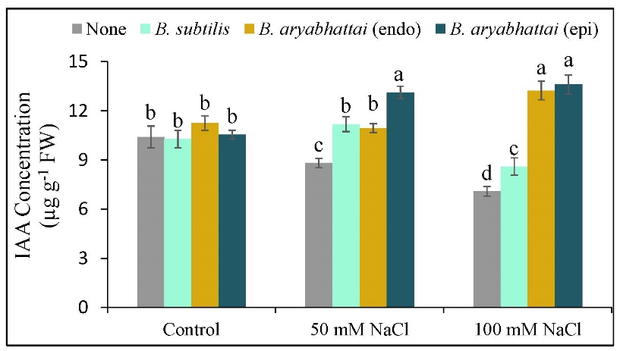
Supplementary Figure 1. Changes in the levels of indole-3-acetic acid (IAA) concentration of rice plants under salt stress (50 and 100 mM NaCl) with the absence or presence of three PGPRs (Bacillus subtilis, epiphytic B. aryabhattai, and endophytic B. aryabhattai). Data are presented as mean ± standard deviation of three replications (n=3). Distinct letters on the bars show significant differences between treatments at p ≤ 0.05 from Tukey’s HSD test.

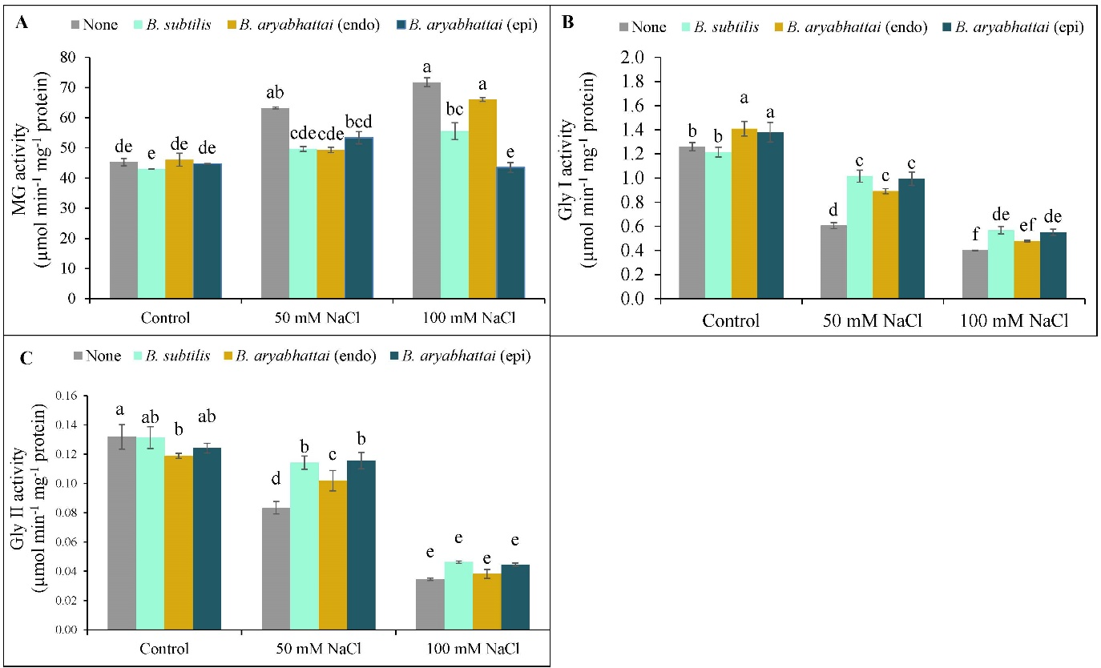
Supplementary Figure 2. Variations in MG (A), Gly I (B), and Gly II (C) activities of rice plants under salt stress (50 and 100 mM NaCl) in the absence or presence of three PGPRs (Bacillus subtilis, epiphytic B. aryabhattai, and endophytic B. aryabhattai). Data are presented as mean ± standard deviation of three replications (n=3). Distinct letters on the bars show significant differences between treatments at p ≤ 0.05 from Tukey’s HSD test.

