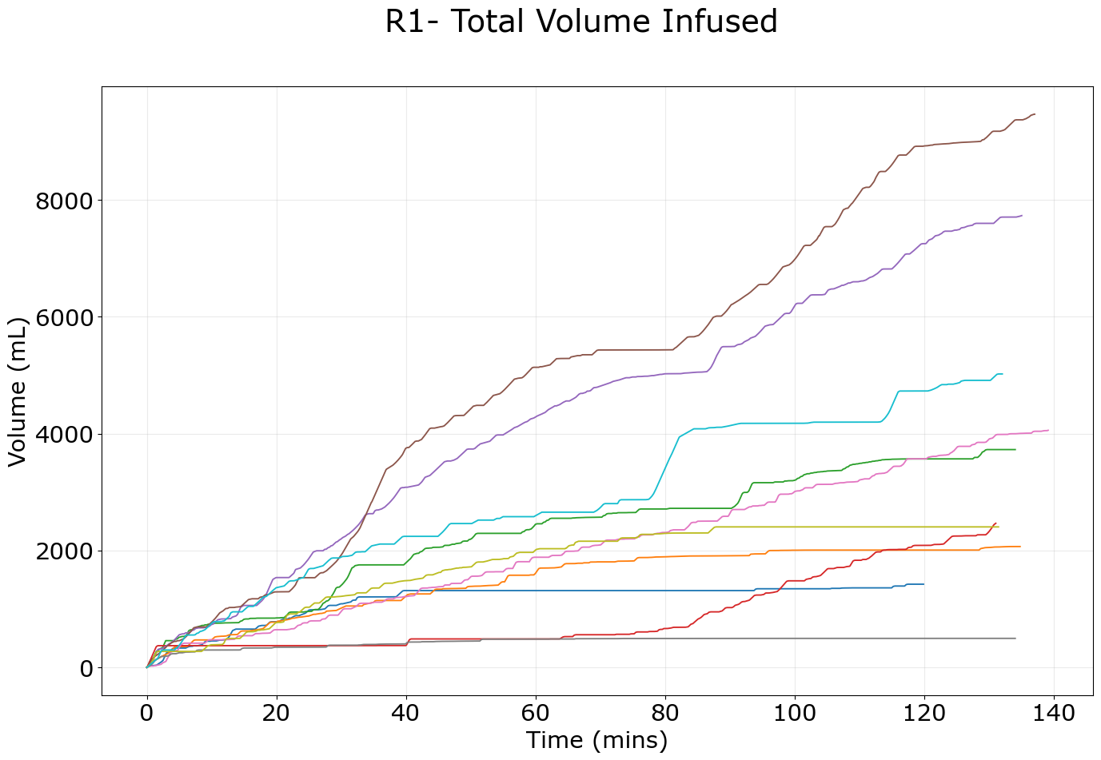**Supplementary Figure 1**. Total infused volume vs. time during the first resuscitation event for each subject who completed this phase of the study.

**Supplementary Figure 2.** Total infused volume vs. time during the second resuscitation event for each subject who completed this phase of the study. Note: one subject had catheter fluid flow issues that required restarting the controller during the experimental phase, resulting in the total duration of this phase being much longer for one subject.