Appendix 1: Consumer Perception of Poultry Products (Pre-test)

**Part1:Sensory and Nutritional Value Perception**

1. Do you usually pay attention to the nutritional attributes of chicken products?
2. Very much concerned
3. Comparatively concerned
4. Not very concerned
5. Indifferent, not concerned
6. Do you know the difference between frozen chicken and fresh chilled chicken?
7. No idea
8. Know but don't understand
9. Have some understanding
10. Basically understand
11. Do you know the difference between white-feathered and yellow-feathered chickens?
12. No idea
13. Know but don't understand
14. Have some understanding
15. Basically understand
16. Where do you mainly get information about the sensory and nutritional value of chicken (multiple choices)?
17. Radio, television
18. Newspapers, magazines
19. Internet
20. Knowledge learned in school
21. Store advertisements
22. WeChat, Weibo, Toutiao, and other new media
23. Promotion by friends and relatives
24. Guidance from highly educated family members
25. Explanations by doctors, scholars, and experts
26. Community propaganda column materials
27. Instructions on food packaging
28. Personal experience from visiting a chicken farm
29. Other (please specify)
30. Please select from 1 (completely disagree) to 5 (completely agree) according to your actual situation for the following questions:

|  |  |  |
| --- | --- | --- |
| Eating an appropriate amount of chicken daily is beneficial to my nutritional health. |  | 1.Completely disagree;  2.Disagree;  3.Neither disagree nor agree;  4.Agree;  5.Completely agree |
| I believe chicken is a high-quality source of protein. |  |
| I think the fat content of chicken is lower than that of pork. |  |
| Compared to pork, chicken has higher cholesterol content. |  |
| I believe that chickens that grow slowly have much higher nutritional value than those that grow quickly. |  |
| The slaughtered chickens sold in the market currently are not very fresh. |  |
| Fresh chilled chicken, kept under low-temperature control during storage and transportation, is safer and more hygienic than live poultry slaughtered on site as it helps inhibit the proliferation of microorganisms. |  |
| The taste difference between white-feathered and yellow-feathered chickens is significant, but their main nutritional components do not differ much. |  |

**Part2:Perception of Chemical Residue and Disease**

1. Which of the following do you know about China's chicken drug residue limit standards (multiple choices)?
2. Ministry of Agriculture Announcement No. 235 "Maximum Residue Limits of Veterinary Drugs in Animal Foods"
3. "Maximum Residue Limits of Pesticides in Food"
4. "Fresh and Frozen Poultry Products"
5. Don't know
6. If you know, how did you learn about these standards (multiple choices)?
7. Professional books
8. Newspapers, magazines
9. Online science popularization
10. WeChat public account articles
11. Friends and relatives
12. Do you usually pay attention to the issues of drug and hormone residues in chicken products?
13. Very much concerned
14. Comparatively concerned
15. Not very concerned
16. Indifferent, not concerne
17. Do you usually pay attention to chicken disease (avian influenza, etc.) issues?
18. Very much concerned
19. Comparatively concerned
20. Not very concerned
21. Indifferent, not concerned
22. If there is an outbreak of disease in poultry, would the amount of poultry you consume decrease significantly/slightly/decrease not much?
23. Please select from 1 (completely disagree) to 5 (completely agree) according to your actual situation for the following questions:

|  |  |  |
| --- | --- | --- |
| I don't often eat poultry because I worry about the residue of many chemical agents (such as tetracycline, doxycycline, and other antibiotics) in chicken, which can affect health if consumed in large amounts. |  | 1.Completely disagree;  2.Disagree;  3.Neither disagree nor agree  4.Agree;  5.Completely agree |
| I think that the majority of poultry have chemical residue issues, and eating chicken is more dangerous than eating pork, beef, fish, etc. |  |
| I am very concerned that the rapid growth of poultry in the market is due to the stimulating effect of hormones. |  |
| I feel that eating parts of the poultry such as the tips, wings, and neck is unsafe. |  |
| I think that most poultry farmers and processors do not produce according to the national poultry drug residue limit standards. |  |
| I am very worried about buying chicken products with avian meat diseases. |  |
| Dead poultry during the breeding process are generally treated harmlessly (by incineration, deep burial, etc.). |  |
| Most of the poultry in the market undergo drug residue and pathogen sampling before going on sale. |  |
| Market live poultry trading can easily lead to the spread of avian diseases, while centralized slaughter and fresh chilled sales can effectively control the spread and infection of avian diseases. |  |

1. Where do you mainly get information about chicken chemical residue and disease (multiple choices)?
   1. Radio, television
   2. Newspapers, magazines
   3. Internet
   4. Knowledge learned in school
   5. Store advertisements
   6. WeChat, Weibo, Toutiao, and other new media
   7. Promotion by friends and relatives
   8. Guidance from highly educated family members
   9. Explanations by doctors, scholars, and experts
   10. Community propaganda column materials
   11. Instructions on food packaging
   12. Personal experience from visiting a chicken farm
   13. Other (please specify)
2. When purchasing chicken products, do you think it is necessary for producers to release information about antibiotics and other additives used in the poultry breeding process?
3. Very necessary
4. Necessary
5. Average
6. Not necessary
7. Very unnecessary

**Part3: Perception of Market Regulation**

1. Do you usually check the food safety supervision bulletin?
2. Often check
3. Occasionally check
4. Not very concerned
5. Indifferent, not concerned
6. Where do you mainly get information about chicken market regulation (multiple choices)?
7. Radio, television
8. Newspapers, magazines
9. Internet
10. Knowledge learned in school
11. Store advertisements
12. WeChat, Weibo, Toutiao, and other new media
13. Promotion by friends and relatives
14. Guidance from highly educated family members
15. Explanations by doctors, scholars, and experts
16. Community propaganda column materials
17. Instructions on food packaging
18. Other (please specify)
19. Please select from 1 (completely disagree) to 5 (completely agree) according to your actual situation for the following questions:

|  |  |  |
| --- | --- | --- |
| I believe that the government's regulation of the sanitary environment and disease control in poultry farms is effective. |  | 1.Completely disagree;  2.Disagree;  3.Neither disagree nor agree  4.Agree;  5.Completely agree |
| The government has regularly released information on drug residue and quality safety sampling of poultry products. |  |
| In recent years, the market supervision department's handling of poultry product safety incidents has been significantly effective. |  |
| I can learn about the regulatory actions of the market supervision department. |  |
| I believe that the government has regulatory measures for the use of drugs and hormones in the breeding and production process of poultry. |  |
| The poultry industry has a high degree of integration in breeding, processing, and upstream and downstream. The contractual relationship between poultry production enterprises and farmers is close, and the quality and safety regulation of each production link is relatively strict. |  |

**Part4: Personal Information Section**

1. what is your sex？
2. Male
3. Female
4. How old are you?
5. Are you married?
6. Married
7. Unmarried
8. Other
9. What is your level of education?
10. Primary school
11. Junior high school
12. High school/Technical secondary school/Vocational high school/Technical school
13. Junior college/Bachelor's degree
14. Master's degree or above
15. What is your current permanent address?
16. Rural area
17. Urban area
18. What is your current occupation?
19. Farmer
20. Local worker
21. Migrant worker
22. Company employee (private enterprise)
23. State-owned enterprise employee
24. Civil servant
25. Science, education, culture, health, and other institutions
26. Self-employed
27. Unemployed or laid-off workers
28. Retired personnel
29. Student
30. Other (please specify)
31. Are you usually the food buyer in the family?
32. Yes
33. No
34. Are you the main cook in the family?
35. Yes
36. No
37. Do you have professional knowledge or work background in the fields of animal husbandry, food, and medical care?
38. Yes
39. No
40. Do you have relatives or friends with good relationships who have professional knowledge or work background in the fields of animal husbandry, food, and medical care?
41. Yes
42. No
43. The total number of permanent residents in your family is __ people, including __ children under 15 years old and __ elderly people over 60 years old.
44. The health status of the members of your family:
45. All are very healthy
46. Good
47. Some members have poor health conditions
48. What is your family's monthly income?
49. 3000 yuan or below
50. 3000-8000 yuan
51. 8000-13000 yuan
52. 13000-18000 yuan
53. 18000-23000 yuan
54. 23000-28000 yuan
55. 28000 yuan or above

Appendix 2 Materials for scenario experiments

**1. Information Source**

**（1）China Central Television (CCTV) News**

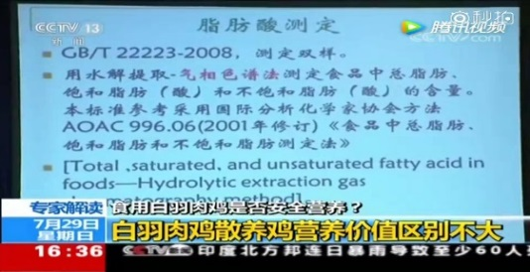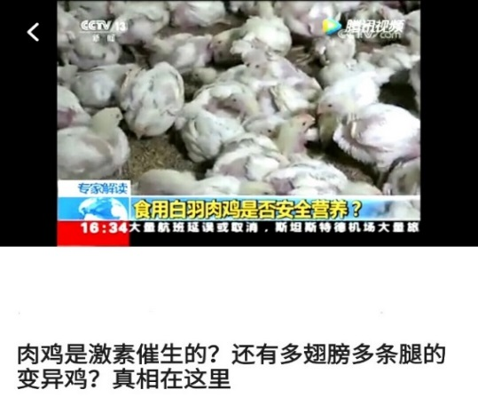

**（2）WeChat Accoun**

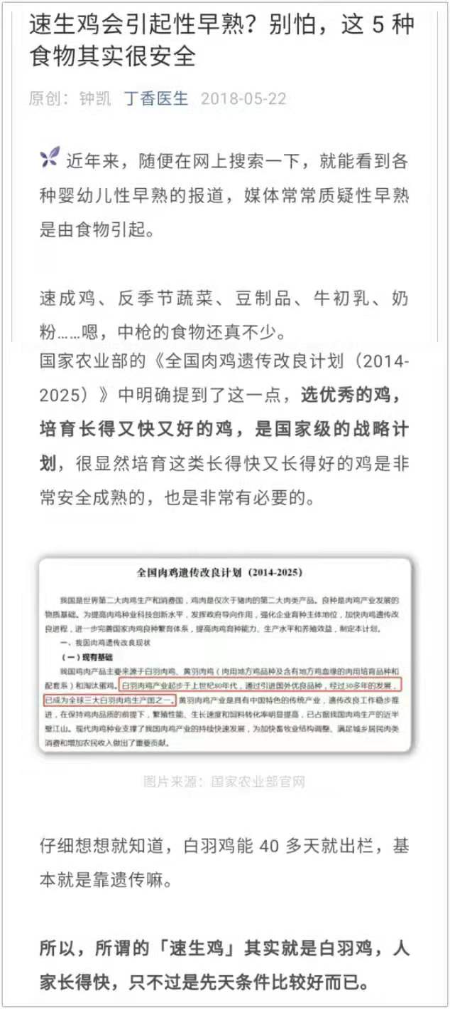

**（3）China Food Safety News**

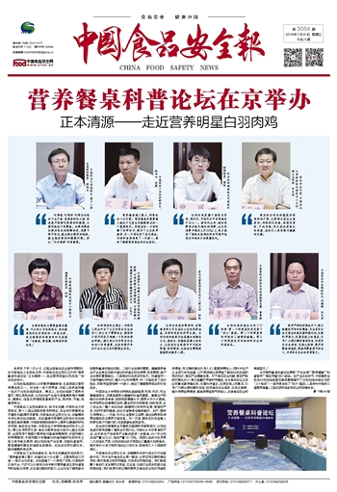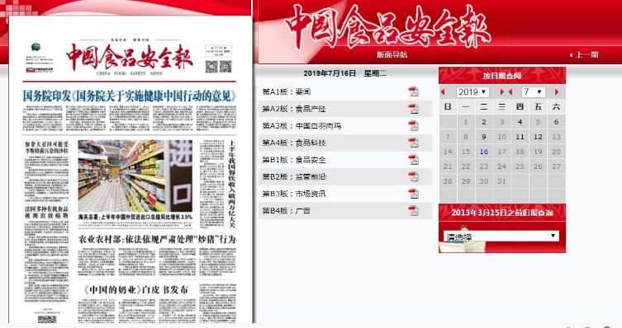

**2.Type of information condition**

**（1）Completely positive* analytical information**

Chicken meat is known for its tenderness, unique flavor, good taste, and high nutritional value, often referred to as 'white meat' along with fish. In comparison to pork, chicken has a higher protein content of about 20% as opposed to pork's average of about 13%. The amino acid composition of chicken protein is closer to that of the human body, making it easier to digest and absorb. Additionally, chicken has a lower fat content with an average of about 9%, while pork averages around 18% fat. Chicken fat is rich in essential fatty acids like linoleic and linolenic acid, giving it a lower melting point. Moreover, chicken has lower calorie content compared to pork for the same amount consumed (excluding 100% lean pork). This makes chicken meat easier for the human body to digest and absorb when compared to other animal meats.

The reason why broilers can grow fast, mainly due to the high intensity of scientific breeding, the design of scientific feed formulas, scientific and reasonable environmental construction of these three main reasons: ① genetic breeding of broilers on the production performance of the contribution of 65% -70%, this process is similar to the current hybrid rice cultivation technology, that is, in the cultivation of nearly a hundred years of breeding process, through the screening of the breast meat and growth of full and fast-growing individuals as the sire line, and gradually cultivated with fast growth, feed conversion rate and other excellent growth characteristics of broiler breeds. The process is similar to the current hybrid rice breeding technology, that is, in nearly 100 years of breeding, through the selection of breast meat and fast-growing individuals as the sire, and gradually bred a fast-growing, feed conversion rate and other excellent growth characteristics of broiler breeds. ② feed preparation: with the previous breeding process only grain bran as breeding feed is different, modern farming according to the different growth stages of broilers, providing different types of full-price feed containing a variety of nutrients, to achieve the "lack of what to make up for what" and mobilize broiler production potential, the feed utilization of broilers increased by 20-30%. The feed utilization rate of broilers has been increased by 20%-30%;③Environmental control, from "site selection + biosecurity" of the environment to "facilities and equipment + scientific management" of the small environment can achieve effective control, light, temperature, humidity, these indexes are weekly, daily, time period as a unit of the management program set up step by step, precise control of the environment, eliminating a variety of negative environmental constraints to ensure that chickens live comfortably, more effective control of epidemics and food quality and safety. Precise control of the environment, eliminating a variety of negative environmental constraints, to ensure that the chicken live comfortably, more effective control of broiler disease problems and food quality and safety, not only to ensure that the chicken grows faster, but also to reduce the use of veterinary drugs in the breeding process. Through these three ways, the current white-feathered broiler meat ratio (the amount of feed consumed by livestock to gain weight of 1 kg) has reached about 1.5-1.7, while pork is 3, beef up to 6, gradually standardizing the breeding process also ensures the quality and safety of broiler products and nutritional value.

To summarize, with such efficient growth performance, hormones have become unnecessary, and the number of veterinary drugs can be scaled down. And a lot of research experiments at home and abroad have also shown that adding hormone substances such as ethylestradiol can not produce a magical ripening effect on chickens, but rather on the cardiovascular, liver and other functions of chickens have side effects, and can easily cause death. The vast majority of farmers today also hold this view. Therefore, the relatively short growth cycle of broiler chickens has nothing to do with hormones.

In addition, through the collation of data from the Food Safety Sampling and Inspection Publication Results Query System, a total of about 8,545 sampling inspections of broilers and their related manufactured products were conducted during the period from 2014 to June 2019, of which only 84 batches of products were found to be unqualified, with a qualification rate of 99.02%, which basically confirms that the quality of broiler products is at a safe level at the present time.

**（2）Completely positive* Conclusive information**

Chicken has a tender meat, unique flavor, good taste characteristics, and has a high nutritional value, and fish and known as "white meat". Compared with pork, ① chicken protein content is higher, the amino acid composition of chicken protein is closer to the human body; ② lower fat content, fat is rich in essential fatty acids; ③ low calorie, the same amount of chicken, its calorie is lower than pork (except 100% lean pork). Therefore, compared with the general livestock meat, chicken is easier to be digested and absorbed by the body.

Broiler can grow fast, mainly due to the high strength of scientific breeding, design of scientific feed formulation, scientific and reasonable environmental construction of the three main reasons: ① through breeding gradually cultivated with the growth of fast, high feed conversion rate and other outstanding growth characteristics of broiler breeds. ② feed formulation: modern chicken industry to achieve the "lack of what to make up for what", and mobilize broiler production potential; ③ environmental control, now broiler farming relying on modern breeding technology, can control the breeding process of various environmental factors, excluding a variety of negative environmental constraints. Through these three ways, effective control of broiler disease problems and food quality and safety, not only to ensure that chickens grow faster, but also to reduce the use of veterinary drugs in the breeding process, while gradually standardizing the breeding process also ensures the quality and safety of broiler products and nutritional value.

In summary, with such efficient growth performance, hormones have become unnecessary and the number of veterinary drugs used can be scaled down. At the same time, a large number of research experiments at home and abroad have also shown that the addition of hormone substances such as ethylestradiol does not have a ripening effect on chickens, but will increase the mortality rate of chickens. Therefore, the relatively short growth cycle of broiler chickens has no relationship with hormones.

In addition, during the period from 2014 to June 2019, the pass rate for sampling chicken and its related manufactured products reached 99.02%, basically confirming that the quality of broiler products is currently at a safe level.

**（3）Both positive and negative *Analytical information**

Chicken has a tender meat, unique flavor, good taste characteristics, and has a high nutritional value, and fish and known as "white meat". Compared with pork, ① chicken protein content is higher, its protein content of about 20%, pork is about 13% on average, the amino acid composition of chicken protein is closer to the human body; ② lower fat content, chicken fat content in the average of about 9%, an average of 18% of pork, fat is rich in essential fatty acids (i.e., unsaturated fatty acids - linoleic acid and linolenic acid), so that chicken fat melting point Low calorie; ③ low calorie, the same amount of chicken, its calorie is lower than pork (except 100% lean pork). Therefore, chicken meat is easier to be digested and absorbed by the human body than general animal meat.

However, due to the short breeding cycle of broilers, although there is no difference in nutrients compared to local chickens, broilers have less intermuscular fat and less flavor substances deposited in the chicken meat, so the taste is not as delicate and fresh as that of local chicken meat in the traditional practice.

The reason why broilers can grow fast, mainly due to the high intensity of scientific breeding, the design of scientific feed formulas, scientific and reasonable environmental construction of these three main reasons: ①genetic breeding of broilers on the production performance of the contribution of 65% -70%, this process is similar to the current hybrid rice cultivation technology, that is, in the cultivation of nearly a hundred years of breeding process, through the screening of the breast meat and growth of full and fast-growing individuals as the sire line, and gradually cultivated with fast growth, feed conversion rate and other excellent growth characteristics of broiler breeds. The process is similar to the current hybrid rice breeding technology, that is, in nearly 100 years of breeding, through the selection of breast meat and fast-growing individuals as the sire, and gradually bred a fast-growing, feed conversion rate and other excellent growth characteristics of broiler breeds. ②feed preparation: with the previous breeding process only grain bran as breeding feed is different, modern farming according to the different growth stages of broilers, providing different types of full-price feed containing a variety of nutrients, to achieve the "lack of what to make up for what" and mobilize the broiler production potential, (the feed utilization of broilers increased by 20-30%;).③Environmental control, from the "site selection + biosecurity" environment to the "facilities and equipment + scientific management" of the small environment can achieve effective control, light, temperature, humidity, these indicators are weekly, daily, time period as a unit of the gradual setting of the management program, the precise control of the environment, eliminating a variety of negative environmental constraints to ensure that chickens live comfortably, effective control of epidemiological problems and food quality and safety. Precise control of the environment, eliminating a variety of negative environmental constraints, to ensure that the chicken live comfortably, effectively control the broiler disease problems and food quality and safety, not only to ensure that the chicken grows faster, but also to reduce the use of veterinary drugs in the breeding process. Through these three ways, the current white-feathered broiler meat ratio (the amount of feed consumed by livestock to gain 1 kilogram) has reached about 1.5-1.7, while pork is 3 and beef up to 6. The gradual standardization of the breeding process also ensures the quality and safety and nutritional value of broiler products.

To summarize, with such efficient growth performance, hormones have become unnecessary, and the number of veterinary drugs can be scaled down. And a lot of research experiments at home and abroad have also shown that adding hormone substances such as ethylestradiol cannot produce a magical ripening effect on chickens, but rather on the cardiovascular, liver and other functions of chickens have side effects, and can easily cause death. The vast majority of farmers today also hold this view. Therefore, the relatively short growth cycle of broiler chickens has nothing to do with hormones.

Nevertheless, due to the characteristics of broiler breeding, at present, China's broiler disease prevention and control is mainly based on vaccine and drug prevention and control, some varieties of antibiotics as feed additives used in animal husbandry has a history of 40 to 50 years, although most of the farms can be in accordance with the relevant regulations on the use of veterinary drugs, but a small number of small-scale farms due to the lack of experience in farming and legal awareness, the process of farming fails to comply with the relevant national standards for the use of drugs, the existence of excessive use of veterinary drugs and antibiotics, and so on, there is a drug residue in the breeding of broiler chickens.

However, through the collation of data from the Food Safety Sampling and Inspection Publication Results Query System, a total of about 8,545 sampling inspections of broilers and their related manufactured products were carried out during the period from 2014 to June 2019, of which only 84 batches of products were substandard, with a pass rate of 99.02%, which basically confirms that the quality of broiler products is currently at a safe level.

**（4）Both positive and negative *Conclusion type information**

Chicken has a tender meat, unique flavor, good taste characteristics, and has a high nutritional value, and fish and known as "white meat". Compared with pork, ① chicken protein content is higher, the amino acid composition of chicken protein is closer to the human body; ② lower fat content, fat is rich in essential fatty acids; ③ low calorie, the same amount of chicken, its calorie is lower than pork (except 100% lean pork). Therefore, compared with the general livestock meat, chicken is easier to be digested and absorbed by the body.

Although there is no difference in nutrients between broilers and local chickens, broilers have fewer flavor substances and their taste is not as delicate and fresh as that of local chickens.

Broiler can grow fast, mainly due to the high strength of scientific breeding, design of scientific feed formulation, scientific and reasonable environmental construction of the three main reasons: ① through breeding gradually cultivated with the growth of fast, high feed conversion rate and other outstanding growth characteristics of broiler breeds. ② feed formulation: modern chicken industry to achieve the "lack of what to make up for what", and mobilize broiler production potential; ③ environmental control, now broiler farming relying on modern breeding technology, can control the breeding process of various environmental factors, excluding a variety of negative environmental constraints. Through these three ways, effective control of broiler disease problems and food quality and safety, not only to ensure that chickens grow faster, but also to reduce the use of veterinary drugs in the breeding process, while gradually standardizing the breeding process also ensures the quality and safety of broiler products and nutritional value.

In summary, with such efficient growth performance, hormones have become unnecessary and the number of veterinary drugs used can be scaled down. At the same time, a large number of experiments have shown that hormonal substances do not have a ripening effect on chickens, but rather increase the mortality of chickens. Therefore, the relatively short growth cycle of broiler chickens has no relationship with hormones. Nevertheless, a small number of small-scale farms fail to fully comply with the national standards for the use of relevant drugs in the breeding process, and there are drug residues in the broiler chickens.

In addition, during the period from 2014 to June 2019, the pass rate for sampling chicken and its related manufactured products reached 99.02%, basically confirming that the quality of broiler products is currently at a safe level.

# Appendix 3 Scenario Experiment Post-test

**Please answer based on your current thoughts and ideas after carefully reading the above information, and there is no right or wrong outcome!**

1. The information source you just read is:
2. Social media WeChat public account
3. China Food Safety Newspaper
4. CCTV News Channel report material
5. The type of information framework you just read is:
6. Completely positive analytical information
7. Completely positive conclusive information
8. Analytical information with both positive and negative aspects
9. Conclusive information with both positive and negative aspects
10. Please fill in the following table based on your current understanding of poultry products:

|  |  |  |
| --- | --- | --- |
| Eating an appropriate amount of chicken daily is beneficial to my nutritional health. |  | 1.Strongly disagree;  2.Disagree;  3.Neither disagree nor agree;  4.Agree;  5.Strongly agree;  1.Strongly disagree;  2.Disagree;  3.Neither disagree nor agree;  4.Agree;  5.Strongly agree; |
| I believe chicken is a high-quality source of protein. |  |
| I think the fat content of chicken is lower than that of pork. |  |
| Compared to pork, chicken has higher cholesterol content. |  |
| I believe that slow-growing chickens have much higher nutritional value than fast-growing chickens. |  |
| The dressed chickens sold in the market currently are not very fresh. |  |
| Frozen chickens, kept under low-temperature control during storage and transportation, are safer and more hygienic than live poultry slaughtered on site, as it helps inhibit the proliferation of microorganisms. |  |
| The taste difference between white-feathered and yellow-feathered poultry is significant, but their main nutritional components are not much different. |  |
| I don't often eat poultry because I worry about the residue of many chemical agents (such as tetracycline, doxycycline, and other antibiotics) in chicken, which can affect health if consumed in large amounts. |  |
| I think that the chemical residue present in most poultry makes eating chicken more dangerous than pork, beef, fish, etc. |  |
| I am very concerned that the rapid growth of poultry in the market is due to the stimulating effect of hormones. |  |
| I feel that eating parts of the poultry such as the tips, wings, and neck is unsafe. |  |
| I believe that most poultry farmers and processors currently do not produce according to the national poultry drug residue limit standards. |  |
| I am very worried about buying chicken products with avian meat diseases. |  |
| Dead poultry during the breeding process are generally treated harmlessly (by incineration, deep burial, etc.). |  |
| Most poultry in the market undergo drug residue and pathogen sampling before going on sale. |  |
| Live poultry trading in the market easily leads to the spread of avian diseases, while centralized slaughter and frozen sales can effectively control the spread and infection of avian diseases. |  |

1. What do you think about the overall safety of poultry products at the moment?
2. Very unsafe
3. Not very safe
4. Average
5. Comparatively safe
6. Very safe
7. In the future, will you increase, maintain, or decrease your consumption of poultry products?
8. Increase chicken consumption every week
9. Maintain current consumption
10. Decrease consumption
11. What is your future frequency of consuming chicken?
12. Do not consume
13. Once a month
14. 2-3 times a month
15. Once a week
16. 2-3 times a week
17. 4 or more times a week.