Supplementary Material

# Supplementary Data: Framework Application, Game Guides, and Instruments.

**Supplementary Data 1.** Framework Application two produce two games: *Stairs, Pits, and Ropes* and *Race to Mars.*

|  |  |  |
| --- | --- | --- |
| **Steps of the Framework** | **Developed Games** | |
| ***Stairs, Pits, and Ropes*** | ***Race to Mars*** |
| **Step 1 - Adopt** | The teacher conducts a survey to evaluate whether the students are familiar with the two board games- ⅰ. Snakes and Ladder and ⅱ. Ludo/Trouble. The classroom survey suggested that almost all the students have played these classic board games before and are familiar with the game mechanics. | |
| **Step 2 - Enhance** | The teacher incorporates additional elements to promote strategical thinking and incorporate essential gaming traits that can enable players increased degree of control to influence the gameplay, rather than solely a “chance-based” game mechanics as explained by Gough (1999). | |
|  | For example, in Snakes and Ladders, a rope card is introduced that enables players to either freeze their opponent for the next turn or avoid falling behind in the game by jumping over the snake tile. These rope cards can be collected and used strategically in suitable circumstances to gain an advantage. Finally, to introduce novelty, the teacher may change the board game's theme. For instance, instead of snakes and ladders, we modernised the theme to incorporate a relatively urban setting where stairs replace the ladder, and snakes are replaced by pits. Thus, the game “Snakes and Ladders” transformed into a new “Stairs, Pits and Ropes” while retaining the original game's simple and familiar mechanics. | Similarly, in Ludo/Trouble, the teacher introduces various types of advantage cards that allow players to stop their opponents' progress, assist their teammates or speed up their advance towards the finish line—additionally, changing the theme of the Ludo game to a space-adventure results in the game “Race to Mars”. |
| **Step 3 - Align** | In this step, the teacher incorporates learning material into the game mechanics, aligning with the learning objectives. In the examples presented, our goal is to facilitate problem-solving sessions, and therefore quiz-like format was applied with practice problems printed on game cards (see Fig. 2 for details). The same practice module delivered during the regular classroom sessions was incorporated into the game. This approach ensures that the teacher’s workload is not increased and no additional effort is targeted towards designing special learning materials to align with the games. | |
| **Step 4 - Implement** | The teacher conducts problem-solving practice sessions using the games designed in steps 1-3. In this step, the students lead the sessions, and the teacher assumes an observational role. The students are provided answer keys to promote peer evaluation. The teacher's main role is to perform classroom observations and gather feedback from students on their experiences of GBL sessions. | |
| **Step 5 - Repurpose** | This final step of our framework addresses an important challenge faced by teachers - obstacles in acquiring educational games or scarcity of readily available educational games (Watson and Yang, 2016). In this step, the teacher can repurpose the same game for a different module or collaborate with other teachers to promote interdisciplinary education. For instance, in our “Race to Mars” game, a mathematics teacher can collaborate with a science teacher to incorporate quiz questions and game elements about space science or the solar systems. Teachers can exchange games with each other to further incorporate novelty and increase the number of available educational games within a school. | |

**Supplementary Data 2.** Game Guide for *Stairs, Pits, and Ropes.*

**STAIRS, PITS, AND ROPES**

**GAME GUIDE**

1. **Game Objective**

Reach the top of the board before your opponents! Answer quiz questions on key cards to earn keys, unlock the stairs and progress upward. Collect rope cards by answering questions correctly and gain valuable resources to strategically advance in the game. Employ your acquired keys and ropes wisely as you navigate the board and reach the top!

1. **Components**

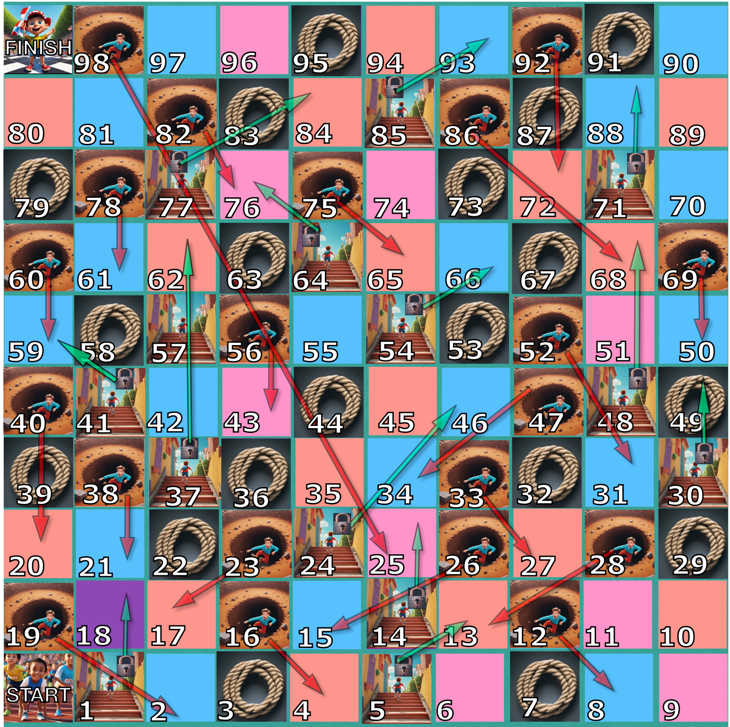

Free AI image generation software Gencraft (Hive.ai, 2023) and Craiyon (Dayma, 2023) were used for images in game components.

**Game Board :** The game board features a path with stairs, pits, and rope tiles.

**Key Cards :** These cards also contain questions. Players answer these questions to earn key cards.

**Rope Cards :** These cards contain questions. Players answer these questions to earn rope cards.

**Tokens :** Players use tokens to mark their tile positions on the game board.

1. **Setup**
2. Place the game board in the center of the playing area.
3. Shuffle the rope cards and key cards separately.
4. Each player selects a token and places it at the starting position on the game board marked as “**START**”.
5. **Gameplay**
6. The player who rolls the highest number using the dice starts the game. Players take turns in clockwise order.
7. On your turn, roll a standard six-sided die and move your token forward the indicated number of tiles along the path on the game board.

**Landing on Stair Tiles**

1. When you land on a space marked with stairs, you encounter a locked door. Draw a key card and solve the mathematical problem written on it. Match your answer with the answer given in the answer sheet and show it to your friends. If your answer is correct, you unlock the stairs, climb up, and play the next tile until your turn ends. Otherwise, you stay on the same tile and wait for your next turn. Discard the key card at the end of your turn.

**Landing on Rope Tiles**

1. If you land on a tile with ropes, you can draw a rope card and answer a question to earn the card. Your turn ends after answering the question. A correct answer earns you the rope card to keep for use in future turns. Unearned rope cards should be discarded.

**Landing on Pit Tiles**

1. If you happen to land on a pit, you’ll fall into its depths back to a lower tile. However, if you possess a rope card, you have the means to escape. You can use the rope card to climb out of the pit, move one step forward on the board, and play the next tile until your turn ends. Discard the rope card after use. If you lack a rope card, you’ll fall through the pit, land your token on a lower tile, and patiently await your next turn.

**Using Rope Tiles**

1. Rope cards can be used on any future turn for various purposes, as described below.
   1. **Climbing out of the pit:** A rope card may be used once to escape a pit, after which it should be discarded.
   2. **Binding an opponent:** Alternatively, you can use the rope card to bind all your opponents. This strategic move results in all your opponents missing their next turn, while you gain the advantage of rolling the dice again.

**Ending a Turn**

1. Your turn ends when you:
   1. land on a blank tile
   2. acquire a rope card
   3. fail to acquire a rope or key card
   4. fall into a pit without a rope card
2. **Winning the Game**

The first player to reach the top of the board on the tile marked with “**FINISH**” emerges as the victor. To clinch the win, you must roll the exact number on the dice required to land on the precise space labelled as “**FINISH**.” For instance, if you find yourself 3 tiles away from the “**FINISH**” block, you must roll the dice and obtain a 3 to complete the race. If you roll a number greater than 3, you will have to stay on your tile and wait for your next turn. Conversely, if you roll a number less than 3, say 2, you’ll advance 2 steps forward and wait for your next turn to roll a 1 to win the game.

Other players can continue to secure second and third places in the game.

1. **Sample Turn/Playthrough**
2. Player 1 rolls a 5 and lands on a stairs space. They draw a key card, answer a question correctly, earn a key card to unlock the stairs and climbs up to the designated tile. The succeeding tile is blank, so their turn ends.
3. Player 2 rolls a 3, draws a rope card, and collects it. Their turn ends.
4. Player 3 rolls a 2 and falls into a pit. However, they have a rope card earned from an earlier turn, so they use it to climb out of the pit and place their token on the next tile forward. This succeeding tile contains a rope, so Player 3 continues to play by drawing a rope card. They collect the card and end their turn.

Developed by: Nautiyal, V., Salvador, E., Silverio, S. (2023)

References:

Dayma, B. (2023). Craiyon (Version 4) [image generator], accessed 20 October 2023. https://www.craiyon.com/

Hive.ai (2023). Gencraft (2023 Version) [image generator], accessed 20 October 2023. https://gencraft.com/

**Supplementary Data 3.** Game Guide for *Race to Mars.*

**RACE TO MARS**

**GAME GUIDE**

1. **Game Objective**

Navigate your rocket around outer space and lead your team to a successful landing on Mars! You will encounter planets, gravitational paths, and international space stations along the way, but you’ll need strategy and teamwork to succeed.

1. **Components**

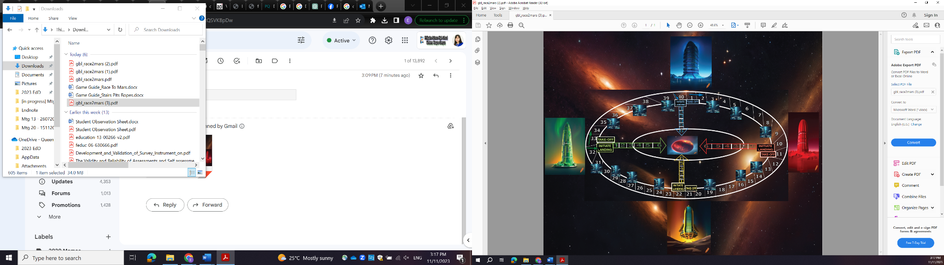

Free AI image generation software Gencraft (Hive.ai, 2023) and Craiyon (Dayma, 2023) were used for images in game components.

**Game Board :** The game board represents outer space, featuring planets and orbital paths.

**Rockets :** Each team consists of two rockets controlled by two players.

**Resource Cards :** Four types of cards (bonus fuel, satellite hack, technical assistant, missile) that provide various advantages in the game.

1. **Setup**
2. Place the game board in the center of the playing area. The game can accommodate up to 4 teams, with each team having 2 players.
3. The team who rolls the highest number using the dice chooses among the Red, Blue, Green and Yellow Space Stations. The team with the second highest number chooses among the remaining Space Stations, and so on until all teams are assigned.
4. Shuffle the advantage cards and place them face down near the game board.
5. Each player selects a rocket and places it on their Space Stations on the game board.
6. **Gameplay**
7. The team who rolled the highest number in C.2. starts the game. Teams take turns in clockwise order. During their team’s turn, each of the two players roll a standard six-sided die.
8. To start the journey, a player must roll a 6 on their die. If successful, you can move your rocket to the “**TAKE-OFF**” position and your turn ends.
9. Continue rolling the dice and advance your rocket clockwise along the gravitational path, completing one revolution until you reach the “**INITIATE LANDING**” position before moving into the inner orbit of Mars. Notice that path instructions per space station are indicated in their respective colors.

**Landing on International Space Stations**

1. When you land on an international space station, choose one type of resource you would like to obtain: bonus fuel, satellite hack, technical assistance, or missile. Draw 1 resource card from the stack of your choice and solve the mathematical problem written on it. Match your answer with the answer given in the answer sheet and show it to your friends. If your answer is correct, you obtain the resource card and have the choice to use it immediately or keep it for later and end your turn. Discard the resource card after 1 use.

**Resource Cards**

There are 4 types of resource cards that you can use strategically. There is no limit to the number of resource cards you can use in a turn.

1. **Bonus Fuel:** Getting a fuel refill means you receive an extra roll of the dice for moving your rocket or for a missile power-up.
2. **Satellite hack:** Hack your opponent’s satellite - steal one resource card of your choice from your opponent. If none of your opponents possesses any resource card during your turn, your only choice will be to keep it for later use.
3. **Technical assistance:** Provide or receive assistance from your teammate in any of the following ways:

* Help them take off and begin their space journey if they have not yet rolled a 6 on their dice.
* Boost their speed and advance them to the same spot as you if you are ahead of them.
* If you are lagging behind, you can receive assistance and move your rocket to the same position as theirs.

1. **Missile**: Shoot at your opponent with a missile, potentially causing their rocket to crash and return to their **TAKE-OFF** position. Roll the die to launch the missile and determine your attack target. For the attack to be considered a hit, the opponent’s rocket must be within ±1 range of the missile target. For example, if your opponent is 4 spaces away, you need to roll a 3, 4, or 5 to hit them successfully. Rolling a 1, 2, or 6 will count as a miss because it will land the missile more than 1 space away from the opponent’s rocket. Note: Your rocket does not move when shooting a missile.

**Missile + Bonus Fuel Combo**: If your opponent rocket is more than 6 spaces away, you can use your bonus fuel card to power-up the missile instead of your rocket. Roll the dice twice for a potential target distance of up to 12 spaces and a missile target range of ±1.

**Ending a Turn**

1. Your turn ends when you:
   1. run out of cards to use
   2. choose to end your turn and keep cards for later
2. **Winning the Game**

To win, both players of a team must successfully land their rocket on Mars. To accomplish a successful landing, you must roll the exact number on the dice required to reach Mars. For instance, if you are 2 spaces away from Mars, you must roll an exact 2 to land. Rolling a number greater than 2 will not be counted and you will have to roll again.

Other teams can continue to play to secure second and third place.

1. **Sample Turn/Playthrough**

Round 1:

1. Team A takes the first turn. Both players on Team A roll the dice. One of them gets a 6, allowing one of their rockets to take off from Earth. The other player rolls a 4, so they’ll have to wait for their next turn. Team B is next, and both of their players roll the dice. One player gets a 6 and takes off. The other player rolls a 3 and will also wait for their next turn.

Round 2:

1. Team A continues their journey with the rocket that took off. They roll the dice and advance along the orbital path. Team B’s rocket, which took off in the previous round, also progresses along the orbital path.

Round 3:

1. Team A reaches an international space station and chooses to answer a question on the resource card, drawing the “Bonus Fuel” card. Team B’s rocket is still in motion and moves closer to Mars.

Round 4:

1. Team A’s rocket, with the “Bonus Fuel” card in hand, continues moving forward. Team B’s other player rolls a 6 and takes off with their second rocket from Earth.

Round 5:

1. Team A is now one space away from Mars but hasn’t yet rolled a 1. They must keep rolling until they get a 1 to land on Mars. Team B’s first rocket reaches an international space station, answers a question on the advantage card, and draws the ”Satellite Hack” card.

Round 6:

1. Team A finally rolls a 1 and successfully lands one of their two rockets on Mars, completing the soft landing. Team B’s second rocket is now in motion, moving toward Mars.

Round 7:

1. Team B’s second rocket reaches an international space station, answers a question on the advantage card, and draws the “Technical Assistant” card.

Round 8:

1. Team B’s second rocket lands on Mars with a roll of 1, completing the game’s objective. Team B successfully lands both of their rockets on Mars and is declared the winner of ”Race to Mars.”

Developed by: Nautiyal, V., Salvador, E., Silverio, S. (2023)

References:

Dayma, B. (2023). Craiyon (Version 4) [image generator], accessed 20 October 2023. https://www.craiyon.com/

Hive.ai (2023). Gencraft (2023 Version) [image generator], accessed 20 October 2023. https://gencraft.com/

**Supplementary Data 4.** Student Feedback Form.

**Let’s Get on Board! Educational Board Games for High School Students**

**Student Feedback Form**

|  |  |  |
| --- | --- | --- |
| **Name** |  | |
| **Age** |  | **Male  Female  Prefer not to Say** |
| **First Quarter Math Grade** | |  |

**Part 1 Instructions:**

Please rate each statement by encircling a score to indicate how much you agree with it.

If you disagree with the statement, circle '1' (Strongly Disagree).

If you somewhat disagree, but not strongly, circle '2.'

If you agree, but not very strongly, circle '4.'

If you strongly agree with the statement, circle '5' (Strongly Agree).

For statements where you have no particular feelings, please circle '3' (Neutral).

|  |  |  |  |  |  |
| --- | --- | --- | --- | --- | --- |
| **Statements** | **Score** | | | | |
| Strongly Disagree | Disagree | Neutral | Agree | Strongly Agree |
| 1. Board games made solving math problems fun for me. | 1 | 2 | 3 | 4 | 5 |
| 2. I enjoyed interacting with my friends to solve math problems while playing math games. | 1 | 2 | 3 | 4 | 5 |
| 3. I didn't enjoy practising math through board games. | 1 | 2 | 3 | 4 | 5 |
| 4. Board games had no effect on my interest towards mathematics. | 1 | 2 | 3 | 4 | 5 |
| 5. We should have teaching sessions with math games every week in school. | 1 | 2 | 3 | 4 | 5 |
| 6. I will play similar games at home with my friends to practice mathematics. | 1 | 2 | 3 | 4 | 5 |
| 7. I enjoy game sessions more than regular math lectures. | 1 | 2 | 3 | 4 | 5 |

**Part 2 Instructions:**

Please complete the following prompts by ticking the appropriate box and filling the blanks.

8. My favourite game was –

Stairs, Pits and Ropes

Race to Mars

because _______________________________________________________________________

___________________________________________________________________________________________________________________________________________________________________________________________________________________________________________________

9. The best thing about solving math problems while playing this game was _____________ ___________________________________________________________________________________________________________________________________________________________________________________________________________________________

10. The thing I did not like about using board games to solve math problems was ________

___________________________________________________________________________________________________________________________________________________________________________________________________________________________

– End of Form –

**Supplementary Data 5.** Classroom Observation Sheet, adapted from PLOT (Algayres et al., 2022).

**Let’s Get on Board! Educational Board Games for High School Students**

**Classroom Observation Sheet**

|  |  |  |  |
| --- | --- | --- | --- |
| **Section** |  | **Date** |  |
| **Venue** |  | **Time Started** |  |
| **Name of Teacher** |  | **Time Finished** |  |

|  |  |  |  |  |
| --- | --- | --- | --- | --- |
|  |  | **Yes** | **No** | **Comments** |
| Question 1 | **Who?** | | | |
| Focus | *players’ profile, preferences, game culture* | | | |
| Item  1 | Most have experience playing similar games |  |  |  |
| 2 | Most have no or little game experience |  |  |  |
| 3 | Students play solo |  |  |  |
| 4 | Students play in teams |  |  |  |
| 5 | Students play as themselves |  |  |  |
| 6 | Students are given a specific role |  |  |  |
| 7 | Students prepared for the game before the session |  |  |  |
| 8 | Students went through the game session on the spot |  |  |  |
| 9 | Some students express discomfort with Game-based Learning |  |  |  |
| Question 2 | **What?** | | | |
| Focus | *tasks, interaction (interface), communication forms, performance (evaluation)* | | | |
| Item  10 | The game has been designed for a specific curriculum |  |  |  |
| 11 | Students have a specific and functioning interface/ material |  |  |  |
| 12 | Problems with the interface/ material  (Explain: _______________________________ ______________________________________ |  |  |  |
| 13 | Students communicate directly with each other during the game session |  |  |  |
| 14 | Students communicate online during the game session |  |  |  |
| 15 | Students have a clear victory goal |  |  |  |
| 16 | Students are given a loose set of objectives |  |  |  |
| 17 | Students get a specific summative evaluation after the game |  |  |  |
| 18 | Student participation in the game is not evaluated |  |  |  |
| 19 | Students easily understand the objectives and tasks of the game |  |  |  |
| 20 | Students self-regulate their progression objectives |  |  |  |

|  |  |  |  |  |
| --- | --- | --- | --- | --- |
|  |  | **Yes** | **No** | **Comments** |
| 21 | Students require a lot of teacher guidance to get started with the game |  |  |  |
| 22 | Teacher frequently intervenes to reframe the game experience |  |  |  |
| 23 | Students express frustration with the difficulty of the game tasks |  |  |  |
| Question 3 | **Why?** | | | |
| Focus | *fun, engagement (cognitive, behavioral, emotional), play dynamics* | | | |
| Item  24 | Students accomplish clearly identified challenges/ tasks |  |  |  |
| 25 | Students accomplish tasks that have equivalences in real life |  |  |  |
| 26 | Students follow the game rules to accomplish their objectives |  |  |  |
| 27 | Students make active use of their knowledge during the game |  |  |  |
| 28 | Students can interact within a simulation of a different context |  |  |  |
| 29 | Students follow a specific narrative |  |  |  |
| 30 | Students engage in discussion often, pleasantly and/ or humorously |  |  |  |
| 31 | Students can change their objectives during the game session |  |  |  |
| 32 | Students appear active and engaged |  |  |  |
| 33 | Some students engage only when actively solicited (by teacher or other students) |  |  |  |
| 34 | Some students appear uninterested and disengaged |  |  |  |
| 35 | Some students ignore the rules or cheat |  |  |  |
| 36 | Some students actively voice discontent with the game |  |  |  |
| Question 4 | **How?** | | | |
| Focus | *mechanics, dynamics, components, player journey, reinforcement* | | | |
| Item  37 | Students engage in collaborative play |  |  |  |
| 38 | Students engage in competitive play |  |  |  |
| 39 | Students hear the learning objectives clearly (teacher or material or interface) |  |  |  |
| 40 | Students show clear understanding of the mechanics and progression |  |  |  |
| 41 | Students “level up” over the course of the game |  |  |  |
| 42 | Students know their score and/ or level at all times |  |  |  |
| 43 | Students can see their level compared to others |  |  |  |
| 44 | Students get immediate feedback from the game |  |  |  |
| 45 | Students get a reward after each action/ objective |  |  |  |

|  |  |  |  |  |
| --- | --- | --- | --- | --- |
|  |  | **Yes** | **No** | **Comments** |
| 46 | Students have possibilities of retry and error |  |  |  |
| 47 | Students can customize their character/ avatar |  |  |  |
| 48 | Students can advance/ influence the story/ narrative during the game |  |  |  |
| 49 | Students can support each other during the game |  |  |  |
| 50 | Students get a debrief session after the game |  |  |  |
| 51 | Students manifest low motivation and/ or disengagement |  |  |  |

1. Please list any questions that the students have raised during test administration and the answers you provided.

|  |
| --- |
|  |

1. Please list down the names of students (1 to 3) who might be suitable for interview about their learning experience, and the behavior they exhibit that made you think so.

|  |
| --- |
|  |

Accomplished by: __________________________________

Name and Signature of Teacher

Thank you very much for your contribution!

Reference:

Algayres, M., Timcenko, O., and Triantafyllou, E. (2022). "Development and use of a playful learning observation tool (PLOT) for active game-based learning in physical classroom situations." in: Proceedings of the16th European conference on games based learning.