Supplementary Figures and Tables

Supplementary Table 1: Primer sequences used for qPCR analysis

Gene |  | Primer sequence | Accession number | Product size (base pairs)
TBP | Forward  Reverse | 5’-GCCAAGAGTGAAGAACAG  5’-GAAGTCCAAGAACTTAGCTG | NM_001172085.2 | 90
RPL13A | Forward  Reverse | 5’-GTCTGAAGCCTACAAGAAAG  5’-TGTCAATTTTCTTCTCCACG | NM_012423.4 | 189
ACAN | Forward  Reverse | 5’-CACCCCATGCAATTTGAG  5’-AGATCATCACCACACAGTC | NM_001135.4 | 82
COL2A1 | Forward  Reverse | 5’-GAAGAGTGGAGACTACTGG  5’-CAGATGTGTTTCTTCTCCTT | NM_001844.5 | 165
SOX9 | Forward  Reverse | 5’-CTCTGGAGACTTCTGAACG  5’-AGATGTGCGTCTGCTC | NM_000346.4 | 172

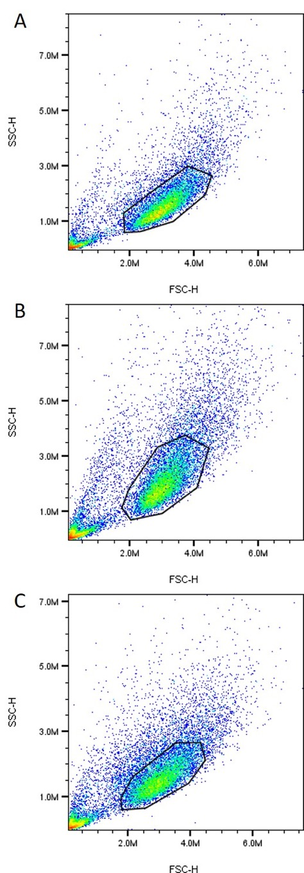
Supplementary Figure 1: Flow cytometry scattergrams plotted using forward (FSC-H) and side scatter (SSC-H) for identifying and gating cell populations. CDC populations (A), NFAC populations (B) and FAC populations (C) were each gated for the most homogeneous, viable cell population as drawn. The 100,000 cells gated in each sample were used in subsequent analysis for cell surface markers. Representative images are shown from a single biological sample for illustrative purposes.

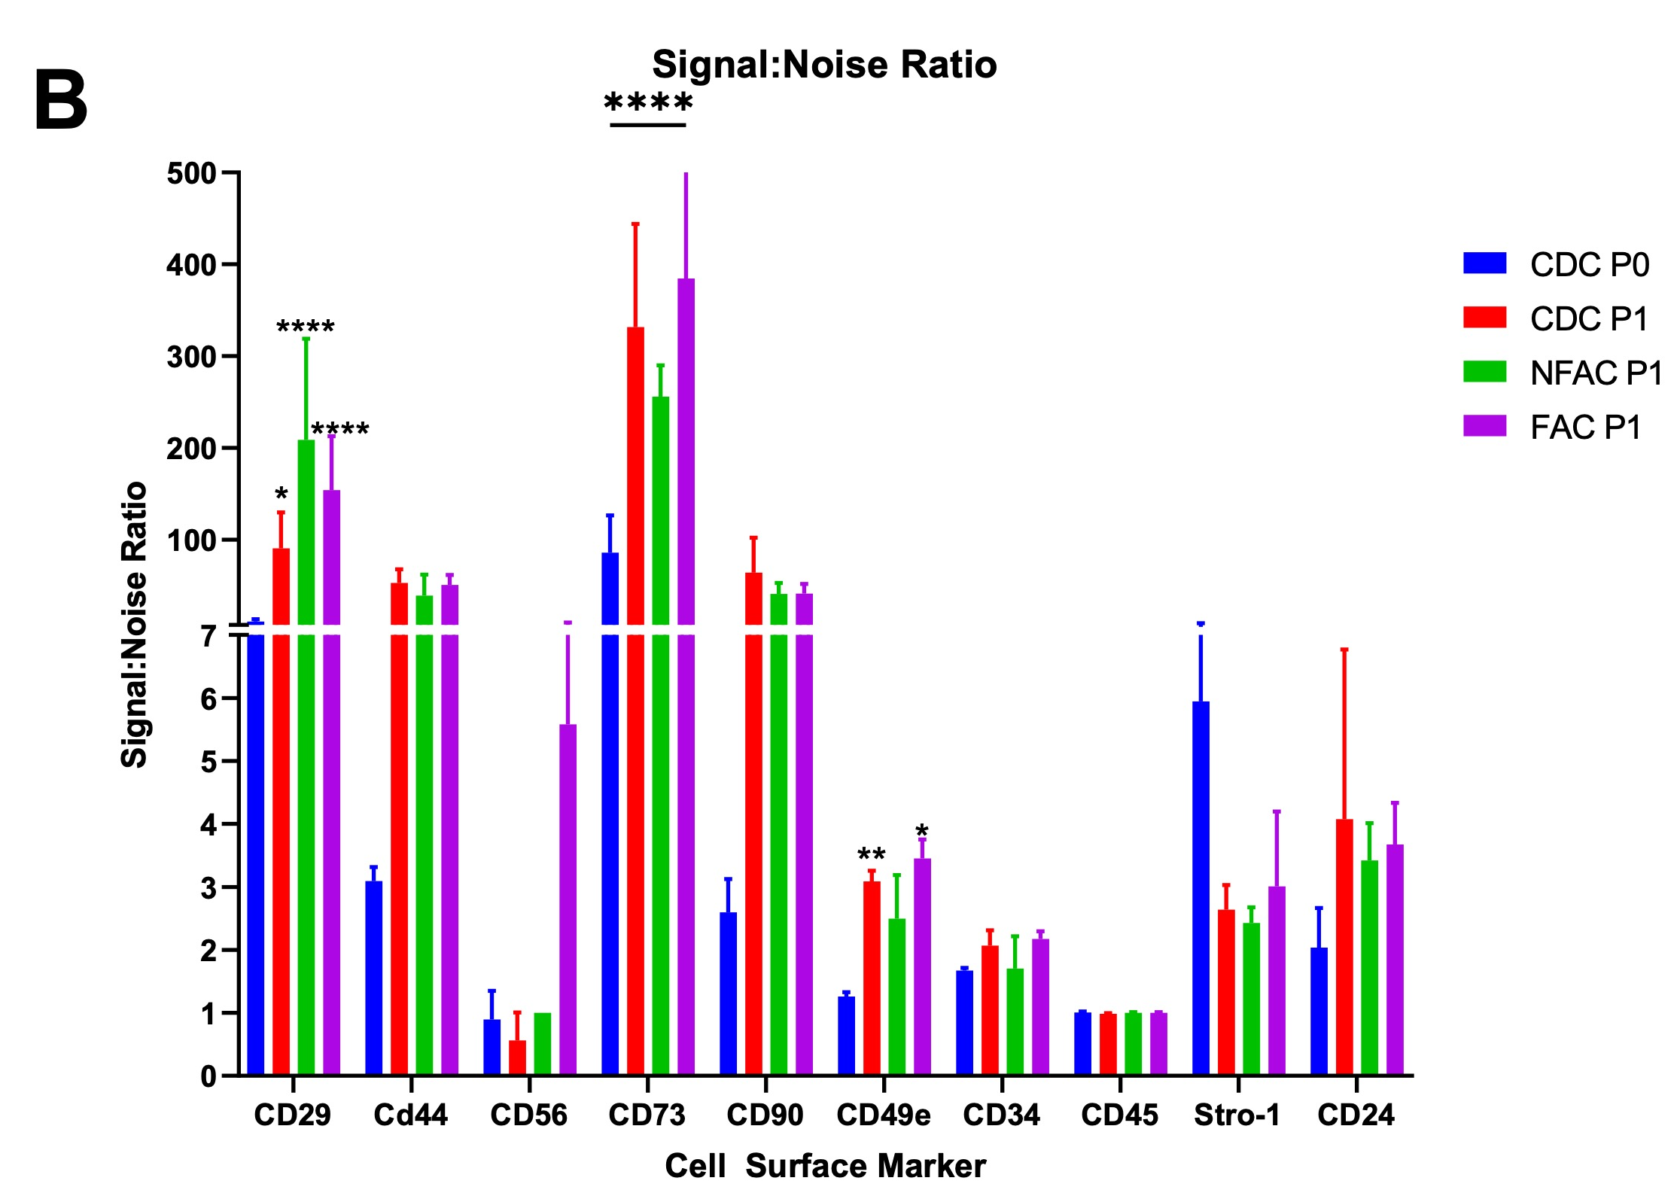

Supplementary Figure 2: Signal:Noise ratios derived from median fluorescence index (MFI) of stained populations corrected for the MFI of the unstained population. A S:N ratio of 1 is therefore equivalent to no fluoresence. Each cell surface marker is examined in the full cell population immediately post-digest at P0 (blue, CDC only) and then in the three populations at P1 (CDC = red, NFAC=green, FAC=purple). The mean S:N ratio of three biological replicates are presented with SD error bars. *=p<0.05; **=p<0.01; ***=p<0.001; ****=p<0.0001.

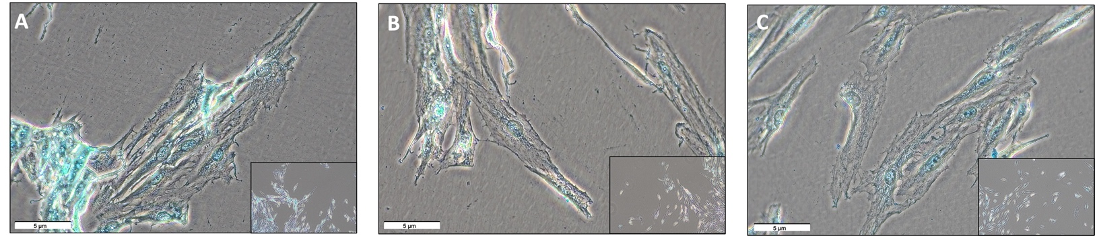

Supplementary Figure 3: Chondrocyte populations stained with Alcian Blue stain at Passage 1. A) CDCs B) NFACs C) FACs are demonstrated at 40x magnification with 10x magnification in the bottom right corner.

