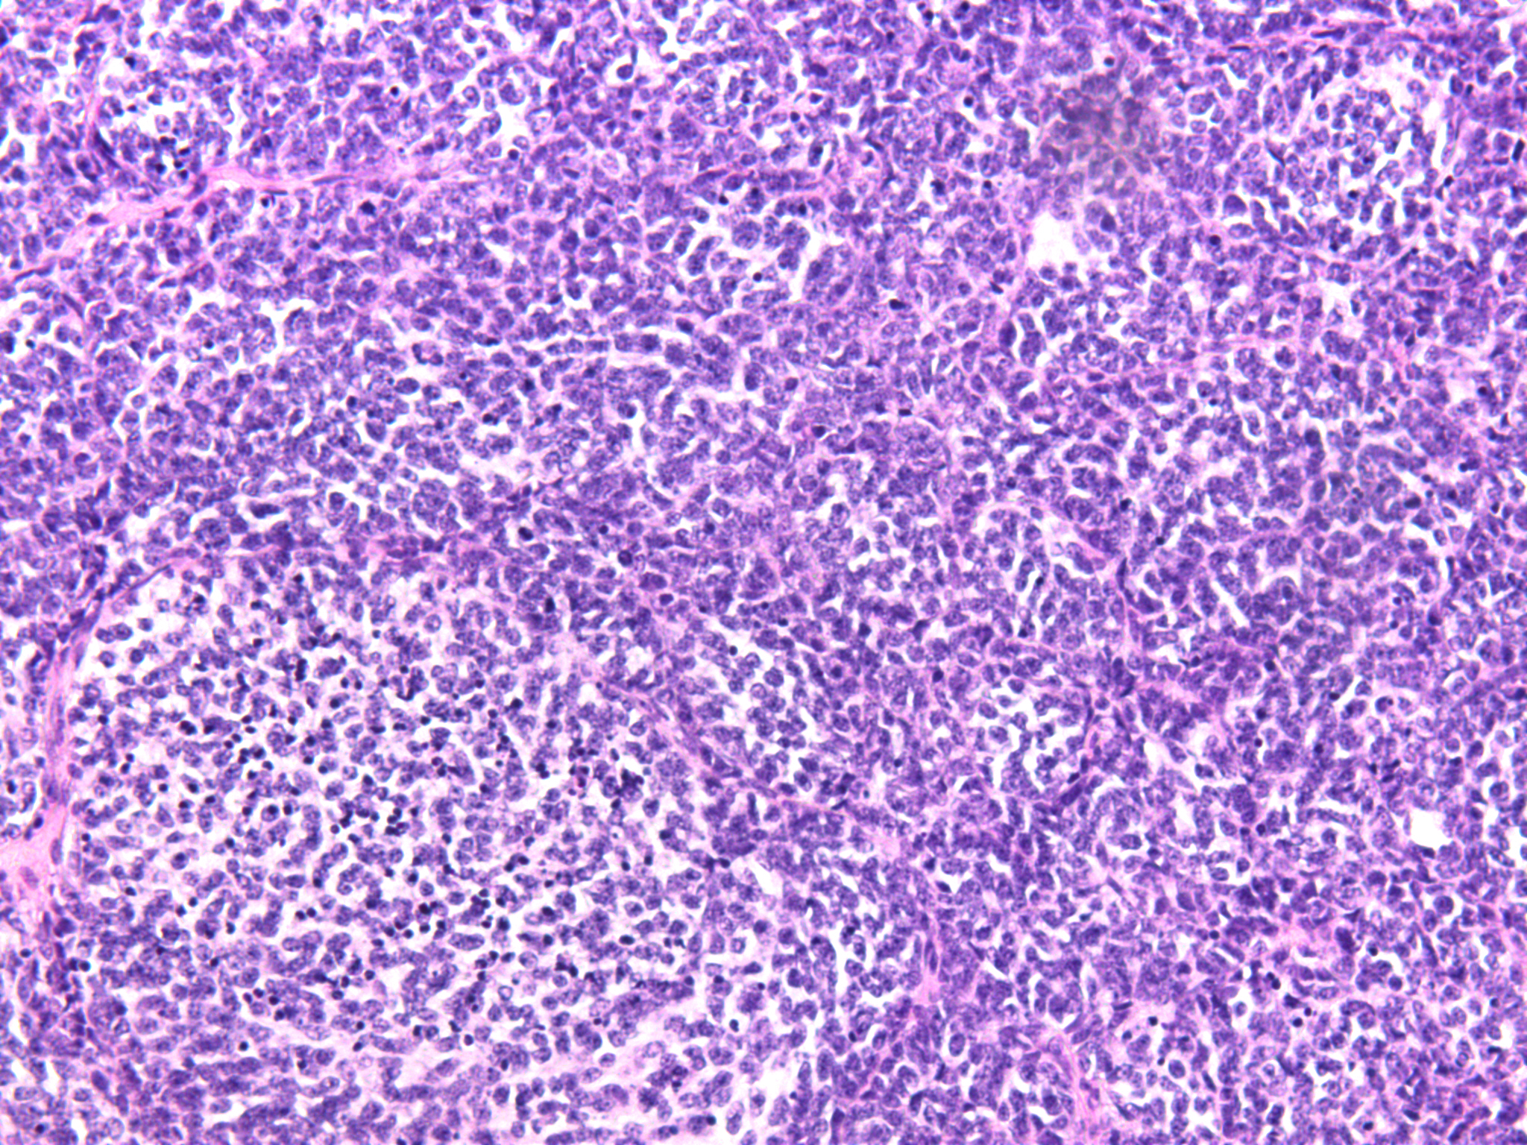

**Figure S1.** Hematoxylin-eosin staining of a tumor sample, magnified at ×200.

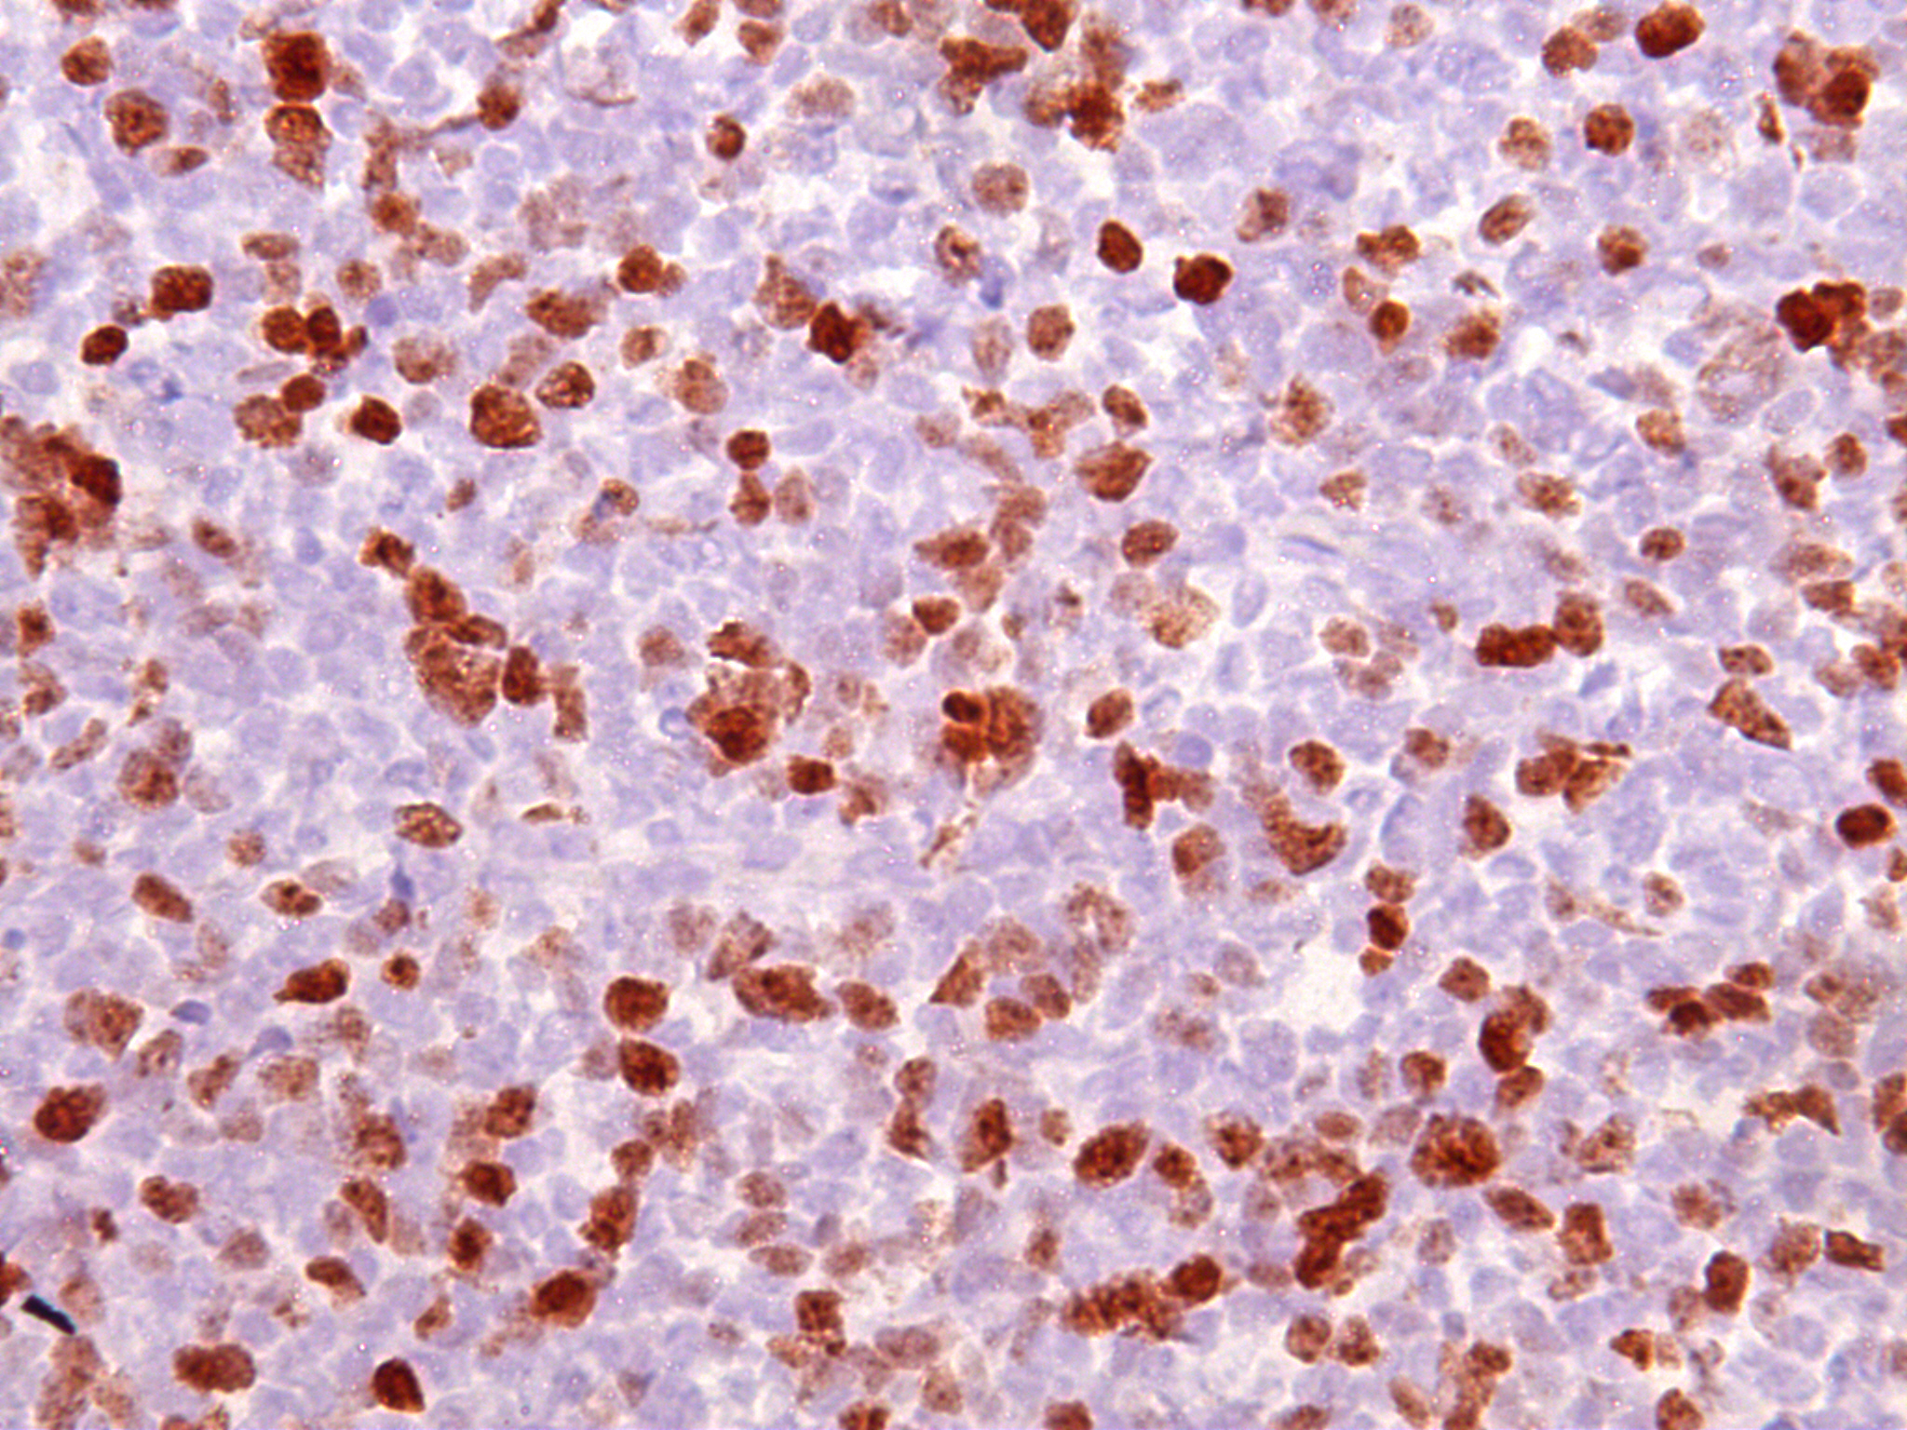

**Figure S2.** Ki-67 staining of a tumor sample, magnified at ×400.