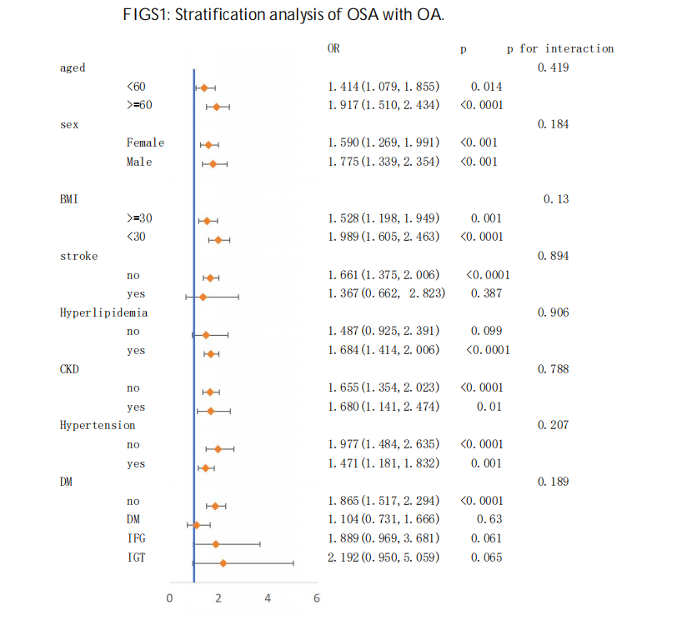

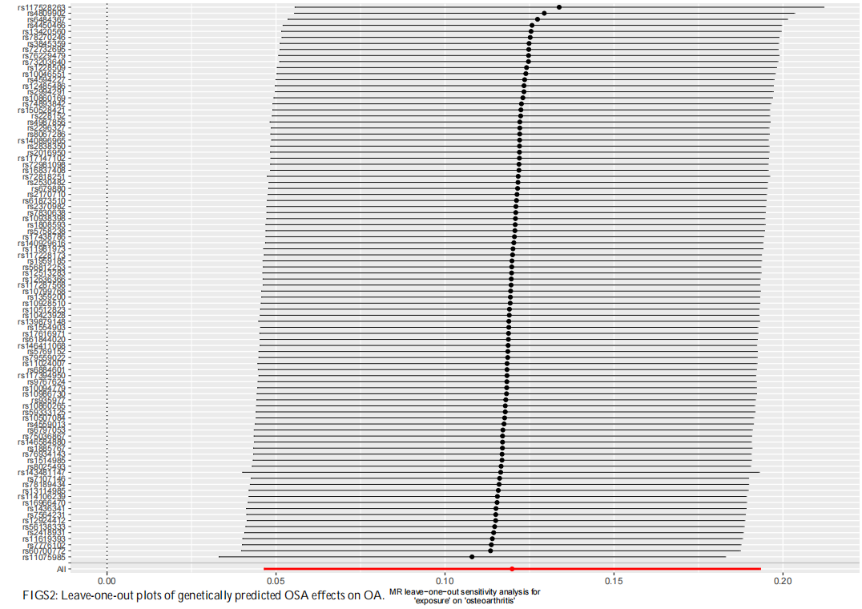

FIGS2 Leave-one-out plots of genetically predicted OSA effects on OA.

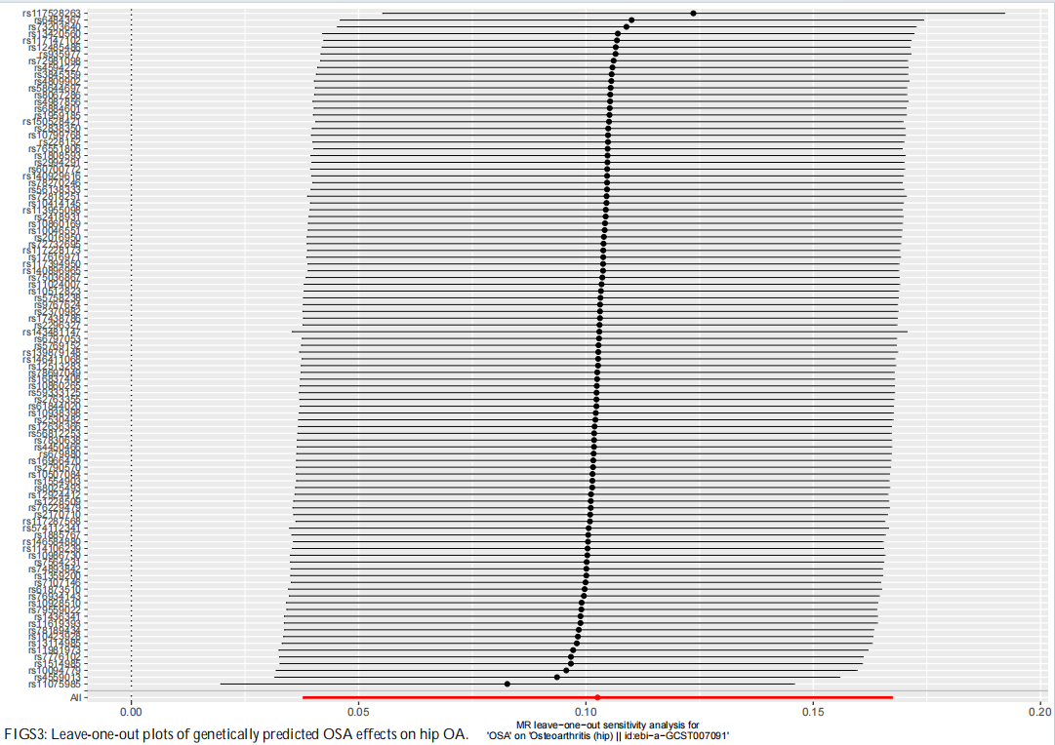

FIGS3 Leave-one-out plots of genetically predicted OSA effects on hip OA.

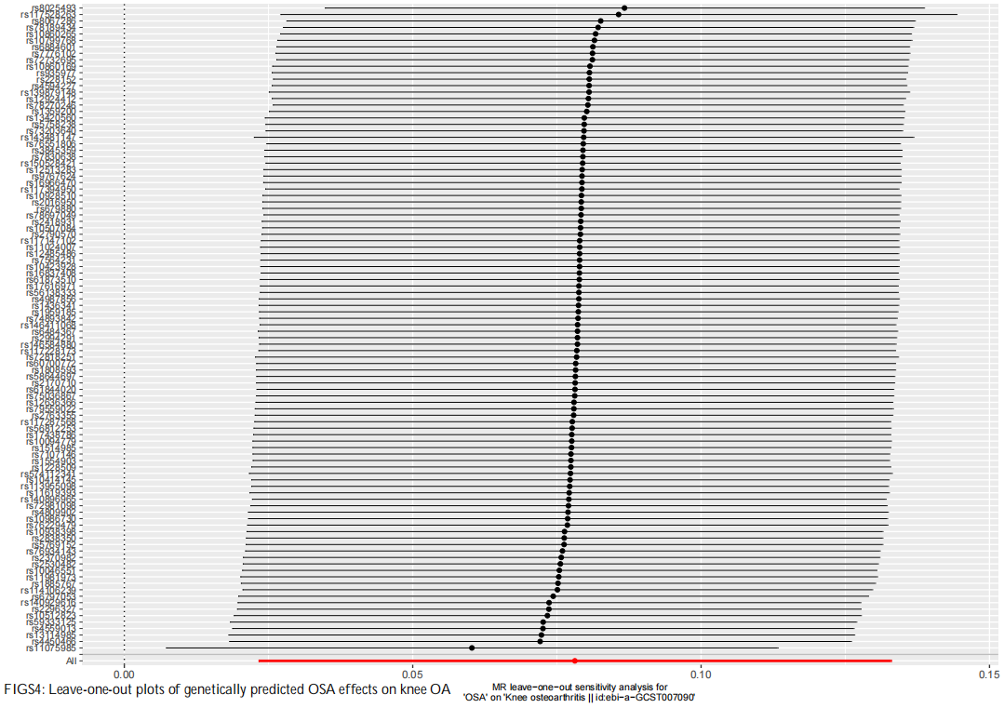

FIGS4 Leave-one-out plots of genetically predicted OSA effects on knee OA

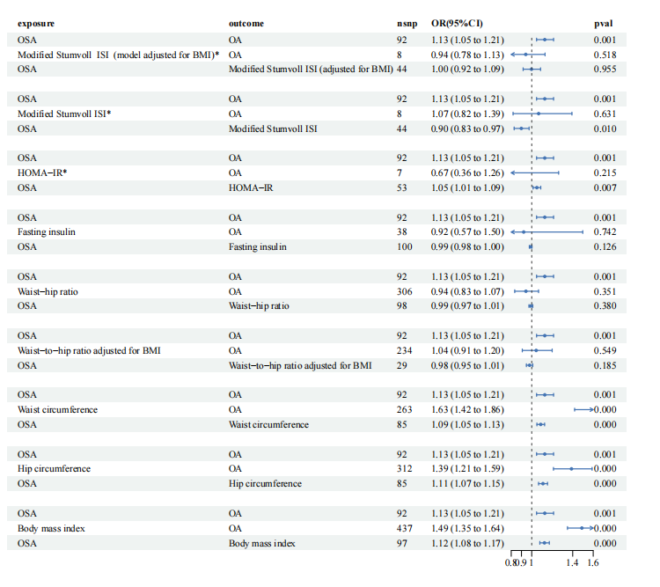

FIGS5 Forest plots of potential mediators underlying the effect of OSA on the OA risk