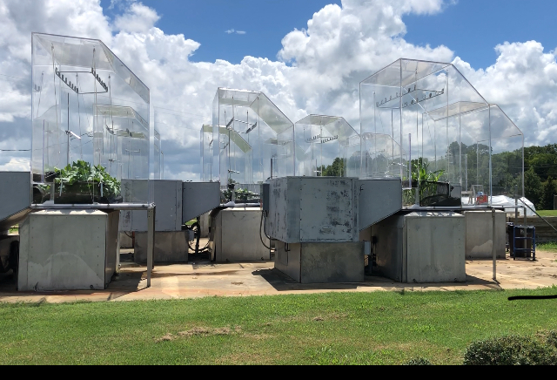
Supplementary Fig. 1. The Soil-Plant-Atmosphere-Research facility (SPAR) used in the study is located at the Environmental Plant Physiology Laboratory, Mississippi State University, Mississippi, MS, USA. Each SPAR facility consists of a plexiglass chamber to hold the plant canopy and a metal soil bin to accommodate the root system. A heating and cooling system at the rear of the facility controls the temperature inside the chamber. A CO₂ analyzer monitors and adjusts the CO₂ levels.

