Supplementary data
Table S1 Ingredients of the high fat and low fat diet.
Item | High fat diet | Low fat diet
Casein L-cystine, g | 276 | 194
Carbohydrate dextrin sucrose, g | 250 | 0
Corn starch, g | 0 | 673
Lard, g | 341 | 0
Soybean oil, g | 0 | 40
Fiber (Cellulose), g | 68 | 48
Mineral and vitamin mixture, g | 65 | 45
Antioxidant (TBHQ), g | 0.07 | 0.01
Total, g | 1000 | 1000
Energy，kcal/g | 5.1 | 3.6
% kcal from Protein | 19% | 19%
% kcal from Carbohydrate | 21% | 71%
% kcal from Fat | 60% | 10%

Table S2 Primer sequences used for qRT-PCR
Name |  | Sequences 5’-3’¹ | Source
UCP-1 | F² | GGCCCTTGTAAACAACAAAATAC | Li, et al., 2022 ^{[3]}
 | R | GGCAACAAGAGCTGACAGTAAAT
PPARα | F | CGTCACGGAGCTCACAGAAT | Clifford, et al., 2021 ^{[4]}
 | R | ACTCGCGTGTGATAAAGCCA
Mafg | F | GACCCCCAATAAAGGAAACAA
 | R | TCAACTCTCGCACCGACA
Scd1 | F | CCGGAGACCCCTTAGATCGA
 | R | TAGCCTGTAAAAGATTTCTGCAAACC
Lpin1 | F | CCTTCTATGCTGCTTTTGGGAACC
 | R | GTGATCGACCACTTCGCAGAGC
Dgat2 | F | GGCGCTACTTCCGAGACTAC
 | R | TGGTCAGCAGGTTGTGTGTC
Srebp1c | F | GGAGCCATGGATTGCACATT
 | R | GGCCCGGGAAGTCACTGT
Pgc1α | F | AAACTTGCTAGCGGTTCTCAC
 | R | GGCAATCCGTCTTCATCCAC
PPARγ | F | GCCCTTTGGTGACTTTATGG
 | R | CAGCAGGTTGTCTTGGATGT
β-actin | F | GTTGGTTGGAGCAAACATC
 | R | CTTATTTCATGGATACTTGGAATG
¹ Primer sequences are displayed in the 5’ to 3’ direction.
² F, forward primer; R, reverse primer.
Table S3 The dimension of particle of inulin with different polymerized degree
No. | Diameter of inulin powder, μm
 | Low polymerized degree | High polymerized degree
1 | 77.733 | 24.765
2 | 76.126 | 23.112
3 | 68.653 | 24.753
4 | 74.019 | 20.138
5 | 96.099 | 19.567
6 | 79.508 | 29.68
7 | 86.551 | 10.415
8 | 159.816 | 19.453
9 | 106.815 | 11.609
10 | 104.564 | 21.958
11 | 104.666 | 20.198
12 | 67.165 | 10.415
13 | 132.868 | 21.307
14 | 66.848 | 12.798
15 | 74.823 | 19.377
16 | 66.509 | 14.608
17 | 74.019 | 8.313
18 | 59.057 | 9.969
19 | 42.517 | 12.964
20 | 50.78 | 7.579
21 | 52.807 | 19.839
22 | 76.907 | 11.035
23 | 41.053 | 14.445
Average | 79.996 | 16.882

Table S4 The detailed wavenumber of FTIR spectra of inulin with different degree of polymerization
Low degree of polymerization inulin |  |  |  | High degree of polymerization inulin
Peak position, cm-1 | Intensity | interpretation |  | Peak position, cm-1 | Intensity | interpretation
599.22 | 0.138 | OH out-of-pla^{[1]}ne bend |  | 598.40 | 0.176 | OH out-of-plane bend
781.48 | 0.0634 | -(CH₂)- rocking |  | 821.70 | 0.114 | 2-ketose
824.84 | 0.096 | 2-ketose^{[2]} |  | 934.06 | 0.344 | OH bending
868.18 | 0.0779 | OH bending |  | 1027.59 | 0.787 | C-O-C stretching
931.45 | 0.196 | OH bending |  | 1133.10 | 0.562 | C-O stretching
1028.74 | 0.572 | C-O-C stretching |  | 1459.03 | 0.321 | C-H bending
1109.68 | 0.402 | C-O stretching |  | 1648.40 | 0.136 | OH bending
1269.26 | 0.204 | C-O stretching |  | 2934.59 | 0.362 | C-H stretching
1340.12 | 0.211 | C-H bending |  | 3385.30 | 0.671 | O-H stretching
1457.07 | 0.251 | C-H bending
1646.91 | 0.106 | OH bending
2934.90 | 0.285 | C-H stretching
3386.55 | 0.58 | O-H stretching

Table S5 The significantly differences of cecal microbiota at different taxonomic levels in mice of different treatment groups
Microbiota |  | Relative Abundance
 |  | LFD | HFD+HDI | HFD+LDI | HFD | SEM | P value
Phylum
 | Verrucomicrobiota | 0.0055 b | 0.2406 a | 0.0781 b | 0.0001 b | 0.00007 | 0.009
 | Fusobacteriota | 0.00069 a | 0.00033 ab | 0.000003 b | 0.000074 b | 0.02265 | 0.005
 | Firmicutes/Bacteroidota | 1.0939 | 2.2978 | 1.6823 | 2.8711 | 0.28637 | 0.136
Family
 | Akkermansiaceae | 0.005464 b | 0.240579 a | 0.078111 b | 0.000128 b | 0.0227 | 0.021
 | Fusobacteriaceae | 0.000688 a | 0.000326 ab | 0.000003 b | 0.000074 b | 0.0001 | 0.034
Genus
 | Akkermansia | 0.005464 b | 0.240579 a | 0.078111 b | 0.000128 b | 0.022651 | 0.013
 | Bilophila | 0.000115 b | 0.000269 b | 0.002074 a | 0.000068 b | 0.000188 | 0.045
 | Candidatus_Soleaferrea | 0.000053 b | 0 b | 0 b | 0.000348 a | 0.00002 | 0.006
 | Cetobacterium | 0.000688 a | 0.000326 ab | 0.000003 b | 0.000074 b | 0.00007 | 0.033
 | Colidextribacter | 0.022275 b | 0.016398 b | 0.018153 b | 0.083236 a | 0.00821 | 0.033
 | GCA_900066575 | 0.001825 b | 0.009164 ab | 0.001404 b | 0.024647 a | 0.002837 | 0.0499
 | Harryflintia | 0.000513 a | 0.000027 b | 0 b | 0.000509 a | 0.00008 | 0.045
 | Incertae_Sedis | 0.000409 ab | 0.001214 ab | 0.002867 a | 0.000174 b | 0.000334 | 0.043
 | Negativibacillus | 0 b | 0 b | 0 b | 0.000373 ab | 0.00002 | 0.014
 | unclassified_Christensenellaceae | 0.000223 b | 0.000053 b | 0.000025 b | 0.001333 ab | 0.00015 | 0.049
 | unclassified_Clostridia | 0.000267 b | 0.000631 ab | 0.001613 a | 0.000197 b | 0.000192 | 0.045
 | unclassified_Erysipelotrichaceae | 0.003598 a | 0 b | 0.000524 b | 0.002224 ab | 0.000512 | 0.044
 | unclassified_Lachnospiraceae | 0.080019 a | 0.091354 a | 0.219439 b | 0.198044 b | 0.023523 | 0.039
Species
 | Ruminococcaceae_bacterium_GD6 | 0.000053 b | 0 b | 0 b | 0.000348 a | 0.00002 | 0.008
 | unclassified_Akkermansia | 0.005464 b | 0.240579 a | 0.078111 b | 0.000128 b | 0.022651 | 0.017
 | unclassified_Cetobacterium | 0.000688 a | 0.000326 ab | 0.000003 b | 0.000074 b | 0.00007 | 0.041
 | unclassified_Colidextribacter | 0.020313 b | 0.016105 b | 0.018083 b | 0.078622 a | 0.007593 | 0.034
 | unclassified_Lachnospiraceae_FCS020_group | 0.000063 a | 0.000943 b | 0.000628 ab | 0.000296 a | 0.000126 | 0.0498
 | unclassified_Negativibacillus | 0 b | 0 b | 0 b | 0.000373 a | 0.00002 | 0.017
Within each row, means without a common letter differ significantly at P < 0.05.

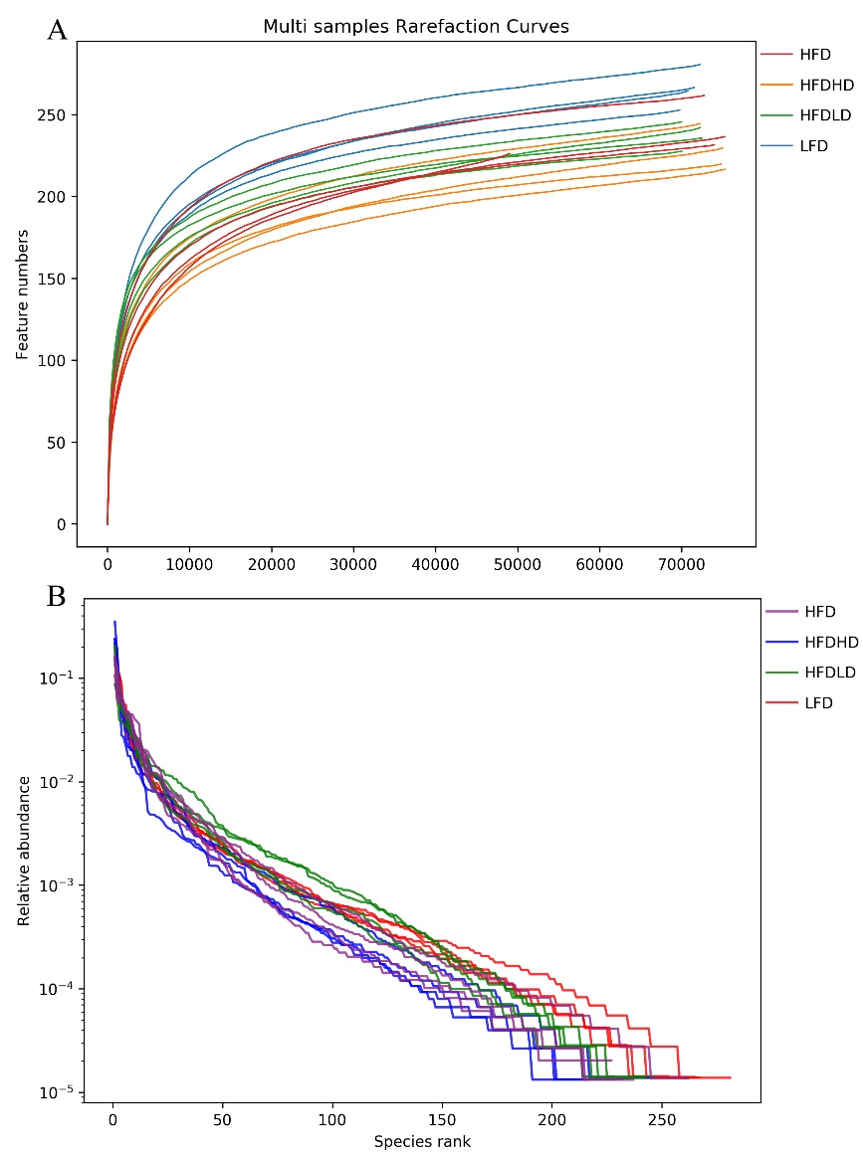
Figure S1 Rarefaction curves (A) and rank abundance plots (B) of cecal microbiota for all samples across different treatment groups. Abbreviations: HFD, high-fat diet treatment group mice; HFDHD, high-fat diet and high-degree polymerization inulin treatment group; HFDLD, high-fat diet and low-degree polymerization inulin treatment group; LFD, low-fat diet treatment group.
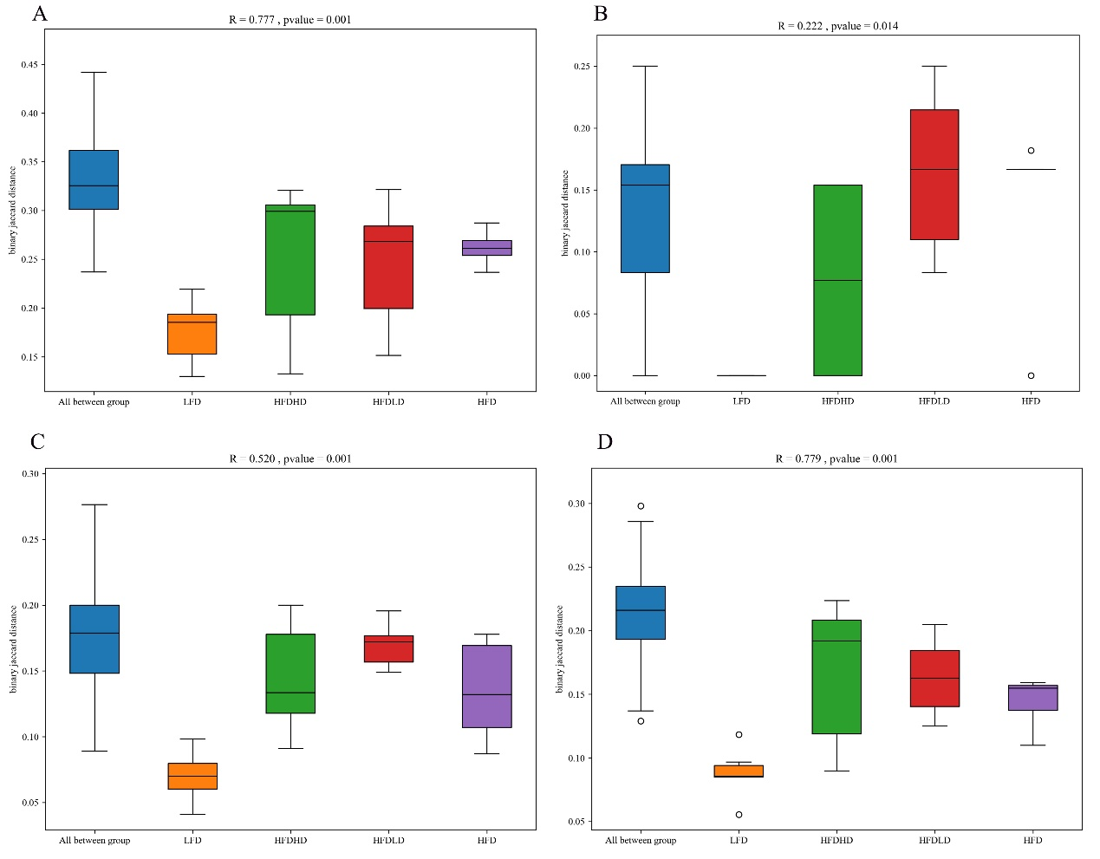
Figure S2 Analysis of similarities (ANOSIM) at the operational taxonomic unit (OTU) level (A), phylum level (B), family level (C), and genus level (D). An R value greater than 0 indicates no significant variations within treatment groups, while a P value less than 0.05 suggests significant differences among treatment groups regarding β diversity. HFD, high-fat diet treatment group mice; HFDHD, high-fat diet and high-degree polymerization inulin treatment group; HFDLD, high-fat diet and low-degree polymerization inulin treatment group; LFD, low-fat diet treatment group.

REFERENCE
[1] COATES J (2000). Interpretation of infrared spectra, a practical approach.
[2] AKRAM W, GARUD N. Optimization of inulin production process parameters using response surface methodology[J]. Future Journal of Pharmaceutical Sciences,2020, 6(1).
[3] LI Y, WANG D, PING X, et al. Local hyperthermia therapy induces browning of white fat and treats obesity[J]. Cell,2022.
[4] CLIFFORD B L, SEDGEMAN L R, WILLIAMS K J, et al. FXR activation protects against NAFLD via bile-acid-dependent reductions in lipid absorption[J]. Cell Metabolism,2021.

