Supplementary Material

Identifying the subgroups of depression trajectories among the middle-aged and elderly Chinese individuals with chronic diseases: an 8-year follow-up study based on CHARLS

Jiaxing Pei1,2, Mei Hu3, Qiang Lu1, Pengfei Zhou4, Yijing Shang1,2, Huiwang Zhang2, Xiaoguang Yang1*, Yunming Li1,2*

**\* Correspondence:**Corresponding Author  
Xiaoguang Yang: [52172999@qq.com](mailto:52172999@qq.com); Yunming Li: [lee3082@sina.com](mailto:lee3082@sina.com)

# Supplementary Figure

**Baseline (2011) include participants=17,705**

**Complete follow-up from 2011 to 2020, n=5,395**

**Sample, n=3,303**

**Excluded samples:**

**Populations lacking sociodemographic information also lack information on depression surveys, n=2,092**

**Final Sample, n=2,178**

**Excluded samples:**

**No chronic diseases, n=1,103**

**Age <45, n=22**

**Figure 1.** Process of sample population screening

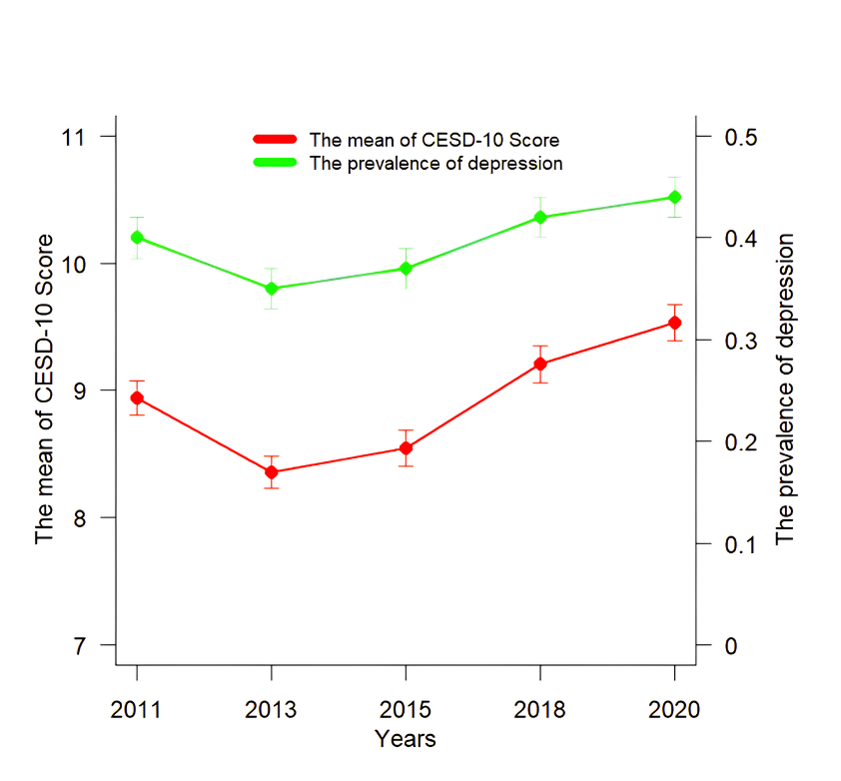

**Figure 2.** The mean of CES-D score (mean ± standard error) across 5 data collections during 2011-2020; prevalence (*p* 95% CI)

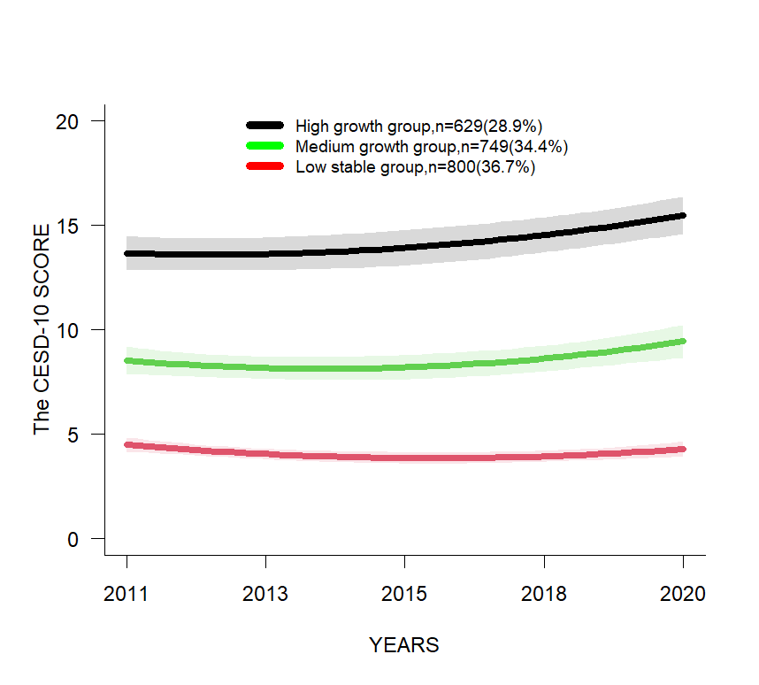

**Figure 3.** Longitudinal LCMM based depression trajectories using CESD-10 score

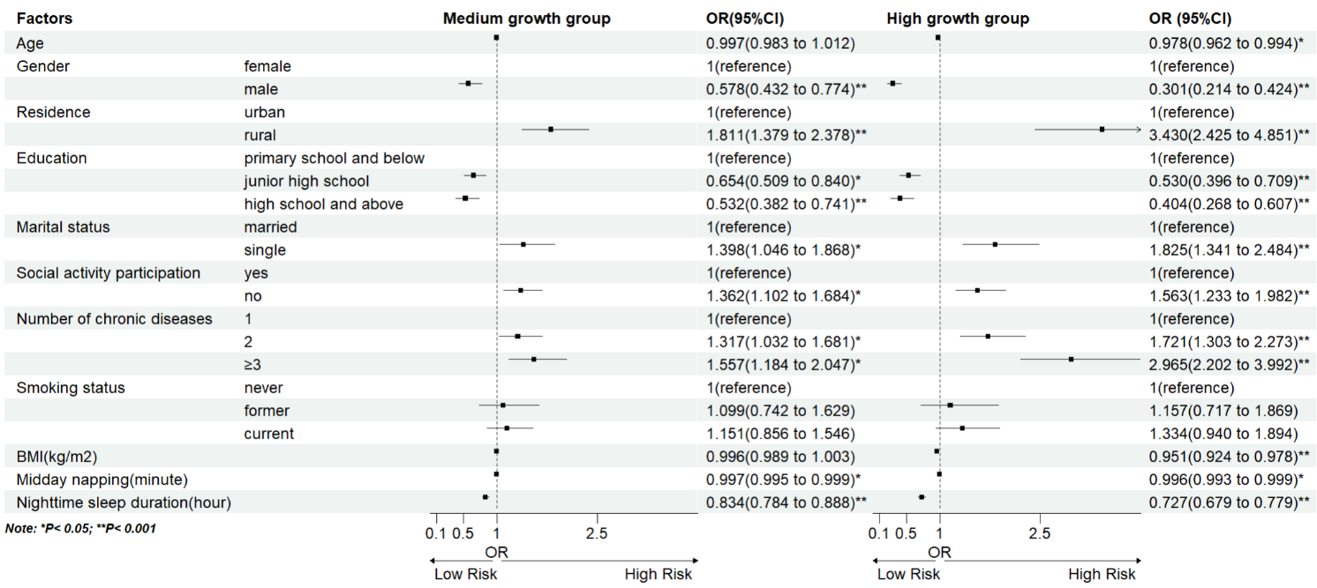

**Figure 4.** Longitudinal LCMM based depression trajectories using CESD-10 score

Note: Multinomial logistic regression model 3: age, gender, residence, education, marital status, social activity participation, number of chronic diseases, smoking status, BMI, midday napping, nighttime sleep duration, with the above 11 predictors as independent variables and trajectory subgroups as the dependent variable.

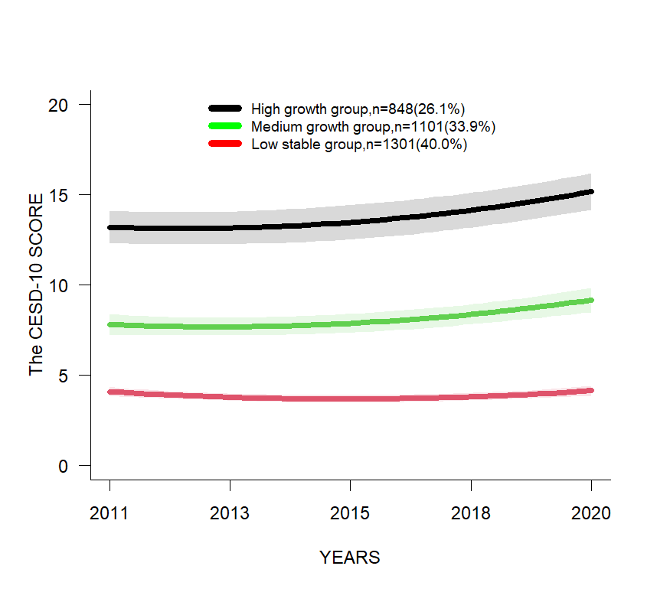

**Figure 5.** Longitudinal LCMM based depression trajectories using CESD-10 score (Sensitive Analysis).