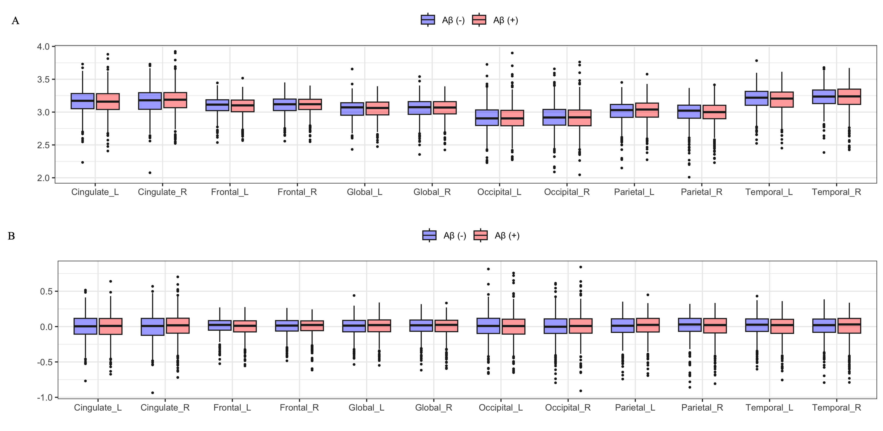
Supplementary Figure S1. Box plots of cortical thickness (upper) and cortical thickness after adjusting covariates (bottom) across Aβ positivity groups.

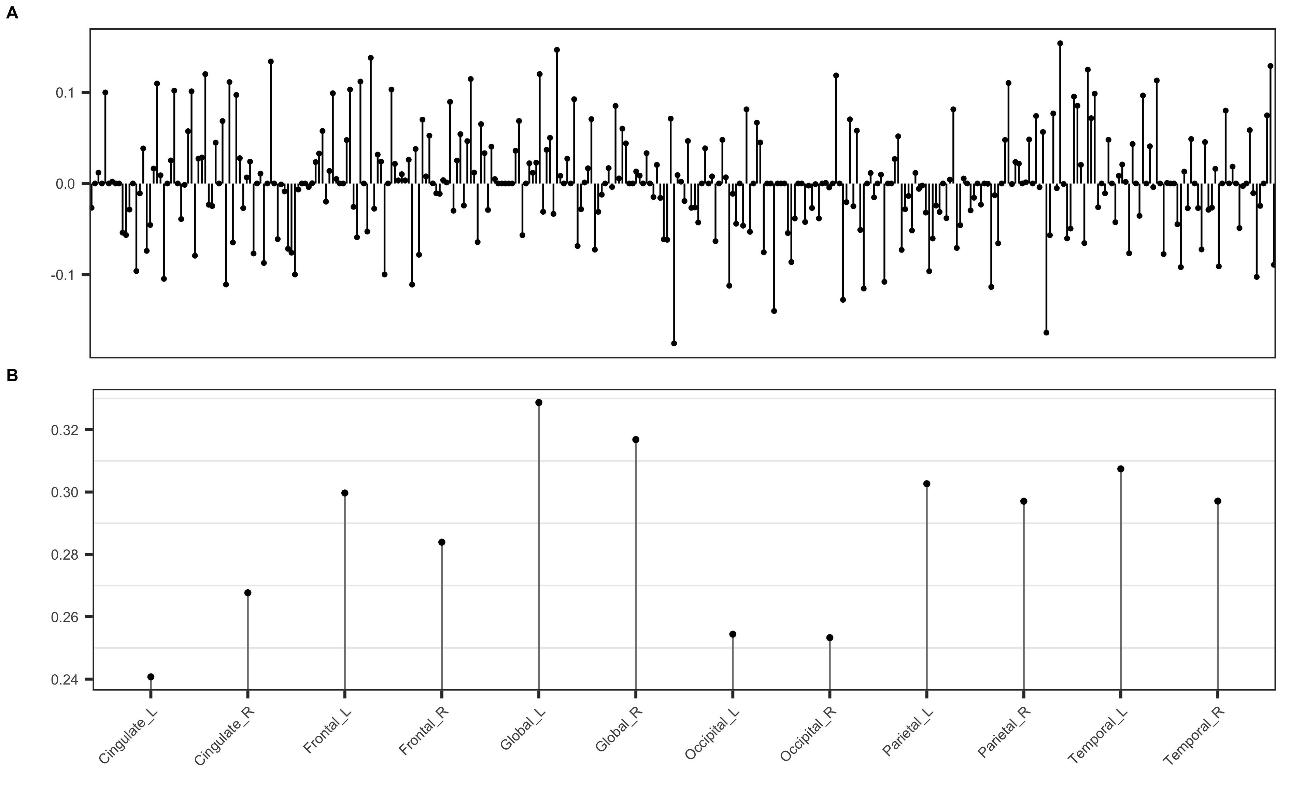
Supplementary Figure S2. The stem plot of SNPs and regions of interest (ROIs) weights estimated by SCCA with total samples.

