Supplementary Materials for
Intranasal HD-Ad-FS Vaccine Induces Systemic and Airway Mucosal Immunities Against SARS-CoV-2 and Systemic Immunity against SARS-CoV-2 Variants in Mice and Hamsters

Peter Zhou^{1†}, Jacqueline Watt^{1†}, Juntao Mai¹, Huibi Cao², Zhijie Li¹, Ziyan Chen^{2, 5}, Rongqi Duan², Ying Quan¹, Anne-Claude Gingras^{1, 3}, James M. Rini^{1, 4*}, Jim Hu^{2, 5*} and Jun Liu^{1*}

† Authors contributed equally to this work
*Correspondence: James M. Rini, Tel: 416-978-0557, james.rini@utoronto.ca; Jim Hu, Tel: 416-813-6412, jim.hu@sickkids.ca; Jun Liu, Tel: 416-946-5067, jun.liu@utoronto.ca

This PDF file includes:
Supplementary Figure 1-8 with corresponding legends

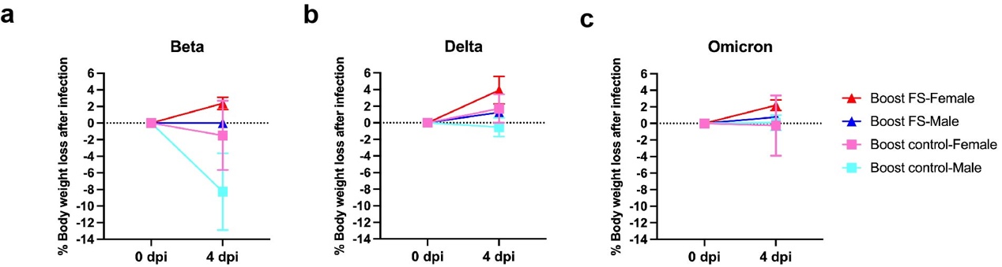
Supplementary Figure 1. Sex-based analyses of weight change in prime-boost HD-Ad-FS vaccinated hACE2 mice. The vaccinated hACE2 mice were challenged with either Beta (a), Delta (b), or Omicron (c) strain. Weight change of the challenged hACE2 mice was monitored at 0 (pre-challenge) and 4 dpi. Dots represented individual hamsters.

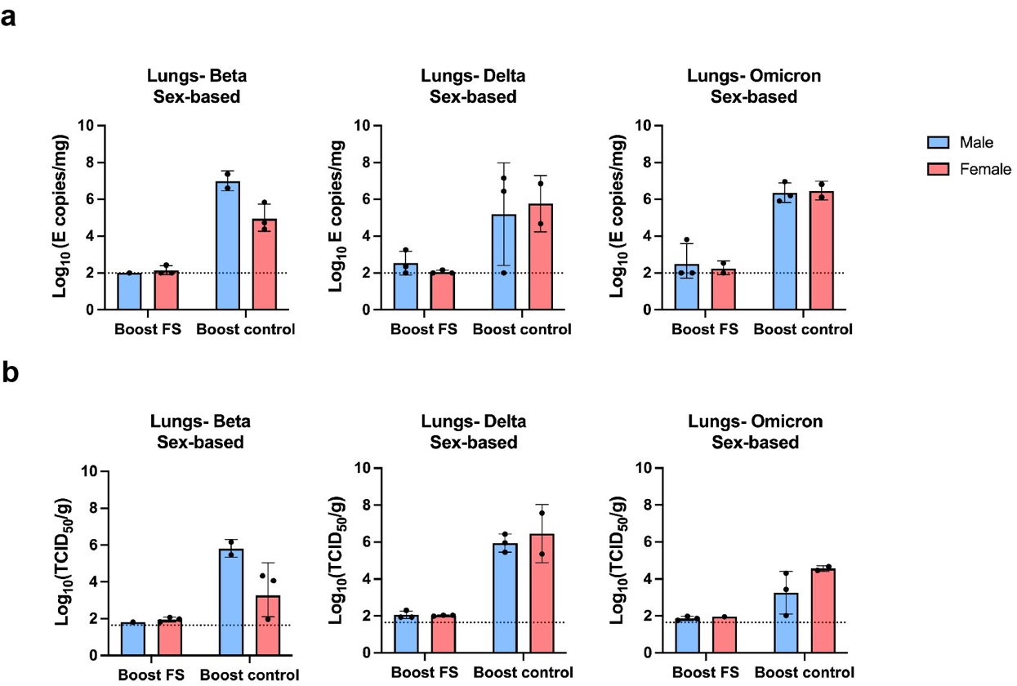
Supplementary Figure 2. (a) Sex-based analyses of SARS-CoV-2 variant RNA levels in the lungs of prime-boost immunized hACE2 mice at 4 dpi. The viral RNA was determined with RT-qPCR. (b) Sex-based analyses of infectious SARS-CoV-2 variant titers in lungs of prime-boost immunized hACE2 mice at 4 dpi. The titers of infectious virus were determined with TCID₅₀ assay. Dots represented individual hamsters. The dotted lines represent the LOD of the assays.

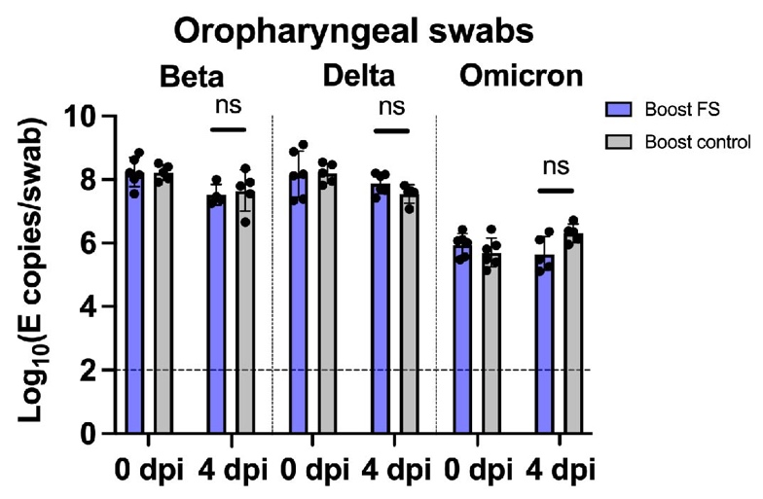
Supplementary Figure 3. RNA levels of SARS-CoV-2 variants in oropharyngeal swabs from prime-boost immunized hACE2 mice. Swabs were collected at 0 (post-challenge) and 4 dpi. The RNA levels were determined with RT-qPCR. Dots represent individual hACE2 mice (n=4, 5, or 6). Dots represented individual hamsters. The horizontal dotted lines represent the LOD of the assays. Statistical analysis was performed by two-way ANOVA. Bars and errors represent the geometric mean with geometric SD. ns, not significant.

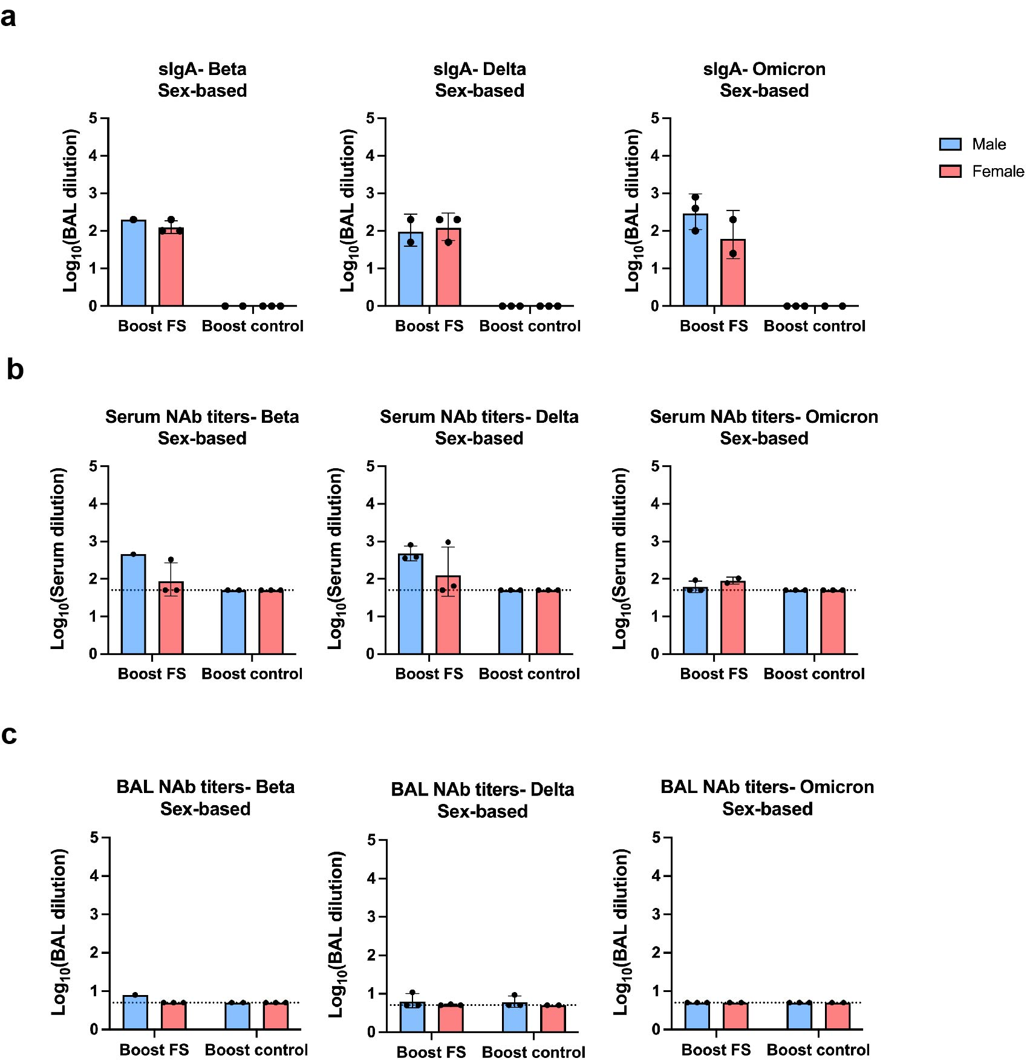
Supplementary Figure 4. (a) Sex-based analysis of the levels of FS-specific sIgA in BALs of prime-boost immunized hACE2 mice at 4 dpi. The starting dilution factor was 1:1. (b) Sex-based analysis of the levels of serum NAbs in prime-boost immunized hACE2 mice at 4 dpi. (c) Sex-based analysis of the levels of BAL NAbs in prime-boost immunized hACE2 mice at 4 dpi. Dots represented individual hamsters. For (b and c), the dotted lines represent the LOD of the assays.

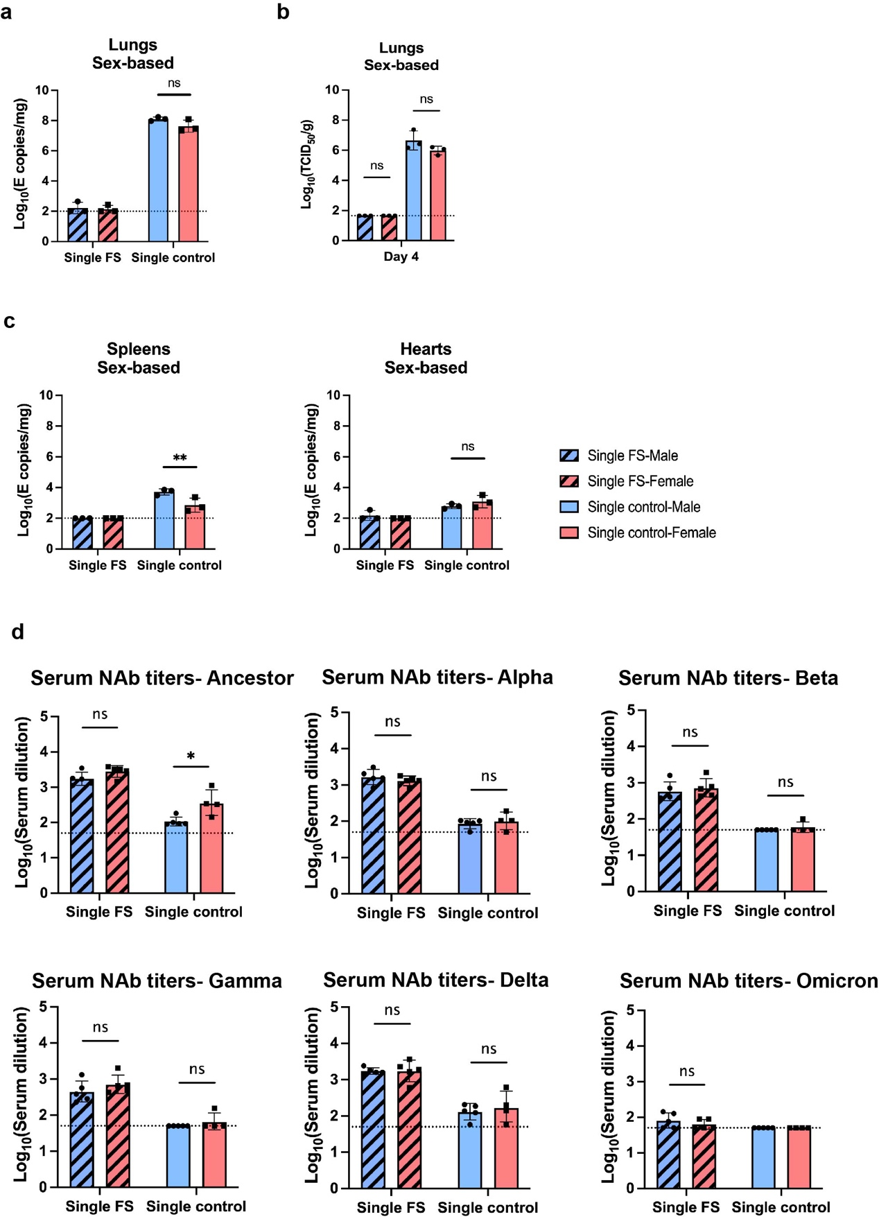
Supplementary Figure 5. (a) Sex-based analysis of SARS-CoV-2 RNA levels in the lungs of single-dose immunized hamsters. The viral RNA was determined with RT-qPCR at 4 dpi. (b) Sex-based analysis of infectious SARS-CoV-2 titers in lungs of single-dose immunized hamsters. The titers of infectious virus were determined with TCID₅₀ assays at 4 dpi. (c) Sex-based analysis of SARS-CoV-2 RNA levels in spleens and hearts of single-dose immunized hamsters. The viral RNA was determined with RT-qPCR at 4 dpi. (d) Sex-based analysis of serum NAb titers against SARS-CoV-2 and variants. Sera were collected from single-dose immunized hamsters at 14 dpi. Dots represented individual hamsters. The dotted lines represent the limit of detection (LOD) of the assays. Statistical analysis was performed by one-way ANOVA. Error bars represent geometric mean with geometric SD. *p<0.05, **p<0.01, and ns, not significant.

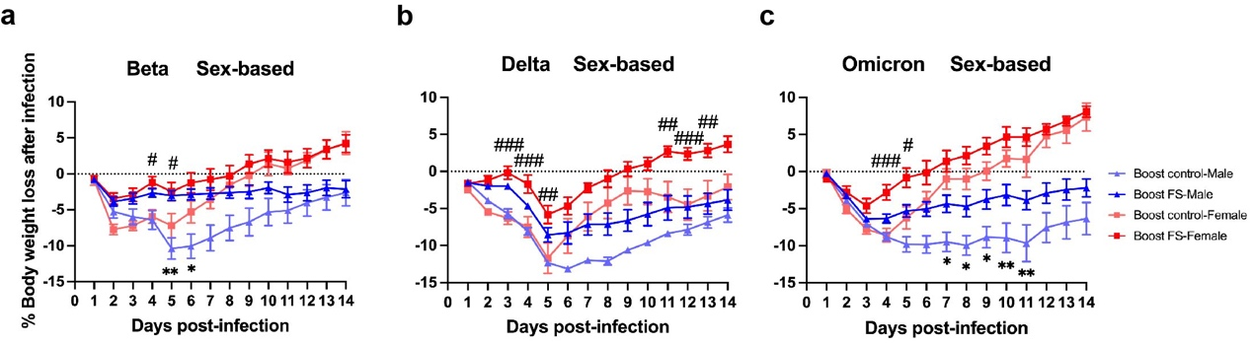
Supplementary Figure 6. Sex-based analysis of weight change in prime-boost immunized hamsters. The weight was monitored at the indicated days after challenging with SARS-CoV-2 variant. The asterisk signs represent statistical analysis in boost-FS hamsters, and the pound signs represent statistical analysis in boost-control hamsters. Dots represented individual hamsters. */#p<0.05, **/##p<0.01, ###p<0.001.

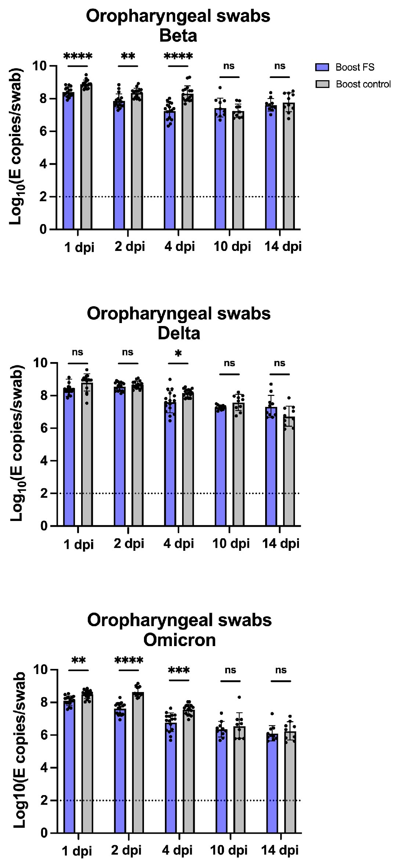
Supplementary Figure 7. RNA levels of SARS-CoV-2 variants in oropharyngeal swabs from prime-boost immunized hamsters. Swabs were collected at the indicated time points. The RNA levels were determined with RT-qPCR. Dots represented individual hamsters. The dotted lines represent the LOD of the assays. Statistical analysis was performed by two-way ANOVA. Bars and errors represent the geometric mean with geometric SD. *p<0.05, **p<0.01, ***p<0.001, ****p<0.0001, ns, not significant.
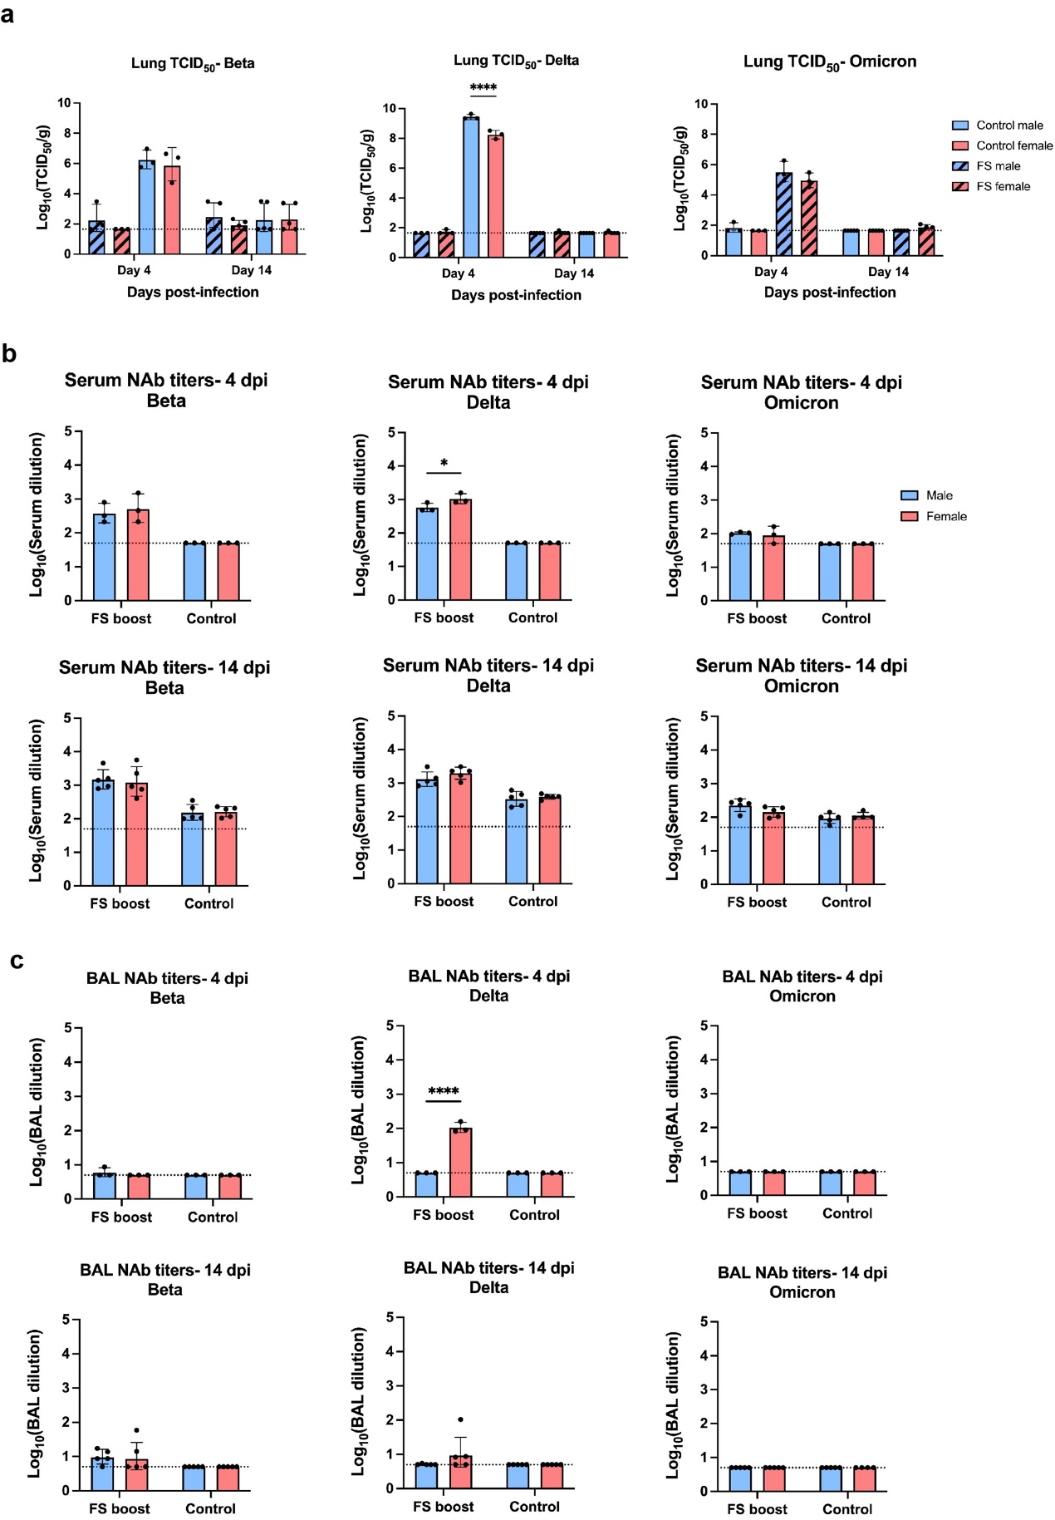

Supplementary Figure 8. (a) Sex-based analysis of infectious titers of the SARS-CoV-2 variants in the lungs of prime-boost immunized hamsters. The titers were determined with TCID₅₀ assays at 4 and 14 dpi. Statistical analysis was performed by two-way ANOVA. Error bars represent geometric mean with geometric SD. ****, p<0.0001. (b) Sex-based analysis of serum NAbs against SARS-CoV-2 variants. Sera of prime-boost immunized hamsters were collected at 4 and 14 dpi. Statistical analysis was performed by one-way ANOVA. Error bars represent geometric mean with geometric SD. *, p<0.05, ns, not significant. (c) Sex-based analysis of NAbs in BALs against SARS-CoV-2 variants. BALs of prime-boost immunized hamsters were collected at 4 and 14 dpi. Statistical analysis was performed by one-way ANOVA. Error bars represent geometric mean with geometric SD. ****p<0.0001. Dots represented individual hamsters. The dotted lines represent the LOD of the assays.

