**Supplementary Material**

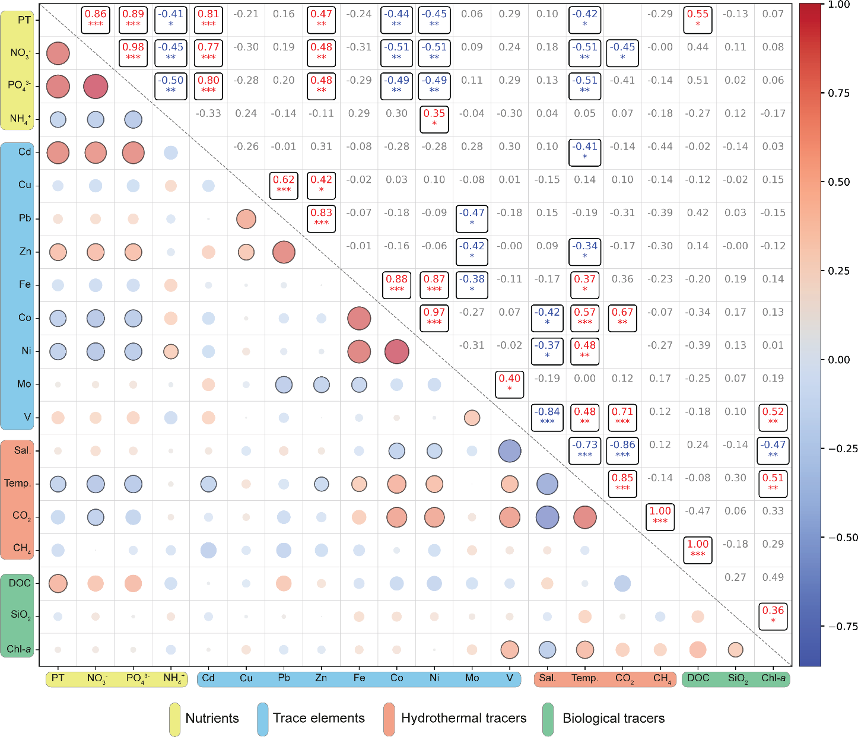

**Figure S1.** Pearson correlation matrix representing the variables measured in both samplings (January and February, 2021) at Port Foster. The lower left triangle visually represents the correlation coefficient (critical r computed for each n), being the size and colour of the circle directly related with the r value. Those r values which r is above the computed critical r are countered. The upper right triangle represents the r value itself and the level of significance is marked with *, being * p < 0.05; ** p < 0.01 and *** p < 0.001, additionally significant r values are outlined. Positive correlations are red and negative correlations are blue. Classification of the nature of each variable in four groups (Nutrients, Trace elements, Hydrothermal tracers and Biological tracers) have been made according to German and Seyfried, (2014). Correlations between CH4 and DOC and pCO2 are not computed due to the absence of temporal data for comparison.

**Table S1** Measured and certified concentrations, recovery percentages of trace metals in Coastal Seawater Reference Material ERM-CA403 and blank concentrations used for the analysis. *BDT = Below detection limit.

|  |  |  |  |  |  |  |  |  |  |  |
| --- | --- | --- | --- | --- | --- | --- | --- | --- | --- | --- |
|  |  | **Fe** | **Co** | **Ni** | **Cu** | **Zn** | **Mo** | **Cd** | **Pb** | **V** |
| **ERM-CA403**  **(ppb)** | Measured  n = 1 | 3.63 | 0.063 | 1.10 | 0.82 | 4.41 | 10.83 | 0.102 | 0.079 | - |
| **ERM-CA403**  **(nM)** | 65 | 1.07 | 18.74 | 12.9 | 67.45 | 112.87 | 0.91 | 0.38 | - |
| **Certified**  **(ppb)** |  | 3.45 | 0.074 | 1.04 | 0.87 | 4.6 | 12 | 0.094 | 0.098 | - |
| **Certified**  **(nM)** |  | 61.78 | 1.26 | 17.72 | 13.69 | 70.36 | 125.07 | 0.84 | 0.47 | - |
| **% Recovery** |  | 105.14 | 85.14 | 106.05 | 94.46 | 95.95 | 90.22 | 108.51 | 80.91 | - |
| **Blank**  **(ppb)** | n = 10 | 0.46±0.24 | 0.051±0.011 | BDT* | 0.04±0.01 | 0.40±0.13 | 0.22±0.02 | 0.004±0.001 | 0.035±0.012 | 0.17±0.01 |
| **Blank**  **(nM)** | 8.24±4.3 | 0.87±0.19 | BDT* | 0.63±0.16 | 6.12±1.99 | 2.29±0.21 | 0.04±0.01 | 0.17±0.06 | 3.34±0.2 |

**Table S2** Variables used to calculate the methane flux across all stations within Port Foster, and the flux expressed in µmol m-2 d-1.

|  |  |  |  |  |  |  |
| --- | --- | --- | --- | --- | --- | --- |
| **Leg 2** | **Coordinates (Lat, Lon)** | **CH4 (nM)** | **Temp. (ºC)** | **Salinity (ppm)** | **Avg. Wind speed at 10m (m s-1)** | **CH4 Flux**  **(µmol m-2 d-1)** |
| **Station-1** | -62.9717963, -60.6784977 | 8.00 | 1.59 | 33.94 | 7.23 | 8.02 |
| **Station-2** | -62.9688711, -60.6996934 | 9.24 | 1.58 | 33.97 | 7.23 | 10.22 |
| **Station-3** | -62.9613522, -60.6737614 | 9.42 | 1.73 | 33.97 | 7.23 | 10.61 |
| **Station-4** | -62.9522301, -60.6840762 | 8.88 | 1.81 | 33.96 | 7.23 | 9.68 |
| **Station-5** | -62.9430807, -60.656057 | 7.63 | 1.78 | 33.97 | 7.23 | 7.44 |
| **Station-6** | -62.9301296, -60.6662262 | 7.12 | 1.82 | 33.98 | 7.23 | 6.56 |
| **Station-7** | -62.9230424, -60.6561956 | 7.92 | 1.78 | 33.97 | 7.23 | 7.96 |
| **Station-8** | -62.9341293, -60.6024654 | 9.50 | 2.64 | 32.72 | 7.23 | 11.17 |
| **Station-9** | -62.9537475, -60.6035744 | 9.86 | 1.30 | 32.81 | 7.23 | 11.10 |
| **Station-10** | -62.974635, -60.6074967 | 7.59 | 1.77 | 33.97 | 7.23 | 7.37 |
| **Station-11** | -62.9831292, -60.5817675 | 6.69 | 3.59 | 32.36 | 7.23 | 6.36 |
| **Station-12** | -62.9845018, -60.5698821 | 15.93 | 1.99 | 33.84 | 7.23 | 22.38 |
| **Station-13** | -62.9886139, -60.5735003 | 13.47 | 1.92 | 33.89 | 7.23 | 17.93 |
| **Station-14** | -62.9887728, -60.6229415 | 10.19 | 1.70 | 33.97 | 7.23 | 11.96 |
| **Station-15** | -62.9758556, -60.6625226 | 8.62 | 1.50 | 34.01 | 7.23 | 9.08 |

**Table S3** Medians, Q1-Q3, histograms and sample number for fluxes and concentrations of CO2 and CH4 in the samples.

|  |  |  |
| --- | --- | --- |
|  | **CO2** | **CH4** |
| **Flux median** | -2.78 mol m-2 yr-1 | 9.68 μmol m-2 d-1 |
| **Flux Q1 – Q3** | -3.58 – 0.26 mol m-2 yr-1 | 7.70 – 11.13 μmol m-2 d-1 |
| **Flux histogram** |  |  |
| **Concentration median** | 328.51 μatm | 8.88 nM |
| **Concentration**  **Q1 – Q3** | 311.72 – 404.64 μatm | 7.77 – 9.68 nM |
| **Concentration histogram** |  |  |
| **N** | 20 | 15 |

**Table S4** Variables used to calculate the carbon dioxide flux across all stations within Port Foster, and the flux expressed in mol m-2 yr-1.

|  |  |  |  |  |  |  |
| --- | --- | --- | --- | --- | --- | --- |
| **Leg 1** | **Coordinates (Lat, Lon)** | **pCO2 (µatm)** | **Temp. (ºC)** | **Salinity (ppm)** | **Wind speed at 10m (m s-1)** | **CO2 Flux** |
| **(mol m-2 yr-1)** |
| **Station-1** | -62.920083, -60.654556 | 555.72 | 2.8 | 33.1 | 7.08 | 5.4 |
| **Station-2** | -62.926, -60.645611 | 492.15 | 2.1 | 33.89 | 7.08 | 3.04 |
| **Station-3** | -62.915472, -60.653167 | 377.95 | 2 | 33.99 | 7.08 | -1.21 |
| **Station-4** | -62.929867, -60.665633 | 330.42 | 2.1 | 33.98 | 7.08 | -2.98 |
| **Station-5** | -62.937778, -60.661111 | 326.61 | 2.2 | 34 | 7.08 | -3.12 |
| **Station-6** | -62.942278, -60.642583 | 341.92 | 2.2 | 33.99 | 7.08 | -2.55 |
| **Station-7** | -62.985083, -60.573972 | 340.79 | 2.6 | 34.01 | 7.08 | -2.58 |
| **Station-8** | -62.994167, -60.560472 | 110.32 | 2.2 | 34.5 | 7.08 | -11.13 |
| **Station-9** | -62.995778, -60.558972 | 298.92 | 2.1 | 34.03 | 7.08 | -4.15 |
| **Station-10** | -62.994639, -60.582389 | 317.84 | 2 | 34.03 | 7.08 | -3.45 |
| **Station-11** | -62.989583, -60.582139 | 322.46 | 2.5 | 34 | 7.08 | -3.27 |
| **Station-12** | -62.992972, -60.604528 | 308.20 | 1.9 | 34 | 7.08 | -3.81 |
| **Station-13** | -62.985694, -60.609306 | 312.89 | 2 | 34 | 7.08 | -3.63 |
| **Station-14** | -62.945, -60.611722 | 424.09 | 2.5 | 33.92 | 7.08 | 0.5 |
| **Station-15** | -62.936972, -60.602806 | 905.58 | 4.4 | 25.45 | 7.08 | 18.96 |
| **Station-16** | -62.943361, -60.616833 | 458.76 | 2.6 | 33.9 | 7.08 | 1.79 |
| **Station-17** | -62.943056, -60.632722 | 398.16 | 2.4 | 33.95 | 7.08 | -0.46 |
| **Station-18** | -62.944028, -60.654556 | 326.04 | 2.1 | 34.05 | 7.08 | -3.14 |
| **Station-19** | -62.948444, -60.671 | 308.06 | 2 | 34.03 | 7.08 | -3.81 |
| **Station-20** | -62.956917, -60.695694 | 295.67 | 2.3 | 33.96 | 7.08 | -4.27 |