Supplementary Material

# Supplementary Tables

**Supplementary Table S1**: Water indices as features derived from Landsat 8 OLI used in the study. <https://custom-scripts.sentinel-hub.com/custom-scripts/landsat-8/indexdb/>

|  |  |  |
| --- | --- | --- |
| **Description** | **Indices** | **formula** |
| Blue-wide dynamic range vegetation index | BWDRVI | 0.1*NIR-BLUE/0.1*NIR+BLUE |
| Chlorophyll Index Green | Clgreen | (NIR/GREEN) - 1 |
| Chlorophyll Vegetation index | CVI | NIR*RED/GREEN2 |
| Coloration index | CI | (RED – BLUE)/RED |
| Corrected Transformed Vegetation Index | CTVI | (((RED-GREEN)/(RED+GREEN)+0.5)/ Abs(((RED-GREEN)/(RED+GREEN)+0.5)))*sqrt(abs(((RED-GREEN)/(RED+GREEN)+0.5)) |
| Difference NIR/Green Difference | GDVI | (NIR-GREEN) |
| Differenced Vegetation Index MSS | DVIMSS | 2.4*NIR - RED |
| Enhanced Vegetation Index | EVI | 2.5*((NIR-RED)/((NIR+6*RED-7.5*BLUE)+1) |
| Enhanced Vegetation Index 2 | EVI2 | 2.4*((NIR-RED)/(NIR+RED + 1)) |
| Enhanced Vegetation Index 2-2 | EVI2-2 | 2.5*((NIR-RED)/(NIR+2.4*RED + 1)) |
| NIR-Green NDVI | GNDVI_1 | (NIR-GREEN)/(NIR+GREEN) |
| NIR-Red NDVI | GNDVI_2 | (NIR-RED)/(NIR+RED) |
| NIR-SWIR1 NDVI | GNDVI_3 | (NIR-SWIR1)/(NIR+SWIR1) |
| NIR-SWIR2 NDVI | GNDVI_4 | (NIR-SWIR2)/(NIR+SWIR2) |
| Normalized difference water index with NIR, SWIR1 & SWIR2 | GNDVI_5 | (NIR-SWIR1)/(NIR+SWIR2) |
| Normalized difference water index with SWIR2 & SWIR1 | GNDVI_6 | (NIR-SWIR2)/(NIR+SWIR1) |
| Normalized difference water index with SWIR1 & SWIR2 | NDVI | (NIR-RED)/(NIR+RED) |
| Normalized Difference NIR/SWIR1 Modified Normalized Difference Vegetation Index | MNDWI1 | (GREEN – SWIR1)/(GREEN + SWIR1) |
| Normalized Difference NIR/SWIR2 Modified Normalized Difference Vegetation Index | MNDWI2 | (GREEN – SWIR2)/(GREEN + SWIR2) |
| Normalized Difference NIR/SWIR1 SWIR2 Modified Normalized Difference Vegetation Index | MNDWI3 | (GREEN – SWIR1)/(GREEN + SWIR2) |
| Normalized Difference NIR/SWIR2 SWIR1 Modified Normalized Difference Vegetation Index | MNDWI4 | (GREEN – SWIR2)/(GREEN + SWIR1) |
| New Water Index | NWI | (BLUE – (NIR+SWIR1+SWIR2))/BLUE + (NIR+SWIR1+SWIR2)) |
| RED SWIR1 band difference | TWI_1 | RED – SWIR1 |
| RED SWIR2 band difference | TWI_2 | RED – SWIR2 |
| Algal Bloom Index | ABI | (RED – BLUE) * (GREEN-BLUE)/(RED-BLUE) – NIR – BLUE) *(GREEN-BLUE)/(NIR-BLUE) |
| Floating Algae Index | FAI | (NIR-RED) +(RED-SWIR1)*( *λnir* - *λred*)/( *λswir* - *λred*)  Where,  *λred* = 662 nm, *λnir* = 835 nm, *λswir* = 1648 nm. |
| Automated water extraction index with SWIR1 | AWEI1 | ( 4 * (GREEN – SWIR1) - (0.25 * NIR + 2.75 * SWIR1)) |
| Automated water extraction index with SWIR1 | AWEI2 | (4 * (GREEN – SWIR2) - (0.25 * NIR + 2.75 * SWIR2)) |
| Automated water extraction index with SWIR2 & SWIR1 | AWEI3 | ( 4 * (GREEN – SWIR1) - (0.25 * NIR + 2.75 * SWIR2)) |
| Automated water extraction index with SWIR1 & SWIR2 | AWEI4 | ( 4 * (GREEN – SWIR2) - (0.25 * NIR + 2.75 * SWIR1)) |
| Automated water extraction index for urban background | AWEInsh | GREEN + BLUE+0.25+1.5(NIR+SWIR1)-0.25*SWIR2) |
| Normalized difference index from NIR and GREEN + BLUE | GBNDVI | (NIR-(GREEN+BLUE))/ (NIR+(GREEN+BLUE)) |
| Normalized difference index of three bands | GRNDVI | (NIR-(GREEN+RED))/(NIR+(GREEN+RED)) |
| Normalized difference index from NIR and BLUE | BNDVI | (NIR-BLUE)/(NIR+BLUE) |
| Two Band ratio | Gossan | SWIR1/RED |
| Normalized difference index of four bands | GARI | (NIR-(GREEN-(BLUE-RED)))/(NIR-(GREEN+(BLUE-RED))) |
| Norm G | Norm G | G/(NIR+R+G) |
| Norm NIR | Norm NIR | NIR/(NIR+R+G) |
| Norm R | Norm R | R/(NIR+R+G) |
| Normalized difference index from GREEN and BLUE | PPR | (GREEN - BLUE)/(GREEN + BLUE) |
| Normalized difference index from GREEN and RED | PVR | (GREEN - RED)/(GREEN + RED) |
| Intensity | I | (1/30.5)(RED + GREEN + BLUE) |
| Two Band ratio | Laterite | SWIR1/SWIR2 |
| Hue | H | arctan((2RED – GREEN -BLUE)/30.5(GREEN -BLUE)) |
| Log of two band ratio | LogR | Log(NIR/RED) |
|  | mCRIG | (BLUE-1 – GREEN-1)*NIR |
| Mid-infrared vegetation index | MVI | NIR/SWIR1 |
|  | MSRNir/Red | (NIR/RED)-1/sqrt((NIR/RED)+1)) |
| Normalized difference index from NIR2 and RED | NLI | (NIR2-RED)/(NIR2+RED) |
| Normalized difference index from (SWIR1 and SWIR2) | NDSI | (SWIR1 – SWIR2)/( SWIR1 + SWIR2) |
| Normalized difference index from (NIR and (GREEN + RED + BLUE) | PNDVI | (NIR-(GREEN+RED+BLUE)) /(NIR+(GREEN+RED+BLUE)) |
| Normalized difference index from (NIR and (RED + BLUE) | RBNDVI | (NIR-(RED+BLUE)) / (NIR+(RED+BLUE)) |
| Shape index | IF | (2*RED-GREEN-BLUE)/GREEN-BLUE |
| Two Band ratio | SR550/670 | GREEN/RED |
| " | SR860/550 | NIR/GREEN |
| " | SRSWIR1/NIR | SWIR1/NIR |
| " | SRSWIR2/NIR | SWIR2/NIR |
| " | DVI | NIR/RED |
| " | RGR | RED/GREEN |
| " | WRI_1 | (GREEN + RED)/(NIR+SWIR1) |
| " | WRI_2 | (GREEN + RED)/(NIR+SWIR2) |
| Two band averages |  | (RED+NIR)/2 |
| " |  | (GREEN+NIR)/2 |
| " |  | (BLUE+NIR)/2 |
| " |  | (RED+GREEN)/2 |
| " |  | (RED+BLUE)/2 |
| " |  | (GREEN+BLUE)/2 |
| Three bands average |  | (BLUE+GREEN+RED)/3 |
| " |  | (BLUE+GREEN+NIR)/3 |
| " |  | (GREEN+RED+NIR)/3 |
| " |  | (BLUE+RED+NIR)/3 |
| Four band averages |  | (BLUE+GREEN+RED+NIR)/4 |
| Surface Algal Bloom Index | SABI | (NIR-RED)/(BLUE+GREEN) |
| Three Band Algorithm | 3BDA-like (KIVU) | (BLUE-RED)/GREEN |

# Supplementary Figures

Figures S1 to S5 show the result of the feature selection analysis for TN of the six proposed algorithms, and Figures S6 to S10 show the corresponding rank analysis using the correlation heat map. Similarly, Figures S11 to S15 show feature selection analysis for TP, and the corresponding correlation matrix using heat maps is shown in Figures S16 to S20.

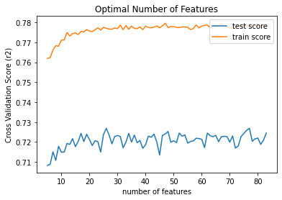

**Supplementary** **Figure S1**: Optimum number of features using AdaBoost for TN

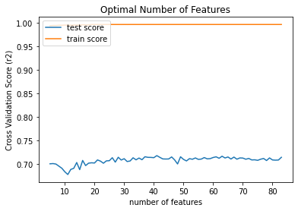

**Supplementary** **Figure S2**: Optimum number of features using GradiantBoost for TN

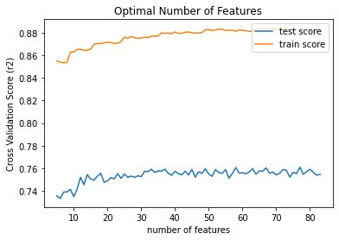

**Supplementary** **Figure S3**: Optimum number of features using Random Forest for TN

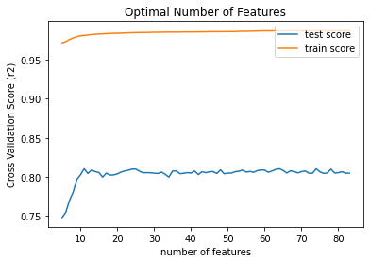

**Supplementary** **Figure S4**: Optimum number of features using XGBoostfor TN

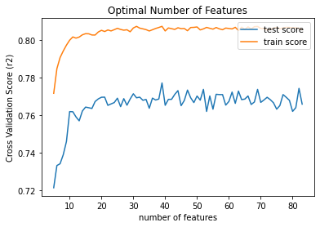

**Supplementary** **Figure S5**: Optimum number of features using SVR for TN

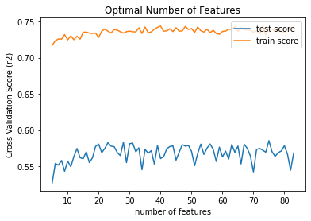

**Supplementary** **Figure S6**: Optimum number of features for TP using AdaBoost

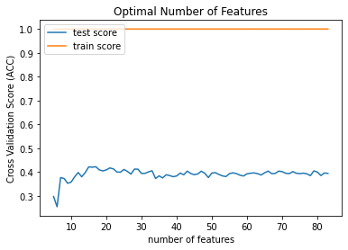

**Supplementary** **Figure S7**: Optimum number of features for TP using GradiantBoost

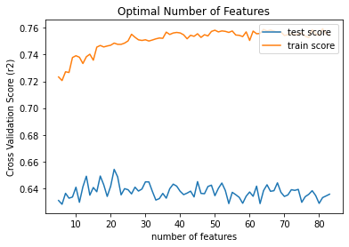

**Supplementary** **Figure S8**: Optimum number of features for TP using Random Forest

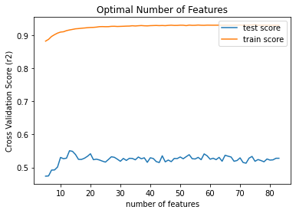

**Supplementary Figure S9:** Optimum number of features for TP using XGBoost

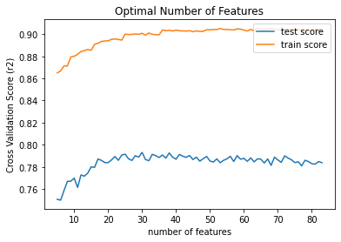

**Supplementary Figure S10**: Optimum feature selection for TP using SVR

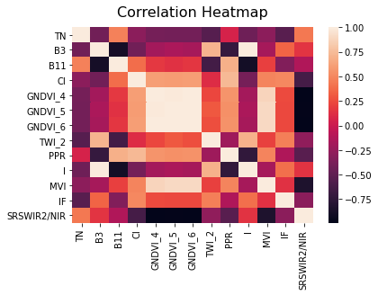

**Supplementary** **Figure S11**: Correlation analysis for TN using SVR

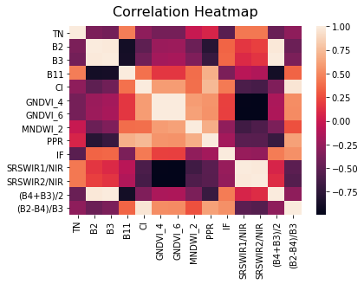

**Supplementary** **Figure S12**: Correlation analysis using AdaBoost for TN

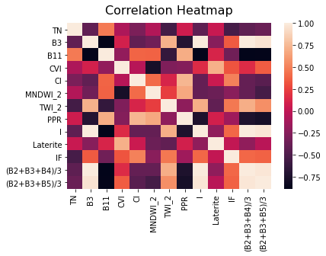

**Supplementary** **Figure S13**: Correlation analysis using GradBoost for TN

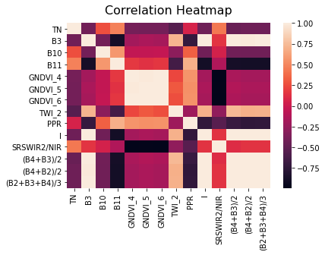

**Supplementary Figure S14**: Correlation analysis for TN using Random Forest



**Supplementary** **Figure S15**: Correlation analysis for TN using XGBoost

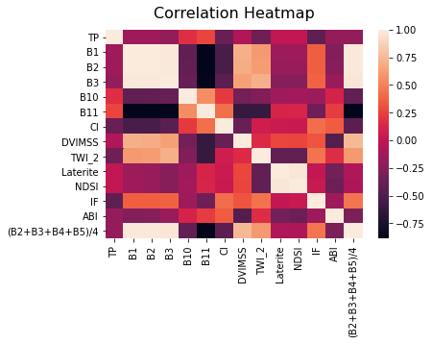

**Supplementary** **Figure S16**: Correlation analysis using AdaBoost for TP

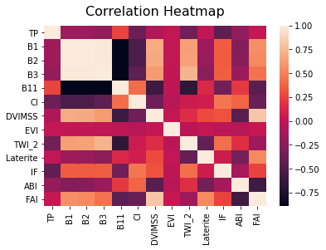

**Supplementary Figure S17**: Correlation analysis using GradBoost for TP

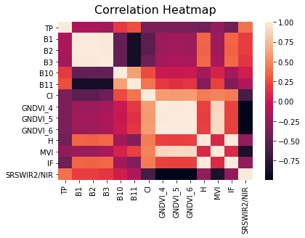

**Supplementary Figure S18**: Correlation analysis using Random Forest for TP

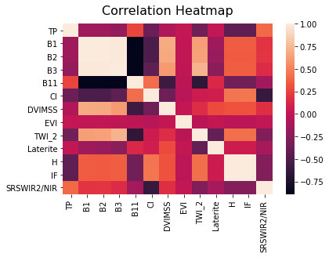

**Supplementary Figure S19**: Correlation analysis using XGBoost for TP

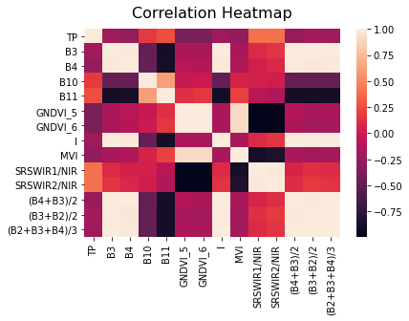

**Supplementary Figure S20**: Correlation analysis using XGBoost for TP