**Supplementary information**

**Nitrogen use efficiencies, flows and losses of typical dairy farming systems in Inner Mongolia**

**Journal: Frontiers in Sustainable Food Systems**

Moge Qili 1, 2, Zhanqing Zhao 3,*, Junwei Bao2,NierWu2, Baomin Gou2,Ying Ying2, Batu Bilige2, Lin Sun2,Yanlin Xue2 and Fuyu Yang1,*

1 College of Grassland Science and Technology, China Agricultural University, Beijing 100193, China

2 Inner Mongolia Academy of Agriculture and Animal Husbandry Science, Hohhot 010031, China

3 School of Land Science and Space Planning, Hebei GEO University, Shijiazhuang 050031, Hebei, China

* Correspondence: [zzqgrass@163.com](mailto:zzqgrass@163.com) (Z.Z.); yfuyu@126.com (F.Y.)

1. **The detailed description of four dairy farm systems**

(1) Traditional pastoral dairy farms (PF): These farms were mainly located in pastoral areas, where both the annual average precipitation and net primary production in this pastoral area were at lower levels (Figure1). They generally had large area grasslands and a small number of dairy cattle predominated by Simmental and Simmental × local breed crossbred cows, therefore the livestock densities were low (Table 1). These farms typically practiced extensive grazing, allowing dairy cattle to roam freely and graze on natural grass (on average 120 grazing days per year). By autumn, farmers cut and transported the better-growing grass from certain areas of their own grassland to storage sheds for winter feeding of dairy cattle. A part of grass was sold out, while corn and commercial feed were totally purchased from outside. The average milk yield per cow was low (Table 1), and part of the milk was used for household consumption, the primary products from these dairy cattle herd included part of milk and live cattle. The solid fraction of cattle manure during housing time was collected by hand and used for warming houses or cooking after air-drying (Figure S3).

(2) Smallholder dairy farms with croplands (SF): These farms primarily located in semi-pastoral areas, where the annual precipitation was higher than those in pastoral areas (Figure 1). All these farms had croplands mainly used for cultivating maize, while only a part of farms owned communal grazing grasslands and non-grazing grasslands, where livestock grazing was prohibited (Figure S1). Similar to PF, the numbers of on-farm dairy cattle dominated by Simmental and Simmental × local breed crossbred cows were also small, but the average agricultural area was much less than that in PF, therefore the average livestock density was higher than that of PF (Table 1). For the farms with grasslands, cattle grazed on communal grazing grasslands for around 70 days during the late spring and summer seasons, and were housed in confinement in other time. The main feed ingredients for the cattle included grain corn, corn straw, grass, and commercial feeds. The primary dairy products from these farms were live cattle, most of which are fattened for a period and then sold, and milk. Crop products accounted for a large proportion of the total farm output, and the economic viability of the breeding system mainly relied on the planting subsystem. The solid fraction of cattle manure from the feedlot were manually collected and applied to on-farm croplands before crop sowing. Part of the liquid fraction was combined with bedding materials and applied to croplands and grasslands, while the remainder entered into the (sub)soils via leaching. Chemical N fertilizer was applied into croplands twice per year.

(3) Industrial landless farms (IDF): These farms maintained large herds of cows, which was dominated by Holstein-Friesian (Table1), and generally adopted modern technologies and professional management for breeding, feeding, and milking (Figure S2). Cows were segregated from heifers and calves and provided with different feed, which was mainly comprised of high-quality alfalfa, hay, green maize silage, and concentrates, etc. Milk production per cow is relatively high due to the superior genetics of the cattle and improved feed management (Figure S2), and the milk was sold to the dairy enterprise (such as MengNiu and YiLi). Both the solid and liquid fractions of the cattle manure in the feedlot were automatically collected into oxidation ponds and regularly transported to the surrounding croplands for application. The manure excreted in the playground is simply discarded.

(4) Coupled dairy cattle and cropland intensive farms (CDF): These farms mainly integrated green maize silage and oat planting with an intensive cow breeding system dominated by Holstein-Friesian (Table 1; Figure S2), and were also characterized by advanced mechanization and professional management. The feed composition, milk production and sell, and manure management in these farms were similar to those in IDF described above. The average livestock density was much high than that of SF. Although all the self-grown forage was used as feed, most of the feed depended on import from outside. Equally, most of manure was exported.

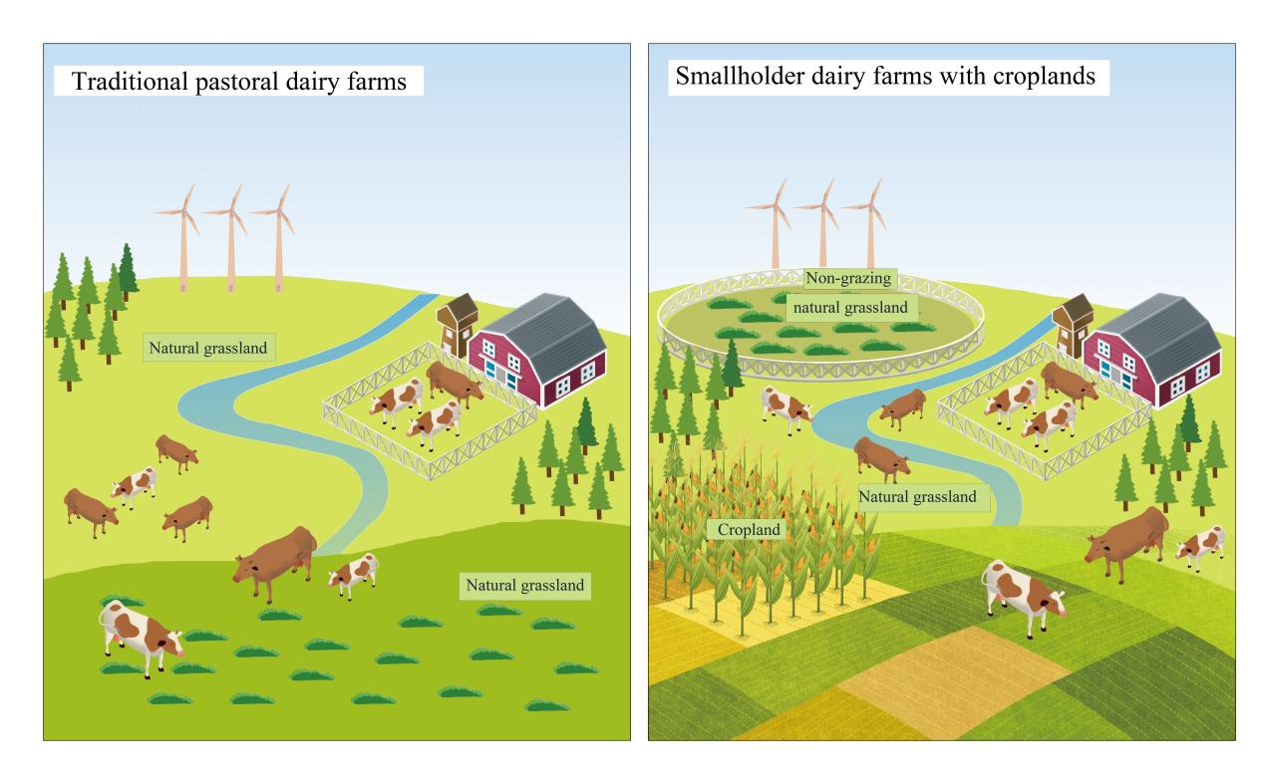

**Figure S1** Traditional pastoral dairy farms and smallholder dairy farms with croplands in Inner Mongolia.

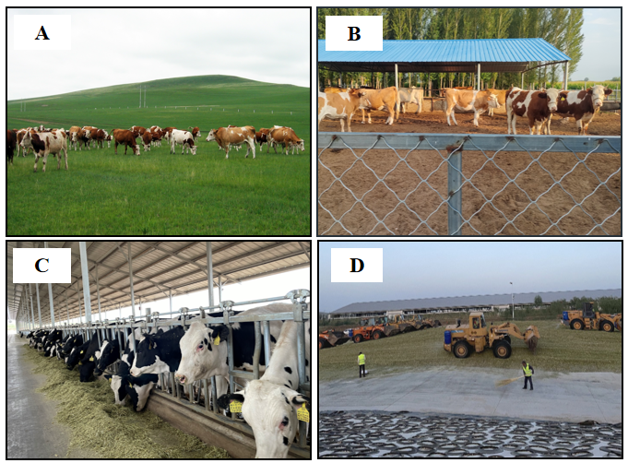

**Figure S2** Representative dairy farm types in Inner Mongolia. **(A)** Traditional pastoral dairy farms, **(B)** smallholder dairy farms with croplands, **(C)** industrial landless farms, **(D)** coupled dairy cattle and cropland intensive farms.

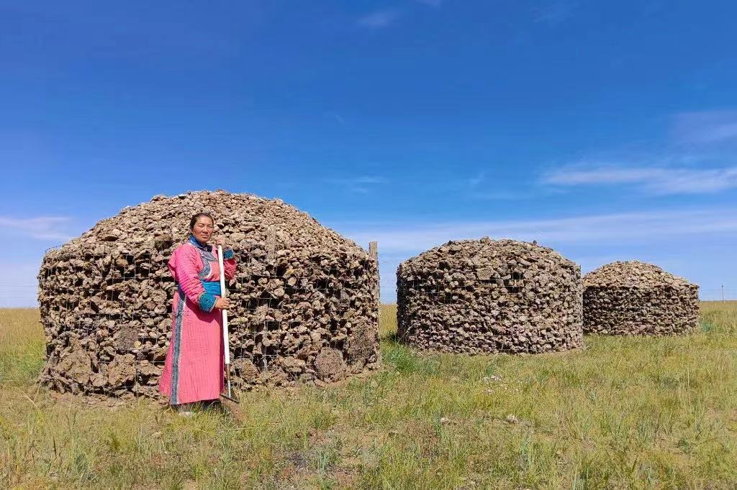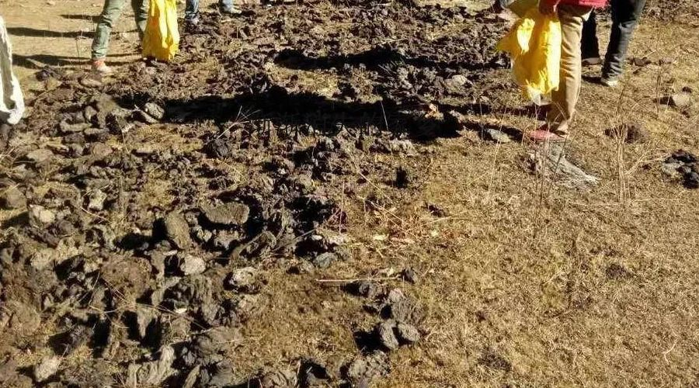

**Figure S3** Manure storage and treatment method in traditional pastoral dairy farms

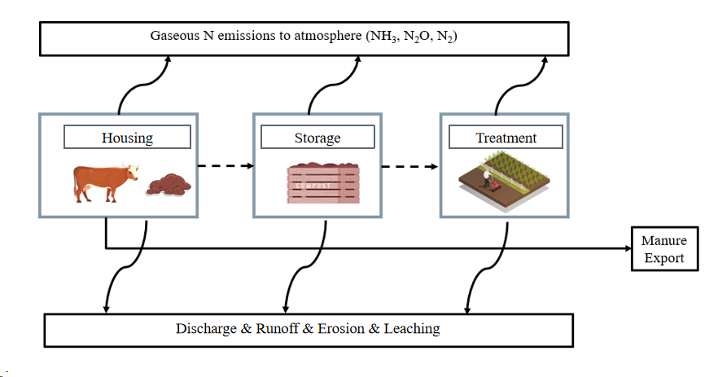

**Figure S4** Nitrogen flows in the manure management chain in a dairy farm system.

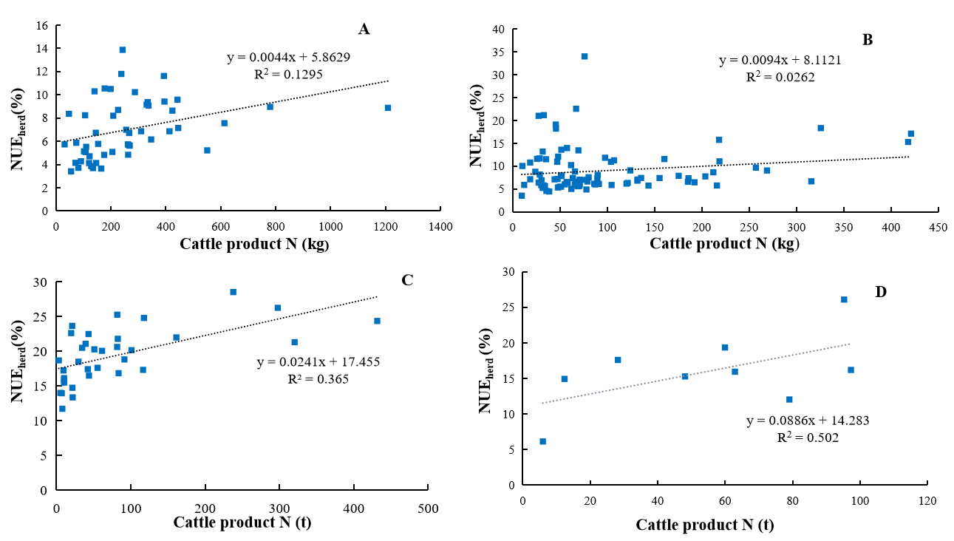

**Figure S5** Relationships between dairy total cattle product N and NUE at herd level of different types of farms (P<0.05). **(A)** Traditional pastoral dairy farms, **(B)** smallholder dairy farms with croplands, **(C)** industrial landless farms, **(D)** coupled dairy cattle and cropland intensive farms.

**Figure S6** Relationship between traditional pastoral area farm deposition N and NUE at farm level (P<0.05)

**Figure S7** Relationship between smallholder dairy farms with croplands percentage of cropping area in farm agricultural area and NUE at farm level (P<0.05)

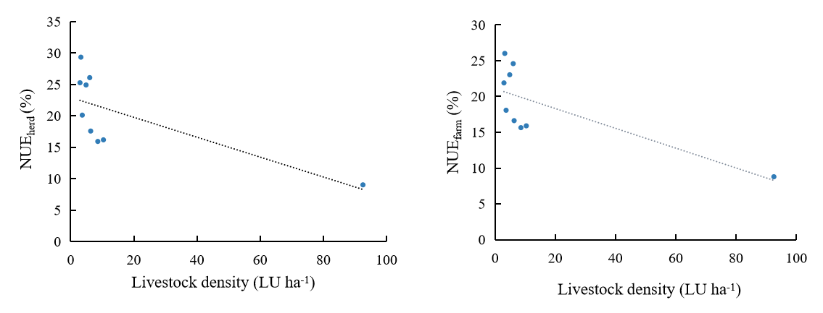

**Figure S8** Relationship between coupled dairy cattle and cropland intensive farms livestock density and NUE at herd and farm level (P<0.05)

|  |
| --- |
| **BoxS1** Equations were used to quantify estimate losses of N to the environment for the NUFER-farm model* |
| **Crop (grass) prodution** |
| *ONH3᠎_land = Ichemicalfertilizer× EFNH3_CF_application + Imanure_applied ×EFNH3_M_application + Imanure_dropped ×EFNH3_M_grazing*  *ON2O_land = Ichemicalfertilizer× EFN2O_CF_application + Imanure ᠎_applied ×EFN2O_M_application + Imanure ᠎_dropped*  *×EFN2O_M_ grazing*  *Odenitrification _land = Ichemicalfertilizer × EFdenitrification _CF_application + Imanure×EFdenitrification _land*  *Oerosion᠎_land =Surplusland×EFerosion _land*  *Orunoff ᠎_land =(Surplusland －Oerosion ᠎_land ) ×EFrunoff ᠎_land*  *Oleaching ᠎_land =(Surplusland－Oerosion ᠎_land －Orunoff ᠎_land )×EFleaching ᠎_land*  *Surplusland =Ifixation+ Idepositon + Ichemicalfertilizer + Imanure ᠎_applied +Imanure ᠎_dropped+ Iirrigation+Iseeds +Iresidues－ Oland_products－ ONH3᠎_land－ ON2O ᠎_land－Odenitrification ᠎_land*  **Dairy cattle prodution**  *ONH3᠎_cattle=Omanure×EFNH3᠎_manure*  *ON2O᠎_cattle=Omanure×EF**N2O᠎_manure*  *Odenitrification᠎_cattle =Omanure×EFdenitrification᠎_cattle*  *Oleaching᠎_cattle =Omanure×EFleaching_cattle*  *Odischarge᠎_cattle =Surplusmanure×EFdischarge ᠎_cattle*  *Surplusmanure=Omanure－ONH3᠎_cattle－ON2O᠎_cattle－Odenitrification ᠎_cattle－Oleaching ᠎_cattle*  ***Notation***  *ONH3᠎_land  N loss via NH3 volatilization from applied synthetic fertilizers, cattle manure and dropped manure*  *ON2O ᠎_land N loss via N2O emission from applied synthetic fertilizers, cattle manure and dropped manure*  *Odenitrification ᠎_land N loss via denitrification from applied synthetic fertilizers, cattle manure*  *Oerosion ᠎_land N loss via erosion from crop (grass) production system*  *O**runoff ᠎_land  N loss via suface runoff from crop (grass) production system*  *Oleaching ᠎_land N loss via leaching from crop (grass) production system*  *Oland_products  Output of N from cropland and grassland including maize grain , maize straw, whole corn silage, oat and grass*  *Omanure  Amount of manures N in housing, storage and treatment sectors, respectively*  *ONH3᠎_cattle N loss via NH3 volatilization from dairy cattle manures in housing, storage and treatment sector, respectively*  *O**N2O᠎_cattle  N loss via N2O emission from dairy cattle manures in housing, storage and treatment*  *sector, respectively*  *Odenitrification ᠎_cattle N loss via denitrification from dairy cattle manures in housing, storage and treatment*  *sector, respectively*  *Oleaching ᠎_cattle  N loss via leaching from dairy cattle manures in housing, storage and treatment sector,*  *respectively*  *Odischarge ᠎_cattle  N loss via discharge from dairy cattle manures in housing, storage and treatment sector,*  *respectively*  *Ichemicalfertilizer  Input of N via synthetic fertilizers including single N and compound fertilizer*  *Imanure ᠎_applied Input of N via manure application in cropland*  *Imanure ᠎_dropped Input of N via dropped manure in grassland during grazing time*  *Imanure Input of N via cattle manure (equals to applied manure N plus dropped manure N)*  *Ifixation  Input of N via biological fixation*  *Idepositon Input of N via deposition*  *Iirrigation  Input of N via irrigation*  *Iseeds Input of N via seeds*  *Iresidues  Input of N via crop residues*  *Surplusland N surplus in crop (grass) production system*  *Surplusmanure Dairy cattle manure N surplus of in housing, storage and treatment sector, respectively* |
|  |

*References：(Ma et al.,2010; Liu et al.,2013; Gu et al.,2013; Bai et al.,2016; Zhao et al.,2017)

**Table S1** Summary of model items

|  |  |  |  |  |
| --- | --- | --- | --- | --- |
| Compartment | Input/Output | | Item | Remark |
| Crop (grass) production | Input | Field information: cultivated area, grazing area, non-grazing area | | Interview |
| Crop type | | Interview |
| Seed amount | | Interview |
| Fertilization: fertilizer type; amount, source; fertilization pattern; N content | | Interview |
| Irrigation pattern; irrigation numbers | | Interview |
| Percentage of crop residues recycled in field | | Interview |
| Nitrogen fixation | | (Maet al., 2010) |
| Deposition | | (Liu et al.,2013) |
| Output | Crop yield | | Interview |
| Crop products fate: sold; used as feed;  Crop residues fates: used as feed; sold; discarded | | Interview |
| NH3, N2O emission, Denitrification, runoff, leaching, erosion and accumulation in the soil | | Calculated |
| Cattle production | Input | Cattle maturity | | Interview |
| Number of cattle | | Interview |
| Mortality rate | | Interview |
| Feeding: feed type, feed intake per head per day; days | | Interview |
| Output | Weight: initial and finished | | Interview |
| Milk yields; | | Interview |
| Eliminated number of animals  Sold cattle, Sold cattle weight | | Interview  Interview |
| Manure management | Input | Housing floor type | | Interview |
| Manure cleaning frequency | | Interview |
| Manure cleaning pattern | | Interview |
| Storage: percentage; methods | | Interview |
| Processing: percentage; methods | | Interview |
| Output | NH3, N2O emission, Denitrification, runoff, discharge, leaching | | Calculated |
| Fates of manure: land-applied, sold, burned | | Interview |
| Parameters |  | N content of cattle manure, | | Table S4 |
| Grain and residues of each crop type,ratio between grain and residues | | Table S4 |
| N content of each feed type | | Interview |
| Cattle carcass fractions and nutrient content  NH3, N2O and N2 emission factors from crop fields | | Table S5  Table S6-S7 |
| NH3 emission factor from dropped manure during grazing time | | (Ma et al., 2010) |
| N2O emission factor of air-dried manure | | IPCC |
| Factors controlling N leaching, runoff and erosion from crop fields | | (Maet al.,2010) |
|  |  | Emission factors of N from manure management chain | | Table S8 |

**Table S2** Average N budgets and range for different types of farms

|  |  |  |  |  |
| --- | --- | --- | --- | --- |
| Farm type | PF | SF | IDF | CDF |
| Farm number | n=51 | n=93 | n=34 | n=9 |
|  | (Unit：kg N per kg N in cattle product) | | | |
| Inputs |  |  |  |  |
| Synthetic fertilizer | — | 19.36(2.9) | — | 0.18 |
| Fixation | — | 0.85 | — | 0.06 |
| Deposition | 9.15 | 2.64 | — | 0.15 |
| Irrigation | — | 0.52 | — | 0.07 |
| Seeds | — | 0.04 | — | 0.003 |
| Feeds | 3.51 | 4.01 | 5.97 | 5.58 |
| Live cattle | 0.07 | 0.04 | 0.02 | 0.02 |
| Total | 12.93 (1.79) | 27.76 (3.4) | 5.99 (0.24) | 6.06 (0.72) |
| Outputs |  |  |  |  |
| Crop products/Grass | 1.25 | 7.57 | — | — |
| Crop residues | — | 2.13 | — | — |
| Cattle products | 1.00 | 1.00 | 1.00 | 1.00 |
| Manure product | — | — | 2.67 | 2.04 |
| Internal flows |  |  |  |  |
| Crops/Grass as feed | 17.10 | 10.13 | — | 1.03 |
| Manure applied to fields | 6.40 | 9.77 | — | 1.14 |
| Consumption | 0.30 | 0.18 | — | — |

PF, SF, IDF, CDF indicate traditional pastoral dairy farms, smallholder dairy farms with croplands, industrial landless farms and coupled dairy cattle and cropland intensive farms, respectively.

**Table S3** Characteristics of manure management systems (%)

|  |  |  |  |  |
| --- | --- | --- | --- | --- |
| Characteristics | PF | SF | IDF | CDF |
| Type of floor |  |  |  |  |
| Concrete | — | — | 100 | 100 |
| Padded floor | 14 | 36 | — | — |
| Sand | 86 | 64 | — | — |
| Manure collection methods |  |  |  |  |
| Mixtures for urine and faeces | 100 | 100 | 98 | 100 |
| Separation for urine and faeces | — | — | 2 | — |
| Manure storage |  |  |  |  |
| Covered and aboveground | — | 4 |  |  |
| Uncovered and aboveground | 100 | 96 | 9 | 11 |
| Uncovered and underground | — |  | 91 | 89 |
| Manure treatment |  |  |  |  |
| Air-drying | 100 | — | — | — |
| Anaerobic fermentation | — | 1 | 3 | — |
| Household biogas |  |  |  |  |
| Industrial biogas |  |  | 1 |  |
| Composting | — | 99 | 9 | 20 |
| Oxidation pond | — | — | 80 | 80 |

PF, SF, IDF, CDF indicate traditional pastoral dairy farms, smallholder dairy farms with croplands, industrial landless farms and coupled dairy cattle and cropland intensive farms, respectively.

**Table S4** Crop/Grass growing days, nutrient content*

|  |  |  |  |
| --- | --- | --- | --- |
| Crop Type | Growing period (day) | Grain/  residue | DM N content (%) |
| maize | 145 | 0.83 | 1.90 |
| Silage maize | 135 | – | 1.44 |
| Maize straw | – | – | 0.61a |
| Oat | 110 | – | 1.92 a |
| Grass | perennial | – | 2.1 |

*References: Maet al., (2010); Liuet al., (2013); Bai et al., (2013)

a From our study

**Table S5** Cattle carcass fractions and N content (%)*

|  |  |  |  |  |  |  |  |
| --- | --- | --- | --- | --- | --- | --- | --- |
|  | Fraction of different parts (%) | | | N content (%) | | | N content of product (%) |
| Edible | Bone | By-product | Edible | Bone | By-product |
| Cattle | 40 | 10 | 50 | 2.4 | 0.17 | 6.29 | 0.50 |

*Reference: Maet al., (2010); Bai et al.,2013.

**Table S6** Ammonia N emission factors in maize production (%)*

|  |  |  |
| --- | --- | --- |
| Fertilizer type | Fertilization pattern | NH3 emissions (%) |
| [Ammonium](javascript:void(0);) [nitrate](javascript:void(0);) | Basal dressing | 1.0 |
| Calcium ammonium nitrate | Basal dressing | 1.5 |
| [Ammonium](javascript:void(0);) [nitrate](javascript:void(0);) | Top dressing | 2.0 |
| Monoammonium phosphate | Basal dressing | 2.0 |
| Wet cow manure | Basal dressing | 2.0 |
| Coated urea | Basal dressing | 3.0 |
| [Diammonium](javascript:void(0);) [phosphate](javascript:void(0);) | Basal dressing | 3.0 |
| Controlled release fertilizer | Basal dressing | 3.0 |
| Ammonium sulfate-nitrate | Basal dressing | 4.0 |
| Coated urea | Top dressing | 5.0 |
| Controlled release fertilizer | Top dressing | 5.0 |
| Cow manure | Basal dressing | 5.0 |
| Monoammonium phosphate | Top dressing | 8.0 |
| [Diammonium](javascript:void(0);) [phosphate](javascript:void(0);) | Top dressing | 9.0 |
| NPK Compound | Basal dressing | 10.0 |
| Urea | Basal dressing | 12.0 |
| Calcium ammonium nitrate | Top dressing | 12.0 |
| Ammonium carbonate | Basal dressing | 13.0 |
| Ammonium sulfate-nitrate | Top dressing | 17.5 |
| Cow manure | Top dressing | 18.0 |
| NPK Compound | Top dressing | 20.0 |
| Ammonium carbonate | Top dressing | 21.9 |
| Wet cow manure | Top dressing | 25.0 |
| Urea | Top dressing | 25.4 |

*References: Caiet al., (2002); Ding (2005); Donget al., (2006); Dong (2007); Liet al., (2002); Li (2007); Li et al., (2011); Li (2014); Suet al., (2007); Zhanget al., (2005).

**Table S7** The N emission factors in N2O from crop/grass production (%)*

|  |  |  |
| --- | --- | --- |
| Fertilizer type | Fertilization pattern | N2O emission (%) |
| Urea | Top dressing | 1.67 |
| Urea | Basal dressing | 1.94 |
| Ammonium carbonate | Top dressing | 0.45 |
| [Ammonium](javascript:void(0);) [nitrate](javascript:void(0);) | Top dressing | 0.57 |
| Calcium nitrate | Top dressing | 0.03 |
| NPK Compound | Basal dressing | 0.06 |
| Cow manure | Basal dressing | 0.05 |

*References: Dinget al., (2001); Dinget al., (2004); Li (2007).

Table S8 Emission factors during manure management chain (%)*

|  |  |  |  |  |  |  |
| --- | --- | --- | --- | --- | --- | --- |
| stage | Floor type | Anti-Seepage | NH3 | N2O | Denitrification | Leaching |
| Housing | Floor with mats | No | 12.5 | 0.5 | 5 | 1 |
| Cement floor | Yes | 23 | 0.5 | 5 | 0 |
| Floor with mats | Yes | 12.5 | 0.5 | 5 | 0 |
| Slatted floor | Yes | 18.5 | 0.5 | 5 | 0 |
| Cement floor | No | 23 | 0.5 | 5 | 1 |
| Slatted floor | No | 18.5 | 0.5 | 5 | 1 |
| Storage | Underground without cover | No | 17 | 0.5 | 5 | 1 |
| Underground with cover | No | 14 | 3 | 15 | 1 |
| Aboveground without cover | No | 17 | 0.5 | 5 | 1 |
| Aboveground with cover | No | 15 | 2 | 10 | 1 |
| Underground without cover | Yes | 17 | 0.5 | 5 | 0 |
| Underground with cover | Yes | 14 | 3 | 15 | 0 |
| Aboveground without cover | Yes | 17 | 0.5 | 5 | 0 |
| Aboveground with cover | Yes | 15 | 2 | 10 | 0 |
| Treatment | Household biogas | No | 8.3 | 0.5 | 5 | 1 |
| Composting | No | 41.8 | 0.87 | 5 | 1 |
| Household biogas | Yes | 8.3 | 0.5 | 5 | 0 |
| Pile up | Yes | 17 | 0.5 | 5 | 0 |
| Industrial biogas | No | 8.3 | 0.5 | 5 | 1 |
| Composting | Yes | 41.8 | 0.87 | 5 | 0 |
| Oxidation pond | No | 41.7 | 0.5 | 5 | 1 |
| Oxidation pond | Yes | 41.7 | 0.5 | 5 | 0 |
| Industrial biogas | Yes | 8.3 | 0.5 | 5 | 0 |
|  | Air-dried | No |  | 0.2 |  |  |

*Reference: Maet al., (2010).

**Table S9** Summary of key parameters and data sources used for the calculation of NUE

|  |  |  |  |  |  |
| --- | --- | --- | --- | --- | --- |
| **Process** | **Parameter codes** | **Brief description** | **Unit** | **Value** | **Data sources** |
| Crop production | deposition | Atmospheric N deposition rate | kg N ha-1 yr -1 | 6.6 | Liu et al.,2013 |
| fixation | Biological N fixation rate | kg N ha-1 yr -1 | Maize and green maize:10 | Bai et al.,2016 |
| TNgrain | N concentration of grain | kg N kg-1 DM | Maize:1.90% | Bai et al.,2016 |
| TNstraw | N concentration of straw | kg N kg-1 DM | Maize straw:0.61%;  grass:2.1% | Bai et al.,2016  Ma et al.,2010 |
| Rs-g | The ratio of straw (DM) to grain (DM) | _ | Maize：1.27 | Gu et al.,2013 |
| seeds | N concentration of seed | kg N kg-1 DM | Corn seed:1.90% | Bai et al.,2016 |
| irrigation | N concentration of irrigation water | kg N ha-1 yr -1 | 6-11 | In our survey |
| Cattle production | meat | N content of the cow body (mainly meat) | kg N kg-1 meat | 2.3%; 2.6% | Bai et al.,2016 |
| milk | N content of the cow milk | kg N kg-1 milk | 4‰ ; 5.3‰ | Bai et al.,2016 |

**Table S10** Interview questionnaire for field information

|  |  |  |  |  |  |  |  |
| --- | --- | --- | --- | --- | --- | --- | --- |
| Field ID | Field area | Is it rented? | Crop type* | Crop area | Grassland area | Crop productivity | Yield of grass harvested |
| Code | ha | 0 : No ; 1: Yes | Code | ha | ha | kg ha-1 | kg |
|  |  |  |  |  |  |  |  |
|  |  |  |  |  |  |  |  |

**\*Crop types:**11= maize; 12green maize;13=oat 14=bean;15= wheat; 16=others (please specify).

**Table S10** Interview questionnaire for the fates of main land products and by-products

|  |  |  |  |  |  |  |  |  |  |  |  |  |  |  |
| --- | --- | --- | --- | --- | --- | --- | --- | --- | --- | --- | --- | --- | --- | --- |
| Crop type* | Main products (Home used%+sale%=100%) | | | | | | By-products (for the family + discard + sale=100%) | | | | | | | |
| For the family | | | | sale | | For the family | | | | Others | | Sale | |
| Food (Alternative) | | Feed (Alternative) | | (Alternative) | | Residues returned to field | Feed | Padding | Compost | Burning | Discard | (Alternative) | |
| Code | % | kg | % | kg | % | kg | % | % | % | % | % | % | % | kg |
|  |  |  |  |  |  |  |  |  |  |  |  |  |  |  |
|  |  |  |  |  |  |  |  |  |  |  |  |  |  |  |

**Table S11** Interview questionnaire for crop production management

Field ID_______

|  |  |  |  |  |  |  |
| --- | --- | --- | --- | --- | --- | --- |
| Item | Unit | Crop types | | | | |
| 1 | 2 | 3 | 4 | 5 |
| Crop type* | Code |  |  |  |  |  |
| Topography 1=Plain (0-7°); 2= Gentle slope field (8-15°); 3=Sloping field (16-25°); 4=Steep slope field (>25°) | Code |  |  |  |  |  |
| Soil texture 1=Clay soil; 2=Loam soil; 3=Sandy soil | Code |  |  |  |  |  |
| 1. Cultivation | | | | | | |
| Method 1=[Rotary](javascript:void(0);) [tillage](javascript:void(0););  2=[Deep](javascript:void(0);) [placement](javascript:void(0););  3= [Deep](javascript:void(0);) [scarification](javascript:void(0);) | Code |  |  |  |  |  |
| Using Machine 0=No; 1=Yes | Code |  |  |  |  |  |
| Crop type on last season | Code |  |  |  |  |  |
| Crop yield on last season | kg |  |  |  |  |  |
| Percentage of residues on last season returned to field | % |  |  |  |  |  |
| 2. Sowing | | | | | | |
| Date | Day / Month |  |  |  |  |  |
| Seed amount | kg ha-1 |  |  |  |  |  |
| Source of the seed  1=Home; 2=Market; | Code |  |  |  |  |  |
| Using machine  0=No; 1=Yes | Code |  |  |  |  |  |
| 4. Irrigation | | | | | | |
| Method 1= Flood irrigation; 2=Drip irrigation; 3=Sprinkler irrigation; 4=Furrow irrigation; 5=Rain fed | Code |  |  |  |  |  |
| Frequency |  |  |  |  |  |  |
| 5. Spraying processing | | | | | | |
| Using machine 0=No; 1=Yes | Code |  |  |  |  |  |
| Frequency |  |  |  |  |  |  |
| 6. Weeds processing | | | | | | |
| Using machine 0=No; 1=Yes | Code |  |  |  |  |  |
| Frequency |  |  |  |  |  |  |
| 7. Harvest | | | | | | |
| Date | Day / Month |  |  |  |  |  |
| Using machine0=No; 1=Yes | Code |  |  |  |  |  |

**\*Crop types:**11= maize; 12green maize;13=oat 14=bean;15= wheat; 16=others (please specify).

**Table S12** Interview questionnaire for fertilization management

|  |  |  |  |  |  |  |  |  |  |  |  |
| --- | --- | --- | --- | --- | --- | --- | --- | --- | --- | --- | --- |
| Order | Method | Date | Using machine** | Fertilizer type 1 | | | | Fertilizer type 2 | | | |
| **[manufacturers](javascript:void(0);)** | Type*** | Application rate | Nitrogen contents (%) | **[manufacturers](javascript:void(0);)** | Type*** | Application rate | Nitrogen contents (%) |
|  |  |  |  |  | Code | kg ha-1 |  |  | Code | kg ha-1 |  |
|  |  |  |  |  |  |  |  |  |  |  |  |
| Fertilizer type 3 | | | | Fertilizer type 4 | | | |
| **[manufacturers](javascript:void(0);)** | Type*** | Application rate | Nitrogen contents (%) | **[manufacturers](javascript:void(0);)** | Type*** | Application rate | Nitrogen contents (%) |
|  | Code | kg ha-1 | N |  | Code | kg ha-1 | N |
|  |  |  |  |  |  |  |  |

**\*Crop types:**11= maize; 12green maize;13=oat 14=bean;15= wheat; 16=others (please specify).

**\*\*Using machine：**0=No; 1=Yes. **Method：**1=Top dressing; 2=Basal dressing; 3=Other (Please specify);

**\*\*\*Fertilizer type：**101=Urea; 102= Ammonium bicarbonate; 103= Monoammonium phosphate; 104=[Diammonium](javascript:void(0);) [phosphate](javascript:void(0);); 105=Formula fertilizer; 106=NPK compound fertilizer; 107=Slow release fertilizer; 108=Controlled release fertilizer; 109=other (Please specify); 201= cattle manure; 202=Commercial organic fertilizer; 203=Bio-organic fertilizer; 204=Other (Please specify)

**Table S13** Interview questionnaire for milk production

|  |  |  |  |  |  |  |  |  |  |  |  |
| --- | --- | --- | --- | --- | --- | --- | --- | --- | --- | --- | --- |
| Stage | Breeding stock | Number of purchased animals | Mortality rate | Fallout rate | period | Weight at the beginning | Weight at the end | Feed conversion ratio | Daily gain | Marketing weight | Milk yield |
| Unit | head | head | % | % | day | kg | kg |  | kg | kg | kg head-1 day-1 |
| Calve |  |  |  |  |  |  |  |  |  |  |  |
| Heifer |  |  |  |  |  |  |  |  |  |  |  |
| Dry milk cows |  |  |  |  |  |  |  |  |  |  |  |
| Lactating cow |  |  |  |  |  |  |  |  |  |  |  |

**Table S14** Interview questionnaire for dairy cattle feeding management

|  |  |  |  |  |  |  |  |  |  |  |  |  |  |  |  |  |  |  |
| --- | --- | --- | --- | --- | --- | --- | --- | --- | --- | --- | --- | --- | --- | --- | --- | --- | --- | --- |
| Stage | Feed intake | | Feedstuffs | | | | | | | | | | | | | | | |
| Feed 1 | | Feed 2 | | Feed 3 | | Feed 4 | | Feed 5 | | Feed 6 | | Feed 7 | | Other | |
| Source | Amount | Source | Amount | Source | Amount | Source | Amount | Source | Amount | Source | Amount | Source | Amount | Source | Amount |
|  | kg head-1 day-1 | | Code |  | Code |  | Code |  | Code |  | Code |  | Code |  | Code |  | Code |  |
|  | Concentrates |  |  |  |  |  |  |  |  |  |  |  |  |  |  |  |  |  |
|  |  |  |  |  |  |  |  |  |  |  |  |  |  |  |  |  |  |
|  |  |  |  |  |  |  |  |  |  |  |  |  |  |  |  |  |  |
|  |  |  |  |  |  |  |  |  |  |  |  |  |  |  |  |  |  |
|  |  |  |  |  |  |  |  |  |  |  |  |  |  |  |  |  |  |
|  | Forage |  |  |  |  |  |  |  |  |  |  |  |  |  |  |  |  |  |
|  |  |  |  |  |  |  |  |  |  |  |  |  |  |  |  |  |  |
|  |  |  |  |  |  |  |  |  |  |  |  |  |  |  |  |  |  |
|  |  |  |  |  |  |  |  |  |  |  |  |  |  |  |  |  |  |
|  |  |  |  |  |  |  |  |  |  |  |  |  |  |  |  |  |  |
| Whether change the feedstuffs 0=No;1=Yes | | | | | | Code |  | | | | | | | | | | | |
| **Feed types：**101=Leymus chinensis; 102=Ryegrass; 103=Alfalfa; 104=Yellow corn silage; 105 =Whole corn silage; 106=Corn residue; 107=Rice residue; 108=Millet residue; 109=Distillers' grains; 110=Corn flour; 111=Sorghum flour; 112=Barly flour; 113=Oat; 114=Soybean meal; 115=Peanut meal; 116=Rapeseed meal; 117=Cottonseed meal; 118=Bran; 119=Concentrated feed; 120=Complete formula feed; 121=Other (Please specify); **Source：**1=On-farm; 2=Market | | | | | | | | | | | | | | | | | | |

**Table S15** Interview questionnaire for dairy cattle feeding management

|  |  |  |  |  |  |  |  |  |  |  |  |  |  |  |  |  |  |  |
| --- | --- | --- | --- | --- | --- | --- | --- | --- | --- | --- | --- | --- | --- | --- | --- | --- | --- | --- |
| Stage | Feed intake | | Feedstuffs | | | | | | | | | | | | | | | |
| Feed 1 | | Feed 2 | | Feed 3 | | Feed 4 | | Feed 5 | | Feed 6 | | Feed 7 | | Other | |
| Source | Amount | Source | Amount | Source | Amount | Source | Amount | Source | Amount | Source | Amount | Source | Amount | Source | Amount |
|  | kg head-1 day-1 | | Code |  | Code |  | Code |  | Code |  | Code |  | Code |  | Code |  | Code |  |
|  | Concentrates |  |  |  |  |  |  |  |  |  |  |  |  |  |  |  |  |  |
|  |  |  |  |  |  |  |  |  |  |  |  |  |  |  |  |  |  |
|  |  |  |  |  |  |  |  |  |  |  |  |  |  |  |  |  |  |
|  |  |  |  |  |  |  |  |  |  |  |  |  |  |  |  |  |  |
|  |  |  |  |  |  |  |  |  |  |  |  |  |  |  |  |  |  |
|  | Forage |  |  |  |  |  |  |  |  |  |  |  |  |  |  |  |  |  |
|  |  |  |  |  |  |  |  |  |  |  |  |  |  |  |  |  |  |
|  |  |  |  |  |  |  |  |  |  |  |  |  |  |  |  |  |  |
|  |  |  |  |  |  |  |  |  |  |  |  |  |  |  |  |  |  |
|  |  |  |  |  |  |  |  |  |  |  |  |  |  |  |  |  |  |
| Whether change the feedstuffs 0=No;1=Yes | | | | | | Code |  | | | | | | | | | | | |
| **Feed types：**101=Leymus chinensis; 102=Ryegrass; 103=Alfalfa; 104=Yellow corn silage; 105 =Whole corn silage; 106=Corn residue; 107=Rice residue; 108=Millet residue; 109=Distillers' grains; 110=Corn flour; 111=Sorghum flour; 112=Barly flour; 113=Oat; 114=Soybean meal; 115=Peanut meal; 116=Rapeseed meal; 117=Cottonseed meal; 118=Bran; 119=Concentrated feed; 120=Complete formula feed; 121=Other (Please specify); **Source：**1=On-farm; 2=Market | | | | | | | | | | | | | | | | | | |

**Table S16** Interview questionnaire for manure management

|  |  |  |  |
| --- | --- | --- | --- |
| Item | Unit | Id |  |
| **Housing (**P9 + P10 + P11 + P12 + P13 + P14 + P15 = 100%**)** | | | |
| Area | m2 | P1 |  |
| Structure 1=Closed; 2=Semi-closed; 3=Open | Code | P2 |  |
| Temperature control facilities 0=No; 1=Yes | Code | P3 |  |
| Floor type 1= Concrete floor; 2= slatted floor; 3=Padded floor | Code | P4 |  |
| Floor material 1=Muddy; 2=Brick; 3=Cement; 21= Plastic | Code | P5 |  |
| Padding material 1=Crop residues; 2=Sawdust; 3=Sand | Code | P6 |  |
| Manure collecting methods 1=Mixtures of urine and faeces; 2= Separation for urine and faeces | Code | P7 |  |
| Cleaning frequency |  | P8 |  |
| Proportion of export | % | P9 |  |
| Proportion of application to field | % | P10 |  |
| Proportion of storage | % | P11 |  |
| Proportion of biogas | % | P12 |  |
| Proportion of compost | % | P13 |  |
| Proportion of oxidation pond | % | P14 |  |
| Proportion of direct discharge to surface water | % | P15 |  |
| **Storage** (P19 + P20 + P21 + P22 = 100%) | | | |
| (1)faeces | | | |
| Storage type 1= Underground; 2=Aboveground; | Code | P16 |  |
| Covered 0=No; 1=Yes | Code | P17 |  |
| Anti-seepage 0=No; 1=Yes | Code | P18 |  |
| Proportion of export | % | P19 |  |
| Proportion of application to field | % | P20 |  |
| Proportion of biogas | % | P21 |  |
| Proportion of compost | % | P22 |  |
| Proportion of air-drying | % | P23 |  |
| **(2)Urine** ( P27 + P28 + P29 + P30 + P31 = 100%) | | | |
| Storage type 1= Underground; 2=Aboveground; | Code | P24 |  |
| Covered 0=No; 1=Yes | Code | P25 |  |
| Anti-seepage 0=No; 1=Yes | Code | P26 |  |
| Proportion of export | % | P27 |  |
| Proportion of application to field | % | P28 |  |
| Proportion of biogas | % | P29 |  |
| Proportion of oxidation pond | % | P30 |  |
| Proportion of direct discharge to surface water | % | P31 |  |
| **Composting** (P35 + P36 = 100%) | | | |
| Method 1= [Aerobic](javascript:void(0);) [composting](javascript:void(0);); 2= Anaerobic composting; | Code | P32 |  |
| Covered 0=No; 1=Yes | Code | P33 |  |
| Anti-seepage 0=No; 1=Yes | Code | P34 |  |
| Proportion of export | % | P35 |  |
| Proportion of application to field | % | P36 |  |
| **Biogas** ( P38 + P39 + P40 + P41 = 100%) | | | |
| Type 0=Household; 1=Industrial | Code | P37 |  |
| Proportion of export | % | P38 |  |
| Proportion of application to field | % | P39 |  |
| Proportion of oxidation pond | % | P40 |  |
| Proportion of direct discharge to surface water | % | P41 |  |
| **Oxidation pond** ( P43 + P44 + P45 = 100%) | | | |
| Anti-seepage 0=No; 1=Yes | Code | P42 |  |
| Proportion of export | % | P43 |  |
| Proportion of application to field | % | P44 |  |
| Proportion of direct discharge to surface water | % | P45 |  |

**References**

Bai, Z. H., Ma, L., Oenema, O., Chen, Q., and Zhang, F. S. (2013). Nitrogen and phosphorus efficiencies in dairy production in China. *J. Environ. Qual.* 42,990–1001

Cai, G., Chen, D., Ding, H., Pacholski, A., Fan, X.; Zhu, Z. (2002). Nitrogen losses from fertilizers applied to maize, wheat and rice in the North China Plain. *Nutr. Cycl. Agroecosyst.* 63,187–195.

Ding, H., Cai, G., Wang, Y., Chen, D. (2011). Nitrification-denitrification losses of nitrogen fertilizer and N2O emission from maize-chao soil system in North China Plain. *Scientia Agricultura Sinica* 34,416–421 (in Chinese).

Ding, H., Wang, Y., Li, W. (2004). Denitrification losses and N2O emission from different nitrogen fertilizers applied to maize-fluvo-aquic soil system. *Scientia Agricultura Sinica* 37, 1886–1891 (in Chinese).

Ding, X. (2005). Ammonia volatilization from nitrogen fertilization in winter wheat-summer maize roation system in the North China. [master thesis]. [Beijing]: China Agricultural University ( in Chinese).

Dong, L. (2006). Evaluation of NH3 emission from pig and dairy cow manure in China. [master thesis]. [Baoding]: Agricultural University of Hebei ( in Chinese).

Dong, W., Hu, C., Zhang, Y. (2006).In situ determination of ammonia volatilization in field of North China. *Chinese Journal of Eco-Agriculture*14,46–48 (in Chinese).

He, C., Liu, X., Fangmeier, A., Zhang, F. (2007). Quantifying the total airborne nitrogen input into agroecosystems in the North China Plain. *Agr. Ecosyst. Enviro.* 121,395– 400.

Li, G., Li, B., Chen, D. (2002). Ammonia volatilization from large field planted with winter wheat and summer maize. *Acta Agriculturae Boreali-Sinica* 17,76–88 (in Chinese).

Li, L., Kelin, H., Guangde, L., Huanyuan, W. (2011). Evaluation of nitrogen loss way in summer maize system under different fertilizer N managements. *Environmental Science* 32, 2617–2624 (in Chinese).

Li, Q. (2014). Effect of Urease inhibitor LIMUS on ammonia mitigation and crop yield and nitrogen use efficiency in different croplands of China.PhD thesis, China Agricultural University, Beijing, China ( in Chinese).

Li, X. (2007). Fate of fertilizer nitrogen and gaseous N loss in winter wheat-summer maize rotation system in North China Plain.  [master thesis]. [Baoding]: Agricultural University of Hebei ( in Chinese).

Liu, X., Zhang, Y., Han, W., Tang, A., Shen, J., Cui, Z. et al., (2013). Enhanced nitrogen deposition over China. *Nature* 494,459–462.

Ma, L., Ma, W.Q., Velthof, G.L., Wang, F.H., Qin, W., Zhang, F.S. et al., (2010). Modeling nutrient flows in the food chain of China. *J. Environ. Qual.* 39,1279–1289.

Su, F., Ding, X., Gao, Z., Huang, B., Chen, X., Zhang, F. (2007). Ammonia volatilization from nitrogen fertilization of winter wheat-summer maize rotation system in the North China Plain. *China Environmental Science* 27, 409–413 (in Chinese).

Zhang, Y., Hu, C., Dong, W. (2005) .Ammonia volatilization from wheat-maize rotation field in the piedmont of Taihang. *Plant Nutrition and Fertilizer Science* 11,417–419 (in Chinese).

Zhao, Z.Q., Bai, Z.H., Wei, S., Ma, W.Q., Wang, M.R., Kroeze, C.et al.,(2017). Modeling farm nutrient flows in the North China Plain to reduce nutrient losses. *Nutr. Cycl. Agroecosyst.* 108, 231–244.