Supplementary Material

Supplementary Figures and Tables
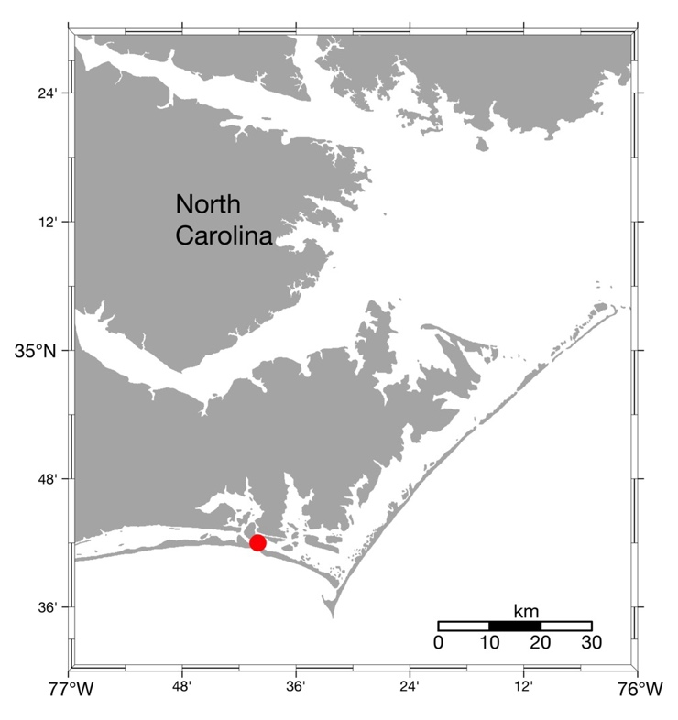
Supplementary Figure 1. Map of sample location for all Oculina arbuscula coral colonies as described in Rivera and Davies (2021).

Supplementary Table 1. Summary of Tukey’s HSD post-hoc test for δ¹⁵N for the aposymbiotic and symbiotic host as well as aposymbiotic host and symbiotic host + symbiont (experiment and type). SE = standard error, DF = degrees of freedom.
Contrast | Estimate | SE | DF | T-ratio | P-value
δ¹⁵N Aposymbiotic ‘Host’(Apo) and Symbiotic ‘Host’ (Sym)
 | Comparison = experiment
1 – 2 | 1.210 | 0.214 | 10.5 | 5.671 | 0.0002
 | Comparison = type
Apo – Sym | 0.820 | 0.203 | 10 | 4.051 | 0.0023
 | Comparison = experiment | type
1,Apo – 2,Apo | 1.565 | 0.294 | 10.2 | 5.314 | 0.0015
1,Apo – 1,Sym | 1.173 | 0.302 | 10 | 3.884 | 0.0135
1,Apo – 2,Sym | 2.033 | 0.294 | 10.2 | 6.903 | 0.0002
2,Apo – 1,Sym | -0.392 | 0.294 | 10.2 | -1.332 | 0.5643
2,Apo – 2,Sym | 0.468 | 0.270 | 10 | 1.733 | 0.3573
1,Sym – 2,Sym | 0.860 | 0.294 | 10.2 | 2.921 | 0.0611
δ¹⁵N Aposymbiotic ‘Host’ (Apo) and Symbiotic ‘Host + Sym’ (Sym)
 | Comparison = experiment
1 – 2 | 1.050 | 0.285 | 10.8 | 3.681 | 0.0037
 | Comparison = type
Apo – Sym | 2.500 | 0.271 | 10 | 9.237 | <.0001
 | Comparison = experiment | type
1,Apo – 2,Apo | 1.599 | 0.393 | 10.4 | 4.068 | 0.0094
1,Apo – 1,Sym | 3.050 | 0.403 | 10 | 7.559 | 0.0001
1,Apo – 2,Sym | 3.549 | 0.393 | 10.4 | 9.030 | <.0001
2,Apo – 1,Sym | 1.451 | 0.393 | 10.4 | 3.692 | 0.0173
2,Apo – 2,Sym | 1.950 | 0.361 | 10 | 5.404 | 0.0014
1,Sym – 2,Sym | 0.499 | 0.393 | 10.4 | 1.270 | 0.5999
δ¹⁵N Symbiotic ‘Host’ (‘H’) and Symbiotic ‘Host + Sym’ (‘H+S’)
 | Comparison = experiment
1 – 2 | 0.687 | 0.223 | 11.7 | 3.074 | 0.0099
 | Comparison = type
‘H’ – ‘H+ S’ | 1.660 | 0.211 | 11 | 7.873 | <.0001
 | Comparison = experiment | type
1,‘H’ – 2,‘H’ | 0.687 | 0.223 | 11.7 | 3.074 | 0.0427
1,‘H’ – 1,‘H + S’ | 1.658 | 0.211 | 11 | 7.873 | <.0001
1,‘H’ – 2,‘H + S’ | 2.345 | 0.307 | 11.4 | 7.636 | <.0001
2,‘H’ – 1,‘H + S’ | 0.971 | 0.307 | 11.4 | 3.162 | 0.0377
2,‘H’ – 2,‘H + S’ | 1.658 | 0.211 | 11 | 7.873 | <.0001
1,‘H + S’– 2,‘H + S’ | 0.687 | 0.223 | 11.7 | 3.074 | 0.0427

Supplementary Table 2. Summary of one-way ANOVA usinf a Tukey’s HSD post-hoc test for δ¹⁵N by experiment and genet (genet, type, and sample). SE = standard error, df = degrees of freedom.
Contrast | Mean Difference | SE | df | p-value
Experiment 1
 | Comparison = genet | type | sample
A,Apo,Host – A,Sym,Host | 0.61 | 0.1784 | 9 | 0.0189
A,Apo,Host – A,Sym,Host+Sym | 2.16 | 0.1784 | 9 | <0.0001
A,Sym,Host – A,Sym,Host+Sym | 1.55 | 0.1784 | 9 | <0.0001
C,Apo,Host – C,Sym,Host | 1.39 | 0.1034 | 3 | 0.0019
C,Apo,Host – C,Sym,Host+Sym | 4.34 | 0.1034 | 3 | <0.0001
C,Sym,Host – C,Sym,Host+Sym | 2.95 | 0.1034 | 3 | 0.0001
E,Apo, Host – E,Sym,Host | 1.31 | 0.1407 | 3 | 0.0054
E,Apo,Host – E,Sym,Host+Sym | 3.29 | 0.1407 | 3 | 0.0004
E,Sym,Host – E,Sym,Host+Sym | 1.98 | 0.1407 | 3 | 0.0016
F,Apo,Host – F,Sym,Host | 0.87 | 0.1034 | 3 | 0.0072
F,Apo,Host – F,Sym,Host+Sym | 2.41 | 0.1034 | 3 | 0.0004
F,Sym,Host – F,Sym,Host+Sym | 1.54 | 0.1034 | 3 | 0.0014
Experiment 2
 | Comparison = genet | type | sample
A,Apo,Host – A,Sym,Host | -0.17 | 0.1749 | 3 | 0.6402
A,Apo,Host – A,Sym,Host+Sym | 1.29 | 0.1749 | 3 | 0.0105
A,Sym,Host – A,Sym,Host+Sym | 1.46 | 0.1749 | 3 | 0.0074
C,Apo,Host – C,Sym,Host | 0.34 | 0.1749 | 3 | 0.2722
C,Apo,Host – C,Sym,Host+Sym | 1.29 | 0.1749 | 3 | 0.0105
C,Sym,Host – C,Sym,Host+Sym | 0.95 | 0.1749 | 3 | 0.0248
D,Apo,Host – D,Sym,Host | 0.59 | 0.1838 | 3 | 0.0963
D,Apo,Host – D,Sym,Host+Sym | 1.7 | 0.1838 | 3 | 0.0055
D,Sym,Host – D,Sym,Host+Sym | 1.11 | 0.1838 | 3 | 0.0185
E,Apo, Host – E,Sym,Host | 0.64 | 0.1838 | 3 | 0.0792
E,Apo,Host – E,Sym,Host+Sym | 1.97 | 0.1838 | 3 | 0.0036
E,Sym,Host – E,Sym,Host+Sym | 1.33 | 0.1838 | 3 | 0.0111
F,Apo,Host – F,Sym,Host | 0.468 | 0.306 | 8 | 1.527
F,Apo,Host – F,Sym,Host+Sym | 1.950 | 0.306 | 8 | 6.363
F,Sym,Host – F,Sym,Host+Sym | 1.482 | 0.306 | 8 | 4.836

