Table S1. Factors to be considered in evaluating the cardiac safety of drugs with the exemption of TQT from the C-QTc model
Hypothesis | Validation result
Hypothesis 1: The drug does not affect subjects’ heart rate. | Placebo-corrected change-from-baseline heart rate (ΔΔHR) of all subjects were between ±10 ms shown in Figure 2a. The unit is bpm.
Hypothesis 2: QTcF is not related to HR. | There was no significant correlation between QTcF and RR shown in Figure 2b.
Hypothesis 3: There is no hysteresis between concentration and ΔQTcF. | The difference value of T_{max} of plasma concentration and ΔQTcF in group 300 mg, 400 mg were within 1 hour. A time course of ΔΔQTcF showing concordance with PK shown in Figure 2c.
Hypothesis 4: Plasma concentration is linear with ΔQTcF. | The shape of concentration VS ΔQTcF did not show nonlinearity shown in Figure 2d and Figure 2e.

Table S2. Summary of QTcF and ΔQTcF

 |  |  | n (%)
 |  |  |  | FCN-437c
Timepoint | Variable | Category | Placebo | 300mg | 400mg | Pooled
1h | QTcF | ≤450 ms | 6 (100.0) | 6 (100.0) | 6 (100.0) | 18 (100.0)
 |  | >450 ms &≤480 ms | 0 ( 0.0) | 0 ( 0.0) | 0 ( 0.0) | 0 ( 0.0)
 |  | >480 ms &≤500 ms | 0 ( 0.0) | 0 ( 0.0) | 0 ( 0.0) | 0 ( 0.0)
 |  | >500 ms | 0 ( 0.0) | 0 ( 0.0) | 0 ( 0.0) | 0 ( 0.0)
 | ΔQTcF | ≤30 ms | 6 (100.0) | 6 (100.0) | 6 (100.0) | 18 (100.0)
 |  | >30ms &≤60 ms | 0 ( 0.0) | 0 ( 0.0) | 0 ( 0.0) | 0 ( 0.0)
 |  | >60 ms | 0 ( 0.0) | 0 ( 0.0) | 0 ( 0.0) | 0 ( 0.0)
2h | QTcF | ≤450 ms | 6 (100.0) | 6 (100.0) | 6 (100.0) | 18 (100.0)
 |  | >450 ms &≤480 ms | 0 ( 0.0) | 0 ( 0.0) | 0 ( 0.0) | 0 ( 0.0)
 |  | >480 ms &≤500 ms | 0 ( 0.0) | 0 ( 0.0) | 0 ( 0.0) | 0 ( 0.0)
 |  | >500 ms | 0 ( 0.0) | 0 ( 0.0) | 0 ( 0.0) | 0 ( 0.0)
 | ΔQTcF | ≤30 ms | 6 (100.0) | 6 (100.0) | 6 (100.0) | 18 (100.0)
 |  | >30ms &≤60 ms | 0 ( 0.0) | 0 ( 0.0) | 0 ( 0.0) | 0 ( 0.0)
 |  | >60 ms | 0 ( 0.0) | 0 ( 0.0) | 0 ( 0.0) | 0 ( 0.0)
3h | QTcF | ≤450 ms | 6 (100.0) | 6 (100.0) | 6 (100.0) | 18 (100.0)
 |  | >450 ms &≤480 ms | 0 ( 0.0) | 0 ( 0.0) | 0 ( 0.0) | 0 ( 0.0)
 |  | >480 ms &≤500 ms | 0 ( 0.0) | 0 ( 0.0) | 0 ( 0.0) | 0 ( 0.0)
 |  | >500 ms | 0 ( 0.0) | 0 ( 0.0) | 0 ( 0.0) | 0 ( 0.0)
 | ΔQTcF | ≤30 ms | 6 (100.0) | 6 (100.0) | 6 (100.0) | 18 (100.0)
 |  | >30ms &≤60 ms | 0 ( 0.0) | 0 ( 0.0) | 0 ( 0.0) | 0 ( 0.0)
 |  | >60 ms | 0 ( 0.0) | 0 ( 0.0) | 0 ( 0.0) | 0 ( 0.0)
4h | QTcF | ≤450 ms | 6 (100.0) | 6 (100.0) | 6 (100.0) | 18 (100.0)
 |  | >450 ms &≤480 ms | 0 ( 0.0) | 0 ( 0.0) | 0 ( 0.0) | 0 ( 0.0)
 |  | >480 ms &≤500 ms | 0 ( 0.0) | 0 ( 0.0) | 0 ( 0.0) | 0 ( 0.0)
 |  | >500 ms | 0 ( 0.0) | 0 ( 0.0) | 0 ( 0.0) | 0 ( 0.0)
 | ΔQTcF | ≤30 ms | 6 (100.0) | 6 (100.0) | 6 (100.0) | 18 (100.0)
 |  | >30ms &≤60 ms | 0 ( 0.0) | 0 ( 0.0) | 0 ( 0.0) | 0 ( 0.0)
 |  | >60 ms | 0 ( 0.0) | 0 ( 0.0) | 0 ( 0.0) | 0 ( 0.0)
5h | QTcF | ≤450 ms | 6 (100.0) | 6 (100.0) | 6 (100.0) | 18 (100.0)
 |  | >450 ms &≤480 ms | 0 ( 0.0) | 0 ( 0.0) | 0 ( 0.0) | 0 ( 0.0)
 |  | >480 ms &≤500 ms | 0 ( 0.0) | 0 ( 0.0) | 0 ( 0.0) | 0 ( 0.0)
 |  | >500 ms | 0 ( 0.0) | 0 ( 0.0) | 0 ( 0.0) | 0 ( 0.0)
 | ΔQTcF | ≤30 ms | 6 (100.0) | 6 (100.0) | 6 (100.0) | 18 (100.0)
 |  | >30ms &≤60 ms | 0 ( 0.0) | 0 ( 0.0) | 0 ( 0.0) | 0 ( 0.0)
 |  | >60 ms | 0 ( 0.0) | 0 ( 0.0) | 0 ( 0.0) | 0 ( 0.0)
6h | QTcF | ≤450 ms | 6 (100.0) | 6 (100.0) | 6 (100.0) | 18 (100.0)
 |  | >450 ms &≤480 ms | 0 ( 0.0) | 0 ( 0.0) | 0 ( 0.0) | 0 ( 0.0)
 |  | >480 ms &≤500 ms | 0 ( 0.0) | 0 ( 0.0) | 0 ( 0.0) | 0 ( 0.0)
 |  | >500 ms | 0 ( 0.0) | 0 ( 0.0) | 0 ( 0.0) | 0 ( 0.0)
 | ΔQTcF | ≤30 ms | 6 (100.0) | 6 (100.0) | 6 (100.0) | 18 (100.0)
 |  | >30ms &≤60 ms | 0 ( 0.0) | 0 ( 0.0) | 0 ( 0.0) | 0 ( 0.0)
 |  | >60 ms | 0 ( 0.0) | 0 ( 0.0) | 0 ( 0.0) | 0 ( 0.0)
8h | QTcF | ≤450 ms | 6 (100.0) | 6 (100.0) | 6 (100.0) | 18 (100.0)
 |  | >450 ms &≤480 ms | 0 ( 0.0) | 0 ( 0.0) | 0 ( 0.0) | 0 ( 0.0)
 |  | >480 ms &≤500 ms | 0 ( 0.0) | 0 ( 0.0) | 0 ( 0.0) | 0 ( 0.0)
 |  | >500 ms | 0 ( 0.0) | 0 ( 0.0) | 0 ( 0.0) | 0 ( 0.0)
 | ΔQTcF | ≤30 ms | 6 (100.0) | 6 (100.0) | 6 (100.0) | 18 (100.0)
 |  | >30ms &≤60 ms | 0 ( 0.0) | 0 ( 0.0) | 0 ( 0.0) | 0 ( 0.0)
 |  | >60 ms | 0 ( 0.0) | 0 ( 0.0) | 0 ( 0.0) | 0 ( 0.0)
12h | QTcF | ≤450 ms | 6 (100.0) | 6 (100.0) | 5 ( 83.3) | 17 ( 94.4)
 |  | >450 ms &≤480 ms | 0 ( 0.0) | 0 ( 0.0) | 0 ( 0.0) | 0 ( 0.0)
 |  | >480 ms &≤500 ms | 0 ( 0.0) | 0 ( 0.0) | 0 ( 0.0) | 0 ( 0.0)
 |  | >500 ms | 0 ( 0.0) | 0 ( 0.0) | 0 ( 0.0) | 0 ( 0.0)
 |  | Missing | 0 ( 0.0) | 0 ( 0.0) | 1 ( 16.7) | 1 ( 5.6)
 | ΔQTcF | ≤30 ms | 6 (100.0) | 6 (100.0) | 5 ( 83.3) | 17 ( 94.4)
 |  | >30ms &≤60 ms | 0 ( 0.0) | 0 ( 0.0) | 0 ( 0.0) | 0 ( 0.0)
 |  | >60 ms | 0 ( 0.0) | 0 ( 0.0) | 0 ( 0.0) | 0 ( 0.0)
 |  | Missing | 0 ( 0.0) | 0 ( 0.0) | 1 ( 16.7) | 1 ( 5.6)
24h | QTcF | ≤450 ms | 6 (100.0) | 6 (100.0) | 5 ( 83.3) | 17 ( 94.4)
 |  | >450 ms &≤480 ms | 0 ( 0.0) | 0 ( 0.0) | 0 ( 0.0) | 0 ( 0.0)
 |  | >480 ms &≤500 ms | 0 ( 0.0) | 0 ( 0.0) | 0 ( 0.0) | 0 ( 0.0)
 |  | >500 ms | 0 ( 0.0) | 0 ( 0.0) | 0 ( 0.0) | 0 ( 0.0)
 |  | Missing | 0 ( 0.0) | 0 ( 0.0) | 1 ( 16.7) | 1 ( 5.6)
 | ΔQTcF | ≤30 ms | 6 (100.0) | 6 (100.0) | 5 ( 83.3) | 17 ( 94.4)
 |  | >30ms &≤60 ms | 0 ( 0.0) | 0 ( 0.0) | 0 ( 0.0) | 0 ( 0.0)
 |  | >60 ms | 0 ( 0.0) | 0 ( 0.0) | 0 ( 0.0) | 0 ( 0.0)
 |  | Missing | 0 ( 0.0) | 0 ( 0.0) | 1 ( 16.7) | 1 ( 5.6)

Table S3. Number (%) of healthy volunteers with treatment-emergent adverse events

 | Placebo  (N=6) | 300mg FCN-437c  (N=6) | 400mg FCN-437c  (N=6) | Total  (N=18)
 | n (%) | n (%) | n (%) | n (%)
Any adverse event | 5 (83.3) | 6 (100.0) | 3 (50.0) | 14 (77.8)
TEAE | 5 (83.3) | 6 (100.0) | 3 (50.0) | 14 (77.8)
FCN-437c related TEAE | 3 (50.0) | 2 (33.3) | 2 (33.3) | 7 (38.9)
Grade 3/4 TEAE | 0.0 (0.0) | 0.0 (0.0) | 0.0 (0.0) | 0.0 (0.0)
Grade 3/4 FCN-437c related TEAE | 0.0 (0.0) | 0.0 (0.0) | 0.0 (0.0) | 0.0 (0.0)
SAE | 0.0 (0.0) | 0.0 (0.0) | 0.0 (0.0) | 0.0 (0.0)
FCN-437c related SAE | 0.0 (0.0) | 0.0 (0.0) | 0.0 (0.0) | 0.0 (0.0)
TEAE leading to withdraw | 0.0 (0.0) | 0.0 (0.0) | 0.0 (0.0) | 0.0 (0.0)
TEAE leading to death | 0.0 (0.0) | 0.0 (0.0) | 0.0 (0.0) | 0.0 (0.0)

Figure S1 Mean + SD FCN-437c plasma concentration by time and dose. Red line, FCN-437c 300 mg (n = 6); blue line, FCN-437c 400 mg (n = 6).
.
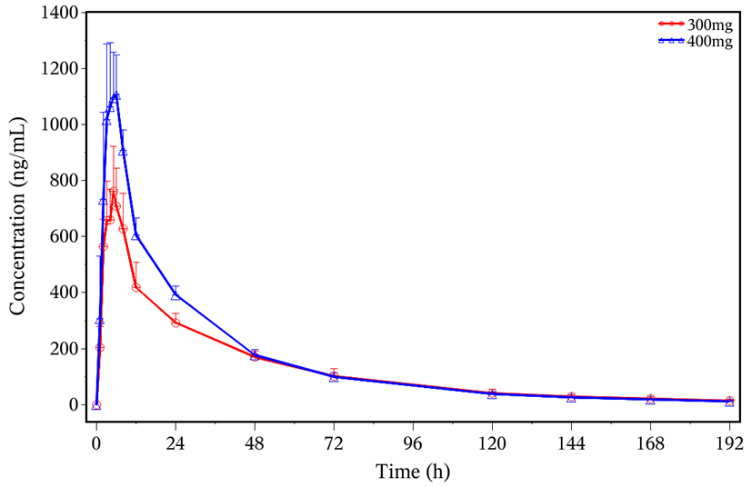

Figure S2 Goodness of fit plots for the final C-QTc model
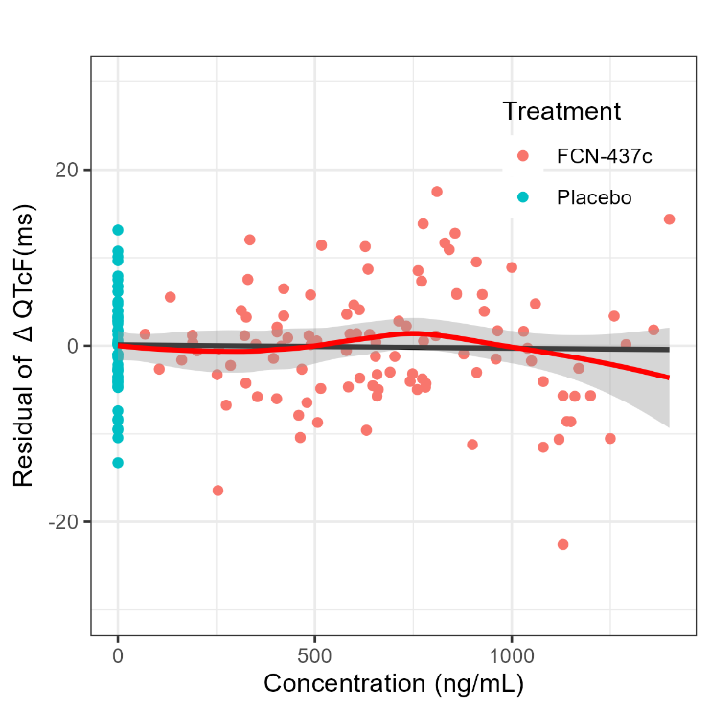 | 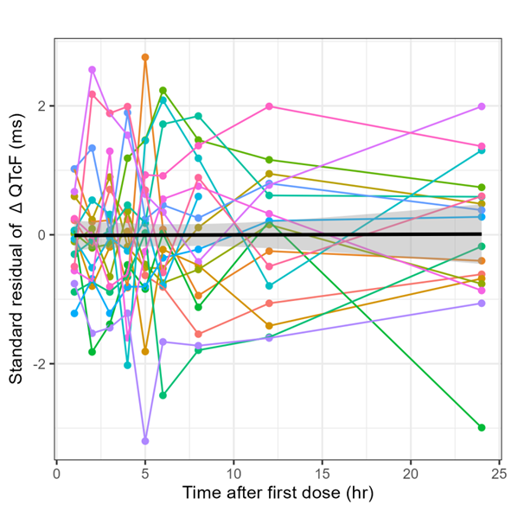
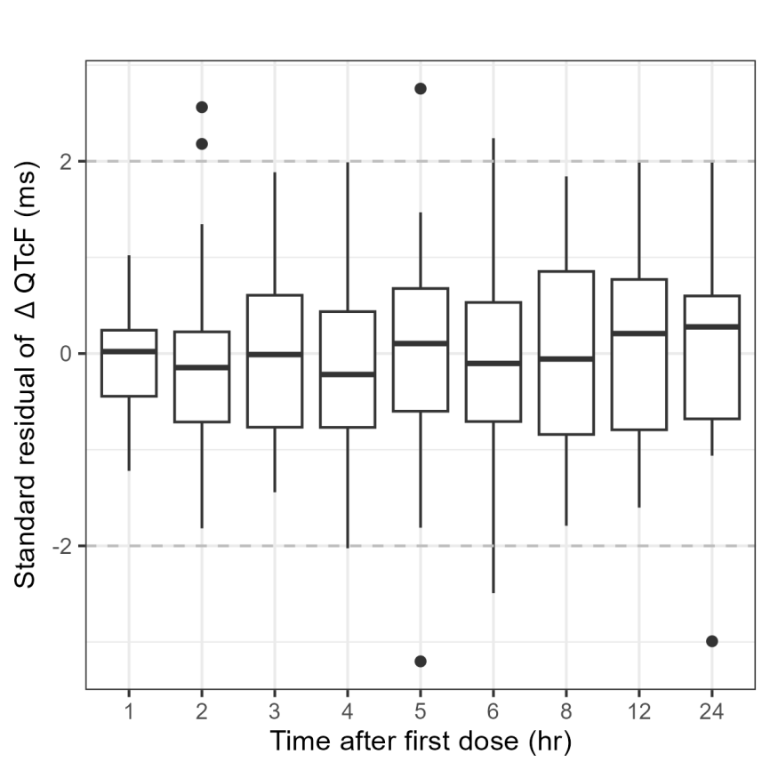 | 