Supplementary

TABLE S1 Annotations table of the 106 features identified as markers from the AMOPLS analysis performed on methanolic (MeOH) and dichloromethane (DCM) extracts of berry skins of Gamay Précoce, Mara, Gamaret and Galotta varieties at the four dates of samplings date analysed in positive (ESI+) ionisation mode by UHPLC-PDA-CAD-HRMS/MS. Features from cluster 1 (lipids) are identified with the GNPS cluster n°34, while features from cluster 4 (flavonoids) are identified with the GNPS cluster n°11. NPClassifier chemical classes are given in the pathway, superclass and class columns. s. node: is for feature identified as a single node.

ID | m/z | t_{R} (min) | Formula | Adduct | Pathway | Superclass | Class | Solvent | Marker in | GNPS cluster n°
5 | 120.0807 | 0.6 | C₈H₉N | [M + H]⁺ | Alkaloids | Tyrosine alkaloids | Isoquinoline alkaloids | DCM/MeOH | attractive | s. node
6 | 166.0862 | 0.6 | C₉H₁₁NO₂ | [M + H]⁺ | Amino acids and Peptides | Small peptides | Aminoacids | DCM/MeOH | attractive | s. node
63 | 487.0849 | 1.49 | C₂₁H₂₀O₁₂ | [M + Na]⁺ | Shikimates and Phenylpropanoids | Flavonoids | Flavonols | DCM/MeOH | attractive | s. node
79 | 287.0550 | 1.65 | C₁₅H₁₀O₆ | [M + H]⁺ | Shikimates and Phenylpropanoids | Flavonoids | Flavonols | DCM/MeOH | attractive | s. node
78 | 471.0899 | 1.65 | C₂₁H₂₀O₁₁ | [M + Na]⁺ | Shikimates and Phenylpropanoids | Flavonoids | Flavonols | DCM/MeOH | attractive | 11
80 | 449.1080 | 1.66 | C₂₁H₂₀O₁₁ | [M + H]⁺ | Shikimates and Phenylpropanoids | Flavonoids | Flavonols | DCM/MeOH | attractive | 11
74 | 501.1007 | 1.7 | C₂₂H₂₂O₁₂ | [M + Na]⁺ | Shikimates and Phenylpropanoids | Flavonoids | Flavonols | DCM/MeOH | attractive | 11
86 | 317.0655 | 1.7 | C₁₆H₁₂O₇ | [M + H]⁺ | Shikimates and Phenylpropanoids | Flavonoids | Flavonols | DCM/MeOH | attractive | 11
89 | 501.1007 | 1.7 | C₂₂H₂₂O₁₂ | [M + Na]⁺ | Shikimates and Phenylpropanoids | Flavonoids | Flavonols | DCM/MeOH | attractive | 11
88 | 479.1186 | 1.7 | C₂₂H₂₂O₁₂ | [M + H]⁺ | Shikimates and Phenylpropanoids | Flavonoids | Flavonols | DCM/MeOH | attractive | 11
28 | 420.1866 | 1.14 | NA | NA | NA | NA | NA | DCM/MeOH | attractive | 62
38 | 420.1866 | 1.14 | NA | NA | NA | NA | NA | DCM/MeOH | attractive | 62
493 | 291.2681 | 5.4 | C₂₀H₃₄O | [M + H]⁺ | Terpenoids | Diterpenoids | Labdane diterpenoids | DCM/MeOH | attractive | 216
621 | 291.2682 | 5.73 | C₂₀H₃₄O | [M + H]⁺ | Terpenoids | Diterpenoids | Labdane diterpenoids | DCM/MeOH | attractive | 216
173 | 225.1485 | 3.09 | C₁₃H₂₀O₃ | [M + H]⁺ | Terpenoids | Meroterpenoids | Prenyl quinone meroterpenoids | DCM | attractive | s. node
53 | 465.1026 | 1.48 | C₂₁H₂₀O₁₂ | [M + H]⁺ | Shikimates and Phenylpropanoids | Flavonoids | Flavonols | DCM | attractive | 11
1007 | 1013.2698 | 6.84 | C₄₈H₅₄N₄O₁₄S₂ | [M + K]⁺ | Amino acids and Peptides | Oligopeptides | Cyclic peptides | DCM | attractive | 32
1735 | 1326.2275 | 8.4 | C₅₆H₅₃N₁₅O₁₁S₆ | [M + Na]⁺ | Amino acids and Peptides | Oligopeptides | RiPPs Thiopeptides | DCM | attractive | 38
1750 | 1266.2609 | 8.41 | NA | NA | NA | NA | NA | DCM | attractive | 38
1781 | 1267.2618 | 8.4 | C₅₁H₅₄N₁₂O₁₉S₄ | [M + H]⁺ | Amino acids and Peptides | Oligopeptides | RiPPs Thiopeptides | DCM | attractive | 151
1013 | 984.2383 | 6.85 | C₄₂H₅₃N₃O₁₆S₄ | [M + H]⁺ | Amino acids and Peptides | Flavonoids | Polyene macrolides | DCM | attractive | 217
31 | 147.0441 | 1.05 | C₉H₆O₂ | [M + H]⁺ | Polyketides | Coumarins | Simple coumarins | DCM | unattractive | s. node
798 | 1074.2899 | 6.46 | C₅₀H₅₃N₉O₁₁S₃ | [M + Na]⁺ | Amino acids and Peptides | Oligopeptides | RiPPs Thiopeptides | DCM | unattractive | s. node
1416 | 1238.1769 | 7.63 | NA | NA | NA | NA | NA | DCM | unattractive | s. node
1431 | 833.2421 | 7.7 | NA | NA | NA | NA | NA | DCM | unattractive | s. node
1472 | 1072.3098 | 7.76 | NA | NA | NA | NA | NA | DCM | unattractive | s. node
1471 | 1238.1762 | 7.79 | NA | NA | NA | NA | NA | DCM | unattractive | s. node
1547 | 833.2418 | 7.93 | NA | NA | NA | NA | NA | DCM | unattractive | s. node
1785 | 712.2346 | 8.41 | C₃₀H₃₃N₉O₁₂ | [M + H]⁺ | Amino acids and Peptides | Oligopeptides | Tripeptides | DCM | unattractive | s. node
397 | 684.2031 | 4.93 | C₂₆H₃₇N₉O₇S₃ | [M + H]⁺ | Amino acids and Peptides | Oligopeptides | Polyamines | DCM | unattractive | 1
662 | 684.2034 | 6.03 | C₂₈H₃₇N₅O₁₁S₂ | [M + H]⁺ | Amino acids and Peptides | beta lactams | Polyamines | DCM | unattractive | 1
770 | 982.2609 | 6.3 | C₄₇H₄₇N₇O₁₁S₃ | [M + H]⁺ | Amino acids and Peptides | Oligopeptides | Cyclic peptides | DCM | unattractive | 1
792 | 684.2030 | 6.44 | C₂₈H₃₇N₅O₁₁S₂ | [M + H]⁺ | Amino acids and Peptides | Oligopeptides | Depsipeptides | DCM | unattractive | 1
1484 | 1027.1931 | 7.81 | NA | NA | NA | NA | NA | DCM | unattractive | 2
1524 | 1027.1938 | 7.92 | NA | NA | NA | NA | NA | DCM | unattractive | 2
26 | 309.0969 | 1.04 | C₁₅H₁₈O₈ | [M - H₂O + H]⁺ | Shikimates and Phenylpropanoids | Phenylpropanoids (C6-C3) | Cinnamic acids and derivatives | DCM | unattractive | 11
32 | 309.0969 | 1.05 | C₁₅H₁₈O₈ | [M - H₂O + H]⁺ | Shikimates and Phenylpropanoids | Phenylpropanoids (C6-C3) | Cinnamic acids and derivatives | DCM | unattractive | 11
879 | 1076.2884 | 6.63 | C₄₈H₆₀ClF₃N₅O₈PS₃ | [M + Na]⁺ | Alkaloids | Tryptophan alkaloids | Carboline alkaloids | DCM | unattractive | 16
888 | 1075.2892 | 6.66 | C₃₇H₅₈N₁₀O₁₉S₄ | [M + H]⁺ | Amino acids and Peptides | Oligopeptides | Cyclic peptides | DCM | unattractive | 16
1707 | 1058.2767 | 8.37 | NA | NA | NA | NA | NA | DCM | unattractive | 16
1778 | 1058.2773 | 8.4 | NA | NA | NA | NA | NA | DCM | unattractive | 16
1492 | 1026.1945 | 7.81 | NA | NA | NA | NA | NA | DCM | unattractive | 17
1523 | 1026.1943 | 7.89 | NA | NA | NA | NA | NA | DCM | unattractive | 17
36 | 349.0900 | 1.08 | C₁₅H₁₈O₈ | [M + Na]⁺ | Shikimates and Phenylpropanoids | Flavonoids | Minor lignans | DCM | unattractive | 22
1643 | 906.2602 | 8.16 | C₄₁H₅₁N₃O₁₄S₃ | [M + H]⁺ | Amino acids and Peptides | Flavonoids | Linear diarylheptanoids | DCM | unattractive | 31
1720 | 906.2606 | 8.41 | C₄₀H₄₃F₆N₅O₉S | [M + Na]⁺ | Amino acids and Peptides | Oligopeptides | Cyclic peptides | DCM | unattractive | 31
1393 | 1178.2098 | 7.58 | NA | NA | NA | NA | NA | DCM | unattractive | 36
1506 | 1028.1919 | 7.88 | NA | NA | NA | NA | NA | DCM | unattractive | 36
1705 | 1118.2424 | 8.4 | C₅₀H₅₇N₅O₁₃S₅ | [M + Na]⁺ | Amino acids and Peptides | Oligopeptides | Indole diketopiperazine alkaloids | DCM | unattractive | 36
449 | 684.2031 | 4.99 | C₂₄H₄₅NO₁₅S₃ | [M + H]⁺ | Amino acids and Peptides | Amino acid glycosides | Glucosinolates | DCM | unattractive | 38
1758 | 982.2641 | 8.39 | C₄₇H₄₇N₇O₁₁S₃ | [M + H]⁺ | Amino acids and Peptides | Oligopeptides | Cyclic peptides | DCM | unattractive | 46
1783 | 998.2972 | 8.39 | C₄₈H₅₉N₃O₁₂S₄ | [M + H]⁺ | Shikimates and Phenylpropanoids | Flavonoids | Glucosinolates | DCM | unattractive | 46
1776 | 685.2037 | 8.4 | C₂₉H₄₀N₄O₉S₃ | [M + H]⁺ | Amino acids and Peptides | Peptide alkaloids | Depsipeptides | DCM | unattractive | 99
1699 | 996.3121 | 8.38 | C₃₈H₅₉N₁₁O₁₂S₃ | [M + K]+ | Amino acids and Peptides | Oligopeptides | Cyclic peptides | DCM | unattractive | 140
1770 | 996.3121 | 8.4 | C₄₂H₅₇N₇O₁₅S₃ | [M + H]⁺ | Amino acids and Peptides | Oligopeptides | Cyclic peptides | DCM | unattractive | 140
1438 | 834.2396 | 7.72 | NA | NA | NA | NA | NA | DCM | unattractive | 176
1538 | 835.2389 | 7.92 | NA | NA | NA | NA | NA | DCM | unattractive | 176
1548 | 834.2391 | 7.93 | NA | NA | NA | NA | NA | DCM | unattractive | 176
7 | 328.1390 | 0.62 | C₁₅H₂₁NO₇ | [M + H]⁺ | Amino acids and Peptides | Small peptides | Dipeptides | MeOH | attractive | s. node
49 | 487.0849 | 1.43 | C₂₁H₂₀O₁₂ | [M + Na]⁺ | Shikimates and Phenylpropanoids | Flavonoids | Flavonols | MeOH | attractive | s. node
61 | 303.0499 | 1.49 | C₁₅H₁₀O₇ | [M + H]⁺ | Shikimates and Phenylpropanoids | Flavonoids | Flavonols | MeOH | attractive | s. node
67 | 451.1234 | 1.55 | C₂₁H₂₂O₁₁ | [M + H]⁺ | Shikimates and Phenylpropanoids | Flavonoids | Dihydroflavonols | MeOH | attractive | s. node
82 | 303.0506 | 1.62 | C₁₅H₁₀O₇ | [M + H]⁺ | Shikimates and Phenylpropanoids | Flavonoids | Flavonols | MeOH | attractive | s. node
159 | 227.1252 | 2.65 | NA | NA | NA | NA | NA | MeOH | attractive | s. node
310 | 694.4006 | 4.18 | C₃₃H₅₉NO₁₄ | [M + H]⁺ | Fatty acids | Glycerolipids | Glycosylmonoacylglycerols | MeOH | attractive | s. node
354 | 281.1724 | 4.71 | NA | NA | NA | NA | NA | MeOH | attractive | s. node
902 | 814.5602 | 6.67 | C₄₄H₈₀NO₁₀P | [M + H]⁺ | Fatty acids | Glycerophospholipids | Oxidized glycerophospholipids | MeOH | attractive | s. node
62 | 465.1027 | 1.49 | C₂₁H₂₀O₁₂ | [M + H]⁺ | Shikimates and Phenylpropanoids | Flavonoids | Flavonols | MeOH | attractive | 11
227 | 455.3517 | 3.65 | C₃₀H₄₆O₃ | [M + H]⁺ | Terpenoids | Triterpenoids | Oleanane triterpenoids | MeOH | attractive | 34
355 | 259.1904 | 4.71 | C₁₄H₂₆O₄ | [M + H]⁺ | Fatty acids | Fatty esters | Wax monoesters | MeOH | attractive | 88
343 | 520.3395 | 4.56 | C₂₆H₅₀NO₇P | [M + H]⁺ | Fatty acids | Glycerophospholipids | Glycerophosphocholines | MeOH | attractive | 121
340 | 478.2928 | 4.54 | C₂₃H₄₄NO₇P | [M + H]⁺ | Fatty acids | Glycerophospholipids | Glycerophosphoethanolamines | MeOH | attractive | 159
705 | 986.6031 | 6.13 | C₄₅H₈₃N₁₁O₁₁S | [M + H]⁺ | Fatty acids | Glycerolipids | Diacylglycerols | MeOH | attractive | 160
837 | 824.5525 | 6.51 | C₄₅H₇₇NO₁₂ | [M + H]⁺ | Fatty acids | Macrolides | Glycerophosphoserines | MeOH | attractive | 160
15 | 465.1017 | 0.82 | NA | NA | NA | NA | NA | MeOH | unattractive | s. node
16 | 465.1017 | 0.83 | NA | NA | NA | NA | NA | MeOH | unattractive | s. node
20 | 449.1080 | 0.95 | NA | NA | NA | NA | NA | MeOH | unattractive | s. node
21 | 479.1185 | 0.99 | C₂₂H₂₂O₁₂ | [M + H]⁺ | Shikimates and Phenylpropanoids | Flavonoids | Flavonols | MeOH | unattractive | s. node
30 | 463.1235 | 1.11 | C₂₂H₂₂O₁₁ | [M + H]⁺ | Shikimates and Phenylpropanoids | Flavonoids | Anthocyanidins | MeOH | unattractive | s. node
42 | 507.1132 | 1.21 | NA | NA | NA | NA | NA | MeOH | unattractive | s. node
47 | 491.1185 | 1.34 | NA | NA | NA | NA | NA | MeOH | unattractive | s. node
48 | 521.1289 | 1.36 | C₂₄H₂₄O₁₃ | [M + H]⁺ | Shikimates and Phenylpropanoids | Flavonoids | Flavonols | MeOH | unattractive | s. node
58 | 505.1343 | 1.49 | C₂₄H₂₄O₁₂ | [M + H]⁺ | Shikimates and Phenylpropanoids | Flavonoids | Flavones | MeOH | unattractive | s. node
60 | 535.1445 | 1.49 | C₂₅H₂₆O₁₃ | [M + H]⁺ | Shikimates and Phenylpropanoids | Flavonoids | Flavones | MeOH | unattractive | s. node
65 | 611.1387 | 1.54 | C₃₀H₂₆O₁₄ | [M + H]⁺ | Shikimates and Phenylpropanoids | Flavonoids | Flavonols | MeOH | unattractive | s. node
76 | 595.1438 | 1.65 | NA | NA | NA | NA | NA | MeOH | unattractive | s. node
81 | 625.1554 | 1.66 | C₃₁H₂₈O₁₄ | [M + H]⁺ | Shikimates and Phenylpropanoids | Flavonoids | Flavonols | MeOH | unattractive | s. node
95 | 679.1640 | 1.79 | C₃₂H₃₂O₁₅ | [M + Na]⁺ | Shikimates and Phenylpropanoids | Flavonoids | Flavones | MeOH | unattractive | s. node
172 | 274.2529 | 3.07 | C₁₉H₃₁N | [M + H]⁺ | Alkaloids | Lysine alkaloids | Piperidine alkaloids | MeOH | unattractive | s. node
306 | 318.3004 | 4.04 | C₁₈H₃₉NO₃ | [M + H]⁺ | Fatty acids | Sphingolipids | Sphingoid bases | MeOH | unattractive | s. node
789 | 607.4189 | 6.33 | C₃₃H₆₀O₈ | [M + Na]⁺ | Fatty acids | Glycerolipids | Diacylglycerols | MeOH | unattractive | s. node
789 | 607.4189 | 6.33 | C₃₃H₆₀O₈ | [M + Na]⁺ | Fatty acids | Glycerolipids | Diacylglycerols | MeOH | unattractive | s. node
909 | 595.4186 | 6.67 | C₃₂H₆₀O₈ | [M + Na]⁺ | Fatty acids | Glycerolipids | Triacylglycerols | MeOH | unattractive | s. node
1298 | 714.5520 | 7.37 | NA | NA | NA | NA | NA | MeOH | unattractive | s. node
1450 | 626.1761 | 7.7 | NA | NA | NA | NA | NA | MeOH | unattractive | 1
10 | 639.1696 | 0.73 | C₃₂H₃₂O₁₅ | [M – H₂O + H]⁺ | Shikimates and Phenylpropanoids | Flavonoids | Dihydroflavonols | MeOH | unattractive | 11
35 | 493.1338 | 1.13 | C₂₃H₂₆O₁₃ | [M – H₂O + H]⁺ | Shikimates and Phenylpropanoids | Flavonoids | Dihydroflavonols | MeOH | unattractive | 11
71 | 655.1660 | 1.62 | C₃₂H₃₀O₁₅ | [M – H₂O + H]⁺ | Shikimates and Phenylpropanoids | Flavonoids | Dihydroflavonols | MeOH | unattractive | 11
97 | 639.1706 | 1.79 | C₃₂H₃₂O₁₅ | [M – H₂O + H]⁺ | Shikimates and Phenylpropanoids | Flavonoids | Dihydroflavonols | MeOH | unattractive | 11
196 | 309.1114 | 3.33 | C₁₉H₁₆O₄ | [M + H]⁺ | Shikimates and Phenylpropanoids | Diarylheptanoids | Linear diarylheptanoids | MeOH | unattractive | 14
59 | 553.1549 | 1.49 | C₂₅H₂₈O₁₄ | [M + H]⁺ | Shikimates and Phenylpropanoids | Isoflavonoids | Simple coumarins | MeOH | unattractive | 22
1357 | 431.3519 | 7.54 | NA | NA | NA | NA | NA | MeOH | unattractive | 30
356 | 425.3773 | 4.73 | C₃₀H₄₈O | [M + H]⁺ | Terpenoids | Triterpenoids | Friedelane triterpenoids | MeOH | unattractive | 34
867 | 441.3727 | 6.57 | C₃₀H₄₈O₂ | [M + H]⁺ | Terpenoids | Triterpenoids | Oleanane triterpenoids | MeOH | unattractive | 34
867 | 441.3727 | 6.57 | C₃₀H₄₈O₂ | [M + H]⁺ | Terpenoids | Triterpenoids | Oleanane triterpenoids | MeOH | unattractive | 34
1737 | 1328.2268 | 8.4 | C₄₅H₆₃N₉O₂₄S₆ | [M + Na]⁺ | Amino acids and Peptides | Oligopeptides | RiPPs Thiopeptides | MeOH | unattractive | 146

FIGURE S1 Geographical maps of the grapevine cultivar collection of Agroscope in Pully next to Lausanne (Switzerland) (A) map showing the situation of the Agroscope vineyard in Pully, (B) aerial view on the Agroscope vineyard in Pully indicating the situation of the grapevine cultivar collection and (C) delineation of the situation of the studied grape cultivars within the grapevine collection. The scale in meters is indicated in the bottom of each map.

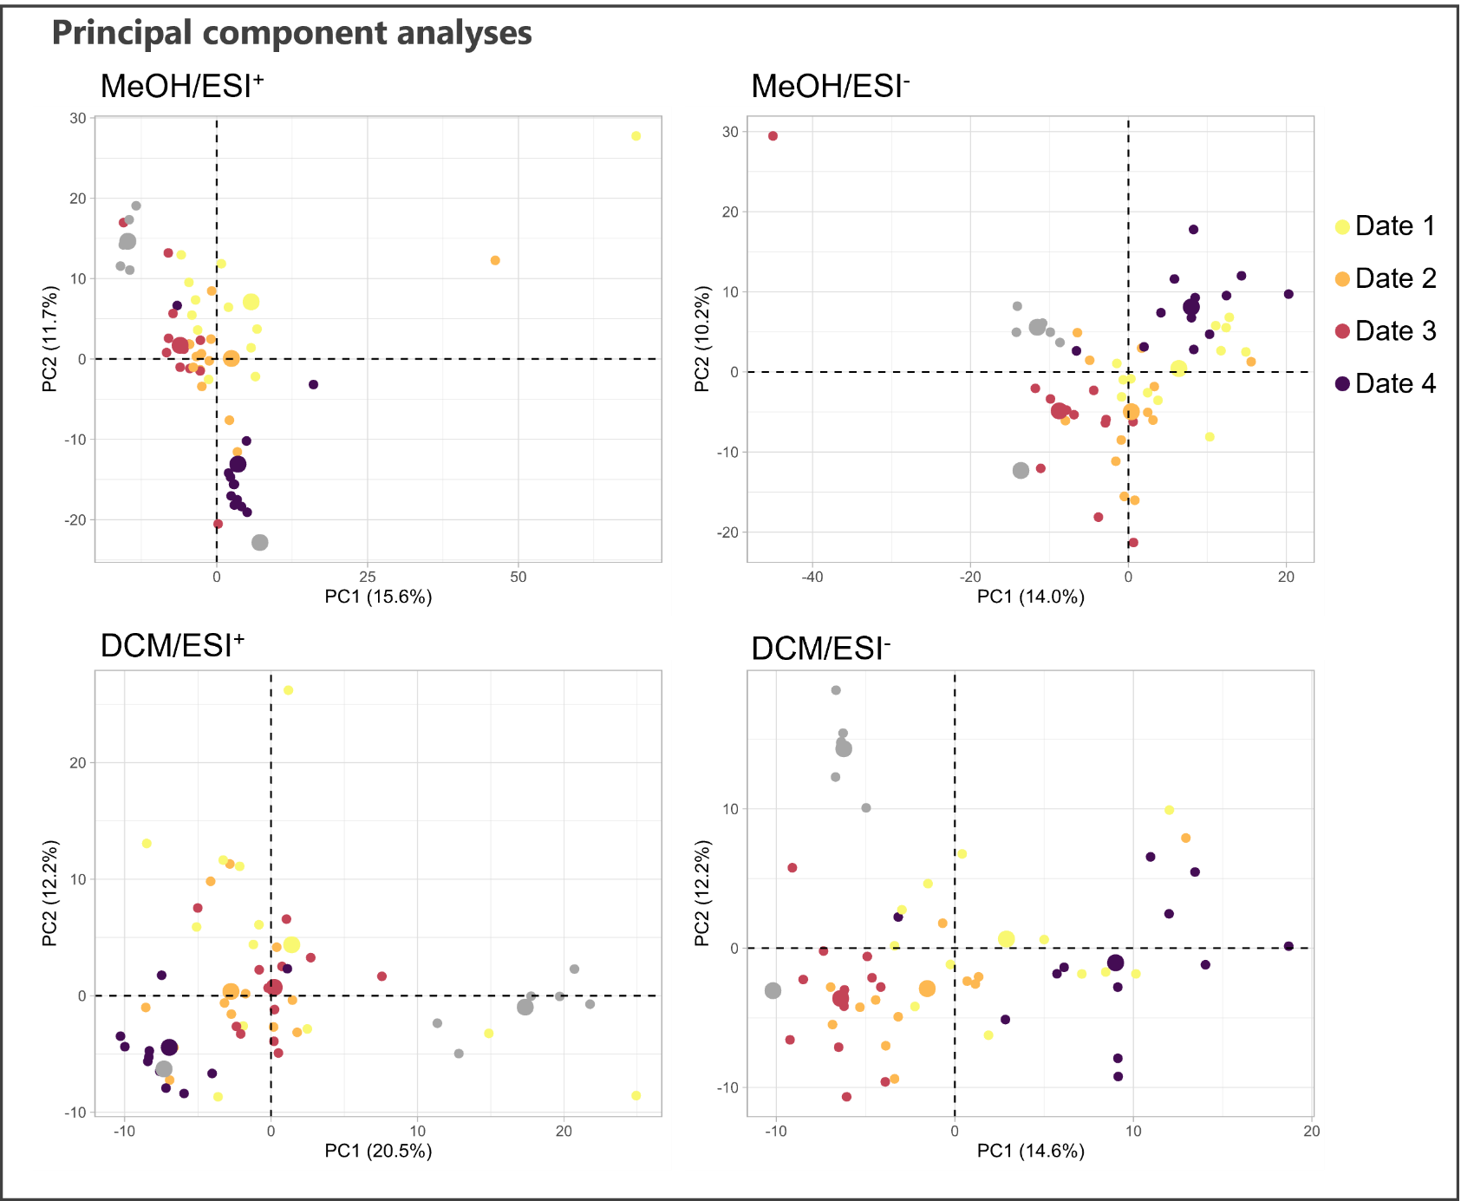
FIGURE S2 Principal component analysis (PCA) of methanolic (MeOH) and dichloromethane (DCM) extracts of berry skins of Gamay Précoce, Mara, Gamaret and Galotta varieties at the four dates of samplings date 1 (yellow), date 2 (orange), date 3 (red) and date 4 (purple) analysed in positive (ESI+) and negative (ESI-) ionisation mode by UHPLC-PDA-CAD-HRMS/MS.

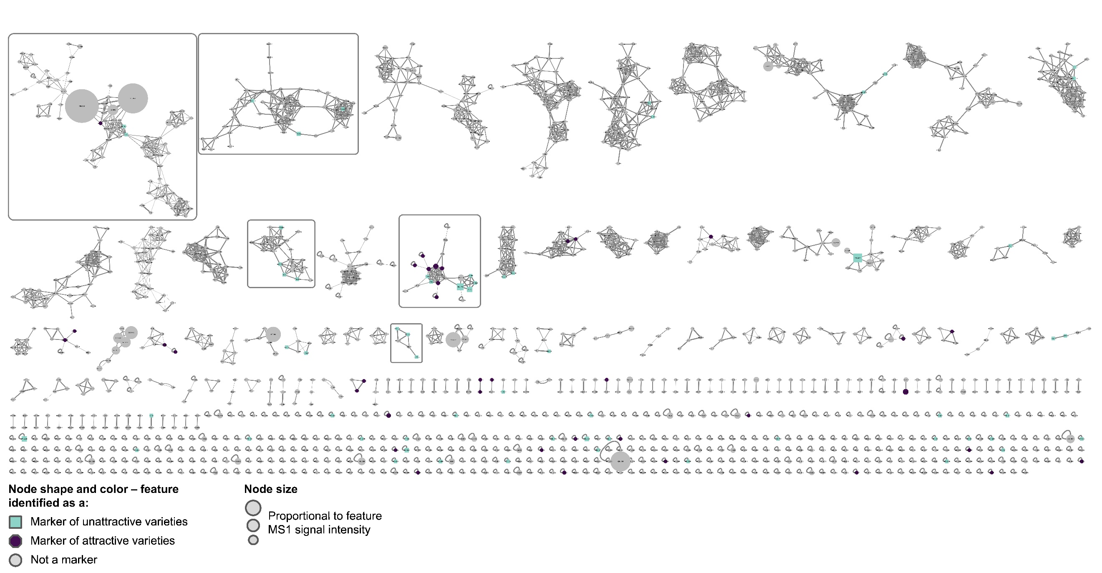
FIGURE S3 Ion identity molecular network of the 1’155 features detected in methanolic (MeOH) and dichloromethane (DCM) extracts of berry skins of Gamay Précoce, Mara, Gamaret and Galotta varieties at the four dates of samplings date analysed in positive (ESI+) ionisation mode by UHPLC-PDA-CAD-HRMS/MS. Coloured nodes correspond to markers identified by AMOPLS analyses as overabundant in attractive varieties (purple) and unattractive varieties (green). The five clusters harbouring at least 3 markers are framed in gray.
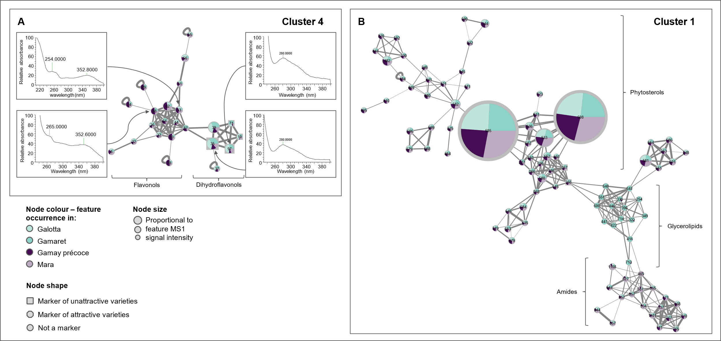
FIGURE S4 (A) Zoom over cluster 4 displaying features annotated as flavonoids and derivatives based on their exact mass, mass spectra (MS2) and UV spectra as displayed on the figure. Flavonols exhibit a specific absorption band (band I) around 350 nm while dihydroflavonols do not absorb in this wavelength spectrum. (B) Zoom over cluster 1 features, annotated as phytosterols, glycerolipids and amides. The two clusters belong to the ion identity molecular network (IIMN) of features detected in methanolic and dichloromethane grape skins extracts from the four grape varieties Galotta, Gamaret, Gamay précoce and Mara at the four sampling dates and analysed by UHPLC-PDA-CAD-HRMS/MS in positive ionisation mode (ESI+). Node size account for combined MS intensities of each feature at the four sampling dates for the four grape varieties. Pie charts within each node indicate the distribution of combined MS intensities of each feature at the four sampling dates for the four grape varieties. Node shape indicates whether the feature is a marker of attractive varieties (octagon), unattractive varieties (square), or not identified as a marker (circle) according to the AMOPLS analyses.

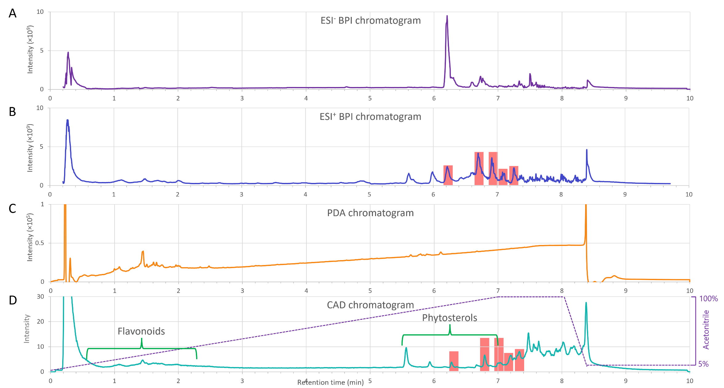
FIGURE S5 (A) Base peak chromatograms in negative and (B) positive ionisation mode, (C) photodiode array detector chromatogram and (D) charged aerosol detector chromatogram of a mix of extracts from grape skin varieties and date of sampling used as quality control mixture. Red squares indicate contaminants.
FIGURE S6 Histograms of feature peak area from cluster 4 (flavonoids) detected in the four grape varieties Galotta, Gamaret, Gamay précoce and Mara at the four sampling dates in methanolic grape skin extracts analysed by UHPLC-PDA-CAD-HRMS/MS. For each grape variety, histograms are chronologically ordered according to the sampling date, from left to right corresponding to sampling date 1 to 4.
FIGURE S7 NPClassifier chemical pathway distribution of markers identified as single nodes in the molecular network. The most represented pathway is the shikimate and phenylpropanoids pathway to which flavonoids belong.

