1. Have you ever observed a Hulong hybrid grouper in the wild (see the image below)?

Yes ( ) No ( )

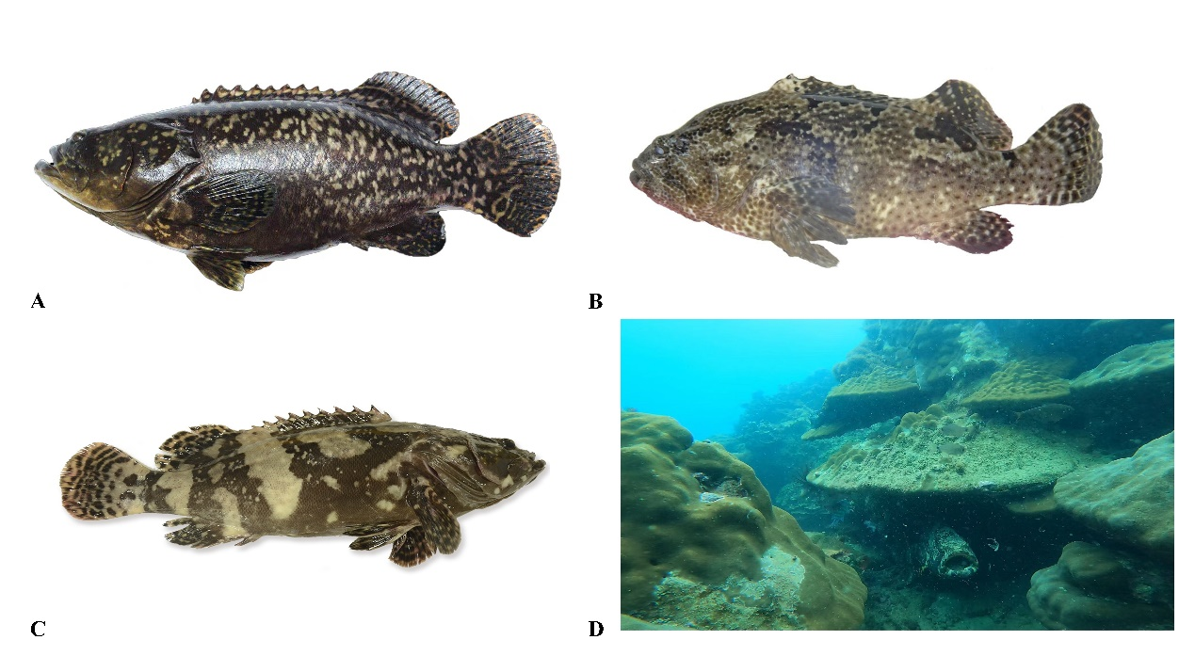

2. In which year did you first capture a Hulong hybrid grouper in the wild?

( )

3. In which sea area did you first capture a Hulong hybrid grouper?

( )

4. By what method did you capture a Hulong hybrid grouper?

Hand fishing ( ) Spearfishing ( ) Various nets ( )

5. In which other locations have you captured a Hulong hybrid grouper to date?

( )

6. What was the smallest weight of a Hulong hybrid grouper you captured in the wild?

( )

7. What was the largest weight of a Hulong hybrid grouper you captured in the wild?

( )

8. In what weight range are most of the Hulong hybrid groupers you captured in the wild?

0-2500g ( ) 2500-5000g ( ) 5000-7500g ( ) 7500-10000g ( ) >10000g ( )

9. In what type of seabed did you capture the Hulong hybrid grouper?

Rocky reef ( ) Coral reef ( ) Nearshore structures (breakwater, seawall, or pier) ( ) Muddy sand ( )

10. At what depth did you capture the Hulong hybrid grouper?

( )

11. In which season did you capture the Hulong hybrid grouper?

( )

12. Have you ever observed a Hulong hybrid grouper feeding?

( )

13. Describe the prey you observed being eaten by the Hulong hybrid grouper:

Fish ( ) Cephalopods ( ) Shrimp/crabs ( ) Others ( )