

Figure S1 : R2 of the mixed linear models for all varieties clustered from week 2 to 8 after mid-veraison.



Figure S2 : Distribution of the R2 of the mixed linear models for each variety considered separately, from week 2 to 8 after mid-veraison.



Figure S3 : The rate of malic acid degradation, expressed as alpha_log_mal, as a function of berry malic acid content at mid-veraison, expressed in μmol/berry.

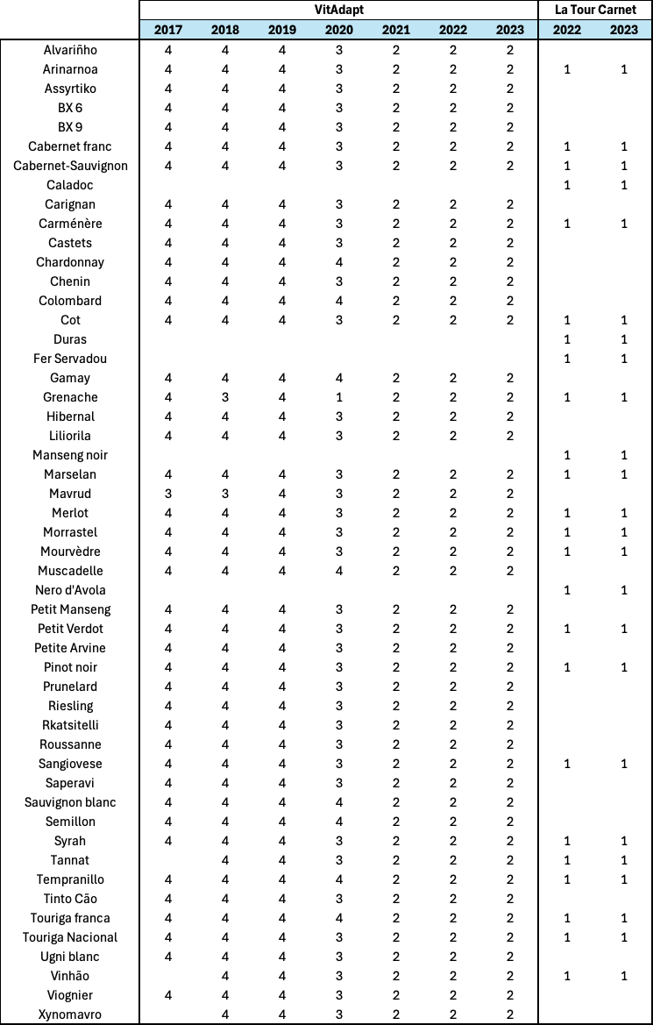

Table S1 : Varieties and their number of replicates for each vintage and each location.