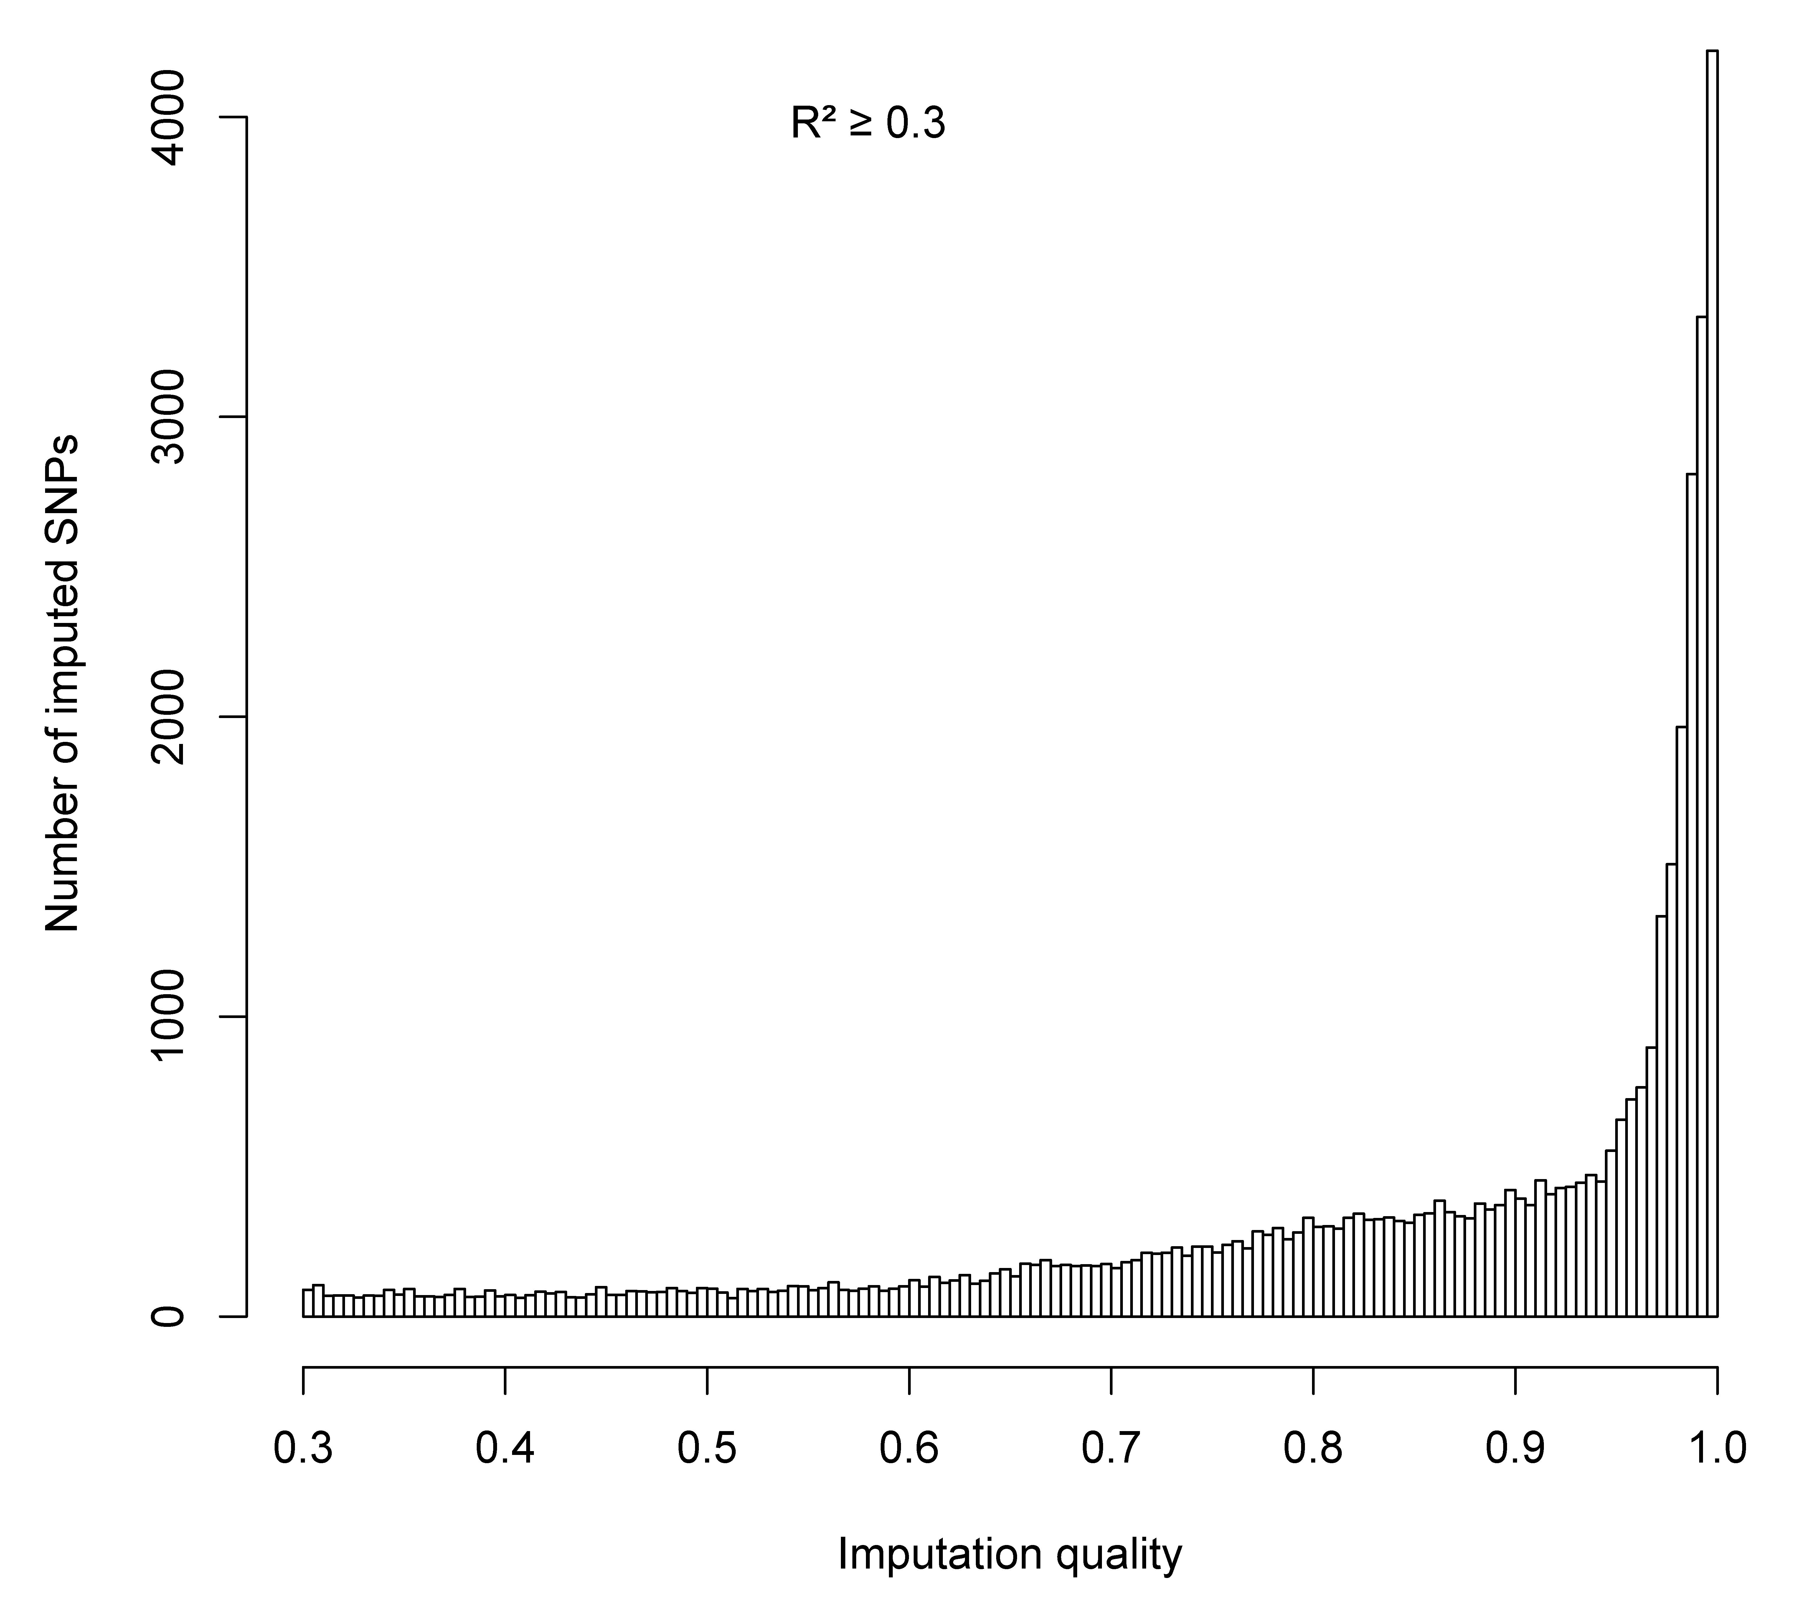
Supplementary Figure 1: The distribution of the imputation information score of the present study.

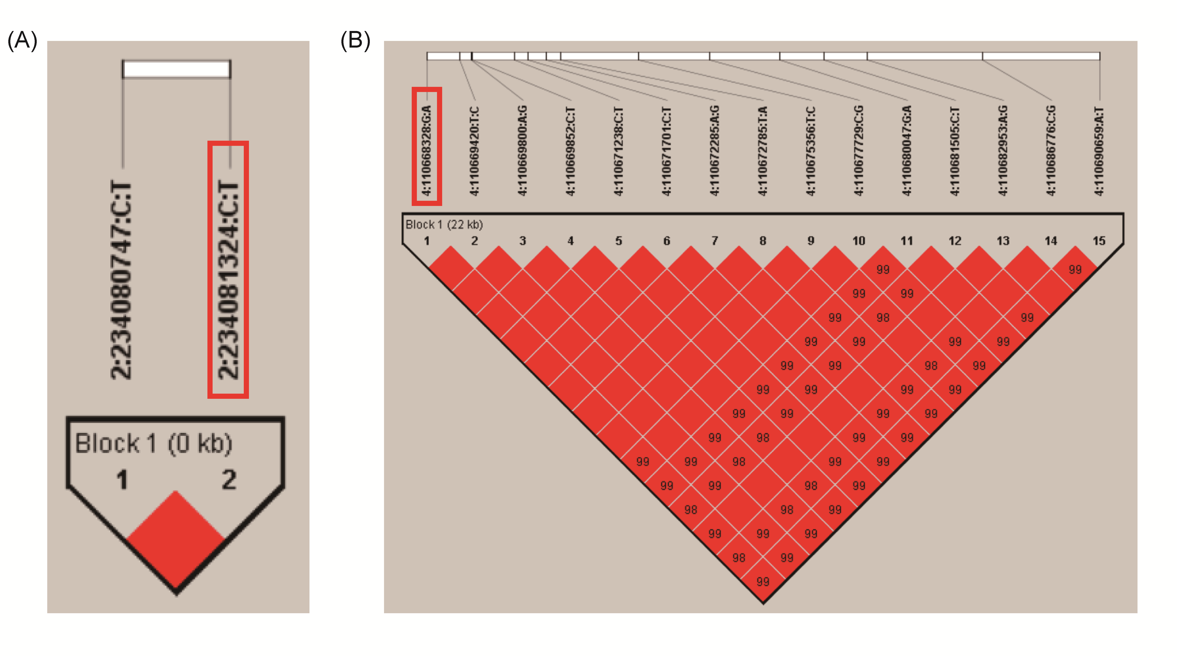
Supplementary Figure 2: Linkage disequilibrium (LD) analysis for 17 significant SNPs located in two genes. (A) two SNPs in INPP5D, (B) 15 SNPs in CFI.
Abbreviations: SNPs, single nucleotide polymorphism.

Supplementary Figure 3. Manhattan plot in the PLCO trial and HLCS study. (A) Manhattan plot for 10,776 SNPs of immunity B cell-related genes in the PLCO trial. (B) Manhattan plot for 369 SNPs of immunity B cell-related genes in the HLCS study. The blue horizontal line indicates P = 0.05 and the red line indicates BFDP = 0.80.

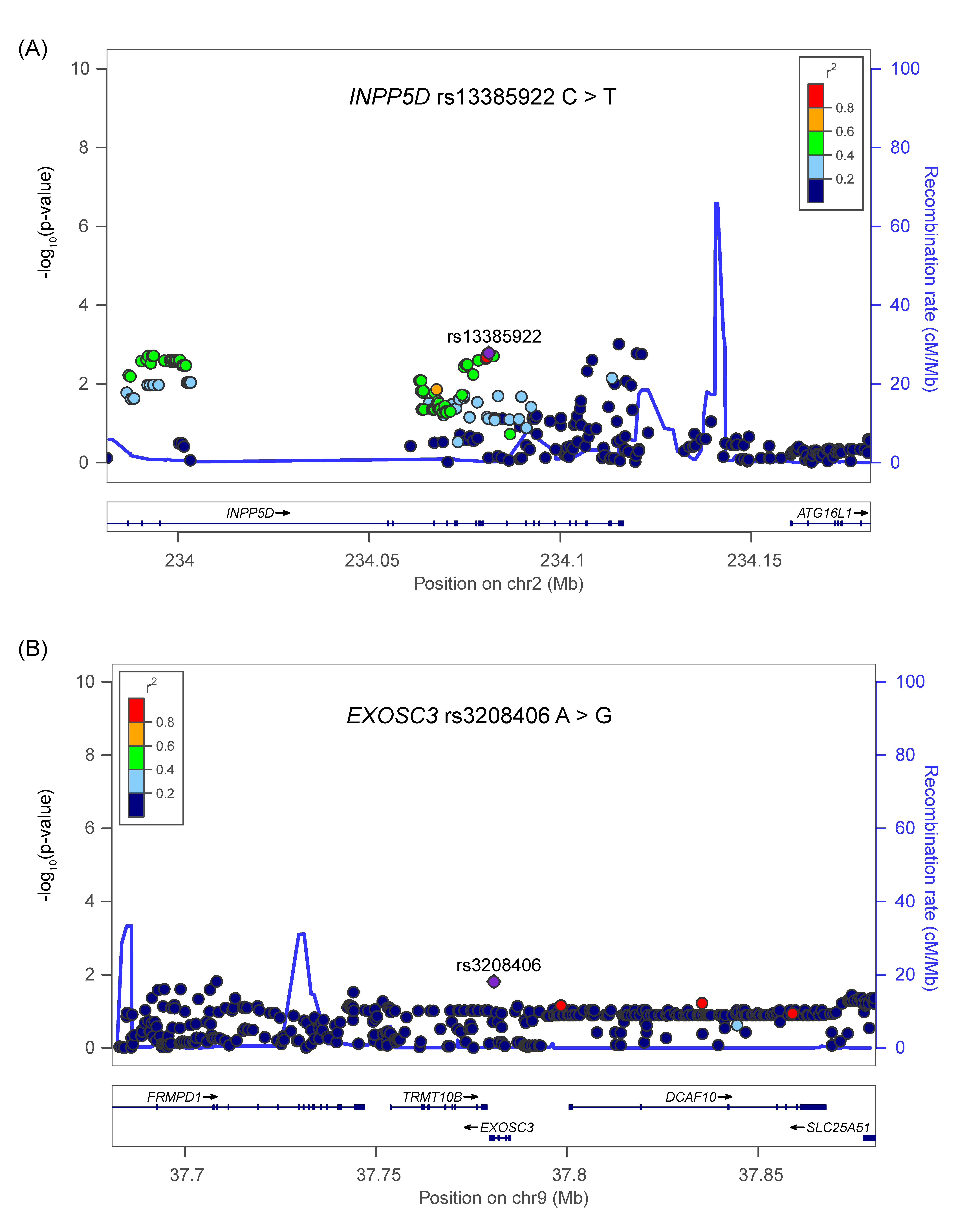
Supplementary Figure 4. Regional association plots for the two independent SNPs in the immunity B cell-related genes.
Regional association plots included 100kb up or downstream of (A) INPP5D and (B) EXOSC3. Data points are colored according to the level of linkage disequilibrium of each pair of SNPs based on the hg19/1000 Genomes European population. The left-hand y-axis shows the association P-value of individual SNPs in the discovery dataset, which is plotted as -log10 (P) against chromosomal base-pair position. The right-hand y-axis shows the recombination rate estimated from HapMap Data Rel 22/phase II European population.
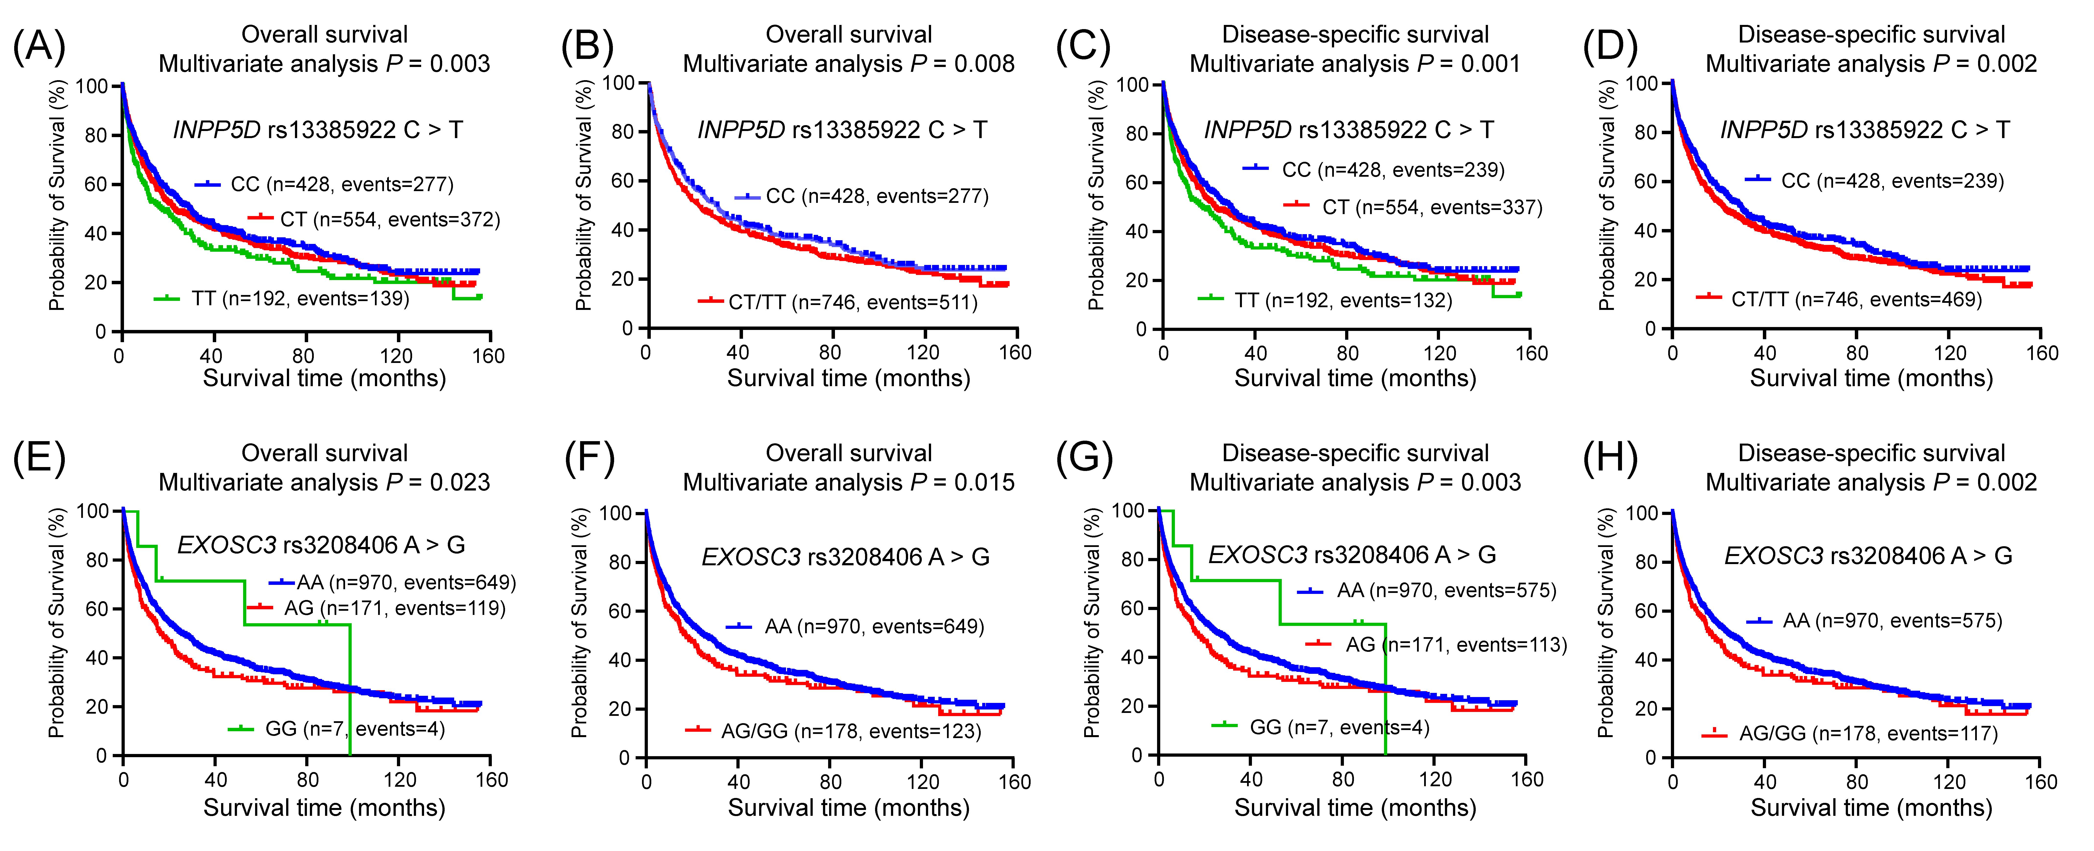
Supplementary Figure 5. Prediction of OS and DSS survival with genotypes of INPP5D rs13385922 and EXOSC3 rs3208406 in the PLCO dataset. Kaplan–Meier survival curves of INPP5D rs13385922 for OS with (A) additive model, (B) dominant model; for DSS with (C) additive model, (D) dominant model; EXOSC3 rs3208406 for OS with (E) additive model; (F) dominant model; for DSS with (G) additive model; (H) dominant model.
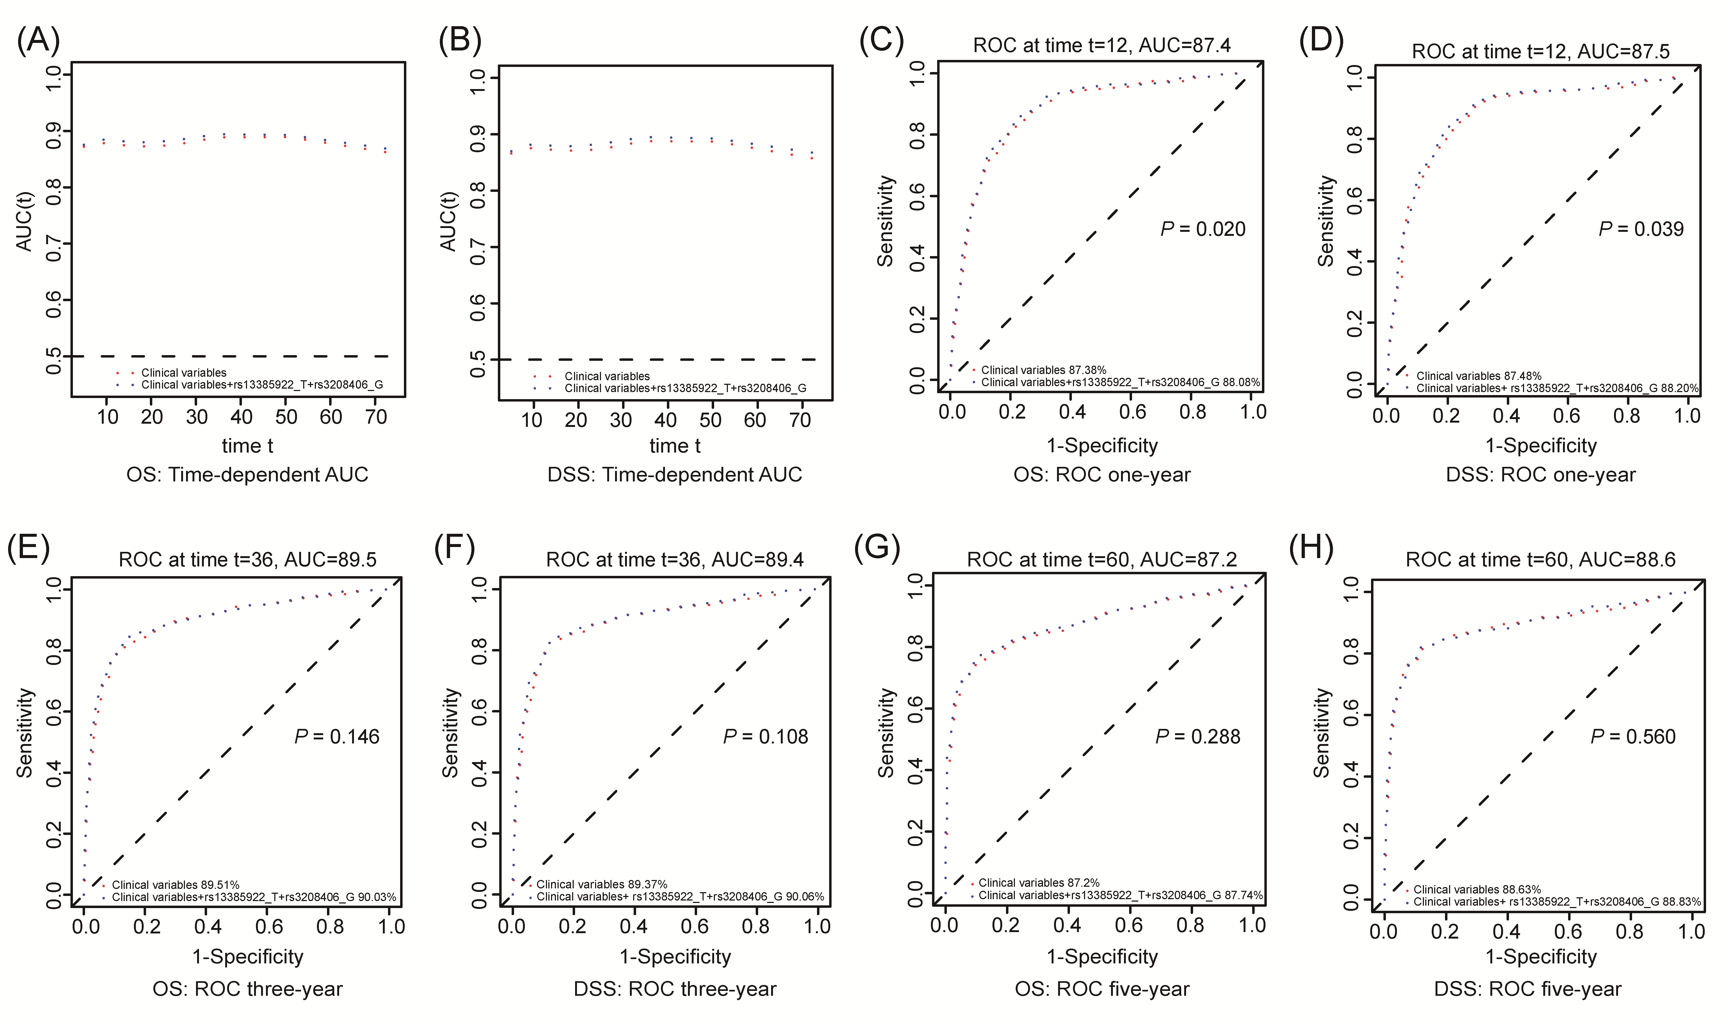
Supplementary Figure 6. NSCLC survival prediction with two SNPs by AUC and ROC curve at the 12th, 36th, and 60th month. Time-dependent AUC analysis of (A) OS and B) DSS based on age, sex, smoking condition, histology, tumor stage, chemotherapy, surgery, principal component, and the two SNPs; The ROC curve evaluation for (C) OS and (D) DSS at 12th month, (E) OS and (F) DSS at 36th month, (G) OS and (H) DSS at 60th month.

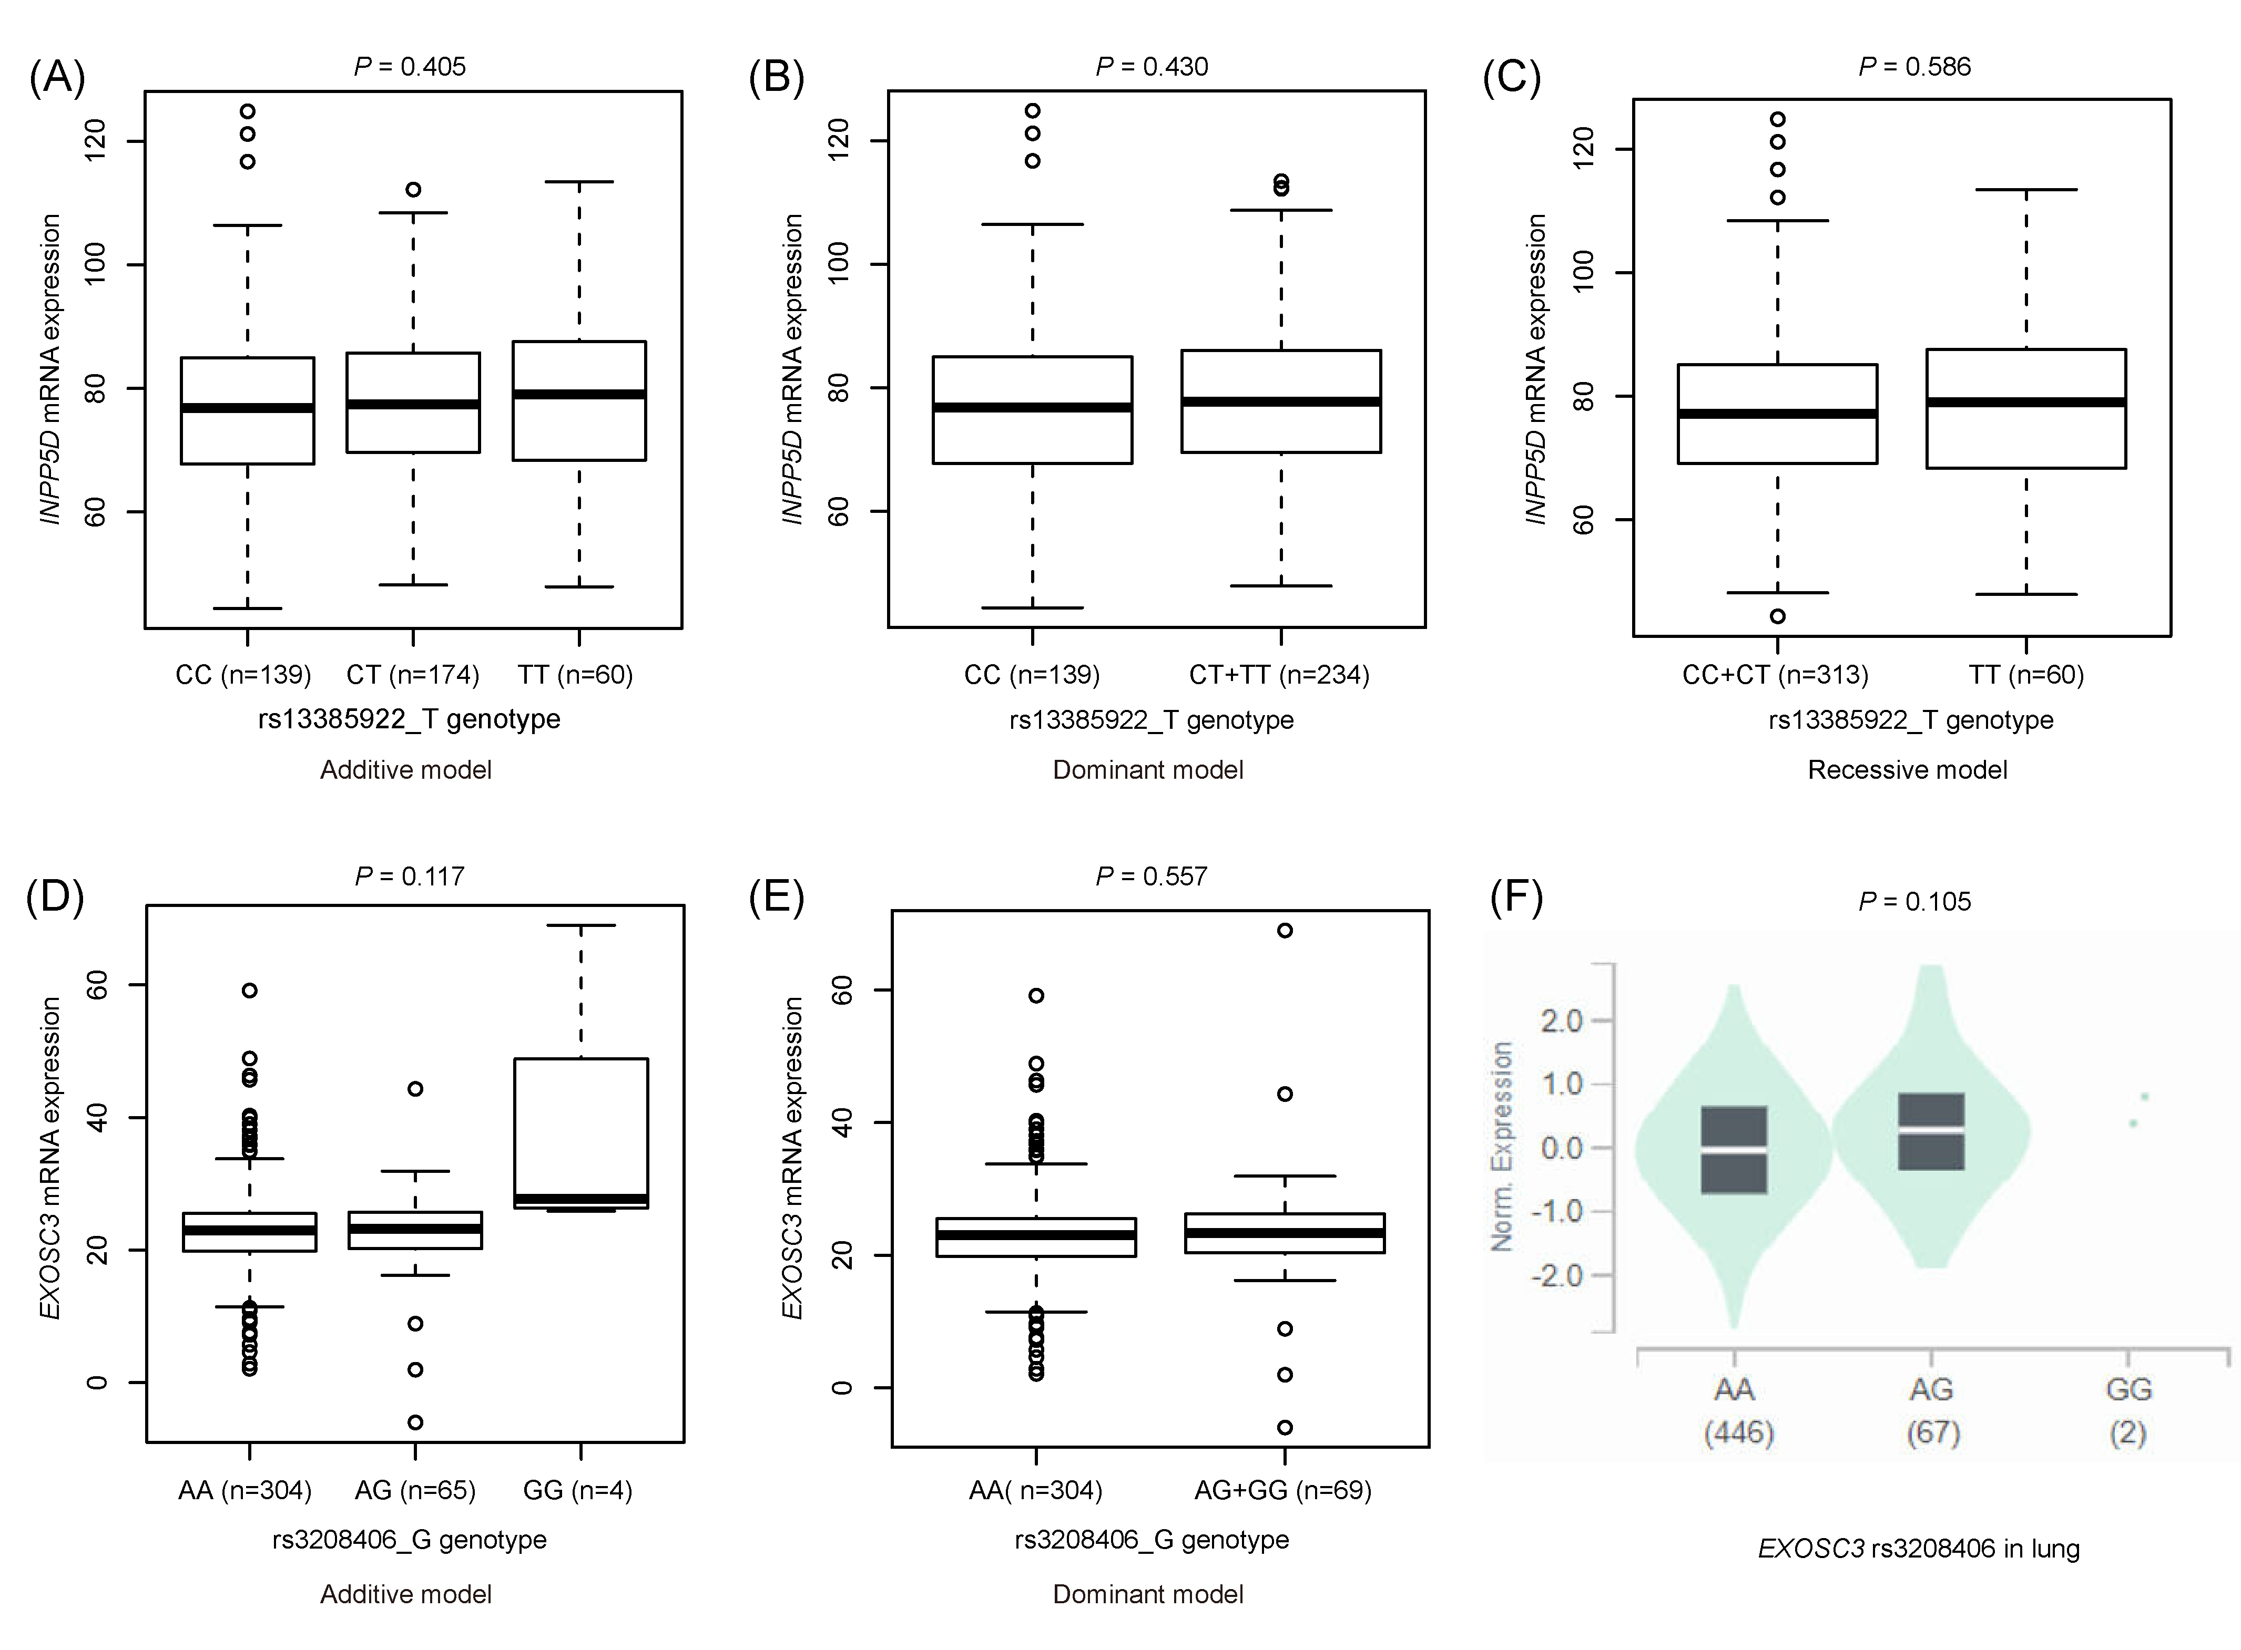
Supplementary Figure 7. Correlation between two genotypes and their corresponding mRNA expression levels.
The eQTL from 1000 Genomes project for INPP5D rs13385922 in (A) additive model, (B) dominant model, and (C) recessive model; for EXOSC3 rs3208406 in (D) additive model and (E) dominant model; The eQTL from GTEx project for EXOSC3 rs3208406 in (F) normal lung tissue.
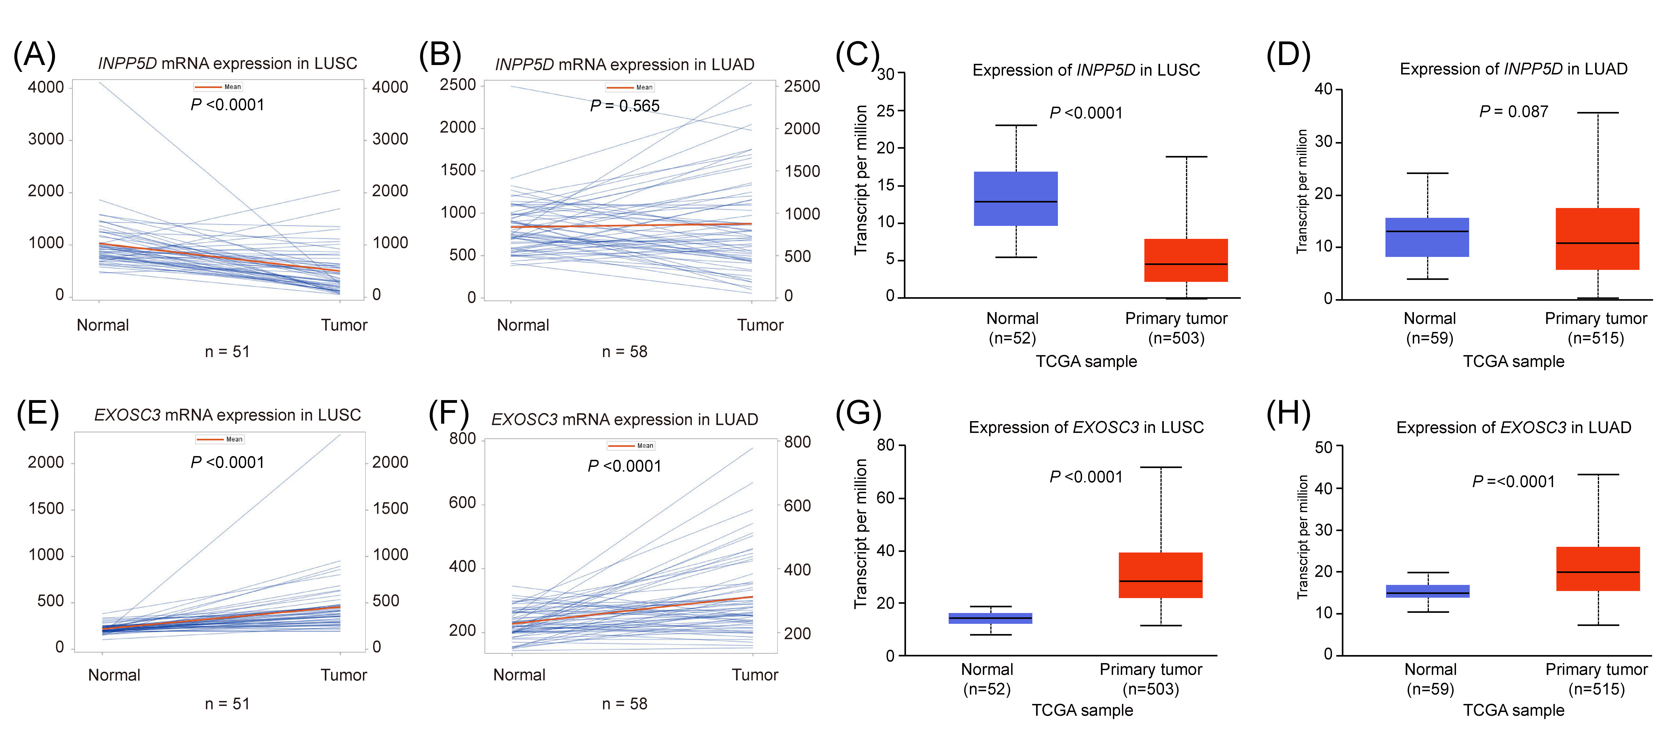
Supplementary Figure 8. Paired and non-paired mRNA expression analysis of INPP5D and EXOSC3 in the TCGA database.
Both paired and non-paired analysis suggested that INPP5D mRNA expression level was significantly down-regulated in LUSC, but not in LUAD (A-D); EXOSC3 mRNA expression level was up-regulated in LUSC and LUAD (E-H).

