Supplementary Table 1 - List of excluded studies and reasons for exclusion. (n=14)

Study title | Author | Reason for exclusion | Year
Improved survival of young adults with cancer following the passage of the affordable care act. | Roth(1) | Did not assess survival outcomes | 2022
Patterns of cancer care and association with survival among younger adolescents and young adults: A population-based retrospective cohort study. | Collins(2) | Did not assess survival outcomes | 2021
Residence in a Hispanic enclave is associated with inferior overall survival among children with acute lymphoblastic leukemia. | Schraw(3) | Did not assess survival outcomes | 2021
Disparities in cancer survival among adolescents and young adults: A population-based study of 88 000 patients. | Murphy(4) | Did not assess survival outcomes | 2021
A U.S. population-based study of insurance disparities in cancer survival among adolescents and young adults. | Colton(5) | Did not assess survival outcomes | 2019
Survival among children diagnosed with acute lymphoblastic leukemia in the United States, by race and age, 2001 to 2009: Findings from the CONCORD-2 study. | Tai(6) | Did not assess survival outcomes | 2018
Effects of socioeconomic status on children with well-differentiated thyroid cancer. | Garner(7) | Did not assess survival outcomes | 2017
Socioeconomic Factors Impact Inpatient Mortality in Pediatric Lymphoma Patients | Puckett(8) | Did not assess survival outcomes | 2016
An examination of parenting capacity variables and child adjustment outcomes across socioeconomic level in pediatric cancer. | Ryan(9) | Did not assess survival outcomes | 2013
Association between insurance and socioeconomic status and risk of advanced stage Hodgkin lymphoma in adolescents and young adults. | Smith(10) | Did not assess survival outcomes | 2012
Magnetic field exposure and long-term survival among children with leukemia. | Foliart(11) | Did not assess survival outcomes | 2006
Health disparities among Tennessee pediatric renal tumor patients. | Neuzil(12) | Exploring the correlation between cancer and race. | 2020
Does socioeconomic status account for racial and ethnic disparities in childhood cancer survival? | Kehm(13) | Exploring the correlation between cancer and race. | 2018
Geographic access to cancer care and mortality among adolescents. | Tai(14) | Exploring the correlation between cancer and geographic location. | 2018
Insurance Status and Risk of Cancer Mortality Among  Adolescents and Young Adults | Rosenberg(15) | Study was not stratified according to cancer type | 2014

References:

1. Roth M, Berkman A, Andersen CR, Cuglievan B, Andrew Livingston J, Hildebrandt M, et al. Improved survival of young adults with cancer following the passage of the affordable care Act. The oncologist. 2022;27(2):135-43.
2. Collins CL, Peng J, Singh S, Hamilton AS, Freyer DR. Patterns of Cancer Care and Association with Survival among Younger Adolescents and Young Adults: A Population-Based Retrospective Cohort Study. Cancer Epidemiology, Biomarkers & Prevention. 2021;30(11):2105-13.
3. Schraw JM, Peckham-Gregory EC, Hughes AE, Scheurer ME, Pruitt SL, Lupo PJ. Residence in a Hispanic Enclave is associated with inferior overall survival among children with acute lymphoblastic leukemia. International journal of environmental research and public health. 2021;18(17):9273.
4. Murphy CC, Lupo PJ, Roth ME, Winick NJ, Pruitt SL. Disparities in cancer survival among adolescents and young adults: a population-based study of 88 000 patients. JNCI: Journal of the National Cancer Institute. 2021;113(8):1074-83.
5. Colton MD, Goulding D, Beltrami A, Cost C, Franklin A, Cockburn MG, et al. A US population‐based study of insurance disparities in cancer survival among adolescents and young adults. Cancer Medicine. 2019;8(10):4867-74.
6. Tai EW, Ward KC, Bonaventure A, Siegel DA, Coleman MP. Survival among children diagnosed with acute lymphoblastic leukemia in the United States, by race and age, 2001 to 2009: Findings from the CONCORD‐2 study. Cancer. 2017;123:5178-89.
7. Garner EF, Maizlin II, Dellinger MB, Gow KW, Goldfarb M, Goldin AB, et al. Effects of socioeconomic status on children with well-differentiated thyroid cancer. Surgery. 2017;162(3):662-9.
8. Puckett Y, Ta A. Socioeconomic Factors Impact Inpatient Mortality in Pediatric Lymphoma Patients. Cureus. 2016;8(5):e624.
9. Ryan JL, Eddington AR, Hullmann SE, Ramsey RR, Wolfe-Christensen C, Chaney JM, et al. An examination of parenting capacity variables and child adjustment outcomes across socioeconomic level in pediatric cancer. Children's Health Care. 2013;42(3):281-93.
10. Smith EC, Ziogas A, Anton‐Culver H. Association between insurance and socioeconomic status and risk of advanced stage Hodgkin lymphoma in adolescents and young adults. Cancer. 2012;118(24):6179-87.
11. Foliart D, Pollock B, Mezei G, Iriye R, Silva J, Ebi K, et al. Magnetic field exposure and long-term survival among children with leukaemia. British Journal of Cancer. 2006;94(1):161-4.
12. Neuzil K, Apple A, Sybenga A, Chen H, Zhao S, Whiteside M, et al. Health disparities among tennessee pediatric renal tumor patients. Journal of Pediatric Surgery. 2020;55(6):1081-7.
13. Kehm RD, Spector LG, Poynter JN, Vock DM, Altekruse SF, Osypuk TL. Does socioeconomic status account for racial and ethnic disparities in childhood cancer survival? Cancer. 2018;124(20):4090-7.
14. Tai E, Hallisey E, Peipins LA, Flanagan B, Lunsford NB, Wilt G, et al. Geographic access to cancer care and mortality among adolescents. Journal of adolescent and young adult oncology. 2018;7(1):22-9.
15. Rosenberg AR, Kroon L, Chen L, Li CI, Jones B. Insurance status and risk of cancer mortality among adolescents and young adults. Cancer. 2015;121(8):1279-86.

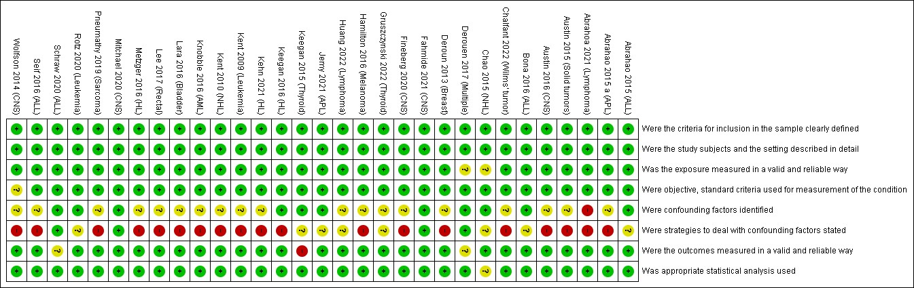
A
B
Supplementary Figure 1 – A. Flowchart of studies included in the systematic review and meta-analysis. B. Risk of bias assessment of each study according to the Joanna Briggs Institute (JBI) Critical Appraisal Checklist for Analytical Cross-Sectional Studies.

Supplementary Figure 2: Pooled hazard ratios for cancer-specific survival according to nSES association in children and AYA with hematological malignancies.

