***Supplementary Material***

Neanderthal exploitation of birds in north-western Europe: Avian remains from Scladina Cave (Belgium)

**Goffette Q, Abrams G, Pirson S, Rots V, Di Modica K, Bray F, Cnuts D, Bonjean D, Amos L**

**\* Correspondence:**

Quentin Goffette: qgoffette@naturalsciences.be

Linda Amos: lamos@ufg.uni-kiel.de

# Supplementary Figures and Tables

## Supplementary Figures

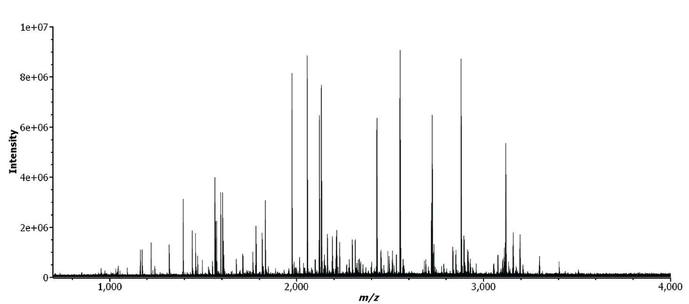

**Supplementary Figure 1.** MALDI FTICR spectra of sample Sc-1985-910-309. The ZooMS markers allows the identification as Tetraoninae.

**Supplementary Figure 2.** MALDI FTICR spectra of sample Sc-1985-783-116. No taxonomic identification is possible due to the presence of contamination.

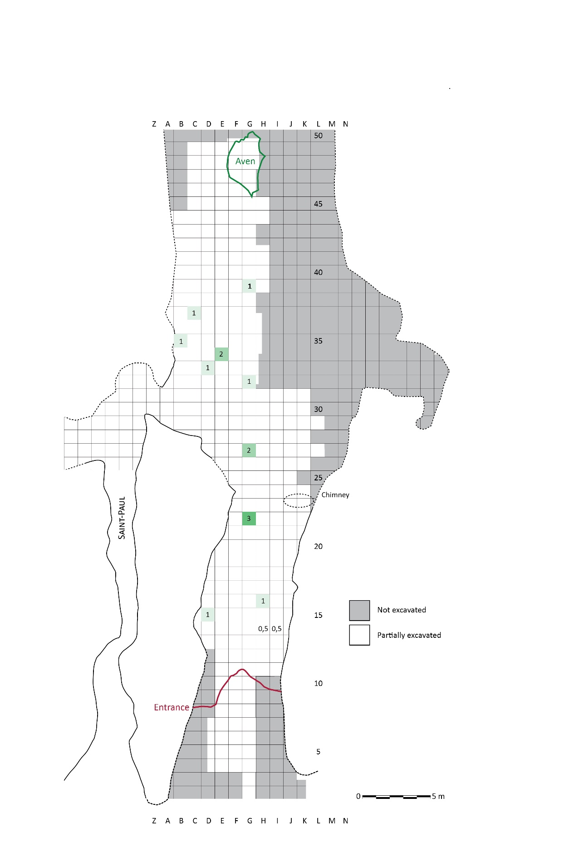

**Supplementary Figure 3.** Unit 1A. Spatial distribution of bird bones. Number of identified specimens have been reported in squares where bird remains were found. When a bone was found at the interface between two squares, the number of remains was divided by two and distributed between the two squares. This explains the presence of decimals in squares H14 and I14. Densities are illustrated using a green color gradient where a darker color indicates a greater concentration of bird bones.



**Supplementary Figure 4.** Unit 4, 4A, 4A-CHE and 4B. Spatial distribution of bird bones. Number of identified specimens have been reported in squares where bird remains were found. Densities are illustrated using a green color gradient where a darker color indicates a greater concentration of bird bones (spatial distribution of anthropological remains according to Figure 4 in Pirson et al., 2014).

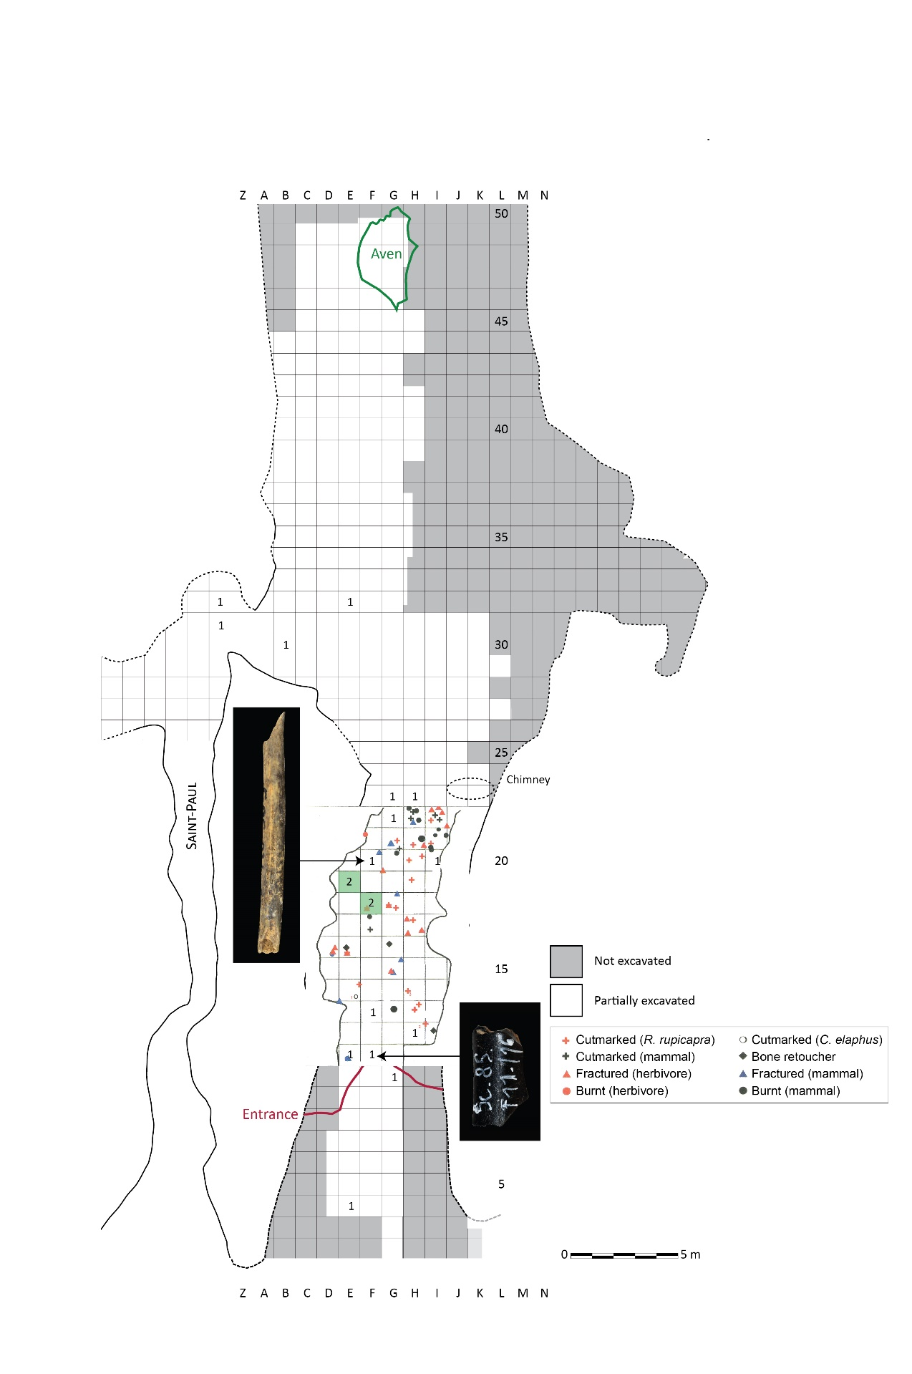

**Supplementary Figure 5.** Unit 5. Spatial distribution of bird bones and mammal remains showing anthropogenic marks. Number of identified specimens have been reported in squares where bird remains were found. Densities are illustrated using a green color gradient where a darker color indicates a greater concentration of bird bones (based on Figure 11 in Patou-Mathis & Lopez-Bayon, 1998).

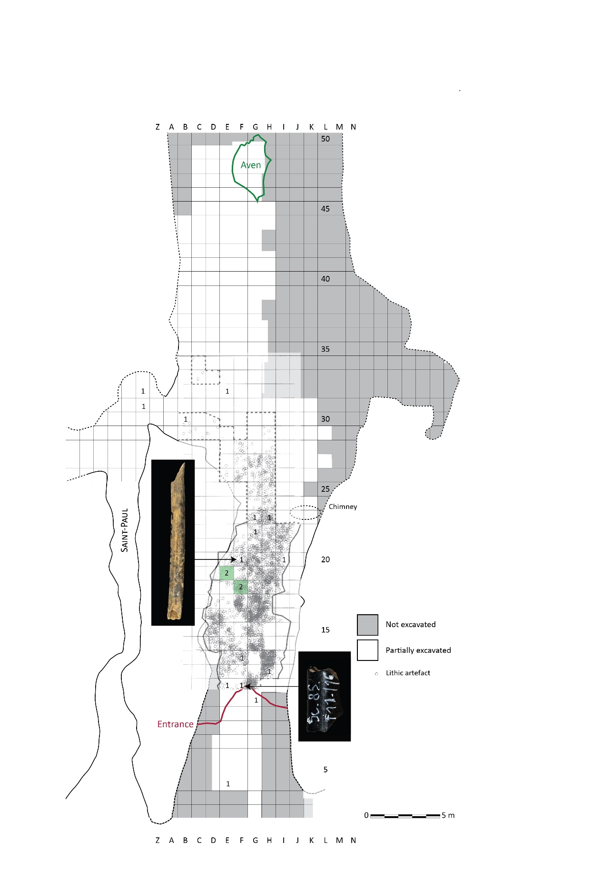

**Supplementary Figure 6.** Unit 5. Spatial distribution of bird bones and lithic artifacts. Number of identified specimens have been reported in squares where bird remains were found. Densities are illustrated using a green color gradient where a darker color indicates a greater concentration of bird bones (based on Figure 2 in Bonjean, 1998b).

## Supplementary Tables

**Supplementary Table 1.** Inventory of the number of identified specimens (NISP) of bird remains from Scladina Cave found in each layer. MIS = Marine Isotopic Stages.

|  |  |  |  |  |  |  |  |  |  |  |  |
| --- | --- | --- | --- | --- | --- | --- | --- | --- | --- | --- | --- |
| Area | Cave | | | | | | | | | | |
| MIS | 3 | | | 3? | 3 | | 3/4 | 5 | | | |
| Unit | end T + begin 1A | 40 | 1A | 1A + BIO | 1B-GRI - US12 | 1B-LI/1B-JO | I | 3 | 3-ASS (=4A-GR) | 3+BIO | 3 |
| **Anseriformes** |  |  |  |  |  |  |  |  |  |  |  |
| Goose (*Anser* cf. *albifrons*) | - | - | - | - | - | - | - | - | - | - | - |
| Anatinae size mallard | 1 | - | 2 | 2 | - | - | - | - | - | - | - |
| Anatinae size wigeon | - | - | - | - | - | - | - | - | - | - | - |
| **Galliformes** |  |  |  |  |  |  |  |  |  |  |  |
| Grey partridge (*Perdix perdix*) | - | - | - | - | - | - | - | - | - | - | - |
| Ptarmigan (*Lagopus* sp.) | - | - | - | - | - | - | 1 | - | - | - | - |
| Black grouse (*Lyrurus tetrix*) | - | - | 2 | - | - | - | - | - | - | - | - |
| Western capercaillie (*Tetrao urogallus*) | - | - | - | - | 1 | 1 | - | 5 | - | 1 | 2 |
| Galliformes size ptarmigan | - | - | 1 | - | - | - | - | 2 | - | - | - |
| Galliformes size capercaillie | - | - | - | 1 | - | - | - | - | - | - | - |
| **Columbiformes** |  |  |  |  |  |  |  |  |  |  |  |
| Wood pigeon? (*Columba* cf. *palumbus*) | - | - | 1 | - | - | - | - | - | - | - | - |
| **Strigiformes** |  |  |  |  |  |  |  |  |  |  |  |
| Eurasian eagle/snowy owl (*Bubo* sp.) | - | - | - | - | - | - | - | - | - | - | - |
| Tawny owl (*Strix aluco*) | - | - | - | - | - | - | - | - | - | - | - |
| Short/long-eared owl (*Asio otus*/*flammeus*) | - | - | - | - | - | - | - | - | - | - | - |
| **Suliformes** |  |  |  |  |  |  |  |  |  |  |  |
| Great cormorant (*Phalacrocorax carbo*) | - | - | - | - | - | - | - | - | - | - | - |
| **Accipitriformes** |  |  |  |  |  |  |  |  |  |  |  |
| Eurasian sparrowhawk (*Accipiter nisus*) | - | - | 1 | - | - | - | - | - | - | - | - |
| Lesser spotted eagle? (*Clanga* cf. *pomarina*) | - | - | - | - | - | - | - | - | - | - | - |
| Eagle size golden eagle | - | - | 1 | - | - | - | - | - | - | - | - |
| **Passeriformes** |  |  |  |  |  |  |  |  |  |  |  |
| Passeriformes size yellowhammer | - | - | 3 | - | - | - | - | - | - | - | - |
| **Total identified bird remains** | **1** | **0** | **11** | **3** | **1** | **1** | **1** | **7** | **0** | **1** | **2** |
| Unidentified bird remains | - | 1 | 5 | 1 | - | - | - | - | 1 | - | - |
| Unidentified bird size goose | - | - | - | - | - | - | - | - | - | - | - |
| **Total unidentified bird remains** | **0** | **1** | **5** | **1** | **0** | **0** | **0** | **0** | **1** | **0** | **0** |
| **Total** | **1** | **1** | **16** | **4** | **1** | **1** | **1** | **7** | **1** | **1** | **2** |

**Supplementary Table 1 (continued).** Inventory of the number of identified specimens (NISP) of bird remains from Scladina Cave found in each layer. MIS = Marine Isotopic Stages.

|  |  |  |  |  |  |  |  |  |  |
| --- | --- | --- | --- | --- | --- | --- | --- | --- | --- |
| Area | Cave | | | | | | | | |
| MIS | 5/6 | | | | | 6 | | | |
| Unit | 4A | V ocre | 4A-CHE | 4A-GX1 (4A-CHE) | 4 | 4B | 4B-UN (sup) | 4B-UN (inf) | 4B-UN+4B-LI |
| **Anseriformes** |  |  |  |  |  |  |  |  |  |
| Goose (*Anser* cf. *albifrons*) | - | - | - | - | - | - | - | - | - |
| Anatinae size mallard | - | - | - | - | 1 | - | - | - | - |
| Anatinae size wigeon | - | - | - | - | - | - | - | - | - |
| **Galliformes** |  |  |  |  |  |  |  |  |  |
| Grey partridge (*Perdix perdix*) | - | - | - | - | - | - | - | - | - |
| Ptarmigan (*Lagopus* sp.) | - | - | - | - | 1 | - | - | - | - |
| Black grouse (*Lyrurus tetrix*) | 2 | - | 1 | - | - | 6 | - | - | - |
| Western capercaillie (*Tetrao urogallus*) | - | - | 1 | 1 | 4 | 15 | 1 | 1 | - |
| Galliformes size ptarmigan | - | - | - | - | 1 | 2 | - | - | - |
| Galliformes size capercaillie | - | - | - | - | - | - | - | - | - |
| **Columbiformes** |  |  |  |  |  |  |  |  |  |
| Wood pigeon? (*Columba* cf. *palumbus*) | - | - | - | - | - | - | - | - | - |
| **Strigiformes** |  |  |  |  |  |  |  |  |  |
| Eurasian eagle/snowy owl (*Bubo* sp.) | 2 | - | - | - | - | 1 | - | - | - |
| Tawny owl (*Strix aluco*) | - | - | - | - | - | 1 | - | - | - |
| Short/long-eared owl (*Asio otus*/*flammeus*) | - | - | - | - | - | - | - | - | - |
| **Suliformes** |  |  |  |  |  |  |  |  |  |
| Great cormorant (*Phalacrocorax carbo*) | - | - | - | - | 1 | - | - | - | - |
| **Accipitriformes** |  |  |  |  |  |  |  |  |  |
| Eurasian sparrowhawk (*Accipiter nisus*) | - | - | - | - | - | - | - | - | - |
| Lesser spotted eagle? (*Clanga* cf. *pomarina*) | - | - | - | - | - | 1 | - | - | - |
| Eagle size golden eagle | - | - | - | - | - | - | - | - | - |
| **Passeriformes** |  |  |  |  |  |  |  |  |  |
| Passeriformes size yellowhammer | - | - | - | - | - | - | - | - | - |
| **Total identified bird remains** | **4** | **0** | **2** | **1** | **8** | **26** | **1** | **1** | **0** |
| Unidentified bird remains | 1 | 1 | - | - | - | 10 | - | - | 1 |
| Unidentified bird size goose | - | - | - | - | - | - | - | - | - |
| **Total unidentified bird remains** | **1** | **1** | **0** | **0** | **0** | **10** | **0** | **0** | **1** |
| **Total** | **5** | **1** | **2** | **1** | **8** | **36** | **1** | **1** | **1** |

**Supplementary Table 1 (continued).** Inventory of the number of identified specimens (NISP) of bird remains from Scladina Cave found in each layer. MIS = Marine Isotopic Stages.

|  |  |  |  |  |  |  |  |  |  |
| --- | --- | --- | --- | --- | --- | --- | --- | --- | --- |
| Area | Cave | | | | | | Sinkhole | | Total |
| MIS | 6 | | | 6/7 | | | 1-3 | |  |
| Unit | 5 | VB | 5+6 | 6 | VIa | 6B+6C | Z1 à Z3 | Z3 à Z4 |  |
| **Anseriformes** |  |  |  |  |  |  |  |  |  |
| Goose (*Anser* cf. *albifrons*) | 1 | - | 1 | - | - | - | 1 | - | 3 |
| Anatinae size mallard | 1 | - | - | - | - | - | - | - | 7 |
| Anatinae size wigeon | 1 | - | - | - | - | - | - | - | 1 |
| **Galliformes** |  |  |  |  |  |  |  |  |  |
| Grey partridge (*Perdix perdix*) | - | - | - | - | - | 1 | - | - | 1 |
| Ptarmigan (*Lagopus* sp.) | - | - | - | - | - | - | - | - | 2 |
| Black grouse (*Lyrurus tetrix*) | 2 | - | - | - | 1 | - | - | - | 14 |
| Western capercaillie (*Tetrao urogallus*) | - | - | 2 | - | - | - | - | - | 35 |
| Galliformes size ptarmigan | 2 | 1 | - | 1 | - | - | - | - | 10 |
| Galliformes size capercaillie | - | - | - | - | - | - | - | - | 1 |
| **Columbiformes** |  |  |  |  |  |  |  |  |  |
| Wood pigeon? (*Columba* cf. *palumbus*) | - | - | - | - | - | - | - | - | 1 |
| **Strigiformes** |  |  |  |  |  |  |  |  |  |
| Eurasian eagle/snowy owl (*Bubo* sp.) | - | - | - | - | - | - | - | - | 3 |
| Tawny owl (*Strix aluco*) | - | - | - | - | - | - | - | - | 1 |
| Short/long-eared owl (*Asio otus*/*flammeus*) | - | 1 | - | - | - | - | - | - | 1 |
| **Suliformes** |  |  |  |  |  |  |  |  |  |
| Great cormorant (*Phalacrocorax carbo*) | - | - | - | - | - | - | - | - | 1 |
| **Accipitriformes** |  |  |  |  |  |  |  |  |  |
| Eurasian sparrowhawk (*Accipiter nisus*) | - | - | - | - | - | - | - | - | 1 |
| Lesser spotted eagle? (*Clanga* cf. *pomarina*) | - | - | - | - | - | - | - | - | 1 |
| Eagle size golden eagle | - | - | - | - | - | - | - | - | 1 |
| **Passeriformes** |  |  |  |  |  |  |  |  |  |
| Passeriformes size yellowhammer | - | - | - | - | - | - | - | - | 3 |
| **Total identified bird remains** | **7** | **2** | **3** | **1** | **1** | **1** | **1** | **0** | **87** |
| Unidentified bird remains | 8 | - | - | - | - | - | - | 1 | 30 |
| Unidentified bird size goose | 2 | - | - | - | - | - | - | - | 2 |
| **Total unidentified bird remains** | **10** | **0** | **0** | **0** | **0** | **0** | **0** | **1** | **32** |
| **Total** | **17** | **2** | **3** | **1** | **1** | **1** | **1** | **1** | **119** |

**Supplementary Table 2.** Inventory of the minimum number of individuals (MNI) from Scladina Cave identified in each layer. MIS = Marine Isotopic Stages.

|  |  |  |  |  |  |  |  |  |  |  |  |
| --- | --- | --- | --- | --- | --- | --- | --- | --- | --- | --- | --- |
| Area | Cave | | | | | | | | | | |
| MIS | 3 | | | 3? | 3 | | 3/4 | 5 | | | |
| Unit | end T + begin 1A | 40 (1A) | 1A | 1A + BIO | 1B-GRI - US12 | 1B-LI/1B-JO | I (1B) | 3-SUP | 3-ASS (=4A-GR) | 3-SUP+BIO | 3-INF |
| **Anseriformes** |  |  |  |  |  |  |  |  |  |  |  |
| Goose (*Anser* cf. *albifrons*) | - | - | - | - | - | - | - | - | - | - | - |
| Anatinae size mallard | + | - | 1 | + | - | - | - | - | - | - | - |
| Anatinae size wigeon | - | - | - | - | - | - | - | - | - | - | - |
| **Galliformes** |  |  |  |  |  |  |  |  |  |  |  |
| Grey partridge (*Perdix perdix*) | - | - | - | - | - | - | - | - | - | - | - |
| Ptarmigan (*Lagopus* sp.) | - | - | - | - | - | - | 1 | - | - | - | - |
| Black grouse (*Lyrurus tetrix*) | - | - | 1 | - | - | - | - | - | - | - | - |
| Western capercaillie (*Tetrao urogallus*) | - | - | - | - | 1 | 1 | - | 1 | - | + | 1 |
| Galliformes size ptarmigan | - | - | + | - | - | - | - | 1 | - | - | - |
| Galliformes size capercaillie | - | - | - | - | - | - | - | - | - | - | - |
| **Columbiformes** |  |  |  |  |  |  |  |  |  |  |  |
| Wood pigeon? (*Columba* cf. *palumbus*) | - | - | 1 | - | - | - | - | - | - | - | - |
| **Strigiformes** |  |  |  |  |  |  |  |  |  |  |  |
| Eurasian eagle/snowy owl (*Bubo* sp.) | - | - | - | - | - | - | - | - | - | - | - |
| Tawny owl (*Strix aluco*) | - | - | - | - | - | - | - | - | - | - | - |
| Short/long-eared owl (*Asio otus*/*flammeus*) | - | - | - | - | - | - | - | - | - | - | - |
| **Suliformes** |  |  |  |  |  |  |  |  |  |  |  |
| Great cormorant (*Phalacrocorax carbo*) | - | - | - | - | - | - | - | - | - | - | - |
| **Accipitriformes** |  |  |  |  |  |  |  |  |  |  |  |
| Eurasian sparrowhawk (*Accipiter nisus*) | - | - | 1 | - | - | - | - | - | - | - | - |
| Lesser spotted eagle? (*Clanga* cf. *pomarina*) | - | - | - | - | - | - | - | - | - | - | - |
| Eagle size golden eagle | - | - | 1 | - | - | - | - | - | - | - | - |
| **Passeriformes** |  |  |  |  |  |  |  |  |  |  |  |
| Passeriformes size yellowhammer | - | - | 1 | - | - | - | - | - | - | - | - |
| **Total identified bird remains** | **0** | **0** | **6** | **0** | **1** | **1** | **1** | **2** | **0** | **0** | **1** |
| Unidentified bird remains | - | 1 | + | + | - | - | - | - | + | - | - |
| Unidentified bird size goose | - | - | - | - | - | - | - | - | - | - | - |
| **Total unidentified bird remains** | **0** | **1** | **0** | **0** | **0** | **0** | **0** | **0** | **0** | **0** | **0** |
| **Total** | **0** | **1** | **6** | **0** | **1** | **1** | **1** | **2** | **0** | **0** | **1** |

**Supplementary Table 2 (continued).** Inventory of the minimum number of individuals (MNI) from Scladina Cave identified in each layer. MIS = Marine Isotopic Stage.

|  |  |  |  |  |  |  |  |  |  |  |
| --- | --- | --- | --- | --- | --- | --- | --- | --- | --- | --- |
| Area | Cave | | | | | | | | | |
| MIS | 5/6 | | | | | 6 | | | |
| Unit | 4A | V ocre (4A) | 4A-CHE | 4A-GX1 (4A-CHE) | 4A+4B | 4B | 4B-UN (sup) | 4B-UN (inf) | 4B-UN+4B-LI |
| **Anseriformes** |  |  |  |  |  |  |  |  |  |
| Goose (*Anser* cf. *albifrons*) | - | - | - | - | - | - | - | - | - |
| Anatinae size mallard | - | - | - | - | 1 | - | - | - | - |
| Anatinae size wigeon | - | - | - | - | - | - | - | - | - |
| **Galliformes** |  |  |  |  |  |  |  |  |  |
| Grey partridge (*Perdix perdix*) | - | - | - | - | - | - | - | - | - |
| Ptarmigan (*Lagopus* sp.) | - | - | - | - | 1 | - | - | - | - |
| Black grouse (*Lyrurus tetrix*) | + | - | 1 | - | - | 1 | - | - | - |
| Western capercaillie (*Tetrao urogallus*) | - | - | + | 1 | + | 2 | + | + | - |
| Galliformes size ptarmigan | - | - | - | - | + | + | - | - | - |
| Galliformes size capercaillie | - | - | - | - | - | - | - | - | - |
| **Columbiformes** |  |  |  |  |  |  |  |  |  |
| Wood pigeon? (*Columba* cf. *palumbus*) | - | - | - | - | - | - | - | - | - |
| **Strigiformes** |  |  |  |  |  |  |  |  |  |
| Eurasian eagle/snowy owl (*Bubo* sp.) | 1 | - | - | - | - | 1 | - | - | - |
| Tawny owl (*Strix aluco*) | - | - | - | - | - | 1 | - | - | - |
| Short/long-eared owl (*Asio otus*/*flammeus*) | - | - | - | - | - | - | - | - | - |
| **Suliformes** |  |  |  |  |  |  |  |  |  |
| Great cormorant (*Phalacrocorax carbo*) | - | - | - | - | 1 | - | - | - | - |
| **Accipitriformes** |  |  |  |  |  |  |  |  |  |
| Eurasian sparrowhawk (*Accipiter nisus*) | - | - | - | - | - | - | - | - | - |
| Lesser spotted eagle? (*Clanga* cf. *pomarina*) | - | - | - | - | - | 1 | - | - | - |
| Eagle size golden eagle | - | - | - | - | - | - | - | - | - |
| **Passeriformes** |  |  |  |  |  |  |  |  |  |
| Passeriformes size yellowhammer | - | - | - | - | - | - | - | - | - |
| **Total identified bird remains** | **1** | **0** | **1** | **1** | **3** | **6** | **0** | **0** | **0** |
| Unidentified bird remains | + | + | - | - | - | + | - | - | + |
| Unidentified bird size goose | - | - | - | - | - | - | - | - | - |
| **Total unidentified bird remains** | **0** | **0** | **0** | **0** | **0** | **0** | **0** | **0** | **0** |
| **Total** | **1** | **0** | **1** | **1** | **3** | **6** | **0** | **0** | **0** |

**Supplementary Table 2 (continued).** Inventory of the minimum number of individuals (MNI) from Scladina Cave identified in each layer. MIS = Marine Isotopic Stages.

|  |  |  |  |  |  |  |  |  |  |
| --- | --- | --- | --- | --- | --- | --- | --- | --- | --- |
| Area | Cave | | | | | | Sinkhole | | Total |
| MIS | 6 | | | 6/7 | | | 1-3 | |  |
| Unit | 5 | VB | 5+6 | 6 | VIa | 6B+6C | Z1 à Z3 | Z3 à Z4 |  |
| **Anseriformes** |  |  |  |  |  |  |  |  |  |
| Goose (*Anser* cf. *albifrons*) | 1 | - | + | - | - | - | + | - | 1 |
| Anatinae size mallard | 1 | - | - | - | - | - | - | - | 3 |
| Anatinae size wigeon | 1 | - | - | - | - | - | - | - | 1 |
| **Galliformes** |  |  |  |  |  |  |  |  |  |
| Grey partridge (*Perdix perdix*) | - | - | - | - | - | 1 | - | - | 1 |
| Ptarmigan (*Lagopus* sp.) | - | - | - | - | - | - | - | - | 2 |
| Black grouse (*Lyrurus tetrix*) | 2 | - | - | - | 1 | - | - | - | 6 |
| Western capercaillie (*Tetrao urogallus*) | - | - | + | - | - | - | - | - | 7 |
| Galliformes size ptarmigan | + | + | - | + | - | - | - | - | 1 |
| Galliformes size capercaillie | - | - | - | - | - | - | - | - |  |
| **Columbiformes** |  |  |  |  |  |  |  |  |  |
| Wood pigeon? (*Columba* cf. *palumbus*) | - | - | - | - | - | - | - | - | 1 |
| **Strigiformes** |  |  |  |  |  |  |  |  |  |
| Eurasian eagle/snowy owl (*Bubo* sp.) | - | - | - | - | - | - | - | - | 2 |
| Tawny owl (*Strix aluco*) | - | - | - | - | - | - | - | - | 1 |
| Short/long-eared owl (*Asio otus*/*flammeus*) | - | 1 | - | - | - | - | - | - | 1 |
| **Suliformes** |  |  |  |  |  |  |  |  |  |
| Great cormorant (*Phalacrocorax carbo*) | - | - | - | - | - | - | - | - | 1 |
| **Accipitriformes** |  |  |  |  |  |  |  |  |  |
| Eurasian sparrowhawk (*Accipiter nisus*) | - | - | - | - | - | - | - | - | 1 |
| Lesser spotted eagle? (*Clanga* cf. *pomarina*) | - | - | - | - | - | - | - | - | 1 |
| Eagle size golden eagle | - | - | - | - | - | - | - | - | 1 |
| **Passeriformes** |  |  |  |  |  |  |  |  |  |
| Passeriformes size yellowhammer | - | - | - | - | - | - | - | - | 1 |
| **Total identified bird remains** | **5** | **1** | **0** | **0** | **1** | **1** | **0** | **0** | **32** |
| Unidentified bird remains | + | - | - | - | - | - | - | + | + |
| Unidentified bird size goose | + | - | - | - | - | - | - | - | + |
| **Total unidentified bird remains** | **0** | **0** | **0** | **0** | **0** | **0** | **0** | **0** | **0** |
| **Total** | **5** | **1** | **0** | **0** | **1** | **1** | **0** | **0** | **32** |

**Supplementary Table 3.** Sedimentary group used in the taphonomic analysis of the avifaunal remains from Scladina Cave with annotations for marine isotope stage (MIS), Unit and Layer of origin, and total NISP of the taphonomic sample.

|  |  |  |  |  |  |  |  |  |  |  |  |  |  |  |  |
| --- | --- | --- | --- | --- | --- | --- | --- | --- | --- | --- | --- | --- | --- | --- | --- |
| GROUP | UNIT 1A | COMPLEX OF UNITS 3 | | | COMPLEX OF UNITS 4A | | | | | UNIT 4B | | | | UNIT 5 | |
| MIS | 3 | 5 | | | | | | | | 6 | | | | | |
| UNIT | 1A | 3-SUP | 3-SUP | 3-INF | 4A | 4A | 4A-CHE | 4A-CHE | 4A+4B | 4B | 4B | 4B | 4B | 5 | 5 |
| LAYER | 1A | 3 | 3-ASS = (4A-GR) | 3 | 4A | V ocre | 4A-CHE | 4A-GX1 | 4 | 4B | 4B-UN (sup) | 4B-UN (inf) | 4B-UN+4B-LI | 5 | VB |
| NISP | 16 | 10 | | | 18 | | | | | 36 | | | | 19 | |

**Supplementary Table 4**. ZooMS markers identified in Sc-1986-910-309 sample. The full name of biomarker is indicated in the first line. The mass of the ZooMS markers identified in the sample are in the second line. The identification is in the last column. The ZooMS markers are taken from publication Eda et al. (2020) and Codlin et al. (2022)

|  |  |
| --- | --- |
| **COL1ɑ1 508 - 519** | 1162.60 |
| **COL1ɑ2 978 - 990** | 1221.66 |
| **COL1ɑ2 484 - 498** | 1463.74 |
| **COL1ɑ2 484 - 498** |  |
| **COL1ɑ2 502 - 519** | 1594.82 |
| **COL1ɑ2 793 - 816** | 2133.10 |
| **COL1ɑ2 454 - 483** |  |
| **COL1ɑ1 586 - 618** |  |
| **COL1ɑ1 586 - 618** | 2879.43 |
| **COL1ɑ1 586 - 618** | 2895.43 |
| **COL1ɑ2 757 - 789** | 2927.49 |
| **COL1ɑ2 757 - 789** |  |
| **COL1ɑ2 520 - 555** |  |
| **COL1ɑ2 520 - 555** | 3193.48 |
| **COL1ɑ2 658 - 687** | 2553.31 |
| **COL1ɑ2 889 - 906** | 1566.77 |
| **Identification** | **466585 [Tetraoninae]** |

**Supplementary Table 5.** Raw data relating to the different taphonomic modification observed on the bird material from Scladina Cave and displayed in Figures 3 and Figure 4 of the main paper. Manganese/concretions: 0 = no modifications, 1 = on 1-25% of the specimen, 2 = on 26-50%, 3 = on 51-75%, 4 = on 76-100%. Trample: 0 = absence, 1 = present. Weathering: 0 = none, 1 = initial cracking, 2 = flaking, 3 = advanced flaking and cracking. Rooting and digestion: 0 = none, 1 = low, 2 = medium, 3 = high (Bocheński et al., 2009).

|  |  |  |  |  |  |  |
| --- | --- | --- | --- | --- | --- | --- |
| **Modifications** | **Rank/type** | **Unit 1A** | **Unit 3** | **Unit 4A** | **Unit 4B** | **Unit 5** |
| Concretion | 0 | 0.250 | 0.400 | 0.833 | 0.778 | 0.474 |
| Concretion | 1 | 0.375 | 0.600 | 0.111 | 0.111 | 0.263 |
| Concretion | 2 | 0.250 | 0.000 | 0.056 | 0.111 | 0.263 |
| Concretion | 3 | 0.125 | 0.000 | 0.000 | 0.000 | 0.000 |
| Manganese | 0 | 0.125 | 0.000 | 0.167 | 0.086 | 0.105 |
| Manganese | 1 | 0.438 | 0.200 | 0.167 | 0.200 | 0.316 |
| Manganese | 2 | 0.250 | 0.300 | 0.167 | 0.429 | 0.158 |
| Manganese | 3 | 0.000 | 0.300 | 0.222 | 0.229 | 0.158 |
| Manganese | 4 | 0.188 | 0.200 | 0.278 | 0.057 | 0.211 |
| Trample | 0 | 0.875 | 0.900 | 0.889 | 0.943 | 0.684 |
| Trample | 1 | 0.125 | 0.100 | 0.111 | 0.057 | 0.316 |
| Weathering | 0 | 0.250 | 0.000 | 0.333 | 0.457 | 0.316 |
| Weathering | 1 | 0.125 | 0.100 | 0.167 | 0.429 | 0.421 |
| Weathering | 2 | 0.375 | 0.500 | 0.333 | 0.114 | 0.158 |
| Weathering | 3 | 0.250 | 0.400 | 0.167 | 0.000 | 0.105 |
| Rooting | 0 | 0.813 | 0.900 | 0.667 | 1.000 | 0.684 |
| Rooting | 1 | 0.125 | 0.100 | 0.333 | 0.000 | 0.316 |
| Rooting | 2 | 0.063 | 0.000 | 0.000 | 0.000 | 0.000 |
| Digestion | 0 | 0.625 | 0.800 | 0.889 | 0.972 | 0.778 |
| Digestion | 1 | 0.375 | 0.200 | 0.111 | 0.000 | 0.167 |
| Digestion | 2 | 0.000 | 0.000 | 0.000 | 0.028 | 0.056 |
| Mechanical | none | 0.500 | 0.300 | 0.611 | 0.528 | 0.421 |
| Mechanical | rodent | 0.000 | 0.000 | 0.000 | 0.000 | 0.053 |
| Mechanical | carnivore | 0.500 | 0.700 | 0.278 | 0.389 | 0.526 |
| Mechanical | Human? | 0.000 | 0.000 | 0.111 | 0.056 | 0.000 |
| Mechanical | carnivore/bird of prey | 0.000 | 0.000 | 0.000 | 0.028 | 0.000 |

## References

Bocheński, Z.M., Tomek, T., and Wertz, K. (2009). The State of Preservation of Bird Remains in a Cave Environment: A Case Study from Ciemna Cave (Poland). Acta zoologica cracoviensia 52(1-2), 1-16.

Bonjean, D. (1998). "Répartition spatiale de l'industrie lithique," in Recherches aux grottes de Sclayn. Volume 2. L’archéologie, eds. M. Otte, M. Patou-Mathis, and D. Bonjean (Liège, Études et Recherches archéologiques de l'Université de Liège 79), 340-376.

Codlin, M. C., Douka, K., & Richter, K. K. (2022). An application of zooms to identify archaeological avian fauna from Teotihuacan, Mexico. Journal of Archaeological Science 148, 105692.

Eda, M., Morimoto, M., Mizuta, T., and Inoué, T. (2020). ZooMS for Birds: Discrimination of Japanese Archaeological Chickens and Indigenous Pheasants Using Collagen Peptide Fingerprinting. Journal of Archaeological Science: Reports 34, 102635.

Patou-Mathis, M., and Lopez-Bayon, I. (1998). "Analyse spatiale des ossements de la couche 5," in Recherches aux grottes de Sclayn. Volume 2. L’'archéologie, eds. M. Otte, M. Patou-Mathis, and D. Bonjean (Études et Recherches archéologiques de l'Université de Liège 79), 377-395.

Pirson, S., Bonjean, D., and Toussaint, M. (2014). “Chapter 5. Stratigraphic origin of the juvenile Neandertal remains from Scladina Cave: re-evaluation and consequences for their palaeoenvironmental and chronostratigraphic contexts”, in The Scladina I-4A Juvenile Neandertal (Andenne, Belgium). Palaeoanthropology and Context, eds M. Toussaint, and D. Bonjean (Études et Recherches archéologiques de l'Université de Liège 134), 93-124.