Supplementary Information

Surveyed MCC Compacts
CBA spreadsheets of concluded MCC (Millennium Challenge Corporation) compact projects can be accessed publicity at https://www.mcc.gov/our-impact/err. These spreadsheets were downloaded and studied to understand the utilization of standard methods of uncertainty characterization (Sensitivity Analysis, Scenario Analysis and Monte Carlo Analysis) in economic analysis at a conventional development agency. Importantly, we paid attention to the summary and presentation of financial decision metrics like the economic rate of return (ERR), net present value (NPV) and present value (PV), as well as the types of uncertainties included in analysis. None of the compacts analyzed conducted uncertainty analysis on climate variables like precipitation and temperature, although about a third of the closed MCC compacts were water sector projects (including water supply, irrigated agriculture, sanitation, storm water drainage, etc.) likely to be affected by changing climate conditions. summarizes the 82 projects from closed MCC compacts surveyed (analysis period ranging from 2005 to 2014 ex-ante, and from 2008 to 2020 ex-post) for this study based on spreadsheets available as of September 1, 2023.

Supplementary Table 1: Summary of Surveyed MCC Compacts
Compact Country | Total Projects | Water Sector
Armenia | 3 | 2
Benin | 3 | 0
Burkina Faso | 5 | 2
El Salvador | 8 | 1
Georgia | 5 | 0
Ghana | 6 | 3
Honduras | 1 | 0
Indonesia | 1 | 0
Lesotho | 5 | 3
Malawi | 1 | 0
Moldova | 1 | 1
Mongolia | 6 | 0
Morocco | 12 | 2
Mozambique | 8 | 5
Namibia | 6 | 0
Philippines | 2 | 0
Senegal | 2 | 3
Tanzania | 5 | 3
Vanuatu | 1 | 0
Zambia | 1 | 1
Total | 82 | 26

Input Data for Hydrologic Modelling using SWAT
Supplementary Table 2 presents the input data used for hydrological modelling. The SWAT hydrologic model is a watershed to river basin-scale model useful in simulating the quality and quantity of surface and ground water, and predicting the environmental impact of land use, land management practices, and climate change. Overall, our model under-predicts the streamflow (percent bias is ≈ -12.4% in calibration and ≈ -21.8% in validation). However, the goodness of fit parameters were acceptable for the purpose of this analysis. Eleven years were specified for the model warm-up period.
Supplementary Table 2: Input Data for Hydrologic Modelling
Watershed / Land Characteristics Data
Data | Source | Spatial Resolution
Digital Elevation Map (DEM) | US Geological Survey (USGS) | 30 m
Land use / Landcover | Food and Agricultural Association (FAO) | 1 km
Soil maps  Digital Soil Map of the World (DSMW) | Food and Agricultural Association (FAO) / UNESCO | Shape file
Climate Data
Data | Source | Temporal Resolution | Coverage
Precipitation | Princeton Global Forcings (PGF) | Daily | 1948 to 2016
Temperature | Princeton Global Forcings (PGF) | Daily | 1948 to 2016
Streamflow | Lesotho Department of Water Affairs (DWA, Gauge SG03) | Daily | 1972 to 2019

SWAT Calibration Parameters
Supplementary Table 3 presents the range and fitted values of the fractions (*), and in some instances exact values, of parameters used for the SWAT hydrologic model calibration and validation.
Supplementary Table 3: SWAT Calibration and Validation Parameters
SWAT Calibration Parameters | Description | Minimum | Maximum | Fitted Value for Calibration | Fitted Value for Validation
*CN2.mgt | Curve Number | -0.0402 | 0.0064 | -0.0333 | -0.0038
*ALPHA_BF.gw | Baseflow alpha factor (1/days) | 0.5195 | 0.7286 | 0.7265 | 0.5454
GW_DELAY.gw | Groundwater delay (days) | 561.2191 | 680.8492 | 606.4094 | 658.2690
GWQMN.gw | Threshold depth of water in the shallow aquifer required for return flow to occur (mm H2O) | 1764.8728 | 2157.1023 | 2005.9959 | 2135.2354
SHALLST.gw | Initial depth of water in the shallow aquifer (mm H2O) | 4954.0195 | 6570.3613 | 6155.3657 | 5796.5376
*RCHRG_DP.gw | Deep aquifer percolation fraction | -0.1364 | 0.0914 | -0.0478 | 0.0847
*ESCO.hru | Soil evaporation compensation factor | 0.6834 | 0.8257 | 0.7239 | 0.7568
*EPCO.hru | Plant uptake compensation factor | -0.1017 | 0.2816 | -0.0966 | 0.0795
CNCOEF.bsn | Plant ET curve number coefficient | 1.5115 | 1.8836 | 1.8524 | 1.8608
*HRU_SLP.hru | Average slope steepness (m/m) | 0.7000 | 1.1112 | 1.0348 | 1.0722
SLSUBBSN.hru | Average slope length (m) | -26.8633 | 12.0898 | 9.0612 | 11.6126
SOL_AWC(..).sol | Available water capacity of the soil layer (mm H²O/mm soil) | 1.2489 | 1.8833 | 1.5881 | 1.2503
EVRCH.bsn | Reach evaporation adjustment factor | 0.7113 | 0.7516 | 0.7114 | 0.7385
REVAPMN.gw | Threshold depth of water in the shallow aquifer for percolation to the deep aquifer to occur (mm H2O) | 302.4072 | 338.5049 | 318.9850 | 334.3266
*BFLO_DIST.bsn | Baseflow distribution | 0.0330 | 0.3018 | 0.1059 | 0.0961
USLE_K(..).sol | USLE equation soil erodibility factor (m³-metric ton cm) | 0.5651 | 0.7886 | 0.6854 | 0.6638

Modelling ICM measures in the SWAT hydrologic model
The check dams were modelled as filtration ponds in SWAT filter sediments using the threshold size of the median particle diameter, d₅₀ as in eq. 1. Sediments smaller than d₅₀ are retained in the filtration ponds, while larger sediments remain suspended in the runoff (Arnold et al., 2013).
$d_{50}=\exp\left[0.41 \left(\frac{m_{clay}}{100}\right)+2.71 \left(\frac{m_{salt}}{100}\right)+5.7 \left(\frac{m_{sand}}{100}\right)\right]$ eq. (1)
where,
m_{clay} – percent clay in the surface soil layer (μm)
m_{silt} – percent silt in the surface soil layer (μm)
m_{sand} – percent sand in the surface soil layer (μm)
The runoff volume from the pond is simulated by the SWAT model based on the beginning (IFLOD1) and end (IFLOD2) of the non-flood season according to eq. 2 to eq. 4. For the study area in Lesotho, based on the summer months, IFLOD1 is May while IFLOD2 is September.
$V_{flowout}= \frac{V-V_{target}}{{ND}_{target}}$ eq. (2)
and, $V_{target}= V_{em}$ eq. (3)
when mon_{fld,beg} < mon < mon_{fld,end}
Or, $V_{target}= V_{pr}+ \frac{\left(1-\min\left[\frac{SW}{FC}, 1\right]\right)}{2} \left(V_{em}- V_{pr}\right)$ eq. (4)
when mon ≤ mon_{fld,beg} or mon ≥ mon_{fld,end}
where,
V_{targ} – target pond volume for a given day (m³H₂O)
V_{em} – volume of water held in the pond when filled to the emergency spillway (m³H₂O)
V_{pr} – volume of water held in the pond when filled to the principal spillway (m³H₂O)
V – volume of water stored in the pond (m³H₂O)
V_{target} – target pond volume for a given day (m³H₂O)
ND_{target} – number of days required for the pond to reach target storage
SW – average soil water content in the subbasin (mm.H₂O)
FC – water content of the subbasin soil at field capacity (mm.H₂O)
mon – month of the year
mon_{fld,beg} – beginning month of the flood (rainy) season
mon_{fld,end} – ending month of the flood (rainy) season
V_{flowout} – volume of water flowing out of the water body during the day (m³H₂O)
The main parameter that drives runoff and infiltration in the contours is the curve number (Boughton, 1989) which was set to the SWAT default of 60 (lower than the calculated average sub-basin curve number of 73) to reduce the rate of runoff and encourage infiltration (Arnold et al., 2013). The length, depth and width of the grassed waterways was adopted from ICM recommendations in the concluded project feasibility studies (AECOM, 2022a). To model revegetation in fenced off areas, a minimum residue land cover of 1000 kg / ha was specified from a possible range of 0 to 5000 kg / ha. Unavailability of data on specific vegetation target for livestock feeding prevented the adoption of more accurate values, and higher values were avoided to prevent excessive evapotranspiration losses (Zölch et al., 2017).

Stochastic Weather Generator
illustrates the performance of the ten 69-year precipitation traces developed by the stochastic weather generator, with the red dots indicating historical monthly averages (1949 to 2016). Weather generator performance was acceptable for the two Princeton precipitation gages, PGF 1 and PGF 2, and the monthly mean precipitation in both observed and simulated timeseries are presented in Supplementary Figure 1.
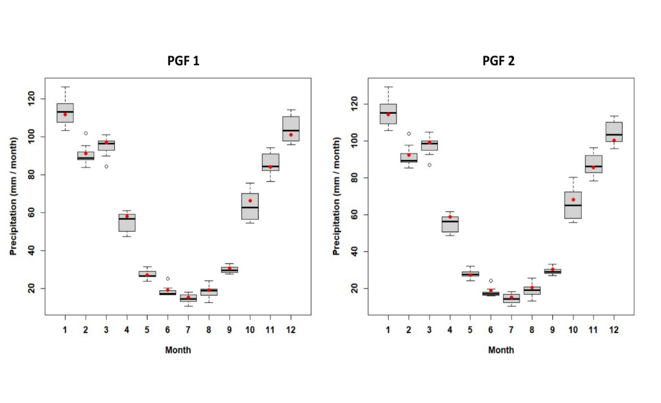
Supplementary Figure 1: Weather Generator precipitation traces

Supplementary Table 4: Mean of monthly precipitation in Observed (PGF gages) and Simulated timeseries.
Month | PGF 1 Observed | PGF 1 Simulated | PGF 2 Observed | PGF 2 Simulated
Jan | 111.9 | 113.4 | 114.3 | 115.1
Feb | 91.3 | 90.6 | 92.2 | 91.5
Mar | 97.1 | 95.0 | 99.0 | 97.3
Apr | 57.9 | 54.9 | 58.7 | 55.0
May | 27.1 | 27.2 | 27.3 | 27.5
Jun | 18.9 | 18.3 | 18.6 | 17.7
Jul | 15.1 | 14.5 | 15.1 | 14.4
Aug | 19.2 | 18.2 | 20.4 | 18.9
Sep | 30.6 | 29.7 | 30.4 | 29.3
Oct | 66.2 | 63.4 | 68.0 | 65.6
Nov | 84.2 | 85.4 | 85.5 | 87.0
Dec | 101.1 | 104.1 | 100.1 | 104.2
Supplementary Figure 2 also presents the Fourier plot showing periods of climate variability in the historical time series. The stochastic weather generator identified 11 significant periods of variability in historical precipitation at 90% confidence interval, and this was used to inform the 10 traces simulated for the climate stress test.
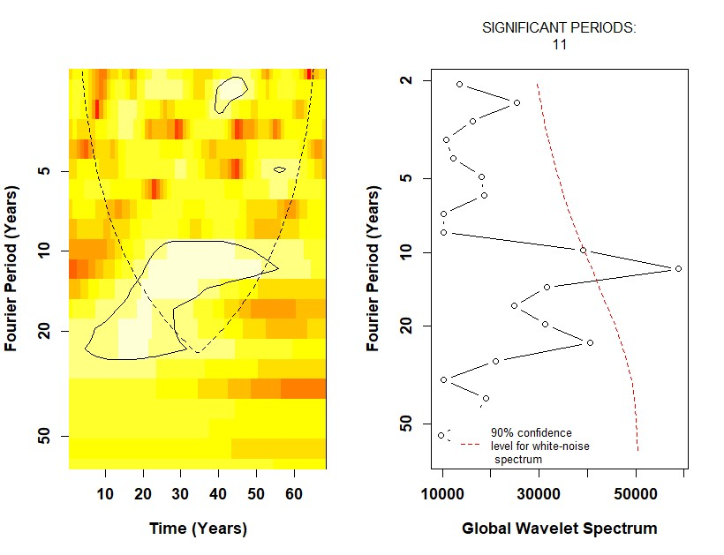
Supplementary Figure 2: Fourier Plot showing 11 significant periods in historical time series (1949 to 2016)

Irrigation Water Requirements
Irrigation water requirement (IWR) was calculated according to eq. 5 to eq. 8, and SAPWAT calculated change in soil water content using eq. 9.
$IWR= \left[\left(K_{cb}+ K_{e}\right).{ET}_{0}\right]-R_{e}$ eq. (5)
${ET}_{c}= \left(K_{c}\right).{ET}_{0}$ eq. (6)
$K_{c}= \left(K_{cb}+ K_{e}\right)$ eq. (8)
where,
ET_{c} – crop evapotranspiration
ET₀ – reference evapotranspiration (the evapotranspiration of short grass).
K_{c} – crop coefficients
K_{cb} – transpiration
K_{e} – soil evaporation
R_{e} – Effective rainfall (the component of rainfall that contributes to crop transpiration)
$∆D=I+\left(P-RO\right)-E-T+CR-DP±SF$ eq. (9)
where,
ΔD – change in soil water content
I – irrigation
P – precipitation
RO – runoff
E – soil surface evaporation
T – crop transpiration
CR – capillary rise
DP – deep percolation
SF – sub-surface flow
A mix of drip and sprinkler irrigation systems with combined irrigation efficiency of 0.95 have been proposed for the MDIH scheme and the gross irrigation requirement (GIR) was calculated according to eq. 10.
$GIR=IWR ×I_{eff}$ eq.(10)
where,
I_{eff} – efficiency of irrigation system
IWR – irrigation water requirement
From a total scheme area of 70 ha marked out for irrigation by the Phamong dam according to the project design, Supplementary Table 5 presents the number of hectares to be irrigated monthly, and their corresponding IWR and GIR (AECOM, 2021). In each climate scenario, the actual number of hectares irrigated monthly is calculated using eq. 11.
$H_{actual,mon}= \left(\frac{A}{{GIR}_{mon}}\right)H_{target,mon}$ eq. (1)
where,
A – amount of water allocated to crops in a given month
H_{actual,mon} – actual hectares of crops irrigated in a given month
Supplementary Table 5: Monthly Target Hectares and corresponding Volumetric Irrigation Demand
Month | Irrigation Water Requirement  (m³/month) | Gross Irrigation Requirement  (m³/month) | Target Hectares
Jan | 45978 | 48398 | 40
Feb | 29703 | 31266 | 50
Mar | 15196 | 15996 | 27
Apr | 15305 | 16111 | 27
May | 14841 | 15622 | 33
Jun | 9782 | 10297 | 26
Jul | 10357 | 10902 | 16
Aug | 8757 | 9218 | 21
Sep | 11594 | 12204 | 12
Oct | 23921 | 25180 | 41
Nov | 33089 | 34831 | 45
Dec | 50500 | 53158 | 44
Total | 269022 | 283182 | 381

Proposed Cropping Patterns
The three alternative crop patterns shown in Supplementary Figure 3 to Supplementary Figure 5 were proposed for the MDIH scheme, and irrigation water requirement (IWR) was calculated as an optimized combination of these three patterns during the feasibility studies (AECOM, 2022a). For the Phamong area, about 70ha of crops in total are expected to be irrigated by the reservoir, with different number of hectares targeted each month based on the seasonality of crops as captured by the cropping patterns. 10% of available land has been dedicated to apples and other specialty crops in the Phamong area to encourage partnership with commercial farmers. The remote location of the Phamong scheme limited the fraction allocated to commercial farming and specialty crops in the area (10%) relative to the other 3 schemes in the more accessible Leribe area (up to 50% in Likhakeng and 60% in Manka and Tsoili Tsoili).
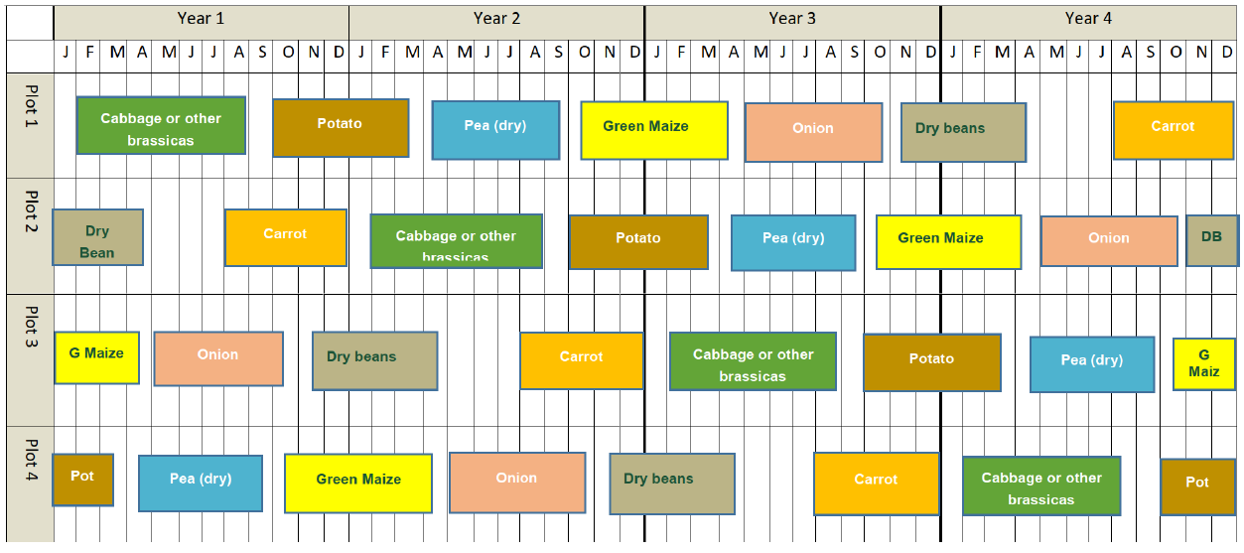
Supplementary Figure 3: Cropping Pattern 1

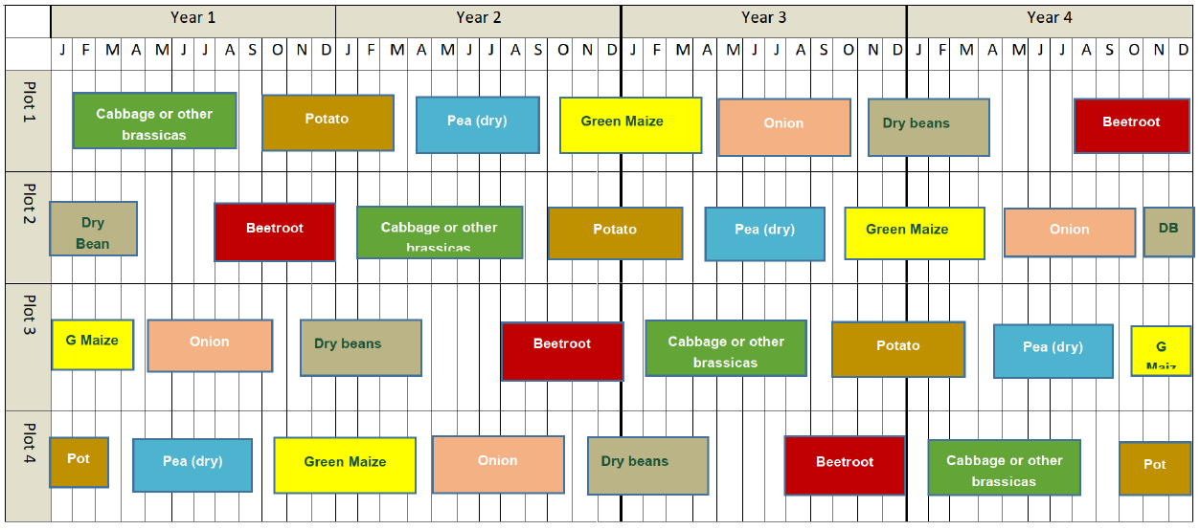
Supplementary Figure 4: Cropping Pattern 2
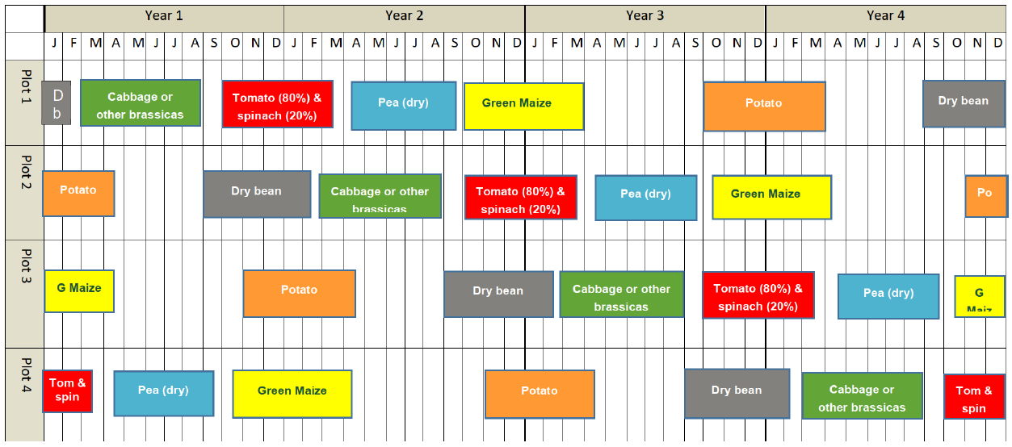
Supplementary Figure 5: Cropping Pattern 3

Groundwater Valuation
Groundwater makes up a relatively small proportion (11.4%) of total water use in Lesotho, but it is a principal source of potable water for the majority of the rural population (Leketa et al., 2018). Estimated groundwater abstractions for domestic use are 22,552,662 m³/year, far exceeding those for industrial use which total around 473,040 m³/year (Leketa et al., 2018). Use of developed and undeveloped springs as well as handpumps, high-capacity production boreholes and river abstraction (Senqu / Orange) systems are all somewhat contingent upon groundwater supplies. However, with the rapid growth within the Senqu (Orange) River Basin, dependence on groundwater resources has expanded greatly (WRP et al., 2007). Groundwater systems in the country often respond to short-term and long-term changes in climate variables, withdrawal, and land use. As the need for reliable year-round sources for towns becomes an increasing priority, several towns have augmented river abstraction systems with the conjunctive use of groundwater from boreholes and wellfields.

Groundwater Availability for the MDIH project
The water resources assessment for the MDIH project (AECOM, 2022a) notes that the limited groundwater resources in the region are already heavily committed to rural domestic water supply and would be insufficient for the purposes of large-scale commercial irrigated horticultural irrigation. Groundwater, in combination with rainwater harvesting from the facility roofs may, however, play a role in supplying potable water for the proposed training and / or service centers, as the costs of treating surface water intended for the irrigation schemes for this purpose would be prohibitive and potentially create competition for the water from the irrigation scheme supply infrastructure.
While no estimates of the volume of water needed to supply the training centers are provided from the feasibility studies, the Agronomic Assessment Report (AECOM, 2022b) estimates a water requirement of 200m³ per year for the service center housing the post-harvest handling (PHH) and integrated cold chain (ICC) facility at Phamong. It is not clear how much of this requirement could be met through rainwater harvesting, which would be less costly than groundwater abstraction, but from our analysis the implementation of ICM in the basin contributes an annual average range of 8,924 m³ to 126,483m³ to deep aquifer recharge across the climate scenarios examined. This suggests that the potable water demand for the service and training center at Phamong could be met by the groundwater recharge resulting from ICM measures and encouraged the inclusion of groundwater benefits in the assessment of the ICM scenario.

Groundwater Value
In purely financial terms, the value of groundwater can be derived from its uses, and from its local availability and quality compared with alternate sources of water (Foster and Chilton, 2022; Bann and Wood, 2012; Fenichel et al., 2016). Proper functioning of many lowland ecosystems also depends on groundwater discharge, including products they provide such as fish, fuel, and wood (Emerton and Bos 2004; Hérivaux and Grémont 2019). The economic value of groundwater can be divided into three main components (Deloitte, 2013; Qureshi et al., 2012):
- Extractive value which measures the value associated with the actual, intended, or potential use of the extracted groundwater by the various sectors of the economy.
- Non-extractive value such as the role that groundwater discharge plays in supporting ecosystems and wetlands, providing ‘base flow’ into surface water resources and supporting recreational activities.
- Option values relate to the value individuals derive from maintaining or preserving the groundwater for their own future benefit, or for future generations.
In addition, groundwater value is driven by a number of factors including its supply and demand and institutional and policy factors (Qureshi et al., 2012; Deloitte, 2013), including:
- The attributes of the groundwater resource (such as scarcity, quality, and reliability).
- The availability and cost of alternative water sources which in turn depend principally on location of use; and
- The type of use (such as irrigation, mining, manufacturing, domestic etc.).
The value of groundwater also has the potential to grow over time in response to increasing future water demands (population and economic growth) and / or growing scarcity or unreliability of surface water supplies as a result of low or less predictable rainfall.

Estimates of the Economic Value of Groundwater from Literature
There are relatively few published estimates of the economic value of groundwater. Where these do exist, they tend to be old (few published studies after 2016), focus on changes in the quality of groundwater (e.g. Rinaudo et al., 2005; Bergstrom et al., 2004; Brox et al., 2003; Hasler et al., 2005), examine the factors that affect groundwater value (Qureshi et al., 2012), or present frameworks for assessing the full range of groundwater benefits (or total economic value) (Department of Environment, 2014; Bann and Wood, 2012, Fenichel et al., 2016; Foster and Chilton, 2022). In cases where changes in groundwater supply are investigated, these are typically for a reduction in supply or to understand people’s preferences for impacts to wetlands and rivers caused by increased groundwater abstraction (e.g. Garrod, Powe and Willis, 2000).
Supplementary Table 6 summarizes the published values from the literature review conducted on economic value of groundwater. Studies undertaken before 2000 were not included in this review as these were considered less reliable given the advances in the application of environmental valuation techniques that have taken place over the past 20 years, and the biophysical, economic, and social changes that have taken place since then and which are likely to shape people’s preferences (demand) for water supply and quality attributes. Groundwater value is highly dependent and sensitive to location and end use which limits the choice of estimates suitable for use in benefits transfer. This is thus an added limitation to our study.

Supplementary Table 6: Summary of Literature Review on Groundwater Valuation (Published Values)
 | Published value | Currency | Unit | Price Year | Source
WTP to maintain groundwater benefits | 60-160 | USD | per HH | 2018 | Charalambous (2019); global median value based on a review of 50 studies
Shadow price of water for crop irrigation | 0.01-0.25 | USD | per m3 | 2018 | Bierkens et al (2019); based on marginal value of water for irrigation of four staple crops and 1 cash crop in the 11 most groundwater-depleted countries in the world
Value of the contribution that groundwater makes to the average acre of Kansas land with access to the aquifer | 17 | USD | per acre foot | 2016 | Fenichel et al (2016); represents value added to land prices for agricultural land overlying / with access to an aquifer
Value of flow regulation services attributable to native vegetation | 2.37 | ZAR | per m3 | 2017 | Turpie et al (2017); estimated in terms of the cost of providing equivalent artificial surface storage capacity required to maintain current water yields
Use value of groundwater | 2000 | AUS$ | per ML | 2013 | Deloitte (2013)
Value added by groundwater for agriculture and associated rural domestic supply | 1.21-2.69 | NAD | per m3 | 1999 (high)  2000 (low) | Bann and Wood (2012)
Value of groundwater recharge | 0.046 | Naira | per liter | 2002 | Acharya and Barbier (2002); groundwater recharge function performed by the Hadejia–Jama’are ﬂoodplain in northern Nigeria which is threatened by planned upstream water utilization schemes.
The values in Supplementary Table 6 were adjusted to the 2021 price year (based on available data) using GDP deflator data from the World Bank (World Bank, 2022) to obtain more current groundwater values for our analysis. Eq. 10 was used to calculate the adjusted groundwater values (Supplementary Table 7) used in our study from the values obtained in the literature.
$P_{later}= \frac{{RPI}_{later}}{{RPI}_{earlier}} ×P_{earlier}$ Eq. (12)
where,
P_{later} – Groundwater value in current analysis year (2021 in our case)
P_{earlier} – Groundwater value in earlier year (extracted from literature)
RPI_{later} – Retail price index in current analysis year (2021 in our case)
RPI_{earlier} – Retail price index in earlier year (based on values extracted from literature)
Supplementary Table 7: Summary of Literature Review on Groundwater Valuation (Adjusted Values for Analysis)
 | Base  (USD/m3) | Low  (USD/m3) | High  (USD/m3) | Unit | Notes
 | 0.20 | 0.01 | 0.67 | m3
 | Adjusted value | Currency | Unit | Price Year | Source
WTP to maintain groundwater benefits | 64.65 | USD | per HH | 2021 | Charalambous (2019) - low
WTP to maintain groundwater benefits | 172.41 | USD | per HH | 2021 | Charalambous (2019) - high
Shadow price of water for crop irrigation | 0.01 | USD | m3 | 2021 | Bierkens et al (2019) - low
Shadow price of water for crop irrigation | 0.27 | USD | m3 | 2021 | Bierkens et al (2019) - high
Value of the contribution that groundwater makes to the average acre of Kansas land with access to the aquifer | 0.02 | USD | m3 | 2021 | Fenichel et al (2016)
Value of flow regulation services attributable to native vegetation | 0.20 | USD | m3 | 2021 | Turpie et al (2017)
Use value of groundwater | 2.25 | USD | m3 | 2021 | Deloitte (2013)
Value added by groundwater for agriculture and associated rural domestic supply | 0.27 | USD | m3 | 2021 | Bann and Wood (2012) - low
Value added by groundwater for agriculture and associated rural domestic supply | 0.67 | USD | m3 | 2021 | Bann and Wood (2012) - high
Value of groundwater recharge | 0.01 | USD | m3 | 2021 | Acharya and Barbier (2002)

GCM Skill Assessment
To evaluate the fit of the GCMs, we compared seasonality (long-term average per month) and average annual depth of precipitation in the study area with historical GCM runs and observed data (from the Princeton dataset) between 1950-2011. From this simple assessment, we calculated,
- Correlations between monthly observed and GCM simulated precipitations
- Bias in precipitation depth of GCM simulated versus observed data.
- Predicted shift in long-term precipitation for each GCM relative to its historical baseline.
While there is no strict threshold recommendation for evaluating GCM fits, our analysis uses correlation threshold of 0.7 to select the final suite of GCMs to include in the analysis shown in Table 4 of the main manuscript. Supplementary Figure 6 visualizes the skill assessment for precipitation data from one of the GCM models. For the ACCESS-CM2 model, correlation was > 0.7 to the Princeton historical data and so it was included while calculating the climate-informed robustness index (CRI) using the bivariate normal distribution.
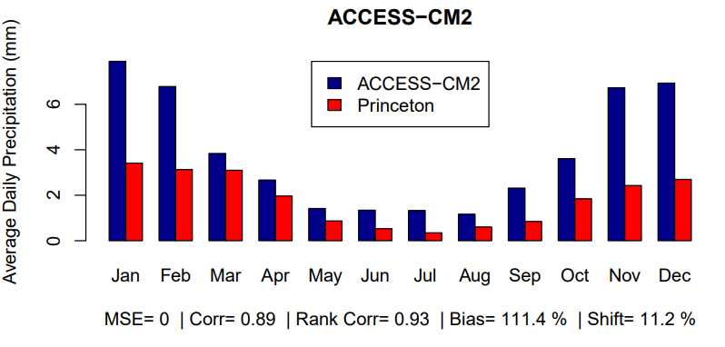
Supplementary Figure 6: Seasonality and fit of historical ACCESS-CM2 model simulations to Princeton Precipitation data (1950 – 2011)

References
Acharya, G. and Barbier, E.B. (2000). Valuing groundwater recharge through agricultural production in the Hadejia-Nguru wetlands in northern Nigeria. Agricultural Economics, 22 (3), 247-259.
Acharya, G. and Barbier, E.B., (2002). Using domestic water analysis to value groundwater recharge in the Hadejia-Jama'are floodplain, Northern Nigeria. American Journal of Agricultural Economics, 84 (2), 415-426.
AECOM. (2021). Lesotho: Feasibility Study on Potential Investments in Irrigated Agriculture and Associated Agronomic, Engineering, Economic, Environmental, and Social Assessments (Irrigation Water Demand Assessment Report).
AECOM. (2022a). Lesotho: Feasibility Study on Potential Investments in Irrigated Agriculture and Associated Agronomic, Engineering, Economic, Environmental, and Social Assessments (Provisional Environmental and Social Management Framework).
AECOM. (2022b). Lesotho: Feasibility Study on Potential Investments in Irrigated Agriculture and Associated Agronomic, Engineering, Economic, Environmental, and Social Assessments (Water Resources Assessment Report.
Arnold, J. G., Kiniry, J. R., Srinivasan, R., Williams, J. R., Haney, E. B., & Neitsch, S. L. (2013). No title. SWAT 2012 Input/Output Documentation,
Bann, C., & Wood, S.C. (2012). Valuing groundwater: A practical approach for integrating groundwater economic values into decision making–A case study in Namibia, Southern Africa. Water Sa, 38(3), 461-466.
Bergstrom, J.C., Boyle, K.J. and Yabe, M. (2004). Trading taxes vs. paying taxes to value and finance public environmental goods. Environmental & Resource Economics, 28 (4), 533-549.
Bierkens, M. F., Reinhard, S., de Bruijn, J. A., Veninga, W., & Wada, Y. (2019). The shadow price of irrigation water in major groundwater‐depleting countries. Water Resources Research, 55(5), 4266-4287.
Brox, J.A., Kumar R.C., and Stollery K.R. (2003) Estimating willingness to pay for improved water quality in the presence of item nonresponse bias. American Journal of Agricultural Economics, 85 (2), 414-428.
Boughton, W. C. (1989). A review of the USDA SCS curve number method. Soil Research, 27(3), 511–523.
Charalambous, A.N. (2019). Groundwater and its economic nature. Q J Eng Geol Hydrogeol 53:176–188.
Deloitte (2013) Economic value of groundwater in Australia [online] accessed at https://www2.deloitte.com/content/dam/Deloitte/au/Documents/finance/deloitte-au-fas-ncgrt-economic-value-groundwater-31-oct-2013-250914.pdf
Department of Environment, (2014). Lesotho environment outlook report 2014: Environment for national prosperity, Ministry of Tourism, Environment and Culture, Maseru, Lesotho, 280 p.
Emerton, L., & Bos, E. (2004). Value. Counting ecosystems as an economic part of water infrastructure. IUCN, Gland, Switzerland and Cambridge, UK, 88.
Fenichel, E. P., Abbott, J. K., Bayham, J., Boone, W., Haacker, E. M., & Pfeiffer, L. (2016). Measuring the value of groundwater and other forms of natural capital. Proceedings of the National Academy of Sciences, 113(9), 2382-2387.
Foster, S. and Chilton, J. (2022). Improving the valuation of groundwater. Hydrogeology Journal, 30: 1031-1034.
Garrod, G., Powe, N. and Willis, K. (2000). Hardham Artificial Recharge Economic Valuation Report prepared by University of Newcastle for Southern Water.
Hasler, B., Lundhede, T., Martinsen, L., Neye, S. and Schou, J. S. (2005). Valuation of groundwater protection versus water treatment in Denmark by choice experiments and contingent valuation. NERI Technical Report No. 543. Roskilde, Denmark: National Environmental Research Institute. Available from: http://www2.dmu.dk/1_viden/2_publikationer/3_fagrapporter/rapporter/FR543.pdf
Hérivaux, C., & Grémont, M. (2019). Valuing a diversity of ecosystem services: The way forward to protect strategic groundwater resources for the future? Ecosystem services, 35, 184-193.
Leketa, K., Migwi, M., Crane, E., Upton, K., Ó Dochartaigh, B.É. and Bellwood-Howard, I. (2018). Africa Groundwater Atlas: Hydrogeology of Lesotho. British Geological Survey. Accessed [date you accessed the information]. http://earthwise.bgs.ac.uk/index.php/Hydrogeology_of_Lesotho
Qureshi, M. E., Reeson, A., Reinelt, P., Brozovic, N., & Whitten, S. (2012). Factors determining the economic value of groundwater. Hydrogeology journal, 20(5), 821.
Rinaudo, J. D., Arnal, C., Blanchin, R., Elsass, P., Meilhac, A. and Loubier, S. (2005). Assessing the cost of groundwater pollution: the case of diffuse agricultural pollution in the Upper Rhine valley aquifer, Water Science and Technology, 52 (9), 153-162.
Turpie, J. K., Forsythe, K. J., Knowles, A., Blignaut, J., & Letley, G. (2017). Mapping and valuation of South Africa's ecosystem services: A local perspective. Ecosystem services, 27, 179-192.
World Bank (2022). GDP Deflator. https://data.worldbank.org/indicator/NY.GDP.DEFL.ZS?locations=LS
WRP Consulting Engineers et al (2007). Review of Groundwater Resources in the Orange River Catchment. Report prepared for ORASECOM as part of a study to inform the Orange River Integrated Water Resources Management Plan [online] available at https://orasecom.org/wp-content/uploads/2020/05/1941GROUNDWATER.pdf
Zölch, T., Henze, L., Keilholz, P., & Pauleit, S. (2017). Regulating urban surface runoff through nature-based solutions–an assessment at the micro-scale. Environmental Research, 157, 135-144.

