***Supplementary Material***

**Histological and transcriptome analyses provide insight into the interaction of grapeand *Colletotrichum viniferum***

Mengru Dou1,2,3, Yuhang Li1,2,3, Yu Hao1,2,3, Kangzhuang Zhang1,2,3, Xiao Yin1,2,3, Zinuo Feng1,2,3, Xi Xu1,2,3, Qi Zhang1,2,3, Wenwu Bao1,2, Xi Chen1,2,3, Guotian Liu1,2,3, Yuejin Wang1,2,3, Ling Tian4,*, Yan Xu1,2,3,*

1State Key Laboratory of Crop Stress Biology in Arid Areas, Northwest A&F University, Yangling, Shaanxi, P.R. China

2College of Horticulture, Northwest A&F University, Yangling, Shaanxi, P.R. China

3Key Laboratory of Horticultural Plant Biology and Germplasm Innovation in Northwest China, Ministry of Agriculture, Yangling, Shaanxi, P.R. China

4School of Management, Shenzhen Polytechnic University, Shenzhen, Guangdong, P.R. China

**\* Correspondence:**Corresponding Author:

Ling Tian ([tianling@szpu.edu.cn](mailto:tianling@szpu.edu.cn))

Yan Xu ([yan.xu@nwsuaf.edu.cn](mailto:yan.xu@nwsuaf.edu.cn))

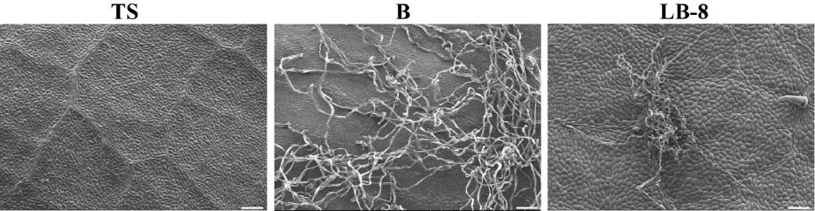**Figures**

**Figure S1**. The adaxial surface of leaves from different germplasms of grapevine was observed by SEM. Scale bar = 100 µm.

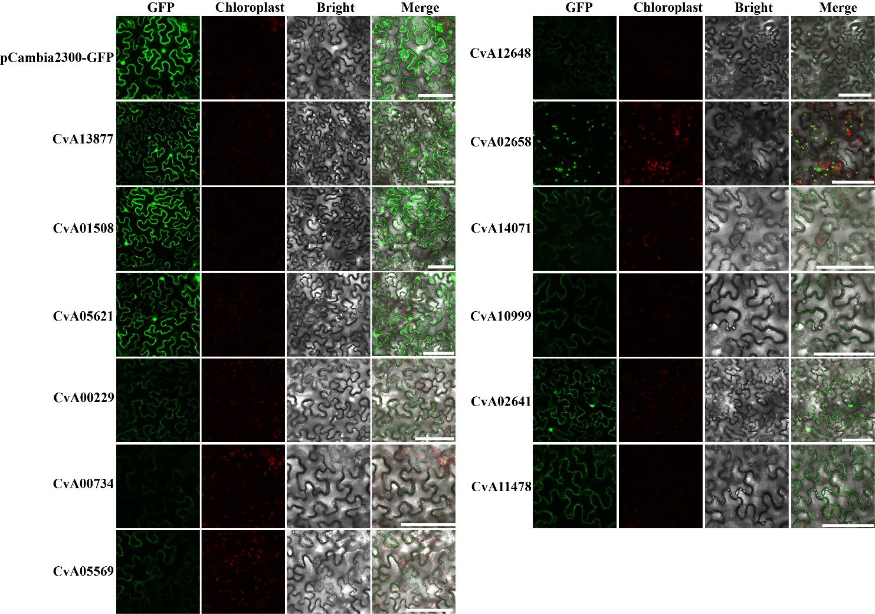

**Figure S2**. Subcellular localization of three effectors in *N. benthamiana* leaves: plasma membrane and the nucleus (CvA13877, CvA01508, CvA05621 and CvA02641), and plasma membrane (CvA00229, CvA00734, CvA05569, CvA12648 CvA14071, CvA10999 and CvA11478), and chloroplast (CvA02658). Effectors-GFP fusion proteins and GFP were transiently expressed in *N. benthamiana* following *Agrobacterium* transformation method. Photographs were taken 24 h after transformation. Scale bars = 100 µm.