Supplementary Material

Annex A: Derivation of Ekman layer depth
Ekman assumed a steady, homogeneous, horizontal flow with friction on a rotating Earth. Thus, horizontal and temporal derivate are zero:
$$\frac{∂}{∂t}=\frac{∂}{∂x}=\frac{∂}{∂y}=0 (A1)$$
Ekman further assumed a constant vertical eddy viscosity of the form:
$$T_{xz}=ρA_{z}\frac{∂u}{∂z} , T_{yz}=ρA_{z}\frac{∂v}{∂z} (A2)$$
Where $T_{xz}, T_{yz}$ are the components of the wind stress in the x and y directions and $ρ$ is the density of sea water.
With these assumptions the x and y components of the momentum equation have the form:
$$fv+A_{z}\frac{∂^{2}u}{∂z^{2}}=0 (A3)$$
$$-fu+A_{z}\frac{∂^{2}v}{∂z^{2}}=0 (A4)$$
Where $f$ is the Coriolis parameter. The solutions from the differential equations (A3) and (A4) are:
$$u=V_{o}exp\left(az\right)cos\left(\frac{π}{4}+az\right) (A5)$$
$$v=V_{o}exp\left(az\right)sin\left(\frac{π}{4}+az\right) (A6)$$
And when the wind is blowing to the north $(T=T_{yz})$ the constants are $V_{o}$ (velocity of the current at seas surface) y a:
$$V_{o}=\frac{T}{\sqrt{ρ_{w}^{2}fA_{z}}} , a=\sqrt{\frac{f}{2A_{z}}} \left(A7\right)$$
Ekman proposed that the Ekman layer depth $D_{E}$ at which the current velocity is opposite the velocity at the surface is given by:
$$D_{E}=\sqrt{\frac{2π^{2}A_{z}}{f}} (A8)$$
In order to derive a final expression more comprehensible we can use equation A7 and the wind stress definition given by:
$$T=ρ_{air}C_{D}U_{10}^{2} (A9)$$
Replacing A9 into A7 we got:
$$V_{o}=\frac{T}{\sqrt{ρ_{w}^{2}fA_{z}}}=\frac{ρ_{air}C_{D}U_{10}^{2}}{\sqrt{ρ_{w}^{2}fA_{z}}} (A10)$$
Solving $A_{z}$ from A8 we got:
$$D_{E}^{2}=\frac{2π^{2}A_{z}}{f}, A_{z}=\frac{f D_{E}^{2}}{2π^{2}} (A11)$$
Replacing A11 into A10 we have:
$$V_{o}=\frac{ρ_{air}C_{D}U_{10}^{2}}{\sqrt{ρ_{w}^{2}f(\frac{fD_{E}^{2}}{2π^{2}})}}=\frac{\sqrt{2}πρ_{air}C_{D}U_{10}^{2}}{ρ_{w}fD_{E}} (A12)$$
Additionally, Ekman proposed a solution for $V_{o}$ given by:
$$V_{o}=\frac{0.0127}{\sqrt{sin(φ)}}U_{10} (A13)$$
Where $φ$ represent the latitude. If we set equal A12 and A13 we have:
$$\frac{0.0127}{\sqrt{sin(φ)}}U_{10}=\frac{\sqrt{2}πρ_{air}C_{D}U_{10}^{2}}{ρ_{w}fD_{E}} (A14)$$
Solving $D_{E}$ from A14 we have:
$$D_{E}=\frac{\sqrt{2}π}{0.0127}\frac{ρ_{air}C_{D}\sqrt{sin(φ)}U_{10}}{ρ_{w}f} (A15)$$
And using the Coriolis parameter definition $f=2Ωsin(φ)$ with $Ω=\frac{2π}{86400}$ in A15 we got:
$$D_{E}=\frac{\sqrt{2}π}{0.0127}\frac{ρ_{air}C_{D}\sqrt{sin(φ)}U_{10}}{ρ_{w}2Ωsin(φ)}=\frac{\sqrt{2}π}{2(0.0127)}\frac{86400ρ_{air}C_{D}U_{10}}{2πρ_{w}\sqrt{sin(φ)}}=\frac{\sqrt{2} (86400)}{4(0.0127)}\frac{ρ_{air}C_{D}U_{10}}{ρ_{w}\sqrt{sin(φ)}} (A16)$$
For the calculation of the Ekman Layer Depth (D_{E}), data from ERA5 (Ta and SLP) and Global Ocean Ensemble Physics Reanalysis (temperature and salinity) were used. The density at the D_{E} was determine using the TEOS-10 equation (McDougall and Barker, 2011). Additionally, the Akima method (Wang et al., 2014) was utilized to interpolate the data from the Global Ocean Ensemble Physics Reanalysis, ensuring accurate values at each pixel and timestep for the corresponding depth.

Annex B: Validation of data
Table B1. Spatial Correlation (CORR), Root Mean Squared Error (RMSE) and Standard Deviation (STD) values for Sea surface temperature (SST), Sea surface salinity (SSS), Chlorophyll-a (Chla), Oxygen (Oxy), Mixed Layer Depth (MLD) and Sea Surface Height (SSH) in the four main upwelling systems during 2002-2019 compared against ARGO profiles (SST, SSS and Oxy) satellites (Chla and SSH) and the Mixed Layer Depth (MLD) contrasted with Argo profiles.

Variable | System | CORR |  |  |  | RMSE |  |  |  | STD
SST |  | DJF | MAM | JJA | SON | DJF | MAM | JJA | SON | DJF | MAM | JJA | SON
 | Benguela | 0.872 | 0.897 | 0.859 | 0.918 | 0.638 | 0.640 | 0.574 | 0.440 | 0.916 | 0.925 | 0.918 | 0.920
 | California | 0.966 | 0.964 | 0.944 | 0.949 | 0.350 | 0.316 | 0.399 | 0.512 | 0.969 | 0.943 | 0.927 | 0.925
 | Canarias | 0.960 | 0.969 | 0.896 | 0.929 | 0.296 | 0.261 | 0.512 | 0.567 | 0.919 | 0.924 | 0.799 | 0.901
 | Humboldt | 0.936 | 0.945 | 0.969 | 0.974 | 0.443 | 0.546 | 0.300 | 0.242 | 0.988 | 0.959 | 0.960 | 0.999
 | Benguela | 0.872 | 0.897 | 0.859 | 0.918 | 0.638 | 0.640 | 0.574 | 0.440 | 0.916 | 0.925 | 0.918 | 0.920
SSS | California | 0.973 | 0.955 | 0.936 | 0.962 | 0.240 | 0.302 | 0.376 | 0.276 | 0.918 | 0.995 | 1.071 | 0.940
 | Canarias | 0.898 | 0.917 | 0.896 | 0.859 | 0.454 | 0.416 | 0.450 | 0.520 | 1.016 | 1.031 | 0.957 | 0.964
 | Humboldt | 0.637 | 0.641 | 0.590 | 0.483 | 0.775 | 0.676 | 0.786 | 0.847 | 0.603 | 0.619 | 0.552 | 0.468
 | Benguela | 0.727 | 0.779 | 0.806 | 0.637 | 0.887 | 0.795 | 0.907 | 0.904 | 1.067 | 1.051 | 0.764 | 0.844
Chla | California | 0.887 | 0.848 | 0.818 | 0.836 | 0.577 | 0.738 | 0.619 | 0.593 | 1.078 | 1.275 | 1.012 | 0.949
 | Canarias | 0.816 | 0.827 | 0.777 | 0.871 | 0.901 | 1.001 | 1.020 | 0.535 | 1.305 | 1.406 | 0.947 | 0.773
 | Humboldt | 0.852 | 0.985 | 0.818 | 0.806 | 0.726 | 0.704 | 0.952 | 1.080 | 1.117 | 1.037 | 1.066 | 1.424
Oxy | Benguela | 0.951 | 0.745 | 0.843 | 0.816 | 0.420 | 0.598 | 0.281 | 0.286 | 0.991 | 1.055 | 1.234 | 1.009
 | California | 0.909 | 0.895 | 0.874 | 0.891 | 0.421 | 0.456 | 0.490 | 0.459 | 0.998 | 0.999 | 0.931 | 0.951
 | Canarias | 0.964 | 0.965 | 0.951 | 0.947 | 0.379 | 0.393 | 0.396 | 0.407 | 1.172 | 1.156 | 1.136 | 1.156
 | Humboldt | 0.870 | 0.855 | 0.866 | 0.879 | 0.659 | 0.736 | 0.689 | 0.647 | 0.769 | 0.763 | 0.761 | 0.758
MLD | Benguela | 0.923 | 0.921 | 0.924 | 0.913 | 1.060 | 1.079 | 1.098 | 1.091 | 1.351 | 1.371 | 1.400 | 1.366
 | California | 0.990 | 0.991 | 0.983 | 0.985 | 1.429 | 1.439 | 1.471 | 1.480 | 1.056 | 1.010 | 1.061 | 1.076
 | Canarias | 0.980 | 0.979 | 0.970 | 0.975 | 1.480 | 1.551 | 1.568 | 1.478 | 0.907 | 0.935 | 0.933 | 0.946
 | Humboldt | 0.979 | 0.982 | 0.987 | 0.986 | 1.993 | 1.976 | 1.926 | 1.945 | 1.056 | 1.048 | 1.034 | 1.038
SSH | Benguela | 0.923 | 0.922 | 0.924 | 0.913 | 1.060 | 1.079 | 1.097 | 1.090 | 1.351 | 1.371 | 1.400 | 1.366
 | California | 0.990 | 0.991 | 0.983 | 0.985 | 1.429 | 1.438 | 1.471 | 1.480 | 1.056 | 1.010 | 1.061 | 1.076
 | Canarias | 0.980 | 0.979 | 0.970 | 0.975 | 1.480 | 1.551 | 1.568 | 1.478 | 0.907 | 0.935 | 0.933 | 0.946
 | Humboldt | 0.979 | 0.982 | 0.987 | 0.986 | 1.993 | 1.976 | 1.926 | 1.945 | 1.056 | 1.048 | 1.040 | 1.038

Annex C: SOM parametrization and best topological structures
SOM parametrization are summarized on Table C1, Annex C following Liu et al (2006b). Six parameters are important in the performance of the SOM algorithm (Kohonen, 2014). First, the initialization parameter where we used linear since generates fewer iterations for QE convergence and smaller TE (Liu et al., 2006). Second, normalization involves the application of scaling methods such as MinMax, Z-score, or MaxAbs. However, MinMax scaling method is particularly advantageous as it ensures that the data range falls within 0 and 1, thereby providing equal importance to variables (Vesanto and Alhoniemi, 2000). Third, map-size where no theoretical principle of choice exists already (Liu et al., 2006; Kohonen, 2014), however there are two approaches to deal with this limitation: i) using a 1-step classification where the size is based on an optimal balance between interpretability and accuracy of the mapping (Hernández‐Carrasco and Orfila, 2018) or ii) using a 2-step classification with SOM as the first stage followed by Hierarchical Agglomerative Clustering (HAC) (Jouini et al., 2016). In this study we use the latter approach, and map-sizes were evaluated for a range of values m, r= 2, 3, 4, 5, where m= number of map rows and r= number of map columns (Supplementary material, Figure S1).
Fourth, neural lattice which is recommended to be rectangular for biophysical phenomena (Kohonen, 2014). Fifth, the neighborhood function, which can be Epanechikov, Gaussian, Cutgaussian and Bubble. For this study we use Gaussian since when we increase number of variables considered increases, introducing high order neighborhood functions has negligible effect on segmentation (Liu et al., 2006). Finally for the training process, we select batch strategy since not requires learning-rate adaptable and is faster and more robust respect the sequential strategy (Liu et al., 2006; Kohonen, 2014).
Table C1. SOM parameters and the optimal assigned values from Liu et al. (2006b)
Parameter type | Assigned value
Initialization | Linear
Normalization | Range scales between 0 and 1
Map size | Small (e.g 3x3, 3x4, 4x3)
Neural lattice | Rectangular
Neighborhood function | Gaussian
Training algorithm | Batch

Figure S1. Topological structure for the SOM algorithm evaluated for each season of the year (columns) and each upwelling system (rows) using topological error (black) and quantization error (blue) metrics. Note the difference in the scales on the y-axis because the metrics can differ and distort the comparison. The lower the metrics the better the performance. The configuration with the least structural complexity is selected if there are similar performances. Grey shading indicates the topological configuration selected for each case.

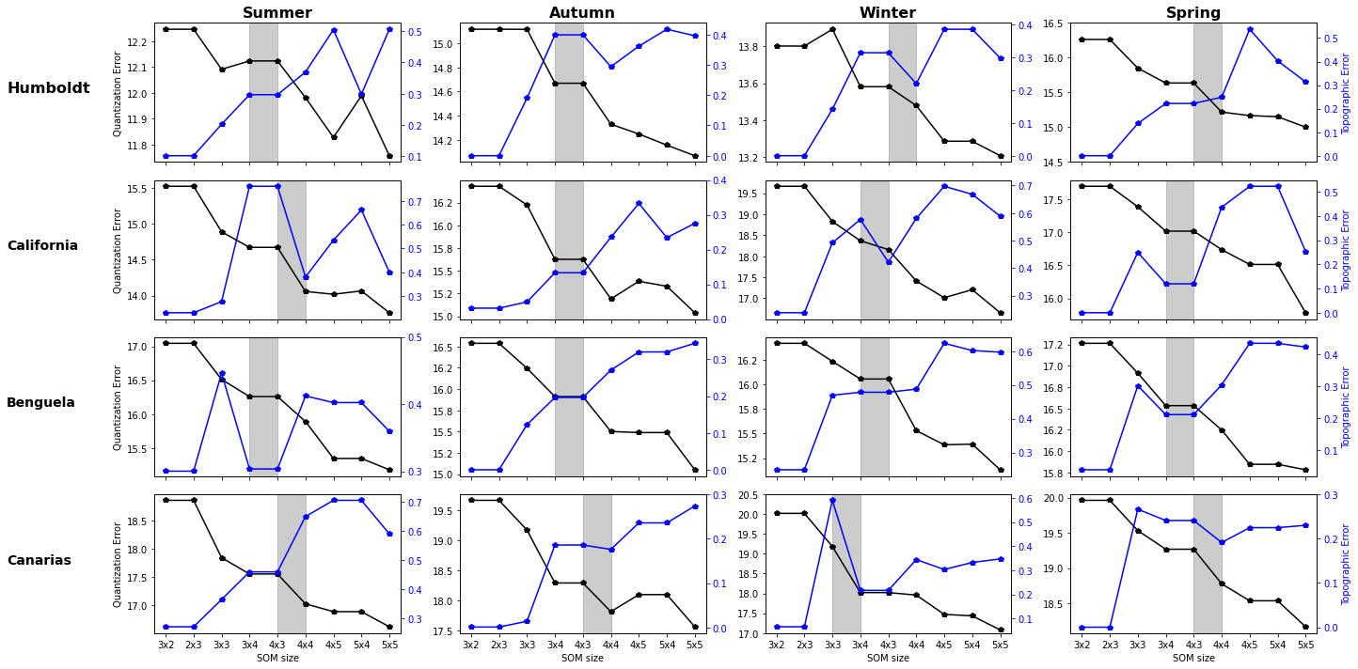
Figure S2. Dominant spatial pattern contribution to SLP anomalies (i.e. difference between 2007-2019 and 1993-2006). The first row is spring and the second one summer season.
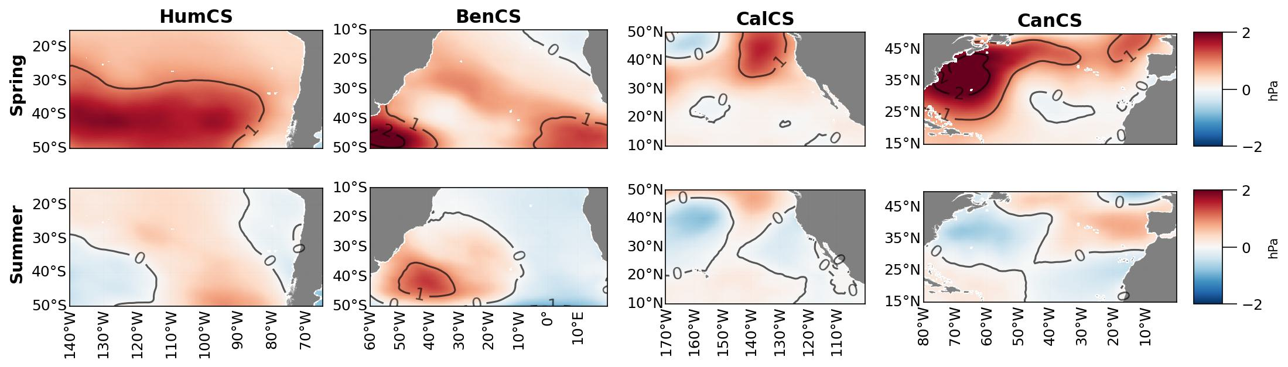

Figure S3. Measures of relative changes in the seasonal cycle (see Equation 5 in manuscript) at upwelling centers, applied to Pressure Gradient (PG), Temperature Gradient (TG), meridional wind (Mw), short-wave radiation (Qsw), sea-surface temperature (SST), mixed-layer depth (MLD, positive means deeper MLD), zonal Ekman transport (Ek), and Ekman pumping (Ep). Colors represent the magnitude of the change and indicate increases (red) and reductions (blue).
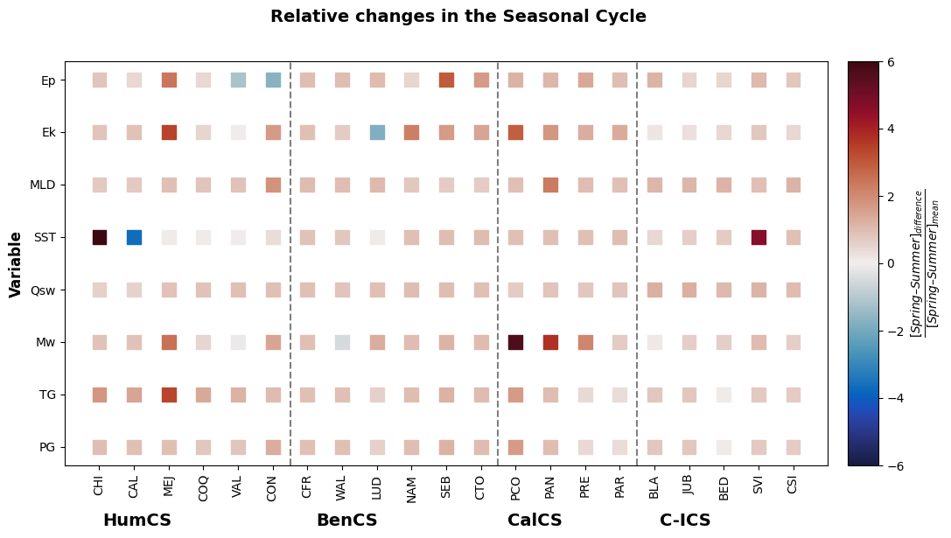

Annex D: Subtropical High Center detection algorithms
Table D1. Algorithm to detect Subtropical high centers (Gilliland and Keim, 2018)
Step | Description
1 | Calculate the mean SLP (M1) in the limits described in for each subtropical High for each day
2 | Select the grid points above M1 SLP value
3 | Calculate the mean SLP (M2) from the result obtained in Step 2
4 | Select the grid points above M2 SLP value
5 | Calculate the mean SLP (M3) from the result obtained in Step 4
6 | Select the grid points above M3 SLP value
7 | Filter all the grid points above one standard deviation from the step 6 calculation
8 | Calculate the mean latitude and longitude from grid points in step 7

Table D2. Algorithm to detect Subtropical high centers (Lambert, 1988; Murray and Simmonds, 1991)
Step | Description
1 | Filter the SLP from the limits described in for each subtropical High for each month
2 | The 8 and 40 nearest neighbor grid points are identified from the step 1
3 | For each grid point a candidate for the center must satisfy that SLP is >= than the 8 neighbor
4 | In addition to the condition in step 3, the SLP from candidate must be > than the remaining 40 neighbor
5 | In the case that more than one grid point present the same maximum SLP value the lowest latitude must be selected
6 | Select the grid points above M3 SLP value
7 | Filter all the grid points above one standard deviation from the step 6 calculation

Annex E: Second and third spatial patterns of variability description for SLP, Mw, Qsw, SST and Ep
Second spatial pattern of variability
The second spatial pattern of variability identified through the SOM-HAC technique reveals a considerable increase of SLP in the HumCS and CalCS regions towards the poles during spring (Fig. S5), contrasting with the observed pattern in C-ICS and BenCS. Consequently, there is an observed augmentation of Mean Wind (MW) towards mid-latitudes and the poles within the Pacific systems. Notably, C-ICS exhibits a declining trend towards the poles. Spatial patterns in SST and Ep are closely like those observed in the first spatial pattern of variability. Additionally, during summer (Fig. S6), there is a decline in SLP across mid-latitudes and towards the poles in all systems except C-ICS, where a sustained increase in Mw (> 6ms⁻¹) is evident throughout the system. SST and Ep patterns closely resemble those observed in spring, with typical increases in Qsw across all systems.
Third spatial pattern of variability
The third spatial pattern of variability in spring (Figure S7) starkly contrasts with the preceding spatial patterns, as evidenced by the decline in SLP, Mw and Qsw values towards the poles across all systems, except for HumCS. Additionally, all systems exhibit a notable rise in SST (>25°C) towards the equator. In summer (Figure S8), a noteworthy pattern emerges in HumCS, marked by an SST increase extending to 30°S, consequently Qsw increments are observed in all the system. Furthermore, there is a poleward SLP increase with moderate Mw increases in mid-latitudes, alongside a reduction in Ep in all the system. In contrast, BenCS displays a significant increase in SLP and Mw towards the poles, coupled with substantial SST drops towards the poles and Ep increases exceeding 0.1 md. Moreover, both BenCS and C-ICS exhibit reductions in Mw and SLP, with SST and Ep patterns not distinctly deviating from those observed in the first or second spatial patterns of variability.
Figure S4. Spatial structure during the spring season for the second spatial pattern of variability, visualized as dominant patterns in SLP (sea-level pressure), Mw (meridional wind), Qsw (shortwave radiation), SST (sea-surface temperature), and Ep (Ekman pumping) during periods when upwelling occurred. These variables are organized in columns, whereas the four rows of plots correspond to the EBUS regions analyzed.
Link: https://github.com/dfbustosus/Supplementary_Figures_SOM_EBUS/blob/main/Annex%20E/FigureS4.jpg
Figure S5. Same as Figure S4 but for summer.
Link: https://github.com/dfbustosus/Supplementary_Figures_SOM_EBUS/blob/main/Annex%20E/FigureS5.jpg
Figure S6. Spatial structure during the summer season for the third spatialpattern of variability, visualized as dominant patterns in SLP (sea-level pressure), Mw (meridional wind), Qsw (shortwave radiation), SST (sea-surface temperature), and Ep (Ekman pumping) during periods when upwelling occurred. These variables are organized in columns, whereas the four rows of plots correspond to the EBUS regions analyzed.
Link: https://github.com/dfbustosus/Supplementary_Figures_SOM_EBUS/blob/main/Annex%20E/FigureS6.jpg
Figure S7. Same as Figure S6 but for summer.
Link: https://github.com/dfbustosus/Supplementary_Figures_SOM_EBUS/blob/main/Annex%20E/FigureS7.jpg

Annex F: Principal spatial patterns of variability for SSS, SSH, Curl, Stress and MLD
First spatial pattern of variability (SSS, SSH, Curl, Stress and MLD)
Figure S8. Spatial structure during the spring season for the first spatial pattern of variability, visualized as dominant patterns in SSS (sea surface salinity), SSH (sea surface height), Curl (wind stress curl), Stress (surface wind stress), and MLD (Mixed Layer Depth) during periods when upwelling occurred. These variables are organized in columns, whereas the four rows of plots correspond to the EBUS regions analyzed.
Link: https://github.com/dfbustosus/Supplementary_Figures_SOM_EBUS/blob/main/Annex%20F/FigureS8.jpg
Figure S9. Same as Figure S8 but for summer
Link: https://github.com/dfbustosus/Supplementary_Figures_SOM_EBUS/blob/main/Annex%20F/FigureS9.jpg
Second spatial pattern of variability (SSS, SSH, Curl, Stress and MLD)
Figure S10. Spatial structure during the spring season for the second spatial pattern of variability, visualized as dominant patterns in SSS (sea surface salinity), SSH (sea surface height), Curl (wind stress curl), Stress (surface wind stress), and MLD (Mixed Layer Depth) during periods when upwelling occurred. These variables are organized in columns, whereas the four rows of plots correspond to the EBUS regions analyzed.
Link: https://github.com/dfbustosus/Supplementary_Figures_SOM_EBUS/blob/main/Annex%20F/FigureS10.jpg
Figure S11. Same as Figure S10 but for summer
Link: https://github.com/dfbustosus/Supplementary_Figures_SOM_EBUS/blob/main/Annex%20F/FigureS11.jpg
Third spatial pattern of variability (SSS, SSH, Curl, Stress and MLD)
Figure S12. Spatial structure during the spring season for the third spatial pattern of variability, visualized as dominant patterns in SSS (sea surface salinity), SSH (sea surface height), Curl (wind stress curl), Stress (surface wind stress), and MLD (Mixed Layer Depth) during periods when upwelling occurred. These variables are organized in columns, whereas the four rows of plots correspond to the EBUS regions analyzed.
Link: https://github.com/dfbustosus/Supplementary_Figures_SOM_EBUS/blob/main/Annex%20F/FigureS12.jpg
Figure S13. Same as Figure S12 but for summer
Link: https://github.com/dfbustosus/Supplementary_Figures_SOM_EBUS/blob/main/Annex%20F/FigureS13.jpg
First spatial pattern of variability (Ta,Zw, v, SSC and SSO)
Figure S14. Spatial structure during the spring season for the dominant spatial patten of variability, visualized as dominant patterns in Ta (air temperature), Zw (zonal wind), v (meridional wind current), SSC (sea surface chlorophyll) and SSO (Sea surface Oxygen) during periods when upwelling occurred. These variables are organized in columns, whereas the four rows of plots correspond to the EBUS regions analyzed.
Link: https://github.com/dfbustosus/Supplementary_Figures_SOM_EBUS/blob/main/Annex%20F/FigureS14.jpg
Figure S15. Same as Figure S14 but for summer
Link: https://github.com/dfbustosus/Supplementary_Figures_SOM_EBUS/blob/main/Annex%20F/FigureS15.jpg
Second spatial pattern of variability (Ta,Zw, v, SSC and SSO)
Figure S16. Spatial structure during the spring season for the second spatial pattern of variability, visualized as dominant patterns in Ta (air temperature), Zw (zonal wind), v (meridional wind current), SSC (sea surface chlorophyll) and SSO (Sea surface Oxygen) during periods when upwelling occurred. These variables are organized in columns, whereas the four rows of plots correspond to the EBUS regions analyzed.
Link: https://github.com/dfbustosus/Supplementary_Figures_SOM_EBUS/blob/main/Annex%20F/FigureS16.jpg
Figure S17. Same as Figure S16 but for summer
Link: https://github.com/dfbustosus/Supplementary_Figures_SOM_EBUS/blob/main/Annex%20F/FigureS17.jpg
Third spatial pattern of variability (Ta,Zw, v, SSC and SSO)
Figure S18. Spatial structure during the spring season for the third spatial pattern of variability, visualized as dominant patterns in Ta (air temperature), Zw (zonal wind), v (meridional wind current), SSC (sea surface chlorophyll) and SSO (Sea surface Oxygen) during periods when upwelling occurred. These variables are organized in columns, whereas the four rows of plots correspond to the EBUS regions analyzed.
Link: https://github.com/dfbustosus/Supplementary_Figures_SOM_EBUS/blob/main/Annex%20F/FigureS18.jpg
Figure S19. Same as Figure S19 but for summer
Link: https://github.com/dfbustosus/Supplementary_Figures_SOM_EBUS/blob/main/Annex%20F/FigureS19.jpg
References
Gilliland, J. M., and Keim, B. D. (2018). Position of the South Atlantic Anticyclone and its impact on surface conditions across Brazil. Journal of Applied Meteorology and Climatology 57, 535–553.
Hernández‐Carrasco, I., and Orfila, A. (2018). The Role of an Intense Front on the Connectivity of the Western Mediterranean Sea: The Cartagena‐Tenes Front. Journal of Geophysical Research: Oceans 123, 4398–4422.
Jouini, M., Béranger, K., Arsouze, T., Beuvier, J., Thiria, S., Crépon, M., et al. (2016). The Sicily Channel surface circulation revisited using a neural clustering analysis of a high‐resolution simulation. Journal of Geophysical Research: Oceans 121, 4545–4567.
Kohonen, T. (2014). MATLAB Implementations and Applications of the Self-Organizing Map. Helsinki, Unigrafia Oy.
Lambert, S. J. (1988). A cyclone climatology of the Canadian Climate Centre general circulation model. Journal of Climate 1, 109–115.
Liu, Y., Weisberg, R. H., and Mooers, C. N. (2006). Performance evaluation of the self‐organizing map for feature extraction. Journal of Geophysical Research: Oceans 111.
McDougall, T. J., and Barker, P. M. (2011). Getting started with TEOS-10 and the Gibbs Seawater (GSW) oceanographic toolbox. Scor/Iapso WG 127, 1–28.
Murray, R. J., and Simmonds, I. (1991). A numerical scheme for tracking cyclone centres from digital data. Australian meteorological magazine 39, 155–166.
Vesanto, J., and Alhoniemi, E. (2000). Clustering of the self-organizing map. IEEE Transactions on neural networks 11, 586–600.
Wang, Y., Yang, D., and Liu, Y. (2014). A real-time look-ahead interpolation algorithm based on Akima curve fitting. International Journal of Machine Tools and Manufacture 85, 122–130.

