**Title**: Heat-absorbing sexual coloration co-adapts with increased heat tolerance in dragonflies.

**Supplementary material**

*Examining effects of ornament darkness and position*

Beyond testing for effects of the presence/absence of wing coloration, we also examined whether species with the highest *CT*max also had wing coloration that was darker and closer to the body, as we expected these traits to lead to the greatest heating. We fit ornament darkness and position as continuous responses in phylogenetic generalized least squares models. To determine each species’ ornament darkness (dark = 2; light = 1; none = 0), we used the designations published in Moore et al. (2021). We examined images from iNaturalist observations to determine the position of each species’ male wing coloration (2 = adjacent to the body; 1 = distal; 0 = none). Species received a score of “2” if they possessed wing coloration that was concentrated in cells adjacent to the axillary sclerite, where the wing attaches to the body. Species received a score of “1” if their wing coloration was concentrated away from the body, and in some observations was more faded in proximal wing cells compared to distal wing cells. Species with no wing coloration received a score of “0”. Following Moore et al. (2021), we used two approaches to test if species that have the highest *CT*max have also evolved darker ornaments with color that is concentrated close to the body.

First, we treated ornament darkness and position as continuous responses in phylogenetic generalized least squares models. We loge-transformed(+1) ornament darkness and color position to improve model fit. In both models, we included species’ *CT*max as a continuous fixed effect. For ornament darkness, a model with Pagel’s *λ* branch-length transformation and a model with no phylogeny received similar support (Pagel’s *λ*:df = 4; AIC = 20.7; No phylogeny: df = 3; AIC = 20.9) compared to a model with Brownian motion (df = 3; AIC = 33.1). We favored the model without phylogeny for ornament darkness because it had fewer parameters. The models for color position showed the most support for Pagel’s *λ* branch-length transformation (df = 4; AIC = 11.7) compared to a model without phylogeny (df = 3; AIC = 14.3) and a model with Brownian motion (df = 3; AIC = 19.1). These analyses show that species with the highest *CT*max also have the darkest wing coloration (LR $χ_{1}^{2}$ = 5.44, P = 0.0197) and coloration that is concentrated close to the body (LR $χ_{1}^{2}$ = 22.56, P < 0.001).

Second, we fit phylogenetic generalized least squares models with ornament darkness and position as categorical effects. In both models, we included species’ *CT*max as a continuous response. For ornament darkness, a model without phylogeny received the best support (df = 3; AIC = 79.2) compared to a model with Pagel’s *λ* branch-length transformation (df = 4; AIC = 80.1) and a model with Brownian motion (df = 3; AIC = 90.0). The models for color position showed similar support for Pagel’s *λ* branch-length transformation (df = 4; AIC = 71.8) and a model without phylogeny (df = 3; AIC = 73.0) compared to Brownian motion (df = 3; AIC = 77.5). However, we favored the model without phylogeny for color position because it had fewer parameters than the Pagel’s *λ* model. We found that species with the darkest wing coloration had significantly higher *CT*max than species without ornaments (dark – none = 2.15, 95%CI = 0.14 to 4.16), and that species with lighter wing coloration had intermediate *CT*max values that did not significantly differ from the other two groups (light – none = 1.62, 95%CI = -2.72 to 5.97; light – dark = -0.53, 95%CI = -4.98 to 3.92). Species with wing coloration that is concentrated adjacent to the body also had higher *CT*max than species without ornaments (adjacent – none = 3.36, 95%CI = 1.56 to 5.17) and species with wing coloration that is concentrated away from the body (adjacent – distal = 3.40, 95%CI = 0.96 to 5.85). However, *CT*max did not significantly differ between species with wing coloration that is concentrated away from the body and species without ornaments (distal – none = -0.05, 95%CI = -2.23 to 2.14).

*Determining interspecific climate conditions*

We determined whether species inhabited temperate versus tropical climates by examining the mean annual temperature that each species experiences across their entire range. For fifteen species, we used published interspecific data on range-wide mean annual temperature (Moore et al., 2021, 2024b). For the remaining four species (*Epigomphus quadracies, Micrathyria ocellata, Tramea cophysa,* and *Tramea binotata*), we quantified range-wide temperatures using the same methods as Moore et al. (2021, 2024b). We gathered 1113 occurrence records of these species from the Global Biodiversity Information Facility and generated a presence/absence matrix of 1º latitude by 1º longitude grid cells across their geographic extents (Vilela and Villalobos, 2015). We scored species as present if at least one observation was found within a cell. To quantify the temperatures across each species’ range, we used the average mean annual temperature (Fick and Hijmans, 2017) across all of the grid cells where the species occurred. The species in our dataset showed a clear bimodal distribution of temperatures across their ranges (Fig. S1), so we grouped species into five “temperate” (cool climate) and fourteen “tropical” species (warm climate).

*GBIF data references:*

GBIF.org (09 June 2024) GBIF Occurrence Download <https://doi.org/10.15468/dl.nxx3k9>

GBIF.org (09 June 2024) GBIF Occurrence Download <https://doi.org/10.15468/dl.8kauuw>

GBIF.org (09 June 2024) GBIF Occurrence Download <https://doi.org/10.15468/dl.ekuedu>

GBIF.org (09 June 2024) GBIF Occurrence Download <https://doi.org/10.15468/dl.mnazyz>

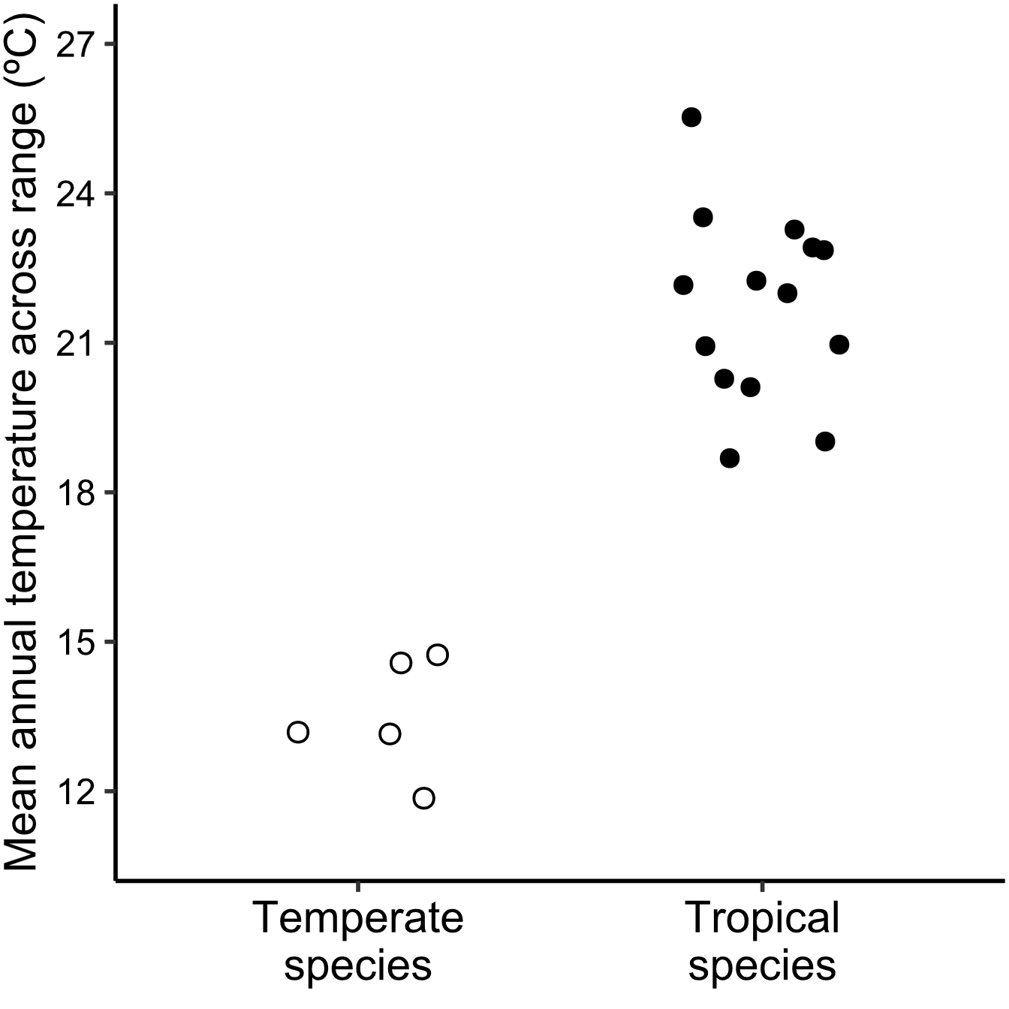

**Figure S1.** Species’ climates were determined from similarities in the mean annual temperatures found across their ranges. The five temperate species are shown with open circles and the fourteen tropical species are shown with closed circles.

**Table S1.** Model comparisons to determine how to incorporate phylogenetic signal in our phylogenetic generalized least squares analyses. For models separated by less than 2 units, the preferred model has fewer degrees of freedom.

|  |  |  |  |  |  |  |
| --- | --- | --- | --- | --- | --- | --- |
| Species subset | Rank | Model of evolution | df | AIC | ΔAIC | Weight |
| Temperate & tropical  (n = 19) | 1 | No phylogeny | 3 | 80.5 | 0 | 0.605 |
| 2 | Pagel’s *λ* | 4 | 81.4 | 0.86 | 0.393 |
| 3 | Brownian motion | 3 | 91.8 | 11.25 | 0.002 |
| Tropical only  (n = 14) | 1 | No phylogeny | 3 | 60.1 | 0 | 0.997 |
| 2 | Brownian motion | 3 | 71.7 | 11.60 | 0.003 |

**Table S2.** Patterns of correlated evolution between wing coloration and heat tolerance (*CT*max). Results were obtained from phylogenetic generalized least squares models fit using no phylogeny, Pagel’s *λ* branch-length transformation, and Brownian Motion. Pagel’s *λ* models did not converge for the analysis that included only tropical species. Significance was assessed using likelihood ratio tests.

|  |  |  |  |  |  |  |  |
| --- | --- | --- | --- | --- | --- | --- | --- |
| Species subset | Model of evolution | Variable | LR $χ_{1}^{2}$ | df | P | *β* ± SE | 95% CI |
| Temperate & tropical  (n = 19) | No phylogeny | Wing color | 5.40 | 1 | 0.0201 | 2.08 ± 0.88 | 0.37 to 3.81 |
| Pagel’s *λ* | Wing color | 13.25 | 1 | 0.0003 | 0.89 ± 0.97 | -1.02 to 2.79 |
| Brownian | Wing color | 13.13 | 1 | 0.0003 | 2.96 ± 0.72 | 1.55 to 4.38 |
| Tropical only  (n = 14) | No phylogeny | Wing color | 5.99 | 1 | 0.0144 | 2.68 ± 1.09 | 0.60 to 4.76 |
| Brownian | Wing color | 12.57 | 1 | 0.0004 | 3.25 ± 0.78 | 1.73 to 4.77 |

**Table S3.** Results from phylogenetic path analysis comparing models of hypothesized evolutionary relationships among wing coloration (yes/no), heat tolerance (*CT*max), and climate (temperate/tropical). All models use Pagel’s *λ* branch-length transformation.

|  |  |  |  |  |  |  |
| --- | --- | --- | --- | --- | --- | --- |
| Model | C | P | CICc | ΔCICc | Relative Likelihood | Weight |
| **(Fig. 2A)** *CT*max compensates for wing color evolution | 4.91 | 0.297 | 15.8 | 0.00 | 1.00 | 0.566 |
| **(Fig. 2B)** *CT*max limits wing color evolution; Climate directly affects *CT*max evolution | 3.05 | 0.217 | 17.7 | 1.90 | 0.39 | 0.219 |
| **(Fig. 2C)** *CT*max compensates for wing color evolution; Climate directly affects color evolution | 4.17 | 0.124 | 18.8 | 3.01 | 0.22 | 0.125 |
| **(Fig. 2D)** *CT*max limits wing color evolution | 8.58 | 0.077 | 19.4 | 3.66 | 0.16 | 0.091 |

**Table S4.** Model comparisons to determine how to incorporate phylogenetic signal in our phylogenetic generalized least squares analyses using only the species measured in May (1976) and species in the family Libellulidae.

|  |  |  |  |  |  |  |
| --- | --- | --- | --- | --- | --- | --- |
| Species subset | Rank | Model of evolution | df | AIC | ΔAIC | Weight |
| Species reported in May (1976)  (n = 13) | 1 | Pagel’s *λ* | 4 | 45.4 | 0 | 0.673 |
| 2 | Brownian motion | 3 | 47.2 | 1.73 | 0.283 |
| 3 | No phylogeny | 3 | 50.9 | 5.44 | 0.044 |
| Species in Libellulidae  (n = 15) | 1 | No phylogeny | 3 | 64.1 | 0 | 0.381 |
| 2 | Pagel’s *λ* | 4 | 64.2 | 0.09 | 0.364 |
| 3 | Brownian motion | 3 | 64.9 | 0.80 | 0.255 |

**Table S5.** Patterns of correlated evolution between wing coloration and heat tolerance (*CT*max) using only the species measured in May (1976) and species in the family Libellulidae. Results were obtained from phylogenetic generalized least squares models fit using no phylogeny, Pagel’s *λ* branch-length transformation, and Brownian Motion. Significance was assessed using likelihood ratio tests.

|  |  |  |  |  |  |  |  |
| --- | --- | --- | --- | --- | --- | --- | --- |
| Species subset | Model of evolution | Variable | LR $χ_{1}^{2}$ | df | P | *β* ± SE | 95% CI |
| Species reported in May (1976)  (n = 13) | Pagel’s *λ* | Wing color | 4.23 | 1 | 0.0396 | 1.29 ± 0.61 | 0.10 to 2.48 |
| Brownian | Wing color | 2.65 | 1 | 0.1033 | 0.83 ± 0.53 | -0.20 to 1.86 |
| No phylogeny | Wing color | 5.16 | 1 | 0.0231 | 2.02 ± 0.87 | 0.31 to 3.73 |
| Species in Libellulidae  (n = 15) | No phylogeny | Wing color | 3.80 | 1 | 0.0514 | 1.94 ± 1.00 | -0.03 to 3.90 |
| Pagel’s *λ* | Wing color | 3.15 | 1 | 0.0759 | 1.68 ± 0.99 | -0.26 to 3.62 |
| Brownian | Wing color | 5.53 | 1 | 0.0187 | 1.76 ± 0.73 | 0.33 to 3.19 |