An Automated Syringe-based PoC RT-LAMP LFB Design for Infectious Disease Detection from Saliva

Dulguunnaran Naranbat1, John Murphy1, and Anubhav Tripathi1.

1Center for Biomedical Engineering, School of Engineering, Brown University, Providence, RI 02912, USA

[*To whom correspondence may be addressed. E-mail: [anubhav_tripathi@brown.edu](mailto:anubhav_tripathi@brown.edu)]

Supplementary Material

# Data availability

The datasets used in this study are available in the NCBI library (GeneBank: MT007544.1 and NCBI Reference Sequence: NM_001101.5).

[**Table S1**](https://docs.google.com/document/d/181LL2D0whNkfQTiMQFgve5WnUUWKpblr2Le16PWZSws/edit#stabl_targeted_size). Targeted N2 and ACTB gene designated site size and the predicted FIP loop, BIP loop, and First dumbbell size.

|  |  |  |
| --- | --- | --- |
| **Targeted regions** | **Size (mer)** | |
| N2 | ACTB |
| Total region | 188 | 212 |
| F3c | 21 | 18 |
| F2c | 22 | 18 |
| LF | 21 | 21 |
| F spacer I (F2c - LF) | 1 | 0 |
| F1c | 19 | 22 |
| F spacer II (LF - F1c) | 3 | 5 |
| B3c | 25 | 25 |
| B2c | 21 | 21 |
| LB | 20 | 20 |
| B spacer I (B2 - LBc) | 0 | 4 |
| B1c | 19 | 19 |
| B spacer II (LBc - B1) | 3 | 0 |
| F and B spacer (F1c - B1) | 5 | 35 |
| FIP loop | 87 | 88 |
| BIP loop | 82 | 84 |
| First dumbell | 134 | 165 |

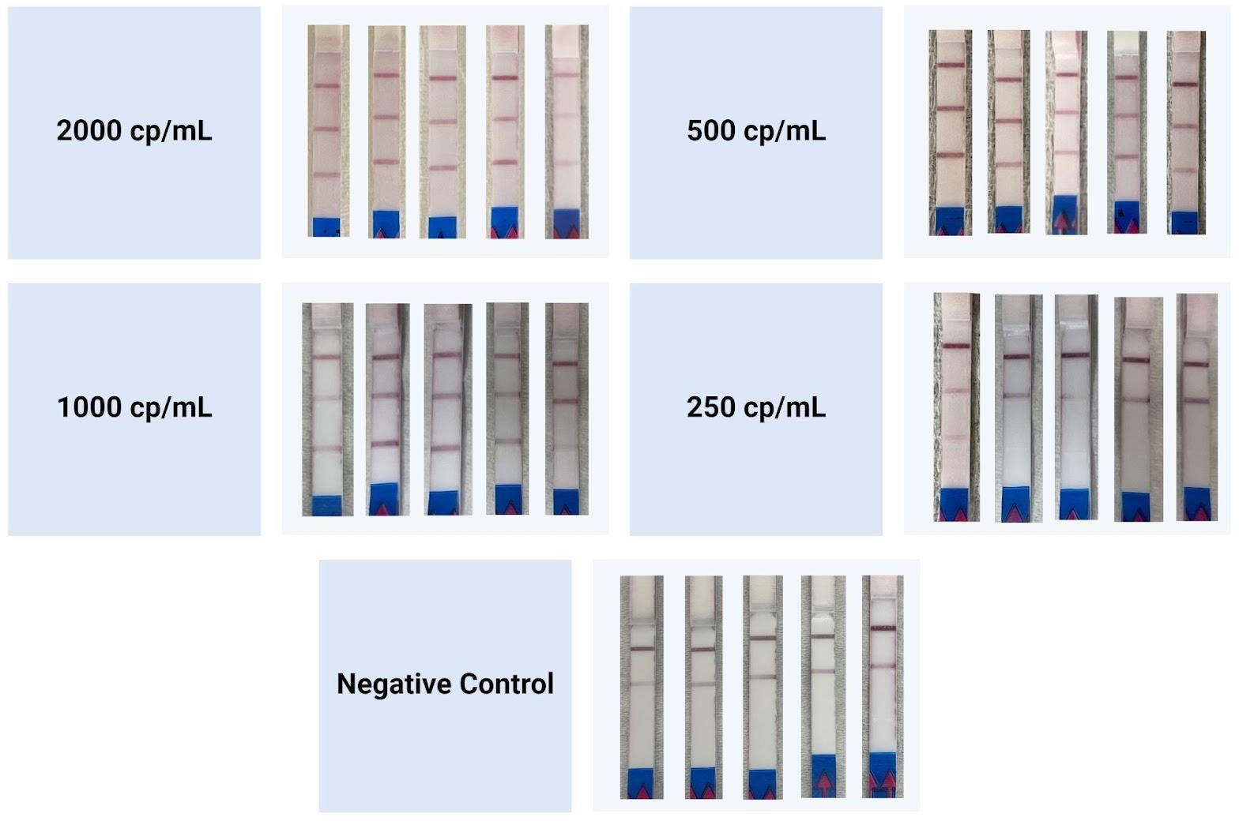

[**Figure S1**](https://docs.google.com/document/d/181LL2D0whNkfQTiMQFgve5WnUUWKpblr2Le16PWZSws/edit#sfigu_LFB_readouts). LFB readouts of amplicons from SPoC at different SARS-CoV-2 spike-in concentrations. From top to bottom, the observable bands read the control band, ACTB target amplification band, and N2 amplification band.

[**Table S2**](https://docs.google.com/document/d/181LL2D0whNkfQTiMQFgve5WnUUWKpblr2Le16PWZSws/edit#stabl_smt_measurment). Measured saliva displacement gravimetric weight (g) of a typical pipettor (control) set at 200 μL and the Saliva Measuring Tube (SMT).

|  |  |  |
| --- | --- | --- |
| Trial | Treatment | Weight (g) |
| 1 | Control | 0.1903 |
| 2 | Control | 0.1998 |
| 3 | Control | 0.2066 |
| 4 | Control | 0.1912 |
| 5 | Control | 0.1914 |
| 6 | Control | 0.2008 |
| 7 | Control | 0.202 |
| 8 | Control | 0.1922 |
| 9 | Control | 0.1925 |
| 10 | Control | 0.1894 |
| 11 | Control | 0.1966 |
| 12 | Control | 0.1945 |
| 13 | Control | 0.193 |
| 14 | Control | 0.189 |
| 15 | Control | 0.2033 |
| 16 | Control | 0.196 |
| 17 | Control | 0.2012 |
| 18 | Control | 0.1873 |
| 19 | Control | 0.1889 |
| 20 | Control | 0.1999 |
| 1 | SMT | 0.1977 |
| 2 | SMT | 0.2015 |
| 3 | SMT | 0.1985 |
| 4 | SMT | 0.2158 |
| 5 | SMT | 0.1873 |
| 6 | SMT | 0.2059 |
| 7 | SMT | 0.2147 |
| 8 | SMT | 0.1983 |
| 9 | SMT | 0.2093 |
| 10 | SMT | 0.1972 |
| 11 | SMT | 0.2106 |
| 12 | SMT | 0.2068 |
| 13 | SMT | 0.2019 |
| 14 | SMT | 0.1983 |
| 15 | SMT | 0.2071 |
| 16 | SMT | 0.2002 |
| 17 | SMT | 0.2155 |
| 18 | SMT | 0.2049 |
| 19 | SMT | 0.2124 |
| 20 | SMT | 0.2014 |