**Supplementary Material**

**CRISPR-Cas9/Cas12a Systems for efficient genome editing and large genomic fragment deletions in *Aspergillus niger***

Guoliang Yuan 1,2,*, Shuang Deng 1,2, Jeffrey J. Czajka 1,2, Ziyu Dai 1,2, Beth A. Hofstad 1,2, Joonhoon Kim 1,2 and Kyle R. Pomraning 1,2,*

1Energy and Environment Directorate, Pacific Northwest National Laboratory, Richland, WA, United States

2US Department of Energy Agile BioFoundry, Emeryville, CA, United States

*Corresponding authors: Guoliang Yuan (guoliang.yuan@pnnl.gov); Kyle R. Pomraning ([kyle.pomraning@pnnl.gov](mailto:kyle.pomraning@pnnl.gov))

**Supplementary Figure S1. Single colonies can be identified under a dissection microscope (Leica MZ16) 19–24 hours post-transformation.**

The red circles highlight the individual colonies.

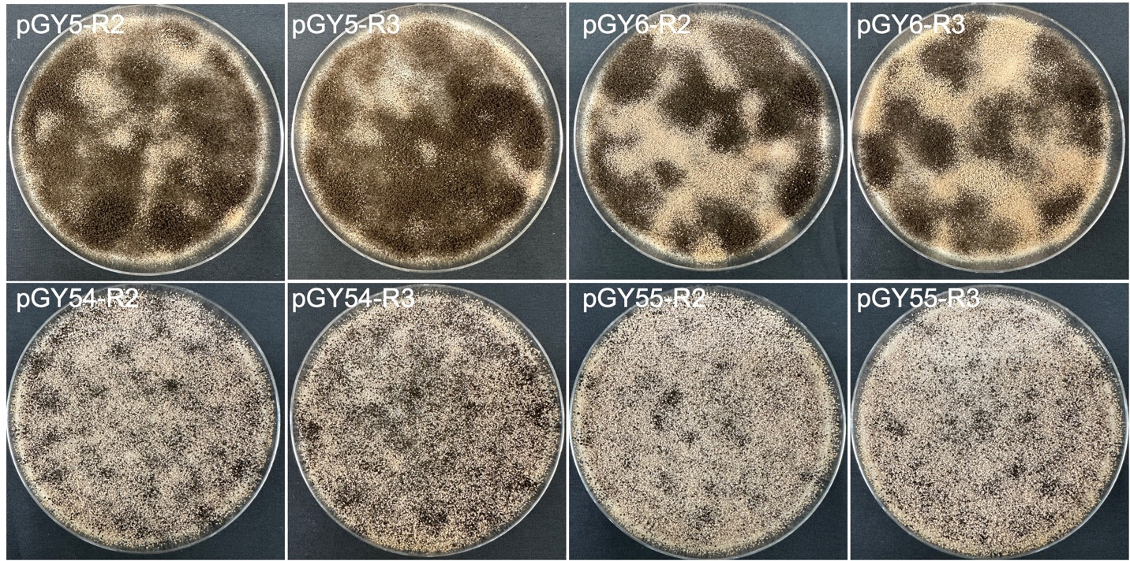

**Supplementary Figure S2. Phenotypic effects of *albA* mutations induced by Cas9 and Cas12a systems (Replicate 2 and 3).**

R stands for a biological replicate.

**Supplementary Figure S3. Phenotypic characteristics of transformants targeting the *albA* gene after single colony isolation on an minimal medium agar slant.**

**Supplementary Figure S4. Phenotypic effects of large chromosome fragment deletion induced by CRISPR-Cas9 and Cas12a systems (Replicate 2 and 3).**

R stands for a biological replicate.

**Supplementary Figure S5. Phenotypic characteristics of selected transformants with large fragment deletions after isolating single colonies on an agar slant.**