Suppl. figure 1: Risk of bias assessment of included studies, using adapted version of Critical Appraisal Skills Programme (CASP) cohort study checklist and display conventions of Arrias et al.ª 1. Study population; 2. Selection bias; 3. Ascertainment of diagnosis; 4. Outcomes; 5. Results.
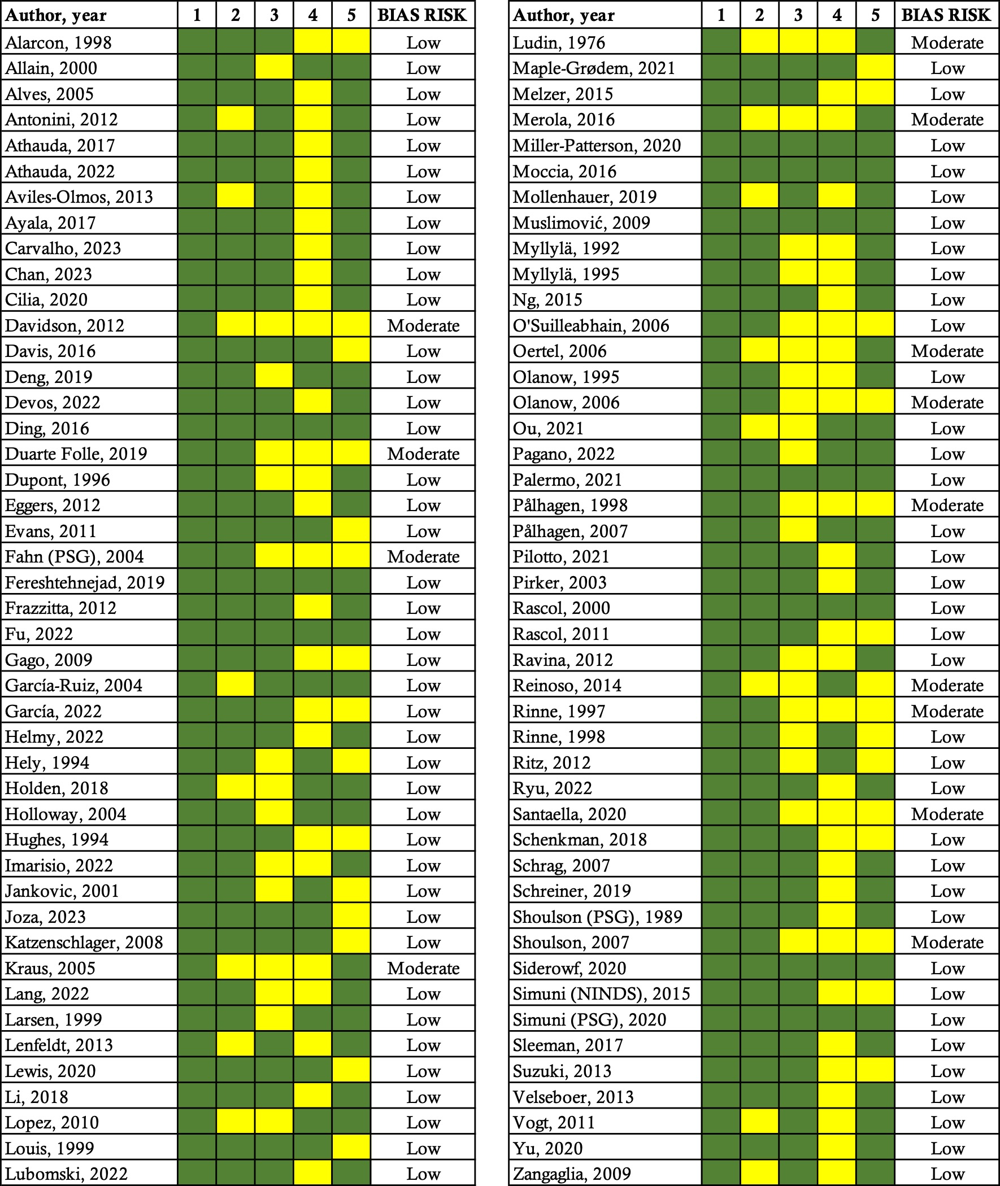

Suppl. figure 2: Motor progression rate (% p.a.) stratified by baseline PD disease duration (< 5 years, 5-10 years, > 10 years). n/a = not available.
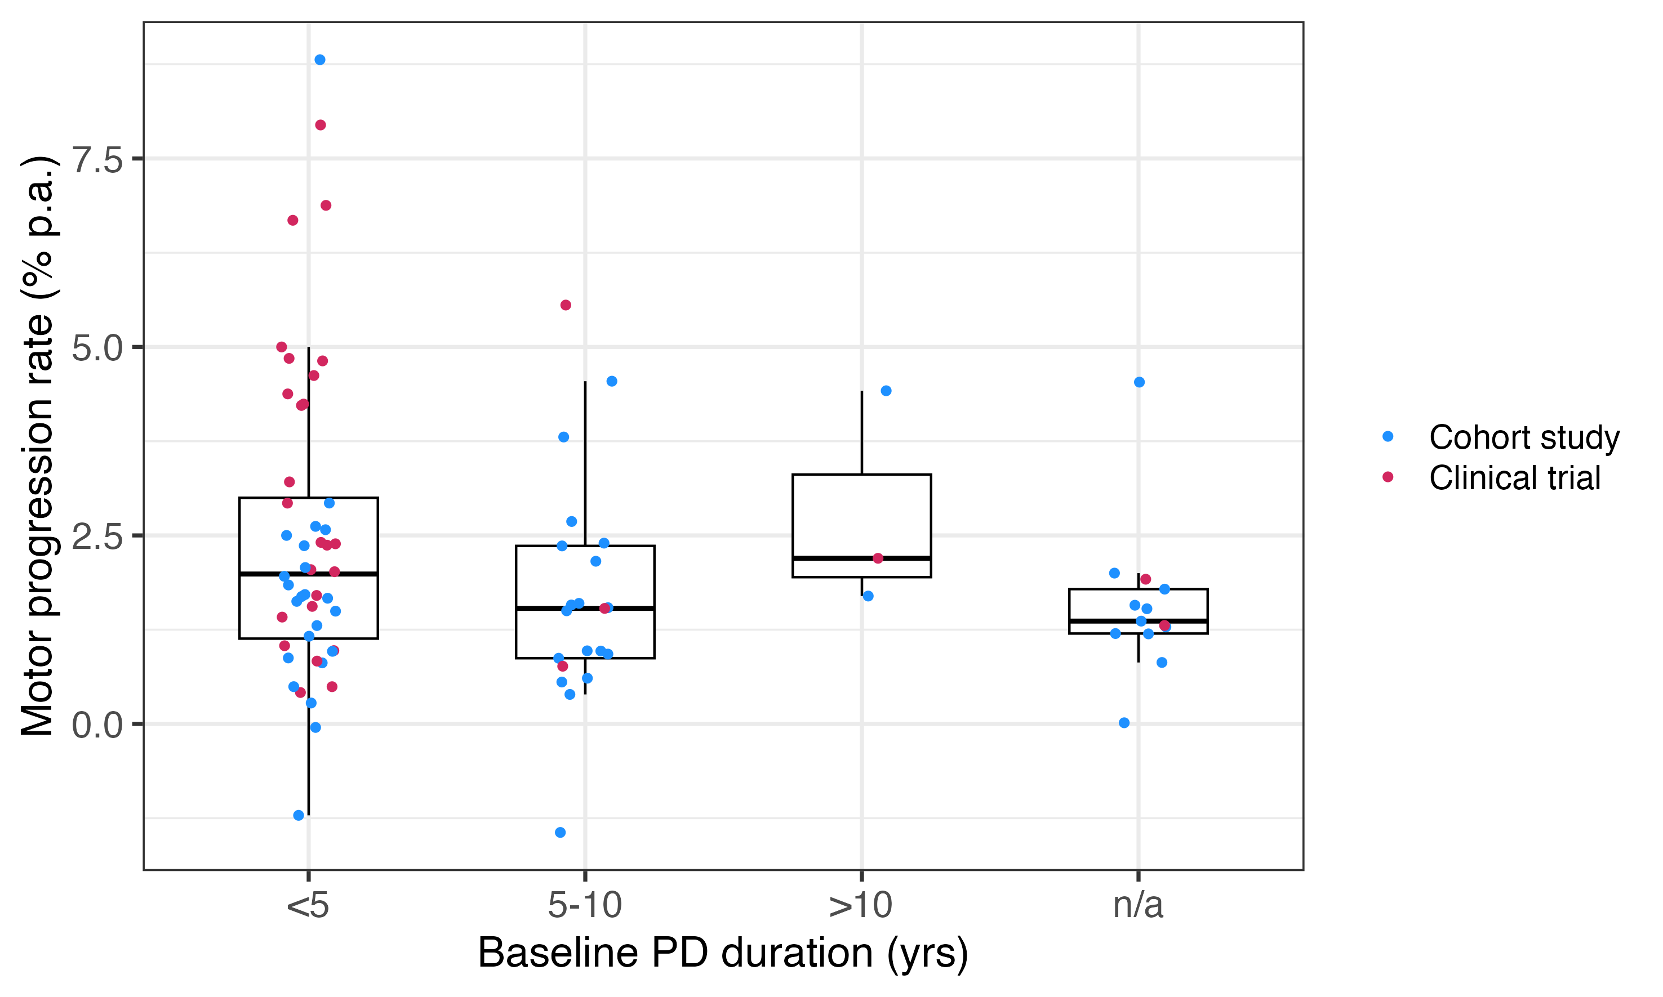Reference:
a. Arrais M, Maricoto T, Nwaru BI, et al. Helminth infections and allergic diseases: systematic review and meta-analysis of the global literature. J Allergy Clin Immunol 2022; 149: 2139–2152.

