EFFICIENT ONE STEP EXTRACTION PROCESS OF GRAMICIDIN S FROM Aneurinibacillus aneurinilyticus BIOMASS

Ksenia Lvova¹, Xanel Vecino¹, Benita Pérez-Cid², Ana B. Moldes¹* and José M. Cruz¹
¹Chemical Engineering Department, School of Industrial Engineering -CINTECX, University of Vigo, Campus As Lagoas-Marcosende, 36310 Vigo, Spain.
²Department of Analytical and Food Chemistry, Faculty of Chemistry-CINTECX, University of Vigo, Campus As Lagoas-Marcosende, 36310 Vigo, Spain.
*Correspondence: amoldes@uvigo.gal

Table S1. Summary of Gramicidin extraction methods from different Bacillus strains.
Microorganism  (strain) | Microbial source | GR form¹ | Extraction method | Reference
Bacillus brevis | Soil | D | Cells acidification;  Extraction with acetone and ether;  Crystallization by acetone | [19]
Bacillus brevis  (Nagano) | No data | S | Extraction with ethanol and HCl at ahigh temperature | [12]
Bacillus brevis | Soil | D | Multi-step extraction process | [20]
A. migulanus  (VKPM B-10212) | Mutant created in llaboratory | S | Ultrafiltration, washing and drying of cells;  Washing by acetone; Extraction with ethanol and HCl repeatedly;  Biomass decolorization by carbon, filtration and washing with ethanol;  Clarification with NaCl;  Crystallization | [21]
A. migulanus  (ATCC 9999^{T} = DSM 2895^{T}; DSM 5668;  DSM 5759) | German Collection of Microorganisms and Cell Cultures (DSMZ) | S | Cells freezing;  Preextraction by NaCl and HCl;  Extraction with ethanol | [22,23]
¹Mixtures of linear Gramicidin A, B, C are denoted as Gramicidin D

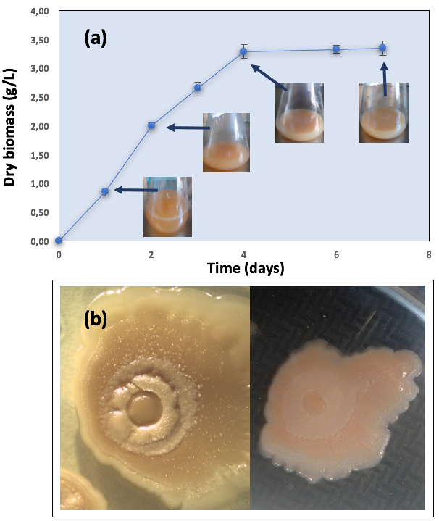
Figure S1. (a) Production of dry microbial biomass (g/L) in the synthetic fermentation medium; (b) Pictures of A. aneurinilyticus colonies isolated on agar medium from TSB.

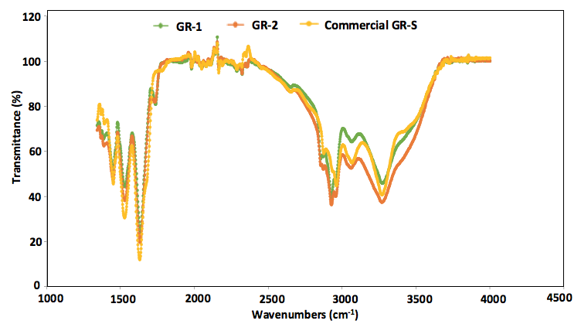
Figure S2. Comparison of FTIR spectra of Commercial GR-S with GR-1 and GR-2 between 1250-4000 cm⁻¹.

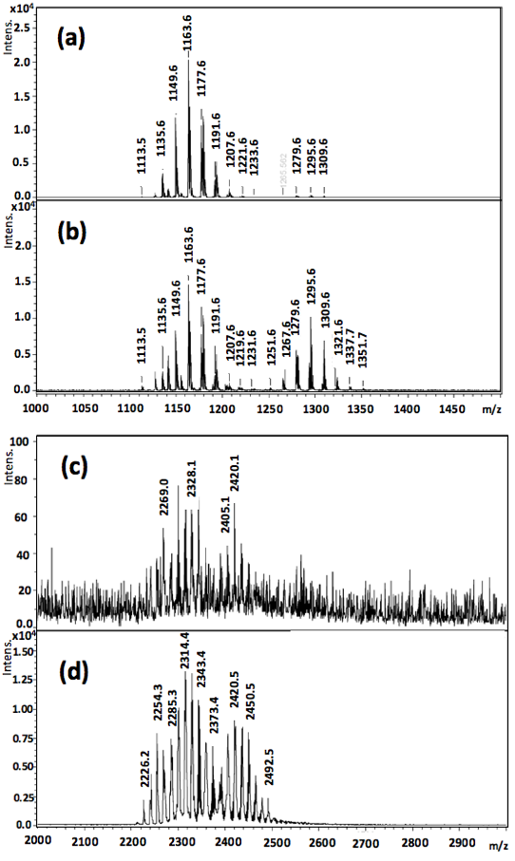

Figure S3. MALDI-TOF MS spectra of Gramicidin extract GR-2 in acidic ethanol obtained at a) room temperature, masses between 1000 and 1500 m/z; b) 40 ºC, masses between 1000 and 1500 m/z; c) room temperature, masses between 2000 and 3000 m/z; d) 40 ºC, masses between 2000 and 3000 m/z.

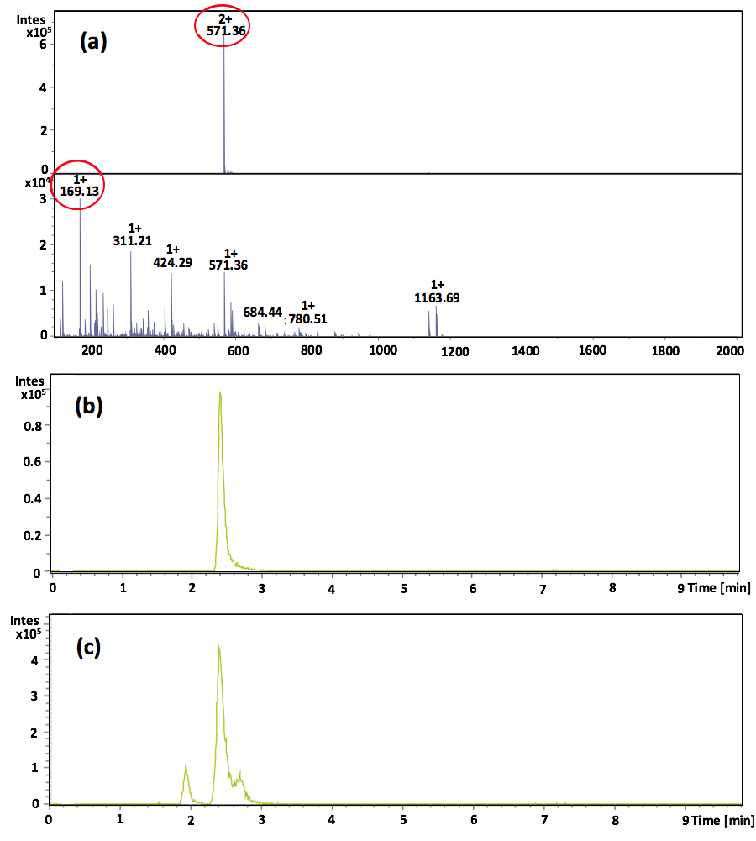

Figure S4. (a) Scan mass and MS/MS spectra of commercial GR-S at a concentration of 5 mg/mL and extracted ion chromatogram (EIC) of: (b) commercial GR-S and (c) GR-2.

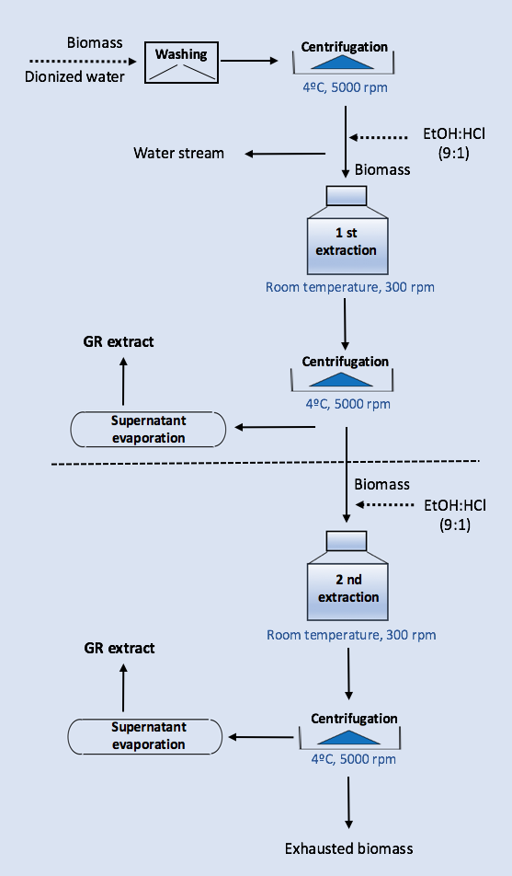

Figure S5. Scheme of two consecutive extraction cycles of Gramicidin from the microbial biomass.

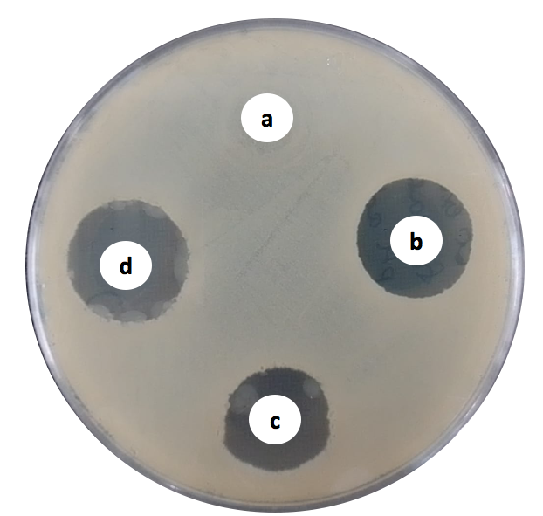

Figure S6. Zone of inhibition of Bacillus licheniformis on TSA: (a) Control without Gramicidin (b) Commercial GR-S at 1 g/L; (c) GR-2 at 1 g/L; (d) GR-2 at 3 g/L.

