Supplementary materials for ‘**Integrated surface-subsurface rock heterogeneities/zonation of the Early Bartonian reservoir in central Tunisia and eastern Tunisian offshore**

Corresponding author: **Jihede Haj Messaoud** ([jihede.hajmessaoud@kaust.edu.sa)](mailto:jihede.hajmessaoud@kaust.edu.sa))

## **4.4. Sequence stratigraphy in a shallow carbonate platform**

### **4.4.1. Sequence T-R 1**

T-R 1 sequence is 36.5 m thick and corresponds to the lithostratigraphic unit 1. Its lower boundary corresponds to the unconformity surface between the limestones deposits of the Ypresian and the overlying lumachellic limestone of the Cherahil Formation. Abundant ostracods and oysters characterize the transgressive system tract (TST, 24 m thick). The upper boundary of this sequence witnessed the first appearance of highly dolomitized levels. The maximum flooding surface (MFS) is underlined at the 24 m level, where an increase in PF is observed. The highstand system tract (HST, 12.5 m thick) is represented by the alternations between azoic dolo-limestones and marls containing bivalves (40%), gastropods (30%) with rare ostracods, and BF (8%). The absence of PF and the low abundance of BF in these marly levels suggest a shallower water depth than the first 24 m.

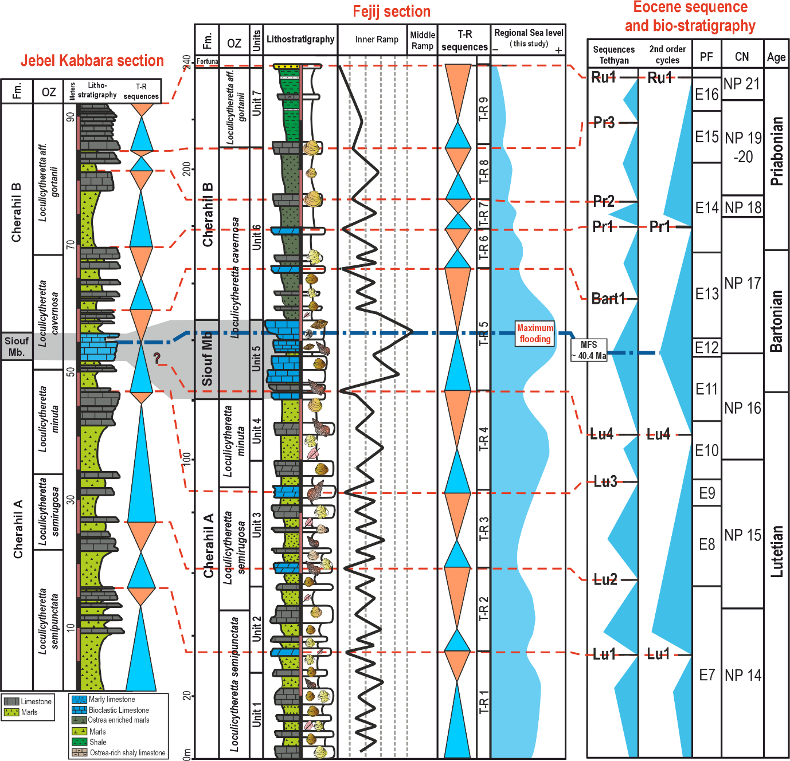Figure S1. Sequence stratigraphy of the Cherahil Formation

### 4.4.2. Sequence T-R 2

This sequence is 28.5 m thick. The TST (15 m thick) alternates between lumachellic limestone and marly beds. The MFS is placed at a 42 m level where the examination of a thin section shows wackestone to packstone textures containing PF (10%) and BF (25%) and ostracods (20 %), associated with fragments of echinoderms. The HST is a 13.5 m-thick sequence corresponding to a thinning-up alternation between lumachellic beds with rare gastropods and frequent dolomitization. The abundance of oysters and gastropods during the HST indicates that shallowing-up reduced the accommodation space and established a more restricted environment. The dolomitic limestone bed at 80 m level corresponds to the upper boundary of the T-R 2 sequence. The top of this bed is a ravined surface indicating a subaerial exposure surface followed by the TST of sequence T-R 3.

### 4.4.3. Sequence T-R 3

This sequence is 26.5 m thick and covers unit 3 of the Cherahil A. Its lower boundary lines up with Facies 4's dolomitic limestone. The bioclastic limestone strata vary in thickness throughout the TST (3 m to 2 m). In the limestone levels, there is a packstone texture with a significant BF (15%), PF (5%) and ostracod content (10%). The MFS of sequence T-R 3 is placed within the marl bed at 71 m level. This level shows fragments of echinoderms and bryozoans with PF (15%) and BF (20%). The HST is represented by high dolomitization of the limestone beds and ends with a thin lumachellic marls level testifying to the significant reduction of the accommodation space (shallowing of the water depth) followed by a thick and azoic dolomitic limestone bed. The surface of this level represents the upper boundary of sequence T-R 3.

### 4.4.4. Sequence T-R 4

T-R 4 (34.5 m) is composed of upper unit 3 in addition to all of unit 4. It corresponds to the uppermost of Cherahil A member. The TST starts after the dolomitic limestone bed at 90 m level and continues with interbedding lumachellic limestones with well-preserved oysters and bioclastic limestone (mud- to wackestone) with low BF abundance (less than 15%). The MFS is placed at a 105 m level where a rich PF (15%) and BF (20%) are observed. The thinning-up alternation of the HST corresponds to dolomitic limestone and marls. The upper boundary of this sequence corresponds to Facies 8 with cm-scaled conglomerates and fine grains of quartz with a scarce fauna. This surface corresponds to a subaerial exposure surface that precedes the deposition of the Siouf member.

### 4.4.5. Sequence T-R 5

The lower boundary falls in the argillaceous-silty marl of Facies 8 followed by the TST corresponding to the Siouf member (25 m). The TST shows an alternation of LBF-rich bioclastic limestones with abundant echinoderms and nummulites. Across the Siouf member, the coarsening-upward trend indicates a gradual increase in deposition energy, culminating at the top of this member by the packstone to grainstone texture with abundant LBF. The MFS is placed at the top of the Siouf member (142 m) with large nummulites, echinoderms, crinoids (F9), and abundant BF with common PF. The abundant and diverse faunal assemblage within Facies 9 indicates the most distal environment. The TST occurs during the lower Bartonian and is characterized by a maximum abundance of large nummulites (*Nummulites gizehensis*) and red algae. The HST is represented by thinning-upward bioclastic limestones separated by thick marls levels with rare benthic microfauna (10%). The upper boundary of sequence T-R 5 corresponds to the dolomitic limestoneof F4.

### 4.4.6. Sequence T-R 6

This sequence falls within the middle part of unit 6 (Fig.7) and is delimited by two dolomitic limestone beds at 164 m and 178 m, respectively. The TST covers the interval between 165 m to 171 m and shows a microfauna represented by BF (20%) associated with PF (8%) and ostracods (5%). The MFS is placed at the 172 m level, where the highest PF abundance is observed (5%). The HST consists of thinning-upwards beds of marls with oysters, gastropods, and rare microfauna and ends with silty marls.

### 4.4.7. Sequence T-R 7

It is a 10.5 m thick sequence starting with dolomitic limestone at 179 m level. Ostrea-enriched marls that resemble sequence T-R 6 make up most of the deposits. The lumachellic limestones (187 m level) form the upper boundary of T-R 7. The MFS is located within the marls of sequence T-R 7 (184 m) with the richest microfossils association. A 3 m-thick sequence of marls with rich oyster shells (up to 30%) and rare PF forms the HST.

### 4.4.8. Sequence T-R 8

This depositional sequence is 17.5 m thick and corresponds to the upper part of Unit 6. This sequence's lower and upper boundaries fall within the brownish lumachellic limestone of F1. T-R 8's middle part relates to ostrea-enriched marls with uncommon gastropods, frequent ostracods, and BF. PF is particularly rare in this sequence. The TST (12 m thick) starts with lumachellic limestone and evolves into marls rich in ostracods (25%) and BF (20%) with rare PF (10%). The HST is recognized by a drop in ostracod and BF abundance together with the presence of silt.

### 4.4.9. Sequence T-R 9

The sequence is 28 m thick and corresponds to unit 7 (Fig.7). The presence of PF and BF at the base of this sequence (20–25%) suggests a transgressive trend that peaks (MFS) at the 219 m level. An abrupt transition outlines the MFS into less frequent PF. The occurrence of silt identifies the HST (20 m thick) within the greenish marls with few fragmented bivalves. This horizon shows scarce fauna (bioturbation, micritization). The top of this sequence corresponds to the Eocene-Oligocene boundary outlined by a thick sandstone level.

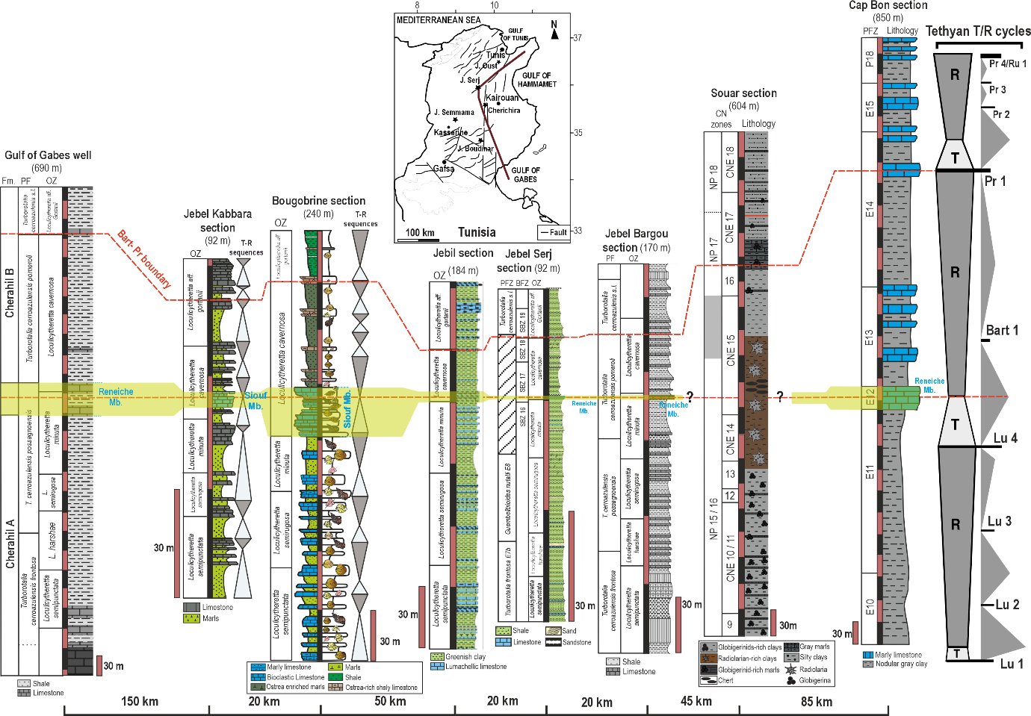

**Figure S2.** Regional stratigraphic correlation between the study area (central Tunisia domain), southern Tunisia Gulf of Gabes), and NE Tunisia (Tunisian dorsal and the Cap Bon peninsula). Note the important thickness and facies variation of the middle-upper Eocene series, which records the differentiation of the seafloor in horsts and graben architecture. The Siouf/Reneiche member (red line) was chosen as a datum for this regional stratigraphic correlation. The Siouf member corresponds to the development of a shallow carbonate shelf in the middle part of the lagoonal facies of the Cherahil Formation, whereas the Reneiche member is developed within the marine clays of the Souar Fm. in NE Tunisia. The sections are Gulf of Gabes well (Amami-Hamdi et al. 2014). Jebel Kabbara (Njahi Derbali and Touir 2019), Bougobrine section (this study), Jebil section (Amami-Hamdi et al. 2016), Jebel Serj (Amami Hamdi and Ben Ismail Lattrache, 2013), Jebel Bargou (Amami-Hamdi et al. 2014), Souar section (Messaoud et al. 2021), and Cap Bon section (Ben-Ismail-Lattrache and Bobier 1984).

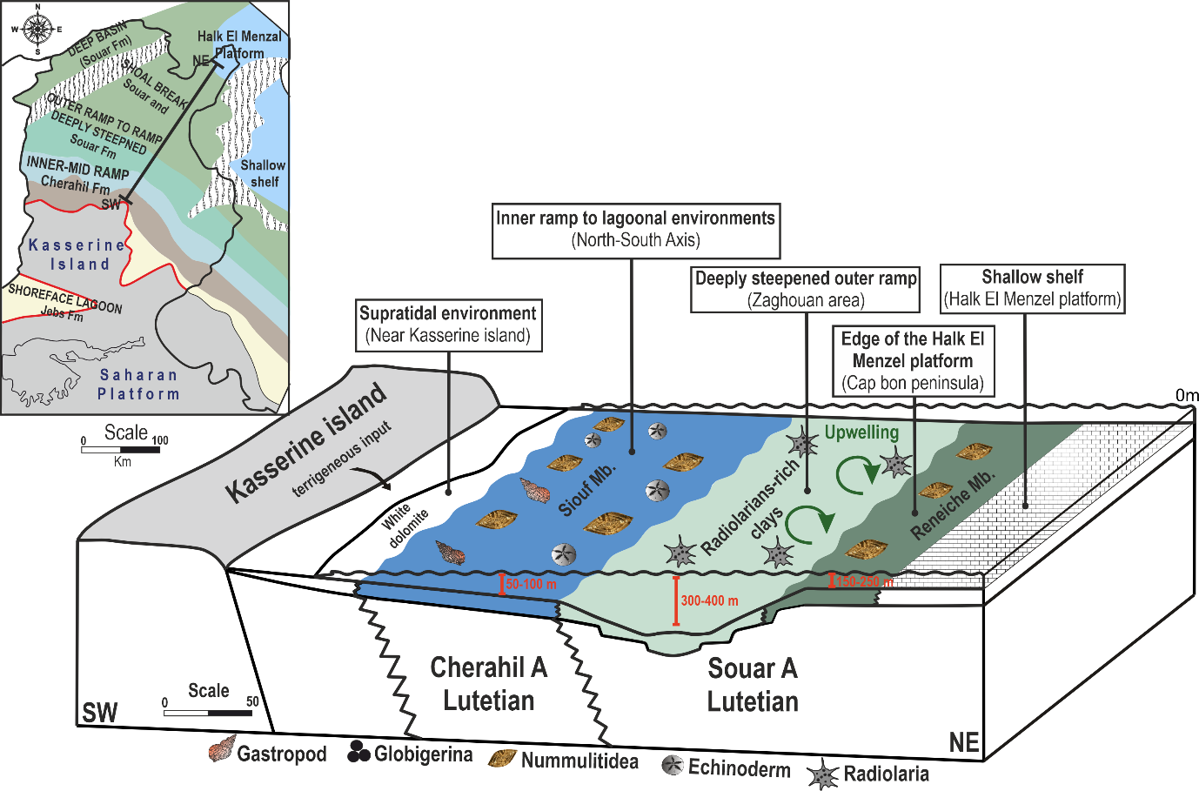 **Figure S3**. NE-SW block diagram showing a schematic representation of the major depositional environments during the early Bartonian.