**Phylogeography, Taxonomy and Conservation of the Endangered Brown Howler Monkey, *Alouatta guariba* (Primates, Atelidae), of the Atlantic Forest.**

**Supplementary Material 4: Extra Figures of Microsatellite Results**

**Figure of TESS for K=2**

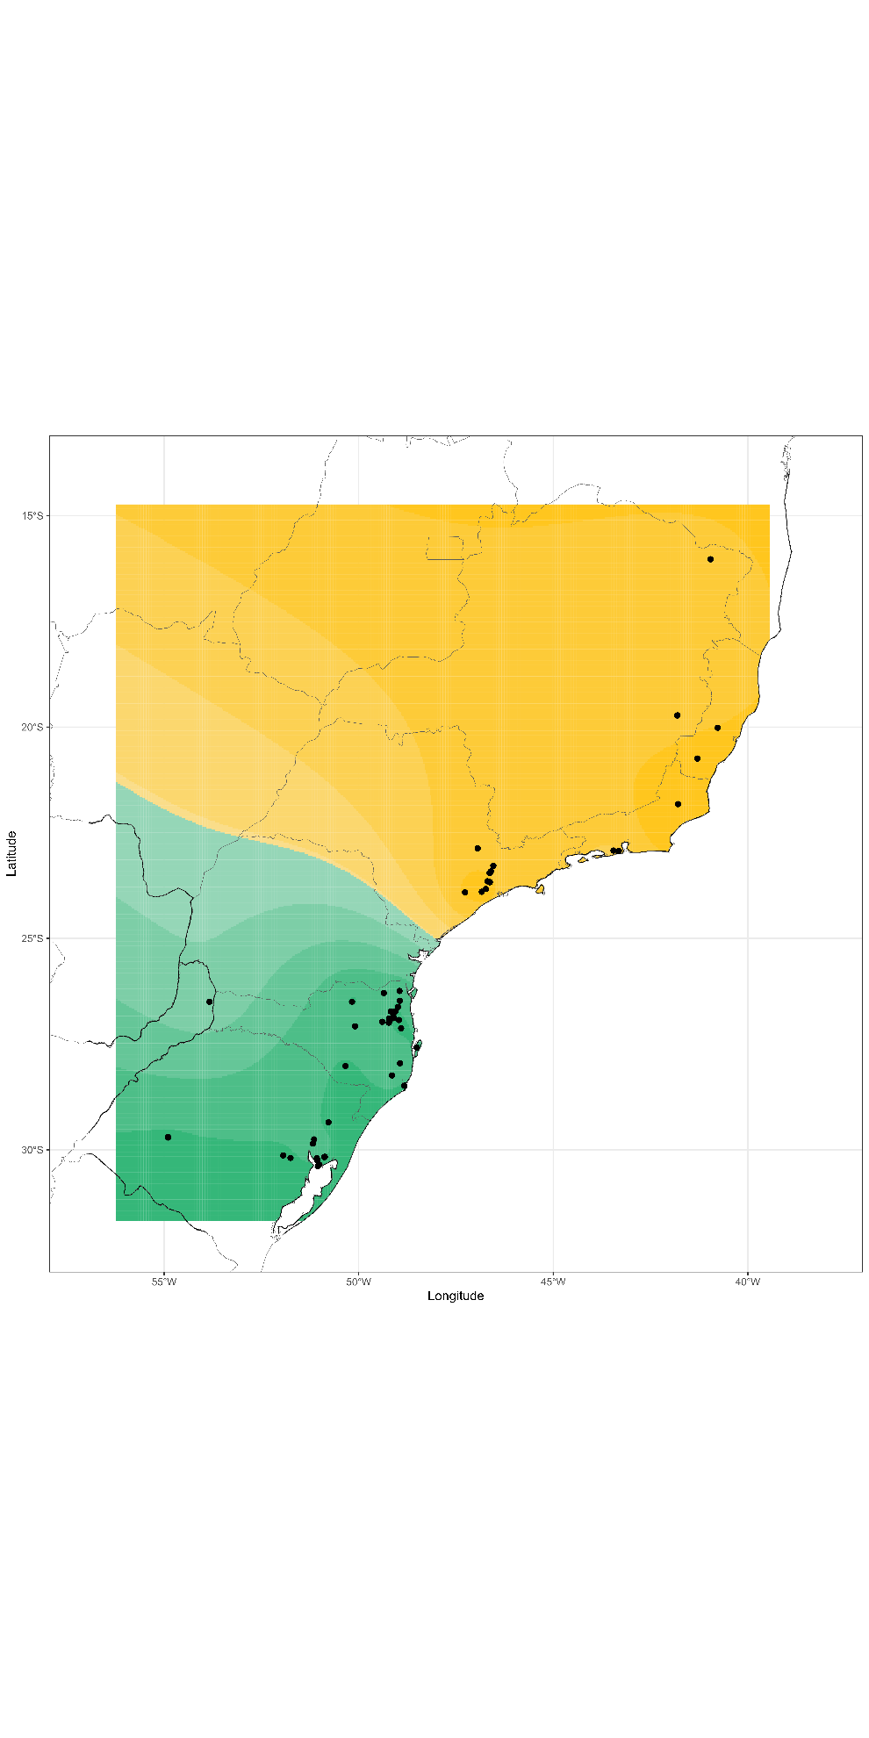

**Figure of Principal Component Analysis**

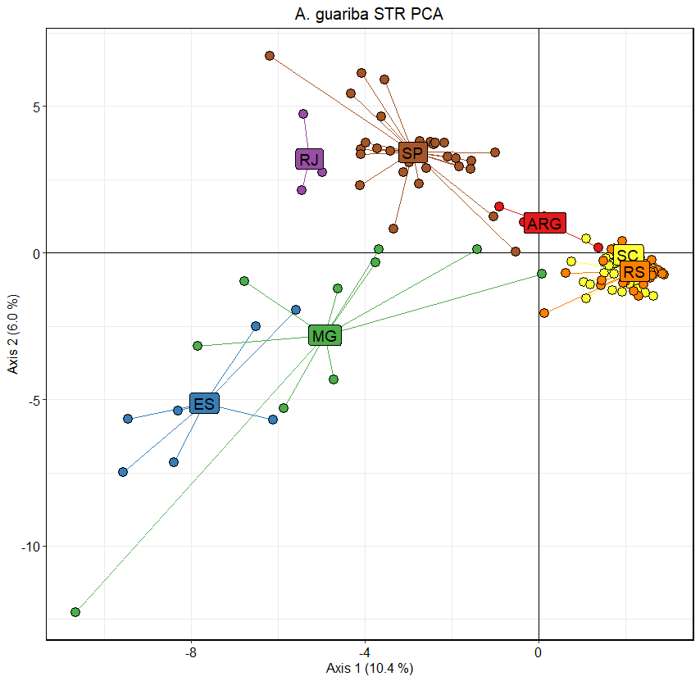

**Figure of FSTs**

