SUPPLEMENTARY TABLE 1 | Conversion between component numbers and MOLIDs.
Component numbers | MOLIDs | Molecule Name | Molecule Structure
A1 | MOL000359 | sitosterol | 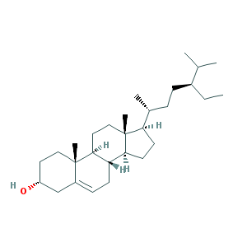
B1 | MOL000358 | beta-sitosterol | 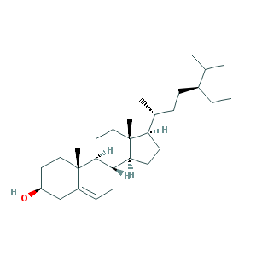
C1 | MOL000449 | Stigmasterol | 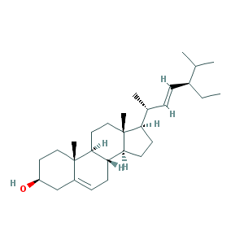
D1 | MOL000173 | wogonin | 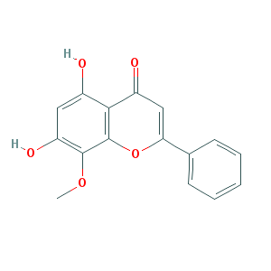
E1 | MOL002897 | epiberberine | 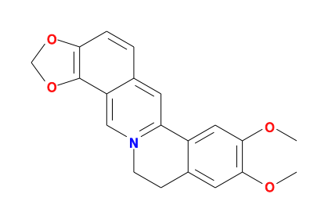
F1 | MOL001458 | coptisine | 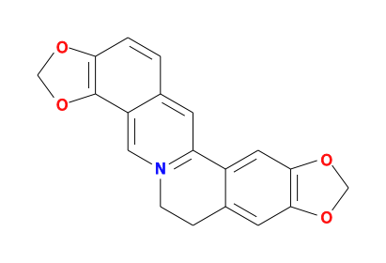
G1 | MOL000098 | quercetin | 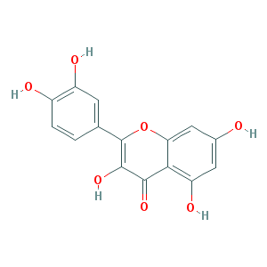
H1 | MOL001689 | acacetin | 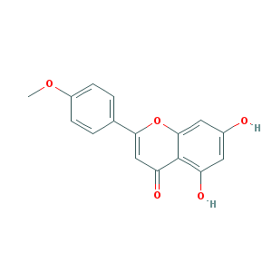
I1 | MOL000006 | luteolin | 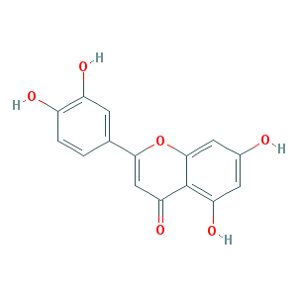
J1 | MOL000422 | kaempferol | 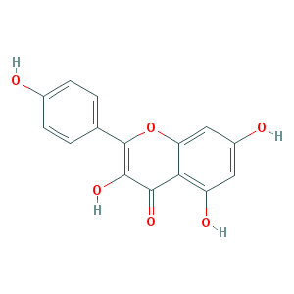
CP1 | MOL004328 | naringenin | 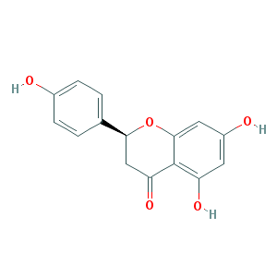
CP2 | MOL005100 | 5,7-dihydroxy-2-(3-hydroxy-4-methoxyphenyl)chroman-4-one | 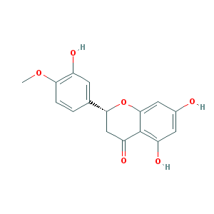
CP3 | MOL005815 | Citromitin | 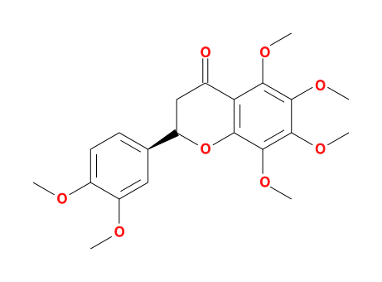
CP4 | MOL005828 | nobiletin | 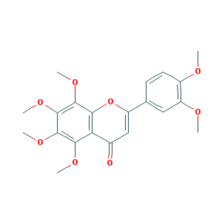
DH1 | MOL002235 | EUPATIN | 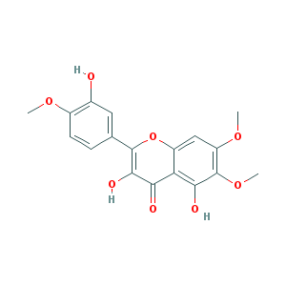
DH2 | MOL002259 | Physciondiglucoside | 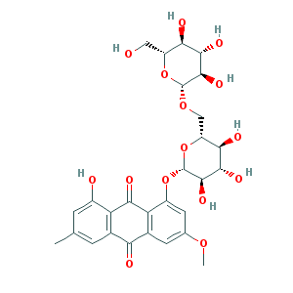
DH3 | MOL002268 | rhein | 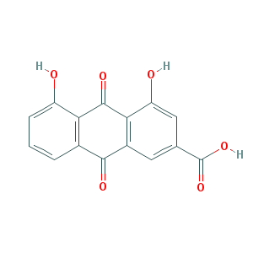
DH4 | MOL002280 | Torachrysone-8-O-beta-D-(6'-oxayl)-glucoside | 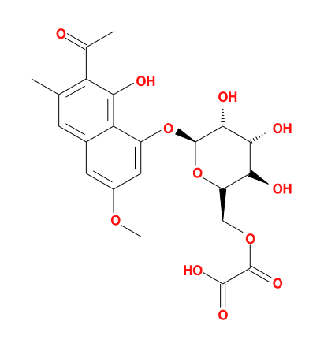
DH5 | MOL002281 | Toralactone | 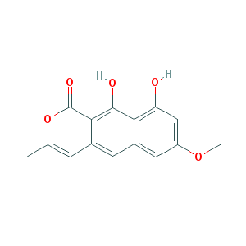
DH6 | MOL002288 | Emodin-1-O-beta-D-glucopyranoside | 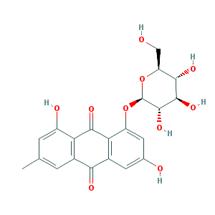
DH7 | MOL002297 | Daucosterol_qt | 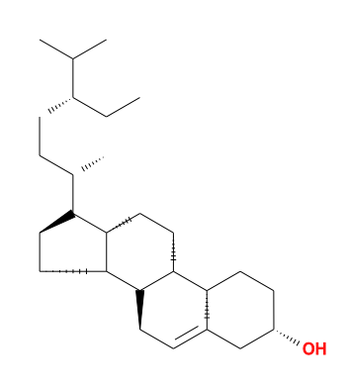
DH8 | MOL000471 | aloe-emodin | 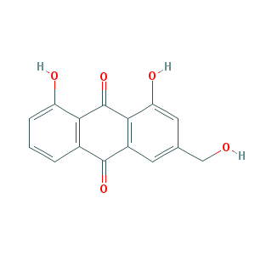
DH9 | MOL000096 | (-)-catechin | 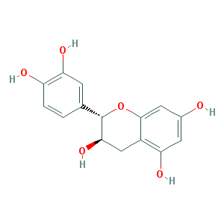
FF1 | MOL000011 | (2R,3R)-3-(4-hydroxy-3-methoxy-phenyl)-5-methoxy-2-methylol-2,3-dihydropyrano[5,6-h][1,4]benzodioxin-9-one | 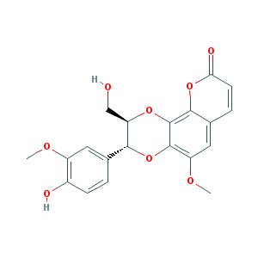
FF2 | MOL011730 | 11-hydroxy-sec-o-beta-d-glucosylhamaudol_qt | 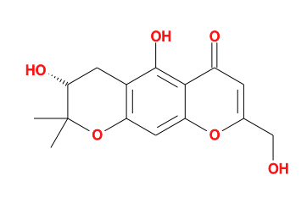
FF3 | MOL011732 | anomalin | 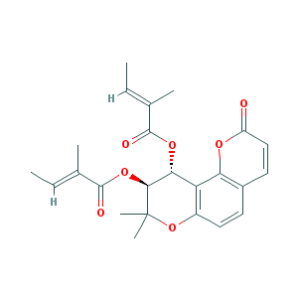
FF4 | MOL011737 | divaricatacid | 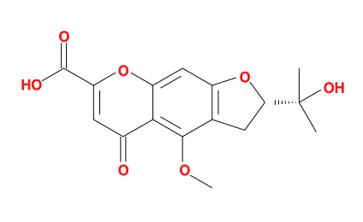
FF5 | MOL011740 | divaricatol | 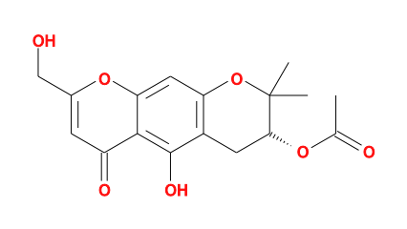
FF6 | MOL001941 | Ammidin | 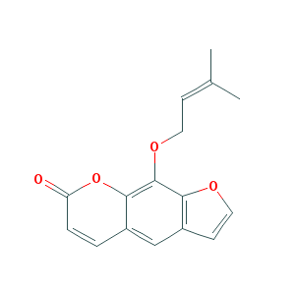
FF7 | MOL011747 | ledebouriellol | 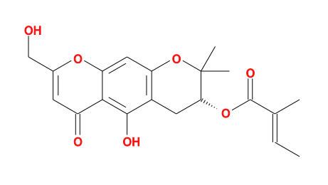
FF8 | MOL011749 | phelloptorin | 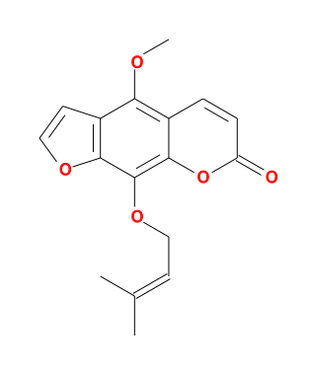
FF9 | MOL011753 | 5-O-Methylvisamminol | 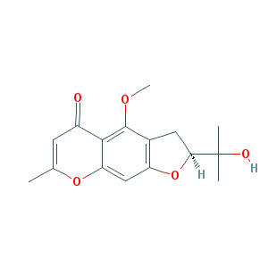
FF10 | MOL002644 | Phellopterin | 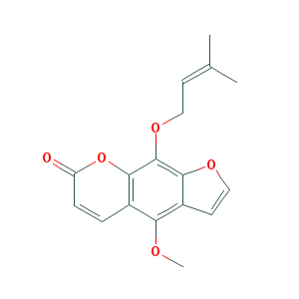
FF11 | MOL001494 | Mandenol | 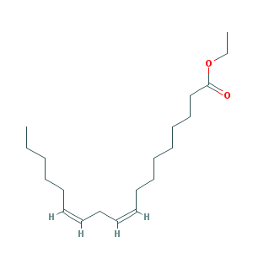
FF12 | MOL001942 | isoimperatorin | 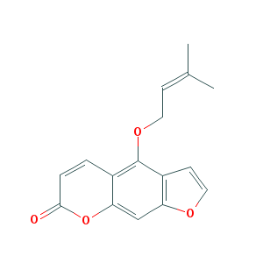
FF13 | MOL003588 | Prangenidin | 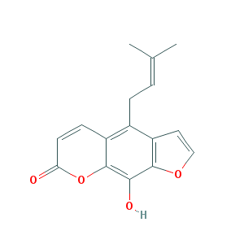
FF14 | MOL007514 | methyl icosa-11,14-dienoate | 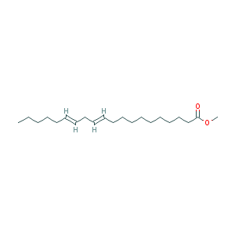
FF15 | MOL013077 | Decursin | 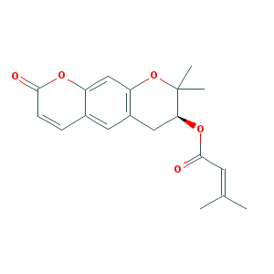
HL1 | MOL001454 | berberine | 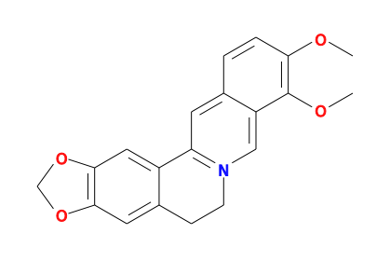
HL2 | MOL002894 | berberrubine | 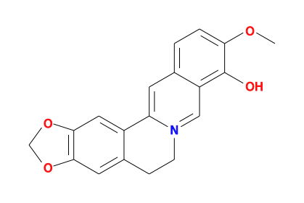
HL3 | MOL002903 | (R)-Canadine | 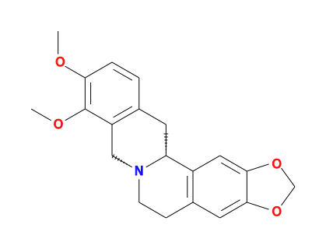
HL4 | MOL002904 | Berlambine | 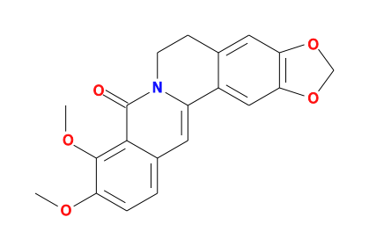
HL5 | MOL002907 | Corchoroside A_qt | 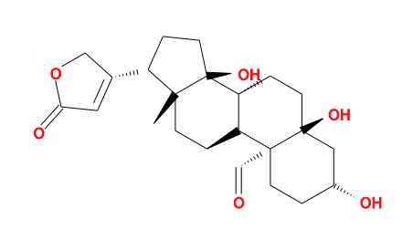
HL6 | MOL000622 | Magnograndiolide | 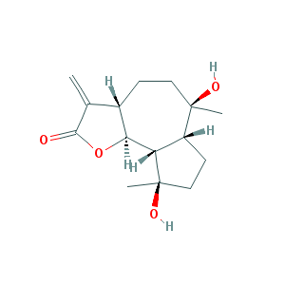
HL7 | MOL000785 | palmatine | 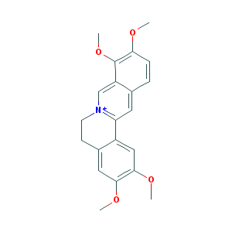
HL8 | MOL002668 | Worenine | 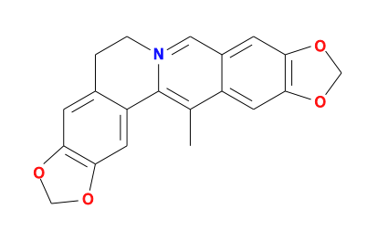
HQ1 | MOL000228 | (2R)-7-hydroxy-5-methoxy-2-phenylchroman-4-one | 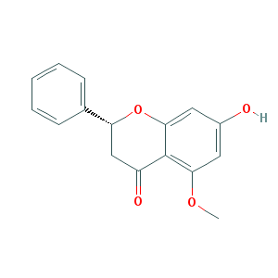
HQ10 | MOL002927 | Skullcapflavone II | 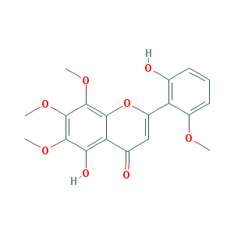
HQ11 | MOL002928 | oroxylin a | 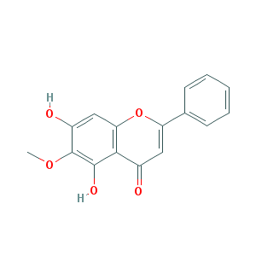
HQ12 | MOL002932 | Panicolin | 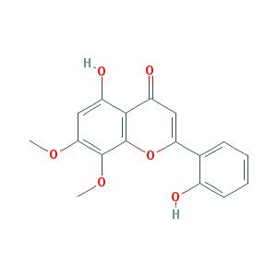
HQ13 | MOL002933 | 5,7,4'-Trihydroxy-8-methoxyflavone | 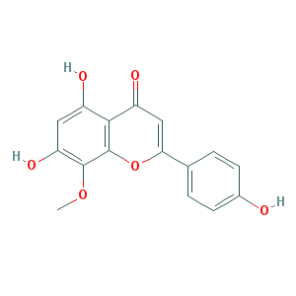
HQ14 | MOL002934 | NEOBAICALEIN | 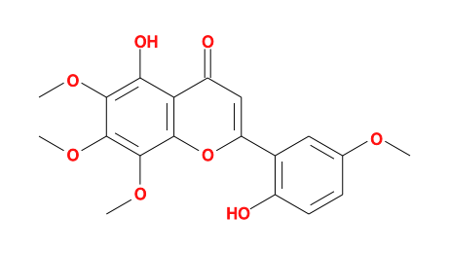
HQ15 | MOL002937 | DIHYDROOROXYLIN | 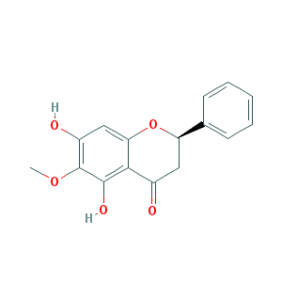
HQ16 | MOL000525 | Norwogonin | 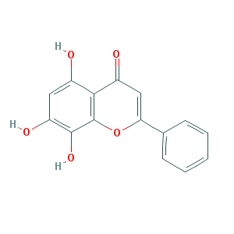
HQ17 | MOL000552 | 5,2'-Dihydroxy-6,7,8-trimethoxyflavone | 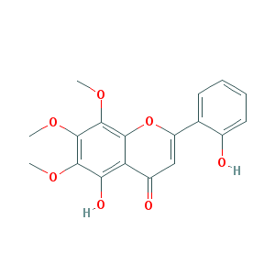
HQ18 | MOL000073 | ent-Epicatechin | 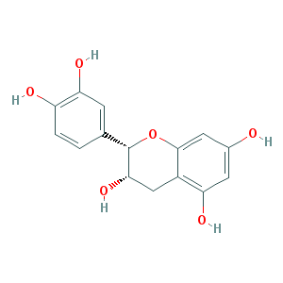
HQ19 | MOL001490 | bis[(2S)-2-ethylhexyl] benzene-1,2-dicarboxylate | 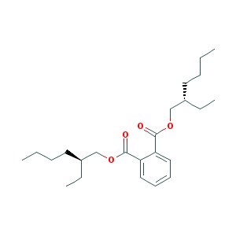
HQ2 | MOL002714 | baicalein | 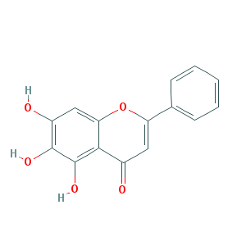
HQ20 | MOL002879 | Diop | 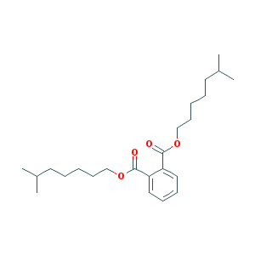
HQ21 | MOL008206 | Moslosooflavone | 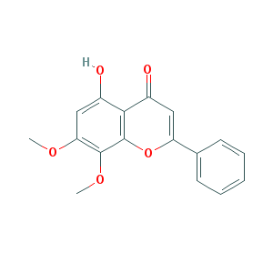
HQ22 | MOL010415 | 11,13-Eicosadienoic acid, methyl ester | 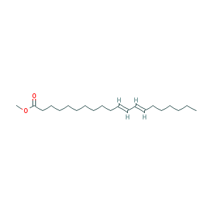
HQ23 | MOL012245 | 5,7,4'-trihydroxy-6-methoxyflavanone | 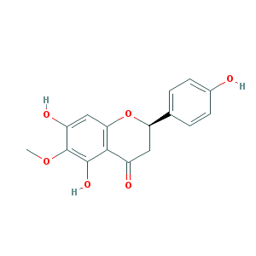
HQ24 | MOL012246 | 5,7,4'-trihydroxy-8-methoxyflavanone | 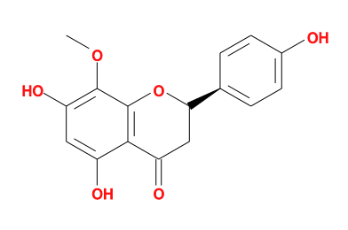
HQ25 | MOL012266 | rivularin | 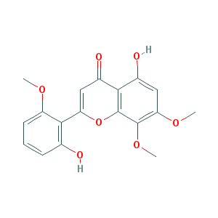
HQ3 | MOL002909 | 5,7,2,5-tetrahydroxy-8,6-dimethoxyflavone | 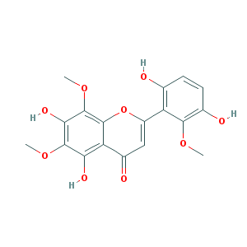
HQ4 | MOL002910 | Carthamidin | 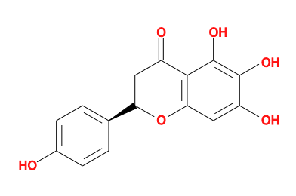
HQ5 | MOL002913 | Dihydrobaicalin_qt | 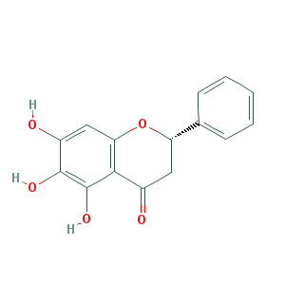
HQ6 | MOL002914 | Eriodyctiol (flavanone) | 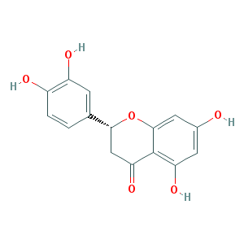
HQ7 | MOL002915 | Salvigenin | 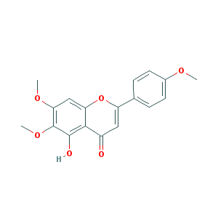
HQ8 | MOL002917 | 5,2',6'-Trihydroxy-7,8-dimethoxyflavone | 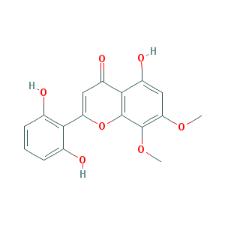
HQ9 | MOL002925 | 5,7,2',6'-Tetrahydroxyflavone | 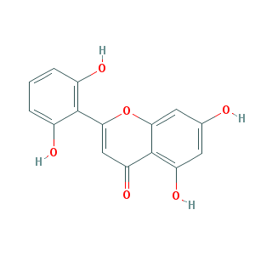
JJS1 | MOL002341 | Hesperetin | 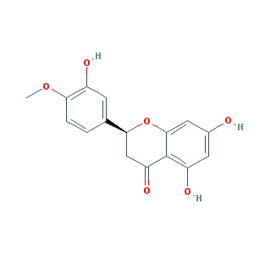
JJS2 | MOL005842 | Pectolinarigenin | 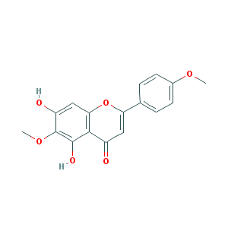
JJS3 | MOL011849 | Schizonepetoside B | 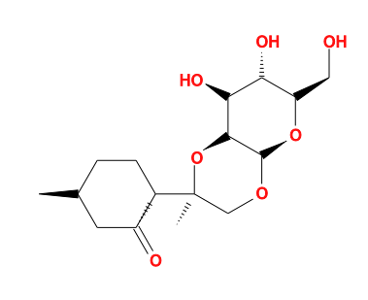
JG1 | MOL001689 | acacetin
JG2 | MOL004355 | Spinasterol | 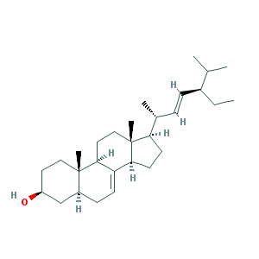
JG3 | MOL004580 | cis-Dihydroquercetin | 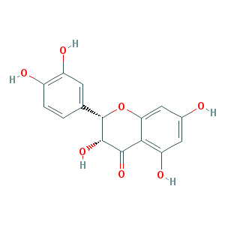
LQ1 | MOL003283 | (2R,3R,4S)-4-(4-hydroxy-3-methoxy-phenyl)-7-methoxy-2,3-dimethylol-tetralin-6-ol | 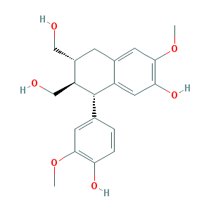
LQ10 | MOL003330 | (-)-Phillygenin | 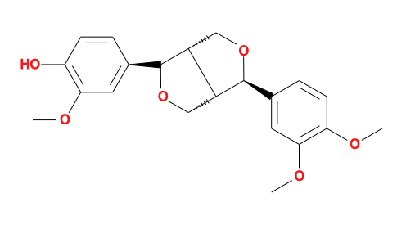
LQ11 | MOL003347 | hyperforin | 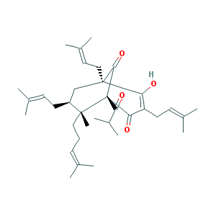
LQ12 | MOL003370 | Onjixanthone I | 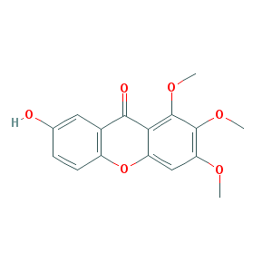
LQ13 | MOL000522 | arctiin | 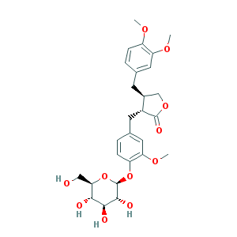
LQ14 | MOL000791 | bicuculline | 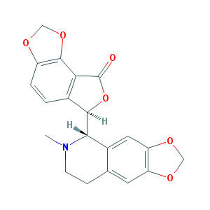
LQ2 | MOL003290 | (3R,4R)-3,4-bis[(3,4-dimethoxyphenyl)methyl]oxolan-2-one | 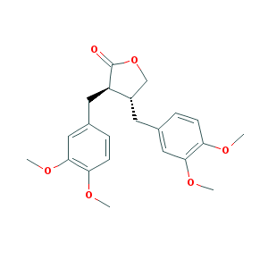
LQ3 | MOL003295 | (+)-pinoresinol monomethyl ether | 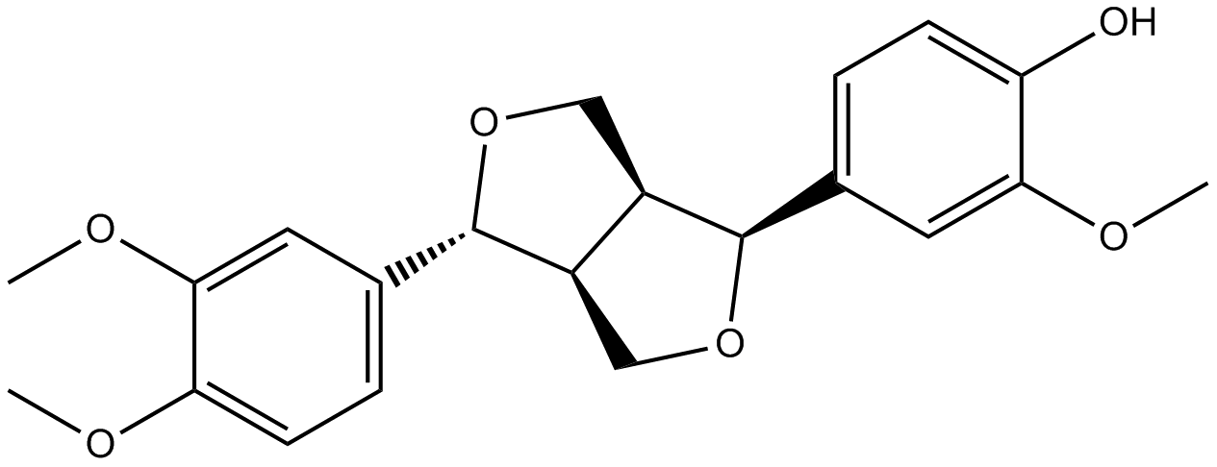
LQ4 | MOL003305 | PHILLYRIN | 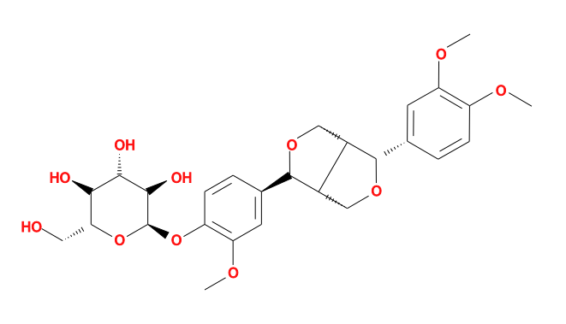
LQ5 | MOL003306 | ACon1_001697 | 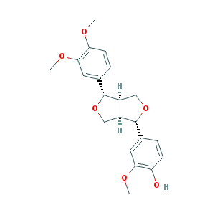
LQ6 | MOL003308 | (+)-pinoresinol monomethyl ether-4-D-beta-glucoside_qt | 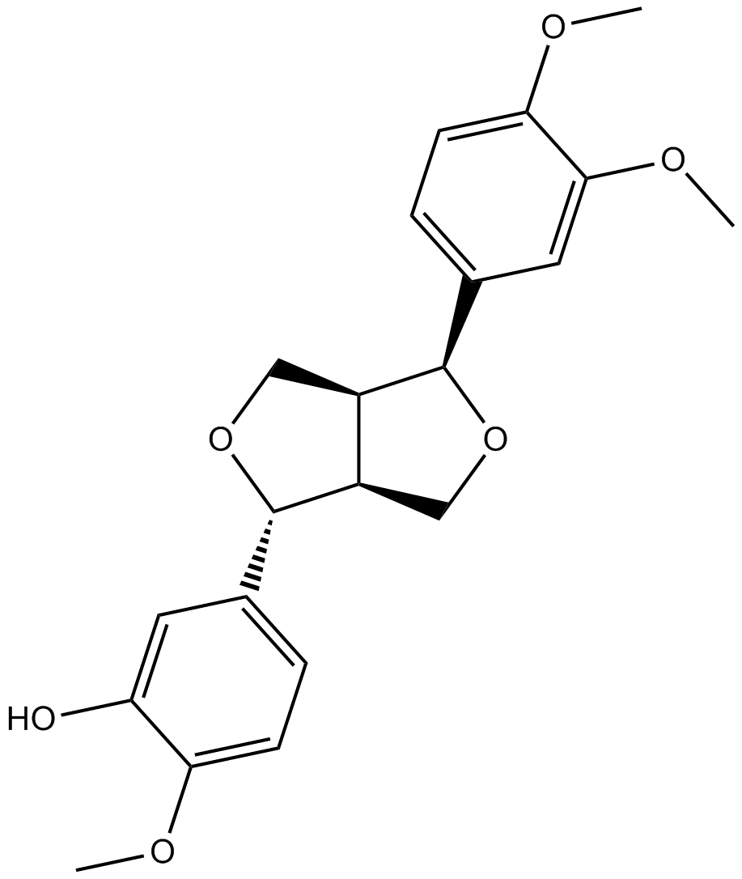
LQ7 | MOL003315 | 3beta-Acetyl-20,25-epoxydammarane-24alpha-ol | 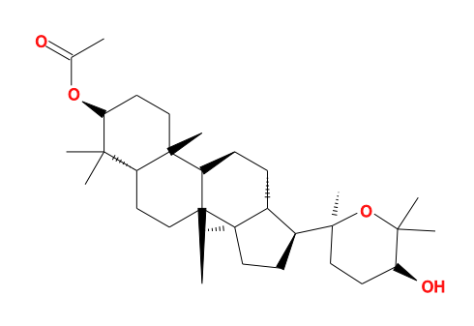
LQ8 | MOL000211 | Mairin | 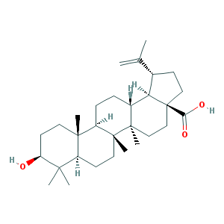
LQ9 | MOL003322 | FORSYTHINOL | 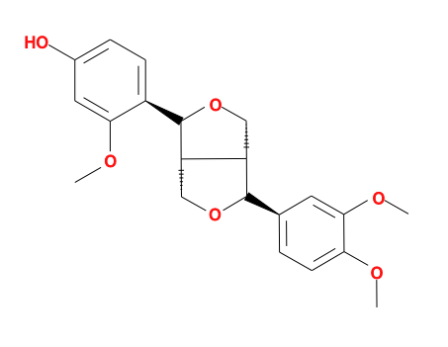
XS1 | MOL002222 | sugiol | 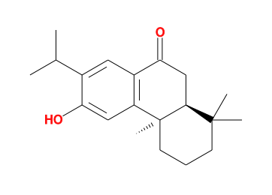
XS2 | MOL007658 | 14-deoxy-12(R)-sulfoandrographolide | 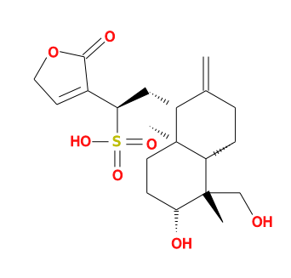
XS3 | MOL007662 | harpagoside_qt | 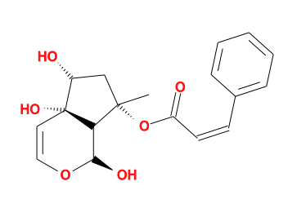
ZM9 | MOL000546 | diosgenin | 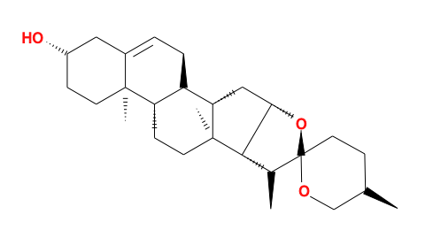
ZM8 | MOL000483 | (Z)-3-(4-hydroxy-3-methoxy-phenyl)-N-[2-(4-hydroxyphenyl)ethyl]acrylamide | 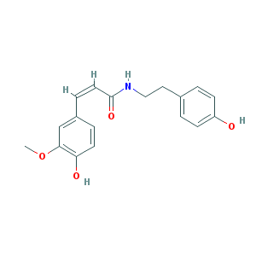
ZM7 | MOL004540 | Anemarsaponin C_qt | 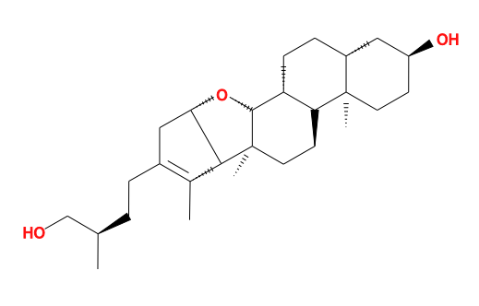
ZM6 | MOL004528 | Icariin I | 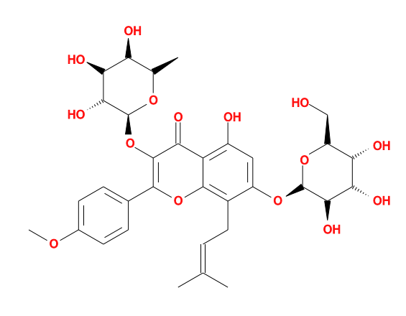
ZM5 | MOL004514 | Timosaponin B III_qt | 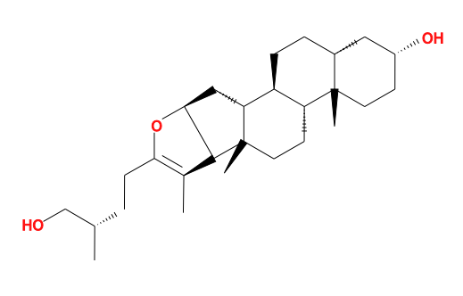
ZM4 | MOL004497 | Hippeastrine | 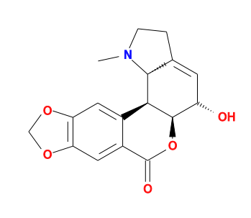
ZM3 | MOL004489 | Anemarsaponin F_qt | 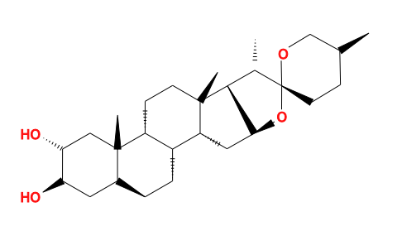
ZM2 | MOL004373 | Anhydroicaritin | 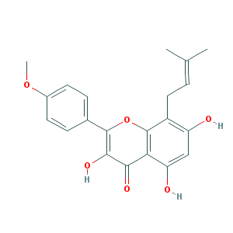
ZM10 | MOL000631 | coumaroyltyramine | 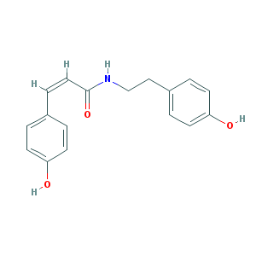
ZM1 | MOL001677 | asperglaucide | 