**Supplementary Figure**

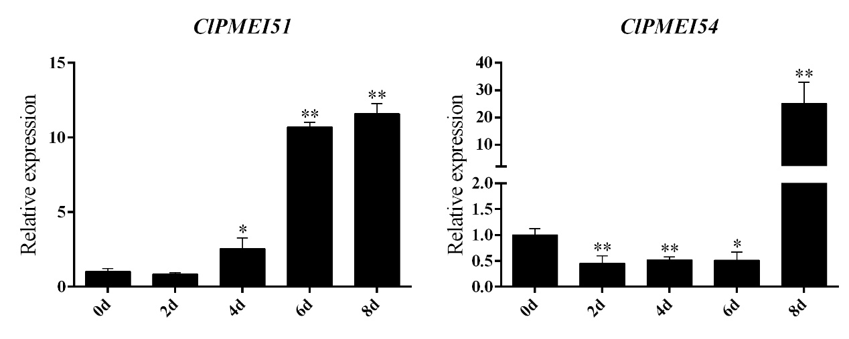

**Fig. S1 Expression analysis of ClPMEI51 and ClPMEI54 in watermelon under drought treatments. Student’s *t*-test was used to determine significant differences at the same period between control group and treatment group. Significance level: * *P*<0.05. ** *P*<0.01.**