Years survival | GCC | ETT | PSTT | P-value
Overall survival
1-year | 0.952  [CI:0.933-0.972] | 0.97  [CI:0.9415-0.9994] | 0.942  [CI:0.898-0.988] | 0.6
3-year | 0.9331  [CI:0.9102-0.9566] | 0.9229  [CI:0.8781-0.970] | 0.875  [CI:0.8115-0.9443] | 0.4
5-year | 0.9166  [CI:0.8908-0.9433] | 0.8952  [CI:0.8426-0.9511] | 0.8759  [CI:0.8115-0.9443] | 0.3
Cancer specific survival
1-year | 0.965  [ CI:0.948-0.982] | 1  [CI:1-1] | 0.942  [CI:0.898-0.988] | 0.9
3-year | 0.9477  [CI:0.9271-0.9688] | 0.9748  [CI:0.9470-1] | 0.909  [CI:0.854-0.968] | 0.4
5-year | 0.9394  [CI:0.9169-0.9624] | 0.9455  [CI:0.9040-0.9890] | 0.909  [CI:0.854-0.968] | 0.4
Table S1: Survival rates compared for GCC, ETT, PSTT over 1, 3, 5 years.

Table S2: Machine learning algorithms performance
Cancer type | ML Algorithm | 10-fold Cross Validation | Accuracy | Mean Bootstrap Estimate [95% CI] | AUC
GCC | LR | 0.708 | 0.66 | 0.67 [0.58–0.76] | 0.75
 | KNN | 0.814 | 0.65 | 0.64 [0.54–0.74] | 0.877
 | RFC | 0.816 | 0.77 | 0.79 [0.69–0.89] | 0.877
 | GBC | 0.781 | 0.83 | 0.80 [0.69–0.90] | 0.904
 | MLP | 0.722 | 0.67 | 0.71 [0.60–0.81] | 0.745
PSTT + ETT | LR | 0.737 | 0.70 | 0.61 [0.46–0.73] | 0.746
 | KNN | 0.670 | 0.70 | 0.60 [0.46–0.74] | 0.805
 | RFC | 0.812 | 0.76 | 0.68 [0.55–0.81] | 0.805
 | GBC | 0.740 | 0.72 | 0.71 [0.58–0.86] | 0.803
 | MLP | 0.720 | 0.76 | 0.63 [0.51–0.76] | 0.822

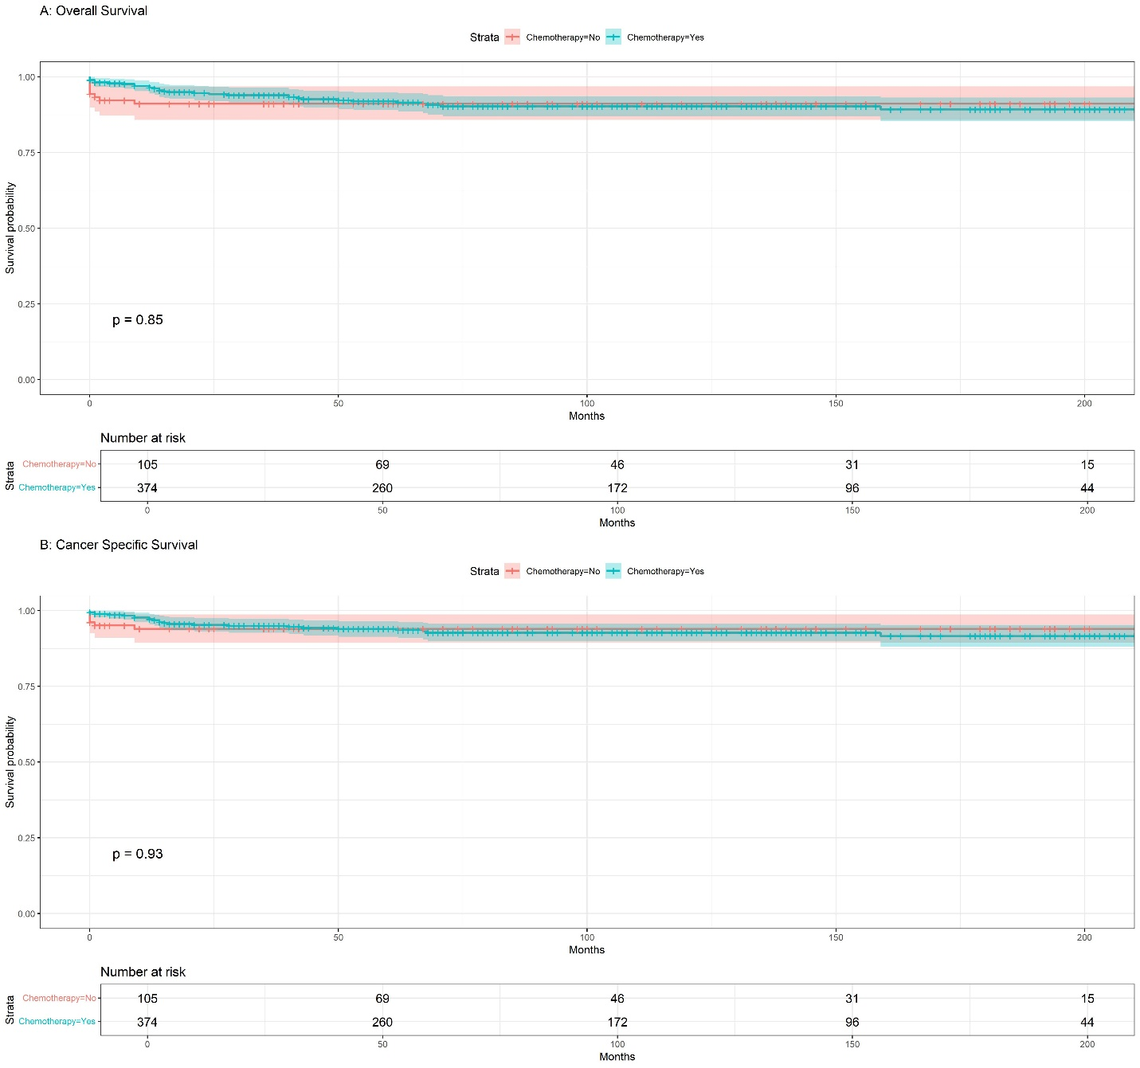
FigureS1 -GCC: a) Kaplan-Meier overall survival (OS) based on chemotherapy; b) Kaplan-Meier cancer-specific survival (CSS) based on chemotherapy.

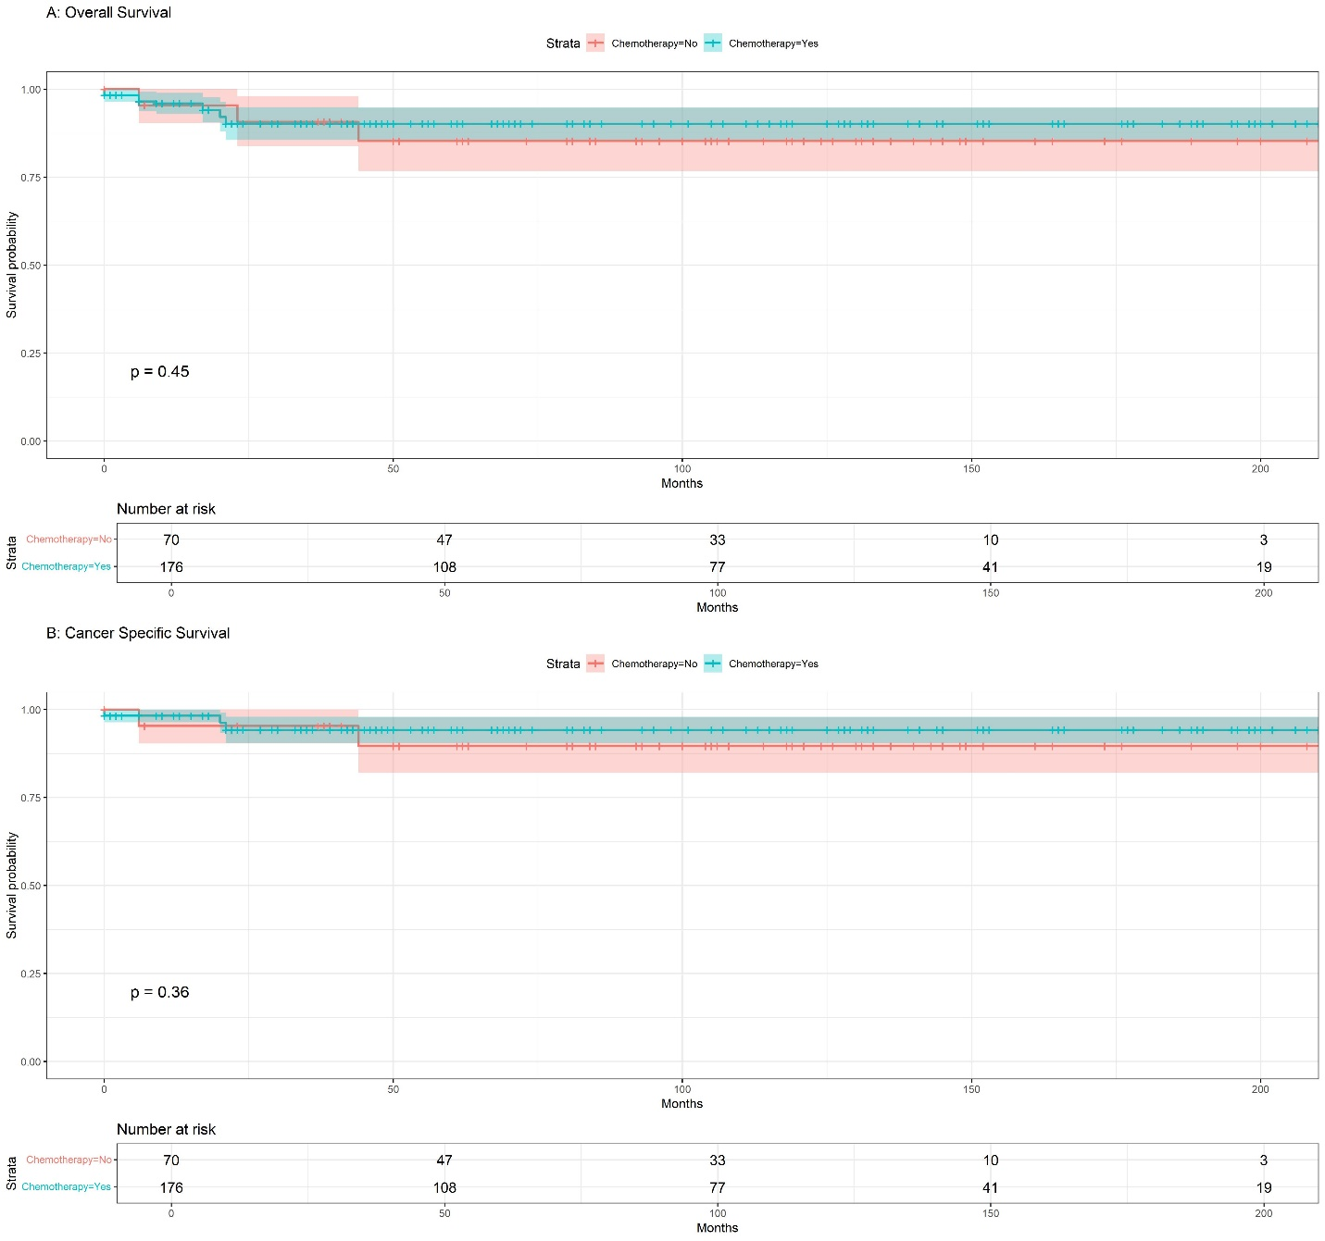

Figure S2-PTSS+ETT: a) Kaplan-Meier overall survival (OS) based on chemotherapy; b) Kaplan-Meier cancer-specific survival (CSS) based on chemotherapy.

