Supplementary Material

**Table 1**. Information of four types of sludge samples analyzed in this study

|  |  |  |  |  |  |  |  |
| --- | --- | --- | --- | --- | --- | --- | --- |
| **Article ID** | **Treatment Process** | **Location** | **Bioreactor scale** | **Bioreactor Number** | **Sequencing Region** | **Sample Number** | **Reference** |
| 1 | SBR | China: Guangdong | Lab | 1 | V3- V4 | 4 | (Yan et al., 2020) |
| 2 | SBR | China: Beijing | Lab | 1 | V3- V4 | 3 | (Cao et al., 2019) |
| 3 | SBRs、SBRo | China: Shenzhen | Lab | 2 | V4 | 1 | (Sun et al., 2018) |
| 4 | CSTR | China: Nanjing | Lab | 2 | V3- V4 | 3 | (Zhang et al., 2022b) |
| 5 | PN-SBR | Spain: Catalonia | Lab | 1 | - | 3 | (Gabarró et al., 2014) |
| 6 | Up-flow fixed-bed anammox reactor | Japan: Tokyo | Lab | 1 | - | 4 | (Suenaga et al., 2021) |
| 7 | Plexiglass | China: Nanjing | Lab | 1 | V3- V4 | 71 | (Niu et al., 2022) |
| 8 | SBBR | China: Chongqing | Lab | 1 | - | 5 | (Hong et al., 2022) |
| 9 | SBR | China: Shenzhen | Lab | 1 | - | 4 | (Miao et al., 2017) |
| 10 | UASB | China: Beijing | Lab | 1 | V3- V4 | 1 | (Wang et al., 2019a) |
| 11 | UASB | China: Beijing | Lab | 1 | V3- V4 | 3 | (Zhu et al., 2018) |
| 12 | Plexiglass | China: Shanghai | Lab | 1 | - | 4 | (Zhuang et al., 2020) |
| 13 | EPD-SBR, UASB, N-SBR | China: Beijing | Lab | 3 | V3- V4 | 3 | (Ji et al., 2018) |
| 14 | CR-SBR+ PN/A-USB+ PD/A-USB | China: Beijing | Lab | 1 | - | 6 | (Zhang et al., 2022a) |
| 15 | Continuous Flow Reactor | China: Beijing | Lab | 1 | - | 3 | (Gao et al., 2023) |
| 16 | SNAD-IFAS | China: Dalian | Lab | 1 | V3- V4 | 6 | (Wang et al., 2018) |
| 17 | PDN-Anammox Biofilter | China: Beijing | Lab | 1 | - | 2 | (Cui et al., 2020) |
| 18 | Step-feed A/O Bioreactor | China: Beijing | Lab | 1 | V3- V4 | 1 | (Gao et al., 2022) |
| 19 | UASB | China: Beijing | Lab | 1 | - | 1 | (Xu et al., 2020) |
| 20 | SBR | China: Beijing | Lab | 1 | V3- V4 | 2 | (Miao et al., 2018) |
| 21 | PNA-SBR | Spain: Catalonia | Lab | 1 | V4 | 3 | (Akaboci et al., 2018) |
| 22 | (SBRs) | Beijing 100124, PR China | Lab | 1 | V3- V4 | 4 | (Wang et al., 2019b) |
| 23 | Anammox-UASB | Beijing 100124，PR China | Lab | 1 | V4 | 6 | (Gong et al., 2020) |
| 24 | SBR | Beijing 100048, China | Lab | 1 | V4 | 6 | (Lv et al., 2020) |
| 25 | IFAS | Beijing 100124, PR China | Lab | 1 | - | 9 | (Yang et al., 2019) |
| 26 | IFAS | Harbin 150090, China | Lab | 1 | V3- V4 | 2 | (Yang et al., 2017) |
| 27 | SNAD-IFAS | Qingdao 266071, PR China | Lab | 1 | - | 7 | (Yang et al., 2017) |
| 28 | A/O | Beijing University of Technology, Beijing, China; | Lab | 1 | - | 1 | (Du et al., 2021) |
| 29 | PNABR | Beijing 100124, PR China | Lab | 1 | - | 2 | (Jiang et al., 2020) |
| 30 | NWMBR | Shanghai Jiaotong University, PR China | Lab | 1 | V4 | 2 | (Ren et al., 2018) |
| 31 | PBBR | Hongkong，China | Lab | 1 | V4 | 11 | (Li et al., 2021) |
| 32 | SBR | China; | Lab | 1 | V4 | 5 | (Huang and Wu, 2020) |
| 33 | PN/A | Beijing 100022, China | Lab | 1 | V3- V4 | 16 | (Yang et al., 2021) |
| 34 | PN/A，A/A/O | Beijing 100124, PR China | Lab | 2 | V3- V4 | 4 | (Gao et al., 2021) |

**Table 2**. Accession numbers of the 16S rRNA gene sequencing datasets analyzed in this study

|  |  |
| --- | --- |
| **Article ID** | **Accession numbers** |
| 1 | SRR11210586, SRR11210587, SRR11210588, SRR11210589 |
| 2 | SRR5885315, SRR5885316, SRR5885317 |
| 3 | SRR4238043 |
| 4 | [SRR19744794](https://trace.ncbi.nlm.nih.gov/Traces?run=SRR19744794), [SRR19744795](https://trace.ncbi.nlm.nih.gov/Traces?run=SRR19744795), [SRR19744796](https://trace.ncbi.nlm.nih.gov/Traces?run=SRR19744796) |
| 5 | SRR1019211, SRR1019209, SRS494429 |
| 6 | DRR189466, DRR189465, DRR189464, DRR189463 |
| 7 | SRR15377087- SRR15377158 |
| 8 | SRR19577258- SRR19577262 |
| 9 | SRR4004225- SRR4004228 |
| 10 | SRR6448375 |
| 11 | SRR6448186- SRR6448188 |
| 12 | SRR10810250, SRR10807893, SRR10807626, SRR10803493 |
| 13 | SRR5879570, SRR6179223, SRR5879569 |
| 14 | SRR19668067, SRR19668068, SRR19668069, SRR19668070, SRR19668071, SRR19668072 |
| 15 | SRR19592836- SRR19592838 |
| 16 | SRR6037377- SRR6037382 |
| 17 | SRR10201390, SRR10201391 |
| 18 | SUB9234646 |
| 19 | SRR10064596 |
| 20 | SRR6056688, SRR6056752 |
| 21 | SRR6012558- SRR6012560 |
| 22 | SRR8359314, SRR8359315, SRR8359316 and SRR8359317 |
| 23 | SRR11212297- SRR11212302 |
| 24 | SRR10695693, SRR10695692, SRR10695691, SRR10695690, SRR10695689, SRR10695688 |
| 25 | SRR6891810- SRR6891818 |
| 26 | SRR4297636, SRR4297637 |
| 27 | SRR10199657, SRR10230800, SRR10230803, SRR10230799, SRR10230802, SRR10230798 and SRR10230801 |
| 28 | SRR5266476 |
| 29 | SRR10609227, SRR10609228 |
| 30 | SRR5260888, SRR5260898 |
| 31 | SRR14923912- SRR14923922 |
| 32 | SRR10567086- SRR10567092 |
| 33 | SRR9943601- SRR9943606 and SRR9943609- SRR993618 |
| 34 | SRR12396692- SRR12396695 |

**Table S3**. Main genera specific to different morphologic microorganisms

|  |  |  |  |  |  |  |  |
| --- | --- | --- | --- | --- | --- | --- | --- |
| SS | SS | Biofilm | Biofilm | GS | GS | IFAS | IFAS |
| Aquicella | 0.000905 | Brumimicrobium | 0.004408 | Meiothermus | 0.005239 | Sphingosinicella | 0.000533 |
| Cutibacterium | 0.000675 | Photobacterium | 0.001332 | mle1-8 | 0.001884 | D8A-2 | 0.000348 |
| Thermoanaerobaculum | 0.000588 | Wenzhouxiangella | 0.000505 | unclassified_Phycisphaerae | 0.001149 | Acetomicrobium | 0.000163 |
| Mizugakiibacter | 0.000373 | UBA9983 | 0.000275 | S-70 | 0.001103 | Limnochordaceae | 0.000156 |
| Lamprocystis | 0.000291 | Vulcanibacillus | 0.000199 | unclassified_Deinococcaceae | 0.000643 | Methyloceanibacter | 0.000156 |
| Prevotellaceae_UCG-001 | 0.000291 | Nitriliruptoraceae | 0.000184 | CCM11a | 0.000552 | 113B434 | 9.24E-05 |
| Prevotellaceae_NK3B31_group | 0.000266 | Sneathiella | 0.000168 | Peptoclostridium | 0.000414 | Arsenophonus | 9.24E-05 |
| Sulfuricurvum | 0.000266 | Lutibacter | 0.000138 | unclassified_Pirellulaceae | 0.000322 | Oligoflexales | 9.24E-05 |
| unclassified_Chromatiaceae | 0.000266 | Dinghuibacter | 0.000122 | Rhodopirellula | 0.00023 | Cerasicoccus | 4.26E-05 |
| Desulfobacter | 0.000256 | unclassified_Vibrionaceae | 0.000122 | Rurimicrobium | 0.00023 | unclassified_Chthoniobacterales | 4.26E-05 |

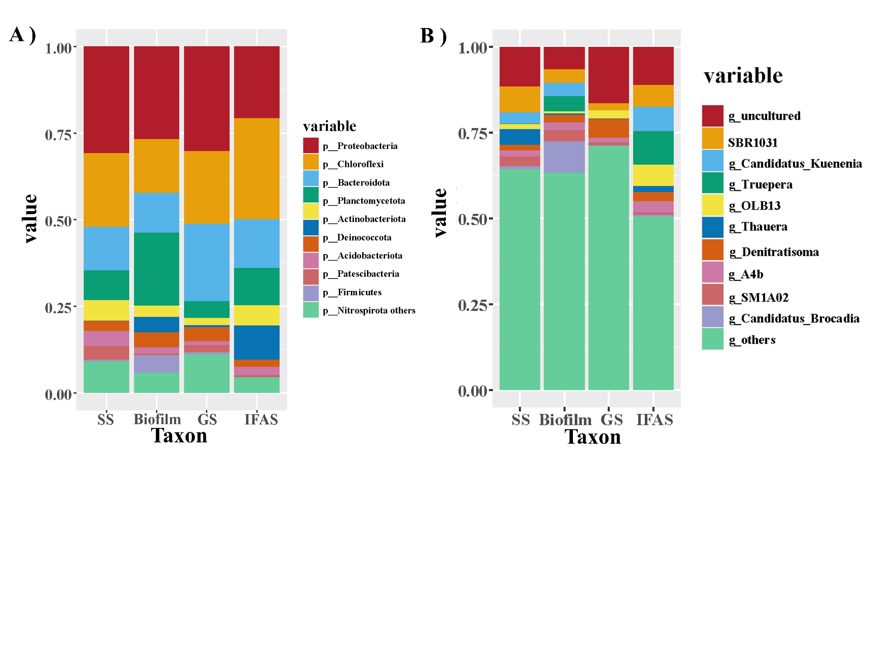

**Fig. S1.** The relative abundance of phylum and genus in four types of sludge. (a) The relative abundances of the ten most abundant phyla of the four forms of sludge (b) the relative abundances of the ten most abundant genera of the four forms of sludge.

**References:**

Akaboci, T.R.V., Gich, F., Ruscalleda, M., Balaguer, M.D., and Colprim, J. (2018). Assessment of operational conditions towards mainstream partial nitritation-anammox stability at moderate to low temperature: Reactor performance and bacterial community. *Chemical Engineering Journal* 350**,** 192-200. doi: <https://doi.org/10.1016/j.cej.2018.05.115>.

Cao, S., Du, R., Peng, Y., Li, B., and Wang, S. (2019). Novel two stage partial denitrification (PD)-Anammox process for tertiary nitrogen removal from low carbon/nitrogen (C/N) municipal sewage. *Chemical Engineering Journal* 362**,** 107-115. doi: 10.1016/j.cej.2018.12.160.

Cui, B., Yang, Q., Liu, X., Wu, W., Liu, Z., and Gu, P. (2020). Achieving partial denitrification-anammox in biofilter for advanced wastewater treatment. *Environ Int* 138**,** 105612. doi: 10.1016/j.envint.2020.105612.

Du, Y., Yu, D., Wang, X., Zhen, J., Bi, C., Gong, X., et al. (2021). Achieving simultaneous nitritation, anammox and denitrification (SNAD) in an integrated fixed-biofilm activated sludge (IFAS) reactor: Quickly culturing self-generated anammox bacteria. *Sci Total Environ* 768**,** 144446. doi: 10.1016/j.scitotenv.2020.144446.

Gabarró, J., González-Cárcamo, P., Ruscalleda, M., Ganigué, R., Gich, F., Balaguer, M.D., et al. (2014). Anoxic phases are the main N2O contributor in partial nitritation reactors treating high nitrogen loads with alternate aeration. *Bioresour Technol* 163**,** 92-99. doi: 10.1016/j.biortech.2014.04.019.

Gao, R., Peng, Y., Li, J., Li, X., Zhang, Q., Deng, L., et al. (2021). Nutrients removal from low C/N actual municipal wastewater by partial nitritation/anammox (PN/A) coupling with a step-feed anaerobic-anoxic-oxic (A/A/O) system. *Sci Total Environ* 799**,** 149293. doi: 10.1016/j.scitotenv.2021.149293.

Gao, R., Peng, Y., Li, J., Liu, Y., Deng, L., Li, W., et al. (2022). Mainstream partial denitrification-anammox (PD/A) for municipal sewage treatment from moderate to low temperature: Reactor performance and bacterial structure. *Sci Total Environ* 806(Pt 2)**,** 150267. doi: 10.1016/j.scitotenv.2021.150267.

Gao, X., Zhang, L., Peng, Y., Ding, J., and An, Z. (2023). The successful integration of anammox to enhance the operational stability and nitrogen removal efficiency during municipal wastewater treatment. *Chemical Engineering Journal* 451**,** 138878. doi: <https://doi.org/10.1016/j.cej.2022.138878>.

Gong, X., Wang, B., Qiao, X., Gong, Q., Liu, X., and Peng, Y. (2020). Performance of the anammox process treating low-strength municipal wastewater under low temperatures: Effect of undulating seasonal temperature variation. *Bioresour Technol* 312**,** 123590. doi: 10.1016/j.biortech.2020.123590.

Hong, Y., Tu, Q., Cheng, H., Huangfu, X., Chen, Z., and He, Q. (2022). Chronic high-dose silver nanoparticle exposure stimulates N(2)O emissions by constructing anaerobic micro-environment. *Water Res* 225**,** 119104. doi: 10.1016/j.watres.2022.119104.

Huang, S., and Wu, D. (2020). Responses of Anammox Granular Sludge to Long-Term Rare Earth Element Feeding: Lanthanum as a Case. *Sustainability* 12(19)**,** 7887.

Ji, J., Peng, Y., Mai, W., He, J., Wang, B., Li, X., et al. (2018). Achieving advanced nitrogen removal from low C/N wastewater by combining endogenous partial denitrification with anammox in mainstream treatment. *Bioresour Technol* 270**,** 570-579. doi: 10.1016/j.biortech.2018.08.124.

Jiang, H., Peng, Y., Li, X., Zhang, F., Wang, Z., and Ren, S. (2020). Advanced nitrogen removal from mature landfill leachate via partial nitrification-Anammox biofilm reactor (PNABR) driven by high dissolved oxygen (DO): Protection mechanism of aerobic biofilm. *Bioresour Technol* 306**,** 123119. doi: 10.1016/j.biortech.2020.123119.

Li, Y.-y., Huang, X.-w., and Li, X.-y. (2021). Use of a packed-bed biofilm reactor to achieve rapid formation of anammox biofilms for high-rate nitrogen removal. *Journal of Cleaner Production* 321**,** 128999. doi: <https://doi.org/10.1016/j.jclepro.2021.128999>.

Lv, Y., Pan, J., Huo, T., Li, J., and Liu, S. (2020). Enhance the treatment of low strength wastewater at low temperature with the coexistence system of AnAOB and heterotrophic bacteria: Performance and bacterial community. *Sci Total Environ* 714**,** 136799. doi: 10.1016/j.scitotenv.2020.136799.

Miao, J., Zhao, Y., and Wu, G. (2017). Effect of organic carbons on microbial activity and structure in denitrifying systems acclimated to nitrite as the electron acceptor. *International Biodeterioration & Biodegradation* 118**,** 66-72. doi: <https://doi.org/10.1016/j.ibiod.2017.01.025>.

Miao, Y., Peng, Y., Zhang, L., Li, B., Li, X., Wu, L., et al. (2018). Partial nitrification-anammox (PNA) treating sewage with intermittent aeration mode: Effect of influent C/N ratios. *Chemical Engineering Journal* 334**,** 664-672. doi: 10.1016/j.cej.2017.10.072.

Niu, L., Hu, J., Li, Y., Wang, C., Zhang, W., Hu, Q., et al. (2022). Effects of long-term exposure to silver nanoparticles on the structure and function of microplastic biofilms in eutrophic water. *Environ Res* 207**,** 112182. doi: 10.1016/j.envres.2021.112182.

Ren, L.F., Lv, L., Kang, Q., Gao, B., Ni, S.Q., Chen, Y.H., et al. (2018). Microbial dynamics of biofilm and suspended flocs in anammox membrane bioreactor: The effect of non-woven fabric membrane. *Bioresour Technol* 247**,** 259-266. doi: 10.1016/j.biortech.2017.09.070.

Suenaga, T., Ota, T., Oba, K., Usui, K., Sako, T., Hori, T., et al. (2021). Combination of 15N Tracer and Microbial Analyses Discloses N2O Sink Potential of the Anammox Community. *Environmental Science & Technology* 55(13)**,** 9231-9242. doi: 10.1021/acs.est.1c00674.

Sun, Y., Wang, H., Wu, G., and Guan, Y. (2018). Nitrogen removal and nitrous oxide emission from a step-feeding multiple anoxic and aerobic process. *Environ Technol* 39(7)**,** 814-823. doi: 10.1080/09593330.2017.1311947.

Wang, C., Liu, S., Xu, X., Zhang, C., Wang, D., and Yang, F. (2018). Achieving mainstream nitrogen removal through simultaneous partial nitrification, anammox and denitrification process in an integrated fixed film activated sludge reactor. *Chemosphere* 203**,** 457-466. doi: 10.1016/j.chemosphere.2018.04.016.

Wang, S., Zhu, G., Li, Y., Wang, X., Zhou, J., and Peng, Y. (2019a). Robustness of anammox granular sludge treating low-strength sewage under various shock loadings: Microbial mechanism and little N(2)O emission. *J Environ Sci (China)* 86**,** 141-153. doi: 10.1016/j.jes.2019.03.016.

Wang, X., Zhao, J., Yu, D., Du, S., Yuan, M., and Zhen, J. (2019b). Evaluating the potential for sustaining mainstream anammox by endogenous partial denitrification and phosphorus removal for energy-efficient wastewater treatment. *Bioresour Technol* 284**,** 302-314. doi: 10.1016/j.biortech.2019.03.127.

Xu, X., Ma, B., Lu, W., Feng, D., Wei, Y., Ge, C., et al. (2020). Effective nitrogen removal in a granule-based partial-denitrification/anammox reactor treating low C/N sewage. *Bioresource Technology* 297**,** 122467. doi: <https://doi.org/10.1016/j.biortech.2019.122467>.

Yan, J., Wang, S., Wu, L., Li, S., Li, H., Wang, Y., et al. (2020). Long-term ammonia gas biofiltration through simultaneous nitrification, anammox and denitrification process with limited N2O emission and negligible leachate production. *Journal of Cleaner Production* 270**,** 122406. doi: <https://doi.org/10.1016/j.jclepro.2020.122406>.

Yang, S., Peng, Y., Zhang, L., Zhang, Q., Li, J., and Wang, X. (2019). Autotrophic nitrogen removal in an integrated fixed-biofilm activated sludge (IFAS) reactor: Anammox bacteria enriched in the flocs have been overlooked. *Bioresour Technol* 288**,** 121512. doi: 10.1016/j.biortech.2019.121512.

Yang, S., Peng, Y., Zhang, S., Han, X., Li, J., and Zhang, L. (2021). Carrier type induces anammox biofilm structure and the nitrogen removal pathway: Demonstration in a full-scale partial nitritation/anammox process. *Bioresour Technol* 334**,** 125249. doi: 10.1016/j.biortech.2021.125249.

Yang, Y., Zhang, L., Cheng, J., Zhang, S., Li, B., and Peng, Y. (2017). Achieve efficient nitrogen removal from real sewage in a plug-flow integrated fixed-film activated sludge (IFAS) reactor via partial nitritation/anammox pathway. *Bioresource Technology* 239**,** 294-301. doi: <https://doi.org/10.1016/j.biortech.2017.05.041>.

Zhang, L., Zhang, Q., Li, X., Jia, T., Wang, S., and Peng, Y. (2022a). Enhanced nitrogen removal from municipal wastewater via a novel combined process driven by partial nitrification/anammox (PN/A) and partial denitrification/anammox (PD/A) with an ultra-low hydraulic retention time (HRT). *Bioresource Technology* 363**,** 127950. doi: <https://doi.org/10.1016/j.biortech.2022.127950>.

Zhang, Q., Zhao, L., Zhang, J., Liu, W., Cai, S., Chen, L., et al. (2022b). Nitrogen contribution and microbial community of size-fractionated anammox sludge in continuous stirred-tank reactors. *Bioresource Technology* 362**,** 127857. doi: <https://doi.org/10.1016/j.biortech.2022.127857>.

Zhu, G., Wang, S., Ma, B., Wang, X., Zhou, J., Zhao, S., et al. (2018). Anammox granular sludge in low-ammonium sewage treatment: Not bigger size driving better performance. *Water Research* 142**,** 147-158. doi: <https://doi.org/10.1016/j.watres.2018.05.048>.

Zhuang, J.-l., Zhou, Y.-y., Liu, Y.-d., and Li, W. (2020). Flocs are the main source of nitrous oxide in a high-rate anammox granular sludge reactor: insights from metagenomics and fed-batch experiments. *Water Research* 186**,** 116321. doi: <https://doi.org/10.1016/j.watres.2020.116321>.