Supplementary Material

Supplementary Figures and Tables

Supplementary Figures
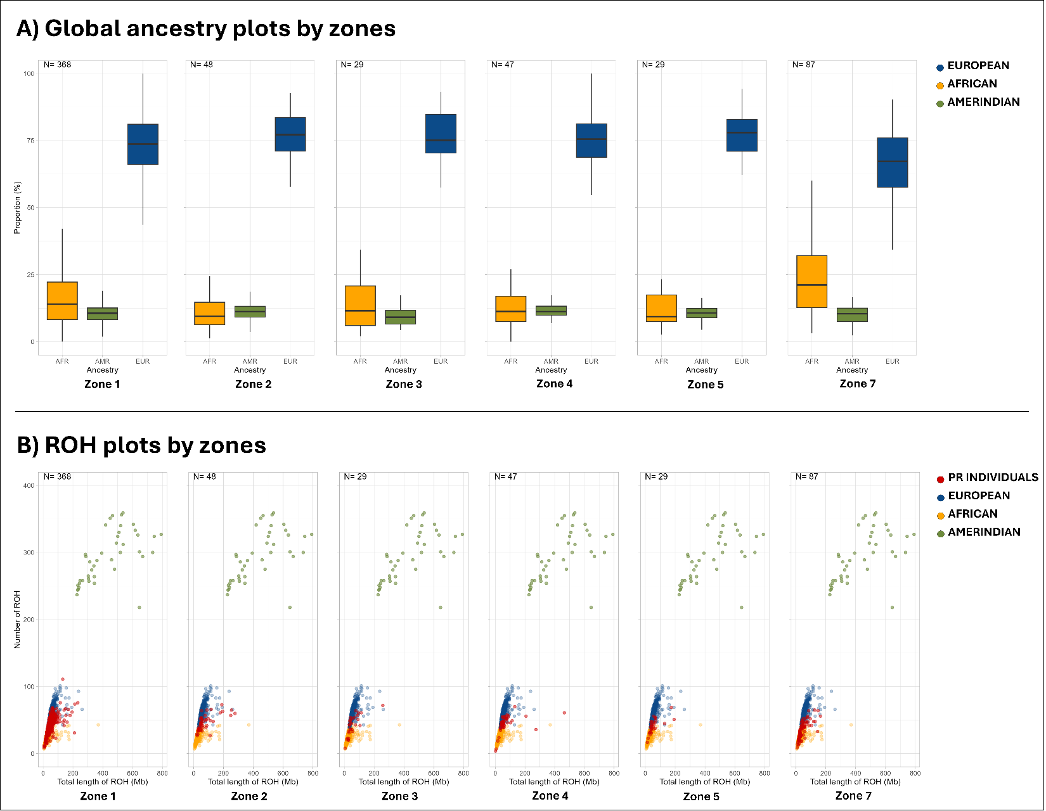
Supplementary Figure 1. A) Global ancestry proportions of individuals in PR by 6 different zones. The yellow color represents the African background, the blue represents the European background, and the green represents the Amerindian background. B) Distributions of total ROH length and number of ROHs in participants from six different zones in PR (represented in red). The yellow, blue, and green colors represent individuals from the HGDP and 1000G reference panel with African, European, and Amerindian backgrounds, respectively. Since there were only two participants from Zone 6, this zone was included in the figure.

Supplementary Tables

Supplementary Table 1. Regions at P < 0.0001 as a result of rare variant gene-based testing for Model 1 (adjusted for sex, age, and first 4 PCs as fixed effects and GRM as a random effect), and Model 2 (also adjusted for APOE-ε4 allele dosage).
 |  | Region | Pvalue | Pvalue_Burden | Pvalue_SKAT | BETA_Burden | SE_Burden
Model 1 | CADD0 | ISL1 | 5.106E-06 | 5.349E-06 | 8.286E-06 | 0.1313922 | 0.0288735
 | CADD10 | BEGAIN | 5.368E-06 | 5.368E-06 | 5.368E-06 | -0.1611823 | 0.0354257
 |  | BCAT1 | 1.891E-05 | 1.891E-05 | 1.891E-05 | 0.2456142 | 0.0574218
 |  | NPM1 | 8.666E-05 | 0.2736582 | 4.715E-05 | 0.0213338 | 0.0194886
Model 2 | CADD0 | ISL1 | 1.557E-05 | 1.483E-05 | 2.525E-05 | 0.1258767 | 0.0290631
 | CADD10 | BEGAIN | 1.367E-06 | 1.367E-06 | 1.367E-06 | -0.1771946 | 0.0366882
 |  | BCAT1 | 6.06E-06 | 6.06E-06 | 6.06E-06 | 0.2670644 | 0.0590292

Supplementary Table 2. Top pathways derived from MAGMA gene-set analysis.
Gene-set name | Number of Genes | P value
 |  | Model 1 | Model 2
Lin tumor escape from immune attack | 18 | 3.9 x 10⁻⁵ | 1.8 x 10⁻⁴
Chiang liver cancer subclass polysomy7 dn | 25 | 3.4 x 10⁻⁴ | 7.0 x 10⁻⁵
Gobp regulation of inflammatory response to antigenic stimulus | 13 | 1.2 x 10⁻⁴ | 1.7 x 10⁻⁵

Supplementary Table 3. PIP values ​​as a result of fine mapping of index markers of suggestive significant loci
Closest gene | Marker | dbSNP | Reference  /effect allele | PIP – Model 1 | PIP – Model 2
AL392172.2 | 1:222779085 | rs4240935 | G/T | 0.34 | 0.38
AC097655.1 | 4:60211881 | rs11131227 | A/C | 0.22 | 0.18
AKR1C2 | 10:5008180 | rs11252881 | T/A | 0.96 | 0.79
SLC38A1 | 12:46230329 | rs11183403 | A/C | 0.86 | 0.84
SCN8A | 12:51658428 | rs7953996 | G/A | 0.08 | 0.11
HAR1A | 20:63109757 | rs112918561 | T/TTG | 0.18 | 0.32

Supplementary Table 4. Global Burden Measurements of ROHs in PR individuals. (Bonferroni-adjusted p-value = 0.0167)
 | 1 Mb |  |  | 2 Mb |  |  | 3 Mb
 | Cases | Controls | P value | Cases | Controls | P value | Cases | Controls | P value
Total Number of ROHs | 5177 | 4121 |  | 1517 | 1031 |  | 870 | 587
Number of ROHs per person | 15.05 | 13.6 | 0.0012 | 4.74 | 3.83 | 0.0023 | 3.51 | 2.84 | 0.0113
Total size of ROHs per person, MB | 42.74 | 32.5 | 0.0003 | 30.66 | 21.32 | 0.0024 | 33.27 | 22.63 | 0.0022
Mean ROH size per person, MB | 2.52 | 2.23 | 0.005 | 5.21 | 4.82 | 0.0872 | 7.92 | 7.41 | 0.1296

Supplementary Table 5. List of clumped 99 SNPs used to construct the PRS.
rs12041364 | rs6846529 | rs71519637 | rs10898437 | rs56407236
rs2070902 | rs62375397 | rs62504296 | rs10792832 | rs1323085091
rs6540874 | rs113706587 | rs7341557 | rs11603136 | rs78534596
rs679515 | rs113472359 | rs10780145 | rs138337950 | rs5848
chr1:207664601 | rs143332484 | rs867230 | rs60228070 | rs2680700
rs2404174 | rs9394766 | rs138529507 | rs11218343 | rs4292
rs75836995 | rs4714447 | rs199563267 | rs11218360 | rs72618590
rs17014873 | rs9349413 | rs1693551 | rs11828225 | rs72973575
rs11694743 | rs1777484658 | rs34674752 | rs17125924 | rs4147910
rs12989701 | rs67250450 | rs34173062 | rs12590654 | rs12151021
rs34546266 | rs74504435 | rs992537601 | rs2009833 | chr19:1066626
rs6733839 | rs4424195 | rs3740204 | rs183428733 | rs72975514
rs6431223 | rs4727449 | rs7912495 | rs593742 | rs12462743
rs7569598 | rs7384878 | rs7068231 | rs11853804 | rs1555830266
rs7421448 | rs13235951 | rs6586028 | rs117618017 | rs12462098
rs28459768 | rs2734895 | rs10838702 | rs1140239 | rs6014724
rs61762319 | rs56402156 | rs12577383 | rs78924645 | rs2154481
rs4690197 | rs11769559 | rs562028 | rs12444183 | rs2830489
rs3916085 | chr8:11817388 | rs1582763 | rs147330136 | rs2830510
rs875394 | rs73223431 | rs638509 | rs4485362

