**Supplementary Table 1** Compressive Modulus of the scaffolds

|  |  |
| --- | --- |
| Scaffold | Compressive Modulus |
| PLA/PCL-VAP | 65.5044 ± 1.98451 MPa |
| PLGA/Mg(OH)2-VAP | 20.7086 ± 0.63024 MPa |

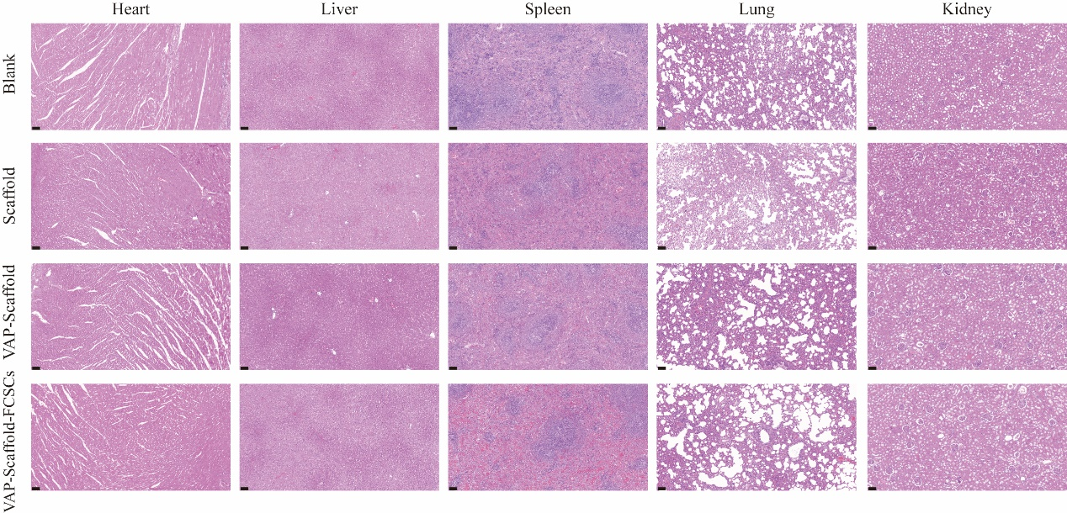

**Supplementary Figure 1**. H&E staining of the heart, liver, spleen, lung, and kidney. No significant inflammatory cell infiltration or pathological changes were observed in the organs of all groups (Scale bar = 100 µm).