Supplementary materials

Figure S1: Questions and answers included in the survey provided to gynecologists.

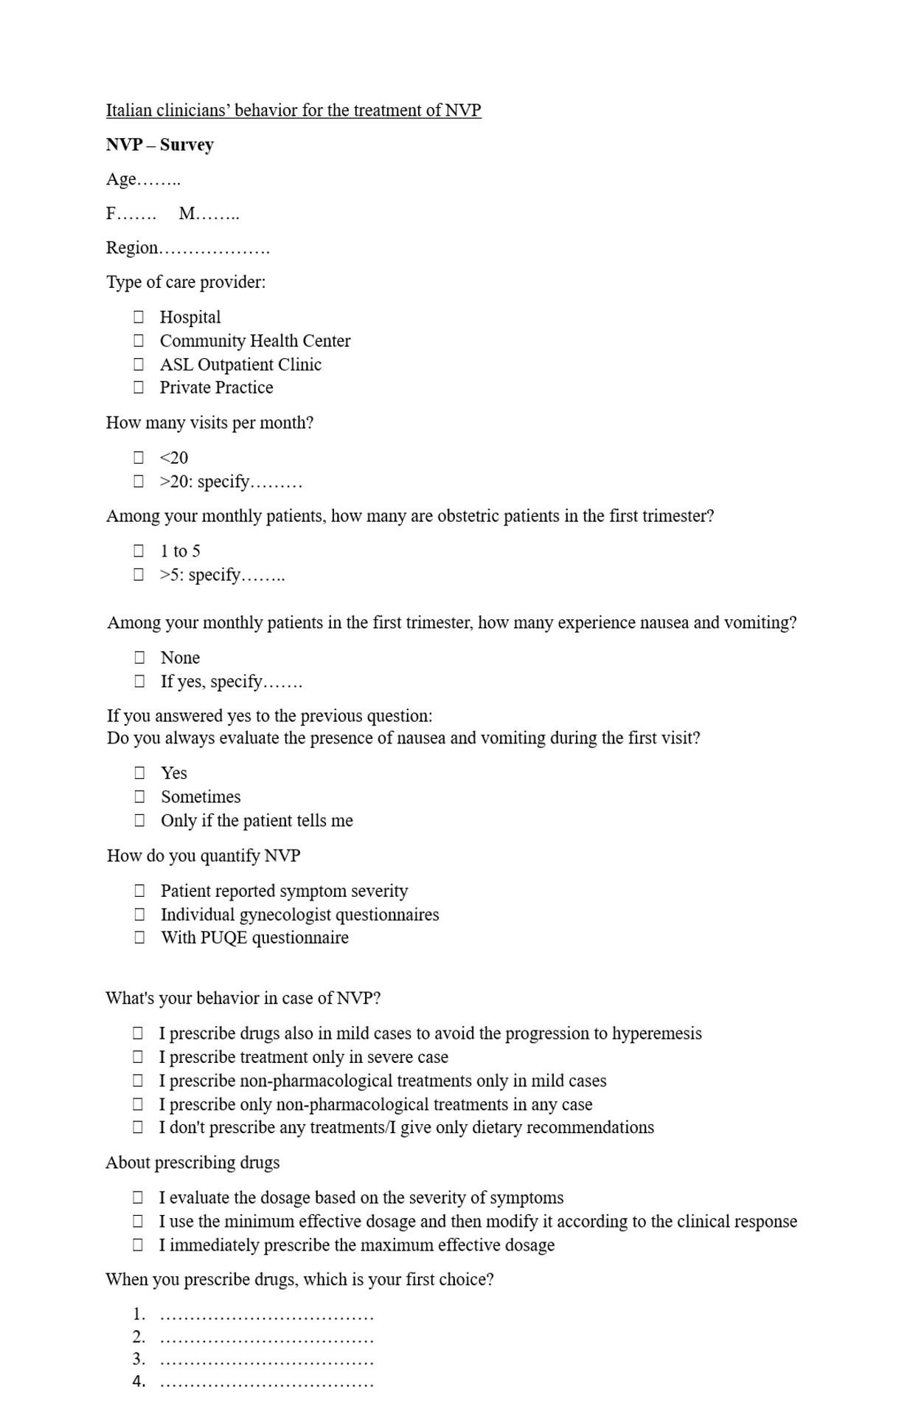
Table S1: Univariate analysis, corrected for geographical origin, on the question “What's your behavior in case of NVP?” (N=150).
Results are expressed as odds ratio (OR) with 95% confidence interval (95%CI); p-value: Likelihood Ratio p-value.

Characteristic | I prescribe treatment only in severe cases | I prescribe non-pharmacological treatments only in mild cases | I prescribe only non-pharmacological treatments in any case | p-value
 | versus | versus | versus
 | I prescribe drugs also in mild cases to avoid the progression to hyperemesis | I prescribe drugs also in mild cases to avoid the progression to hyperemesis | I prescribe drugs also in mild cases to avoid the progression to hyperemesis
Gender |  |  |  | 0.0171
Male | 1 | 1 | 1
Female | 0.38 (0.16 : 0.87) | 2.08 (0.44 : 20.11) | 2.06 (0.44 : 19.98)
Age (years) |  |  |  | 0.1011
<=45 | 1 | 1 | 1
46-55 | 3.78 (1.1 : 14.22) | 0.66 (0.06 : 3.74) | 4.44 (0.85 : 28.76)
56-65 | 4.08 (1.43 : 13.35) | 0.65 (0.14 : 2.64) | 1.46 (0.26 : 9.37)
>65 | 4.47 (1.22 : 17.88) | 0.84 (0.08 : 4.98) | 3.18 (0.43 : 23.74)
Years of activity |  |  |  | 0.1448
≤ 10 | 1 | 1 | 1
11-20 | 4.33 (1.01 : 25.64) | 2.23 (0.44 : 14.11) | 9.58 (0.83 : 1328.35)
21-30 | 6.82 (1.64 : 40.2) | 1.29 (0.18 : 9.34) | 8.43 (0.73 : 1169.46)
31-40 | 6.05 (1.39 : 36.55) | 0.81 (0.07 : 6.80) | 3.87 (0.19 : 580.05)
>40 | 3.99 (0.71 : 27.73) | 1.49 (0.12 : 12.97) | 2.85 (0.01 : 548.63)
Type of care provider |  |  |  | 0.6090
Public sector | 1 | 1 | 1
Freelance | 0.64 (0.28 : 1.45) | 0.67 (0.15 : 2.40) | 1.45 (0.39 : 5.27)
How many visits per month? |  |  |  | 0.1467
>20 | 1 | 1 | 1
≤ 20 | 2.63 (0.69 : 10.17) | 4.02 (0.63 : 21.11) | 0.57 (0 : 5.62)
How many patients do you see in the first trimester of the month? |  |  |  | 0.0313
>5 | 1 | 1 | 1
≤ 5 | 3.37 (1.51 : 7.77) | 1.63 (0.42 : 5.74) | 1.41 (0.36 : 4.89)
Do you always check the presence of NVP during the first visit? |  |  |  | 0.5597
Yes | 1 | 1 | 1
Only if the patient tells me | 1.51 (0.47 : 4.71) | 1.29 (0.13 : 6.83) | 3.25 (0.53 : 16.02)
Sometime | 1.57 (0.34 : 6.48) | 0.62 (0.01 : 6.66) | 3.88 (0.60 : 21.16)
How do you quantify NVP? |  |  |  | 0.2121
Patient reported symptom severity | 1 | 1 | 1
Individual gynecologist questionnaires | 0.58 (0.14 : 1.96) | 1.02 (0.10 : 5.22) | 0.27 (0.01 : 2.35)
With PUQE questionnaire | 0.19 (0.01 : 1.90) | 0.74 (0.01 : 7.60) | 0.65 (0.01 : 6.8)
About prescribing drugs |  |  |  | 0.1974
I evaluate the dosage based on the severity of symptoms | 1 | 1 | 1
I use the minimum effective dosage and then modify it according to the clinical response | 0.62 (0.26 : 1.43) | 2.3 (0.62 : 10.23) | 2.22 (0.57 : 10.10)
I immediately prescribe the maximum effective dosage | 0.39 (0.11 : 1.22) | 0.98 (0.09 : 6.59) | 1.10 (0.10 : 7.50)
When you prescribe drugs, which is your first choice? |  |  |  | 0.0686
doxylamine 10mg/pyridoxine 10mg | 1 | 1 | 1
food supplements (ginger/vit. B) | 2.35 (0.58 : 9.15) | 3.17 (0.51 : 15.73) | 7.55 (1.66 : 35.31)
sodium+potassium+citric acid+riboflavin+thiamine+  pyridoxine | 2.03 (0.16 : 18.77) | 4.96 (0.40 : 43.9) | 2.57 (0.02 : 38.16)
Other | 5.78 (0.61 : 81.56) | 4.16 (0.03 : 100.11) | 19.96 (2.23 : 252.8)

Table S2: Univariate analysis, corrected for geographical origin, on the question “How do you quantify NVP?” (N=157).
Results are expressed as odds ratio (OR) with 95% confidence interval (95%CI); p-value: Likelihood Ratio p-value.

Characteristic | Individual gynecologist questionnaires | With PUQE questionnaire | p-value
 | versus | versus
 | Patient reported symptom severity | Patient reported symptom severity
Gender |  |  | 0.3151
Male | 1 | 1
Female | 2.42 (0.68 : 12.90) | 1.31 (0.23 : 13.55)
Age (years) |  |  | 0.5227
<=45 | 1 | 1
46-55 | 3.11 (0.64 : 18.99) | 0.59 (0.01 : 11.61)
56-65 | 2.66 (0.68 : 14.67) | 1.71 (0.27 : 18.16)
>65 | 2.19 (0.32 : 15.19) | 1.99 (0.15 : 25.81)
Years of activity |  |  | 0.2620
≤ 10 | 1 | 1
11-20 | 6 (0.54 : 821.95) | 2.59 (0.13 : 385.62)
21-30 | 8.93 (0.94 : 1192.73) | 2.25 (0.11 : 334.97)
31-40 | 4.72 (0.36 : 664.2) | 4.89 (0.37 : 689.24)
>40 | 14.15 (1.02 : 2031.85) | 6.71 (0.32 : 1028.8)
Type of care provider |  |  | 0.8484
Public sector | 1 | 1
Freelance | 1.16 (0.39 : 3.28) | 0.74 (0.07 : 4.24)
How many visits per month? |  |  | 0.6400
>20 | 1 | 1
≤ 20 | 1.72 (0.31 : 6.82) | 1.03 (0.01 : 12.38)
How many patients do you see in the first trimester of the month? |  |  | 0.5601
>5 | 1 | 1
≤ 5 | 0.59 (0.17 : 1.74) | 1.23 (0.20 : 6.73)
Do you always check the presence of NVP during the first visit? |  |  | 0.7482
Yes | 1 | 1
Only if the patient tells me | 0.71 (0.07 : 3.24) | 2.08 (0.19 : 12.91)
Sometime | 1.61 (0.28 : 6.53) | 0.86 (0.01 : 9.18)
What's your behavior in case of NVP? |  |  | 0.3401
I prescribe drugs also in mild cases to avoid the progression to hyperemesis | 1 | 1
I prescribe treatment only in severe cases | 0.61 (0.15 : 2.06) | 0.18 (0.01 : 1.76)
I prescribe non-pharmacological treatments only in mild cases | 0.98 (0.10 : 4.95) | 0.77 (0.01 : 8.10)
I prescribe only non-pharmacological treatments in any cases | 0.25 (0.01 : 2.2) | 0.64 (0.01 : 6.80)
I don't prescribe any treatments/I give only dietary recommendations | 1.08 (0.01 : 14.52) | 2.45 (0.02 : 39.98)
About prescribing drugs |  |  | 0.5311
I evaluate the dosage based on the severity of symptoms | 1 | 1
I use the minimum effective dosage and then modify it according to the clinical response | 1.64 (0.53 : 5.45) | 1.74 (0.22 : 19.47)
I immediately prescribe the maximum effective dosage | 1.47 (0.25 : 6.69) | 5.66 (0.70 : 66.22)
When you prescribe drugs, which is your first choice? |  |  | 0.7227
doxylamine 10mg/pyridoxine 10mg | 1 | 1
food supplements (ginger/vit. B) | 0.53 (0.06 : 2.44) | 1.57 (0.15 : 9.53)
sodium+potassium+citric acid+riboflavin+thiamine+  pyridoxine | 0.84 (0.01 : 9.59) | 2.92 (0.02 : 44.35)
Other | 0.62 (0.01 : 6.04) | 1.73 (0.01 : 20.84)

