Supporting Information
Claroidoglomus etunicatum enhances Pteris vittata L. arsenic resistance and accumulation by mediating the rapid reduction and transport of arsenic in roots
Guofei Pan ^{a1}, YueZhen Xu ^{a1}, WeiZhen Li ^{a1}, Linyan Zan ª, Xueli Wang ^{a,} *
ª Guangxi Key Laboratory for Agro-Environment and Agro-Products Safety, State Key Laboratory for Conservation and Utilization of Subtropical Agri–Bioresources, National Demonstration Center for Experimental Plant Science Education, College of Agriculture, Guangxi University, Nanning 530004, China.
¹These authors contributed to the work equllly.

*Corresponding author:
Xueli Wang, E-mail: wxl0524@126.com

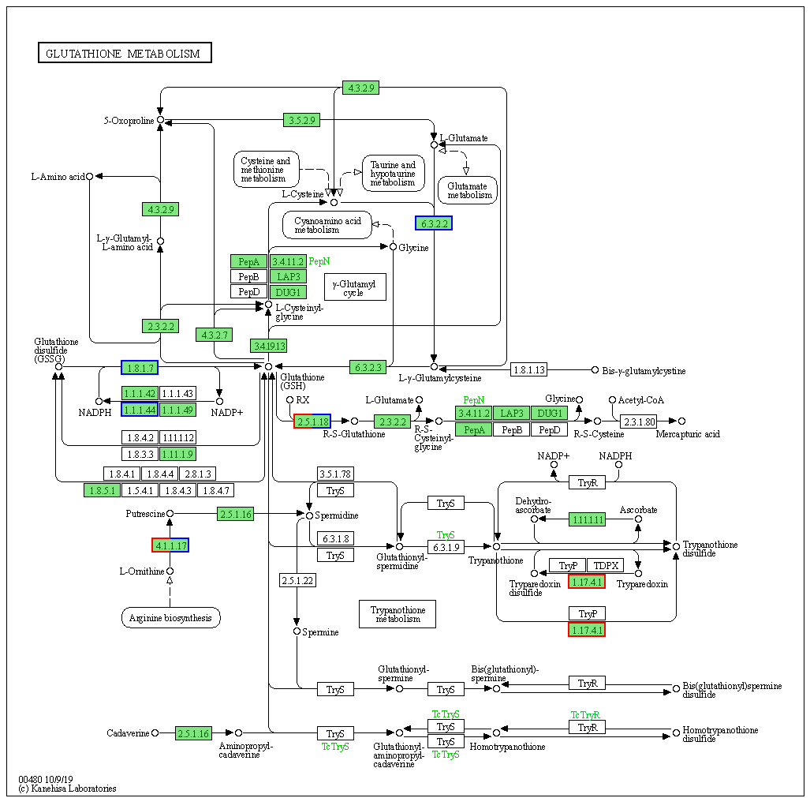
Fig. S1 Differential gene metabolic pathway diagram
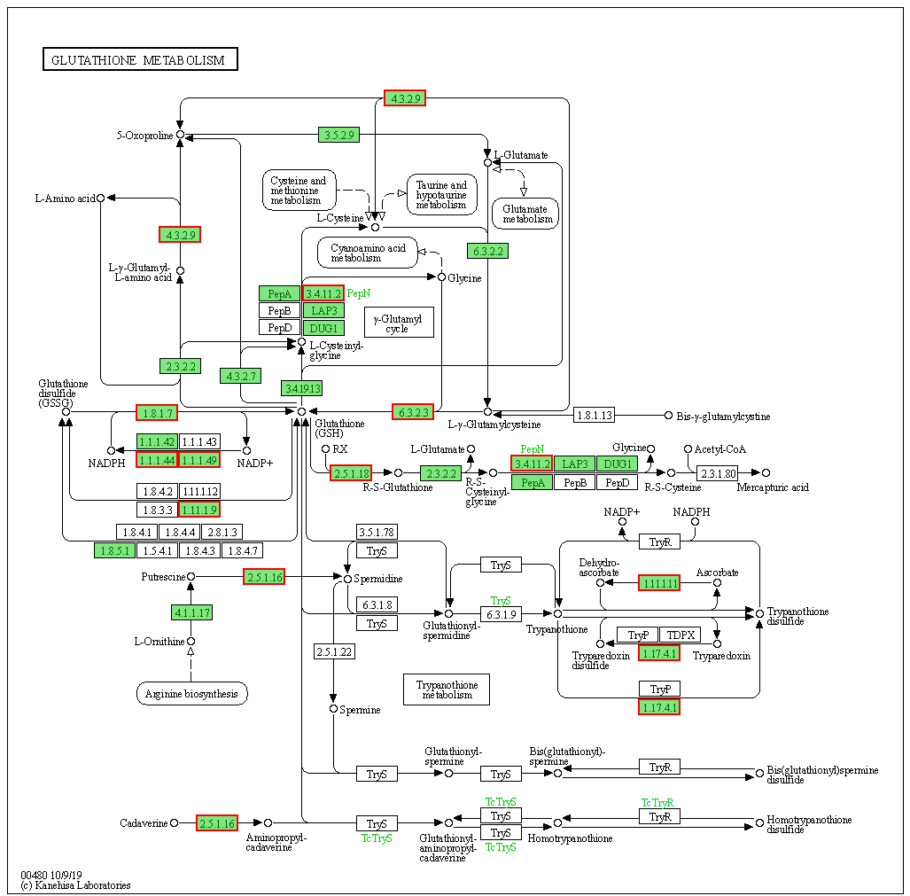
Fig. S2 Leading Edge metabolic pathway diagram

Table S1
Physical and chemical properties of the tested soil.
longitude | latitude | Total Arsenic (mg kg⁻¹) | pH | Organic matter  (g kg⁻¹) | Available phosphorus  (mg kg⁻¹) | Available potassium  (mg kg⁻¹)
108.8242 N | 22.7143 E | 7.78 | 4.49 | 12.02 | 1.77 | 38.77

Table S2
Primers of protein gene were determined
Gene Name | Gene ID | Primer-F | Primer-R
β-Actin |  | GGGCAGTATTTCCAAGCATAGTGGG | TGCCTCGCTTTGATTGAGCCTCATC
PvPIP1-1 | TRINITY_DN1610_c1_g1 | GCTTGGTGCCGAGATTGTTG | TGGTCATCCCATGCTTGCTT
PvNIP6-1 | TRINITY_DN13097_c0_g1 | GGAGGGTGCTGCGATTATGA | AAAGGCACCTCTGACCATCG
PvPIP2-1 | TRINITY_DN1669_c1_g1 | GCCACCCTCCTCTTCCTCTA | ATTGCGCCACCATGTACAGA
PvPht1;1 | TRINITY_DN35649_c0_g1 | CCCTCATTGCACTCTGCTCA | CAACCGTGCAGGGAAGATCT
PvPht2;1 | TRINITY_DN11245_c0_g1 | CATGGAGCCGGTGAAGTAGG | TTGGCAAGCTTGACTCCCAT
PvGSTF1 | TRINITY_DN26745_c0_g1 | GCCACCCTCCTCTTCCTCTA | ATTGCGCCACCATGTACAGA
PvGAPC1 | TRINITY_DN10105_c0_g1 | GTATGACTCTACCCACGGCG | TCTCGTTGACACCCATCACG
PvACr2 | TRINITY_DN2794_c0_g2 | CCTCACAAAAGGCTTCCCCA | AAGCCGCACCACAGGTTTAT
PvOCT4 | TRINITY_DN9350_c0_g1 | GTCGTGCTGGTTTGGTTCAC | GCGTCTACCGATATGCCGAA
PvPht1;3 | TRINITY_DN688_c0_g1 | AAGCCGATACAGATGCAGGG | CCCCACCTGATTCTTGTCCC
PvNRT1/ PTR FAMILY 5.1 | TRINITY_DN158_c0_g1 | CAACAAGCATTCCACGGGTG | CCCCATCTGCGTCGTTAAGT
PvNRT1/ PTR FAMILY 6-3 | TRINITY_DN13756_c0_g1 | ACACCCACCAACTCTCGTTC | CTCCACTGAGCAAGTCCTCC
PvNRT1/ PTR FAMILY 6-3 | TRINITY_DN14280_c0_g1 | ATGAGCAAGGGGTGTGGATG | AGCTGGTGGGATCTTGAAGC
PvPATP1 | TRINITY_DN10629_c0_g1 | CCTGGTGATGTTGTCGAGCT | ACTGCCATACTCTCTCCGGT
PvPATP1-3 | TRINITY_DN2110_c0_g1 | GCCTTCAACACGGGAGATGA | GCGCCATACTTTGACACAGC
PvPATP2 | TRINITY_DN7892_c0_g1 | GTGAAGCCCAGTCCCTTACC | GTGAGCCGACTTTGACTCCA

Table S3
Sequencing data statistics table
Sample | Raw reads | Raw bases | Clean reads | Clean bases | Error rate(%) | Q20(%) | Q30(%) | GC content(%)
CE4 | 54163030 | 8178617530 | 53459024 | 7954592963 | 0.0255 | 97.82 | 93.73 | 47.54
CE2 | 58907230 | 8894991730 | 58255562 | 8685506981 | 0.025 | 98 | 94.17 | 47.41
CE1 | 46849630 | 7074294130 | 46221764 | 6879119225 | 0.0253 | 97.85 | 93.84 | 47.89
CK3 | 47776730 | 7214286230 | 47185188 | 7011220057 | 0.0252 | 97.91 | 93.93 | 47.74
CK2 | 49030528 | 7.4E+09 | 48424306 | 7.22E+09 | 0.0253 | 97.87 | 93.83 | 47.43
CK1 | 55384560 | 8.36E+09 | 54719576 | 8.16E+09 | 0.0251 | 97.99 | 94.11 | 47.68

