Supplementary Material

Transcriptomics and metabolomics analyses reveal pollen abortion mechanism in alfalfa early stage male sterile lines
Huicai Cai ^{1#}, Shuhe Zhang ^{1#}, Weijie Yu ¹, Xue Jia ¹, Lan Yu ¹, Bo Xu ^{1*}, Yingzhe Wang ^{2*}
* Correspondence: Bo Xu: xubo6299@jlau.edu.cn
* Correspondence: Yingzhe Wang: yingzhe120@163com

Table 1 Statistical table of transcript assembly results
Length range/bp | Transcript |  | Unigene
 | Number | Percentage | Number | Percentage
200～300 | 44 483 | 18.78% | 33 682 | 33.60%
300～500 | 45 480 | 19.20% | 25 352 | 25.29%
500～1 000 | 54 598 | 23.05% | 17 807 | 17.76%
1 000～2 000 | 55 489 | 23.43% | 13 349 | 13.32%
2 000+ | 36 818 | 15.54% | 10 063 | 10.04%
Total number | 236 868 |  | 100 253
Total length | 257 222 216 |  | 80 015 464
N50 N50 length | 1 750 |  | 1 493
Mean length | 1 085.93 |  | 798.14

Table 2 Statistical table of the functional genes annotated
Anther developmental stage | Late anther tetrads stage | Early mononuclear stage
Annotated numbers | 1 622 | 1 761
COG | 351 | 386
GO | 906 | 975
KEGG | 391 | 430
KOG | 714 | 773
Pfam | 1 004 | 1 060
Swiss-Prot | 960 | 975
eggNOG | 1 193 | 1 262
Nr | 1 607 | 1 727

Table 3 TOP DEGs Function Annotation of late anther tetrads
Sequence ID | log₂FC | Zhongmu No.1 ID | Function annotation
c101272.graph_c2 | 7.77 | MsG0780039618.01.T01 | Protein processing in endoplasmic reticulum (ko04141)
c49254.graph_c0 | 6.27 | MsG0580024574.01.T01 | DNA replication (ko03030)
 |  |  | Nucleotide excision repair (ko03420)
 |  |  | Mismatch repair (ko03430)
 |  |  | Homologous recombination (ko03440)
c77905.graph_c0 | 5.88 | Not found | Purine metabolism (ko00230)
 |  |  | Pyrimidine metabolism (ko00240)
 |  |  | RNA polymerase (ko03020)
c86796.graph_c0 | 5.65 | MsG0480021617.01.T01 | Plant-pathogen interaction (ko04626)
c94557.graph_c1 | 5.31 | MsG0480022581.01.T01 | Steroid biosynthesis (ko00100)
 |  |  | Sesquiterpenoid and triterpenoid biosynthesis (ko00909)
c67112.graph_c0 | 5.26 | MsG0380014878.01.T01 | Oxidative phosphorylation (ko00190)
c49254.graph_c1 | 5.21 | MsG0580024574.01.T01 | DNA replication (ko03030)
 |  |  | Nucleotide excision repair (ko03420)
 |  |  | Mismatch repair (ko03430)
 |  |  | Homologous recombination (ko03440)
c48307.graph_c0 | 4.91 | Not found | DNA replication (ko03030)
 |  |  | Nucleotide excision repair (ko03420)
 |  |  | Mismatch repair (ko03430)
 |  |  | Homologous recombination (ko03440)
c85386.graph_c1 | 4.82 | MsG0580029116.01.T01 | DNA replication (ko03030)
 |  |  | Nucleotide excision repair (ko03420)
 |  |  | Mismatch repair (ko03430)
 |  |  | Homologous recombination (ko03440)
c96182.graph_c0 | 4.49 | MsG0180000170.01.T01 | DNA replication (ko03030)
 |  |  | Nucleotide excision repair (ko03420)
 |  |  | Mismatch repair (ko03430)
 |  |  | Homologous recombination (ko03440)
c85072.graph_c0 | 4.41 | MsG0780040755.01.T01 | Endocytosis (ko04144)
c32553.graph_c0 | 4.37 | MsG0180003746.01.T01 | mRNA surveillance pathway (ko03015)
c92329.graph_c0 | 4.34 | MsG0580024320.01.T01 | DNA replication (ko03030)
 |  |  | Nucleotide excision repair (ko03420)
 |  |  | Mismatch repair (ko03430)
 |  |  | Homologous recombination (ko03440)
c95028.graph_c0 | 4.18 | MsG0880043336.01.T01 | DNA replication (ko03030)
 |  |  | Nucleotide excision repair (ko03420)
 |  |  | Mismatch repair (ko03430)
 |  |  | Homologous recombination (ko03440)
c95085.graph_c2 | 4.07 | MsG0180003703.01.T01 | Ribosome biogenesis in eukaryotes (ko03008)
c23020.graph_c0 | 4.02 | MsG0480018099.01.T01 | RNA transport (ko03013)
c89334.graph_c1 | -4.18 | MsG0480022342.01.T01 | Protein processing in endoplasmic reticulum (ko04141)
c87087.graph_c0 | -4.26 | MsG0180002285.01.T01 | Glycerolipid metabolism (ko00561)
 |  |  | Glycerophospholipid metabolism (ko00564)
c91790.graph_c0 | -4.32 | MsG0780041813.01.T01 | Oxidative phosphorylation (ko00190)
c83310.graph_c0 | -4.34 | MsG0180000119.01.T01 | Phenylpropanoid biosynthesis (ko00940)
c68183.graph_c0 | -4.36 | MsG0180005882.01.T01 | Oxidative phosphorylation (ko00190)
c101621.graph_c0 | -4.41 | MsG0180005340.01.T01 | RNA transport (ko03013)
 |  |  | mRNA surveillance pathway (ko03015)
 |  |  | RNA degradation (ko03018)
c53690.graph_c0 | -4.45 | MsG0580024151.01.T01 | Ribosome (ko03010)
c80672.graph_c0 | -4.49 | Not found | Glutathione metabolism (ko00480)
c80312.graph_c0 | -4.59 | MsG0580028095.01.T01 | Alanine, aspartate and glutamate metabolism (ko00250)
 |  |  | beta-Alanine metabolism (ko00410)
 |  |  | Taurine and hypotaurine metabolism (ko00430)
 |  |  | Butanoate metabolism (ko00650)
c49174.graph_c0 | -4.68 | MsG0580028095.01.T01 | DNA replication (ko03030)
 |  |  | Nucleotide excision repair (ko03420)
 |  |  | Mismatch repair (ko03430)
 |  |  | Homologous recombination (ko03440)
c84860.graph_c0 | -4.69 | MsG0880047070.01.T01
 |  |  | Pentose and glucuronate interconversions (ko00040)
 |  |  | Starch and sucrose metabolism (ko00500)
c65246.graph_c0 | -4.72 | MsG0580028983.01.T01 | Plant-pathogen interaction (ko04626)
c92104.graph_c0 | -4.82 | MsG0280010151.01.T01 | Glycolysis/Gluconeogenesis (ko00010)
 |  |  | Carbon fixation in photosynthetic organisms (ko00710)
 |  |  | Carbon metabolism (ko01200)
 |  |  | Biosynthesis of amino acids (ko01230)
c81990.graph_c0 | -4.97 | MsG0780036132.01.T01 | Oxidative phosphorylation (ko00190)
 |  |  | Phagosome (ko04145)
c88154.graph_c0 | -4.99 | MsG0480020618.01.T01 | Purine metabolism (ko00230)
 |  |  | Pyrimidine metabolism (ko00240)
 |  |  | RNA polymerase (ko03020)
c89071.graph_c0 | -5.19 | MsG0480021446.01.T01 | Oxidative phosphorylation (ko00190)
 |  |  | Phagosome (ko04145)
c81212.graph_c0 | -5.39 | MsG0180004198.01.T01 | Protein processing in endoplasmic reticulum (ko04141)
c100714.graph_c1 | -5.39 | MsG0280007405.01.T01 | Plant-pathogen interaction (ko04626)
c48388.graph_c0 | -5.43 | MsG0480022888.01.T01 | Plant-pathogen interaction (ko04626)
c83553.graph_c0 | -5.61 | MsG0780039166.01.T01 | Ribosome biogenesis in eukaryotes (ko03008)
c73952.graph_c0 | -5.76 | MsG0480022872.01.T01 | DNA replication (ko03030)
 |  |  | Nucleotide excision repair (ko03420)
 |  |  | Mismatch repair (ko03430)
 |  |  | Homologous recombination (ko03440)
c72975.graph_c0 | -5.77 | Not found | Nitrogen metabolism (ko00910)
c84488.graph_c0 | -5.83 | Not found | Nucleotide excision repair (ko03420)
 |  |  | Ubiquitin mediated proteolysis (ko04120)
c98297.graph_c1 | -6.13 | MsG0280010749.01.T03 | Amino sugar and nucleotide sugar metabolism (ko00520)
c49512.graph_c0 | -6.28 | MsG0580028280.01.T02 | Ubiquitin mediated proteolysis (ko04120)
c59113.graph_c0 | -6.44 | MsG0480022221.01.T01 | Ascorbate and aldarate metabolism (ko00053)
c85517.graph_c0 | -6.52 | MsG0180004113.01.T01 | Protein processing in endoplasmic reticulum (ko04141)
c94250.graph_c0 | -6.81 | MsG0280009277.01.T01 | Pentose and glucuronate interconversions (ko00040)
 |  |  | Starch and sucrose metabolism (ko00500)
c98384.graph_c0 | -7.19 | MsG0880047069.01.T01 | Pentose and glucuronate interconversions (ko00040)
 |  |  | Starch and sucrose metabolism (ko00500)
c94636.graph_c1 | -7.37 | MsG0280007949.01.T01 | Pentose and glucuronate interconversions (ko00040)
 |  |  | Starch and sucrose metabolism (ko00500)
c100007.graph_c0 | -7.58 | MsG0780041411.01.T02 | Pentose and glucuronate interconversions (ko00040)
 |  |  | Starch and sucrose metabolism (ko00500)
c93045.graph_c0 | -7.71 | MsG0680030722.01.T01 | Pentose and glucuronate interconversions (ko00040)

Table 4 TOP DEGs function annotation of early mononuclear
Sequence ID | log2FC | Zhongmu No.1 ID | Function annotation
c77905.graph_c0 | 7.19 | Not found | Purine metabolism (ko00230)
 |  |  | Pyrimidine metabolism (ko00240)
 |  |  | RNA polymerase (ko03020)
c101301.graph_c0 | 5.71 | MsG0480020539.01.T01 | Plant hormone signal transduction (ko04075)
c48307.graph_c0 | 5.68 | Not found | DNA replication (ko03030)
 |  |  | Nucleotide excision repair (ko03420)
 |  |  | Mismatch repair (ko03430)
 |  |  | Homologous recombination (ko03440)
c92726.graph_c0 | 5.32 | MsG0280008959.01.T01 | DNA replication (ko03030)
 |  |  | Nucleotide excision repair (ko03420)
 |  |  | Mismatch repair (ko03430)
 |  |  | Homologous recombination (ko03440)
c28242.graph_c0 | 5.03 | Not found | Oxidative phosphorylation (ko00190)
c73373.graph_c0 | 4.86 | Not found | Oxidative phosphorylation (ko00190)
c84778.graph_c0 | 4.66 | MsG0780037601.01.T01 | DNA replication (ko03030)
 |  |  | Nucleotide excision repair (ko03420)
 |  |  | Mismatch repair (ko03430)
 |  |  | Homologous recombination (ko03440)
c99653.graph_c1 | 4.56 | MsG0780037601.01.T01 | DNA replication (ko03030)
 |  |  | Nucleotide excision repair (ko03420)
 |  |  | Mismatch repair (ko03430)
 |  |  | Homologous recombination (ko03440)
c50562.graph_c0 | 4.46 | Not found | Oxidative phosphorylation (ko00190)
c105957.graph_c0 | 4.38 | Not found | Phosphatidylinositol signaling system (ko04070)
c23793.graph_c0 | 4.13 | MsG0880043189.01.T01 | RNA degradation (ko03018)
c84062.graph_c0 | 4.08 | MsG0880045990.01.T01 | Phenylpropanoid biosynthesis (ko00940)
 |  |  | Flavonoid biosynthesis (ko00941)
 |  |  | Stilbenoid, diarylheptanoid and gingerol biosynthesis (ko00945)
c73385.graph_c1 | 4.02 | Not found | RNA transport (ko03013)
c92215.graph_c0 | -4.02 | MsG0380017320.01.T01 | Starch and sucrose metabolism (ko00500)
c107271.graph_c0 | -4.02 | MsG0280008333.01.T01 | Spliceosome (ko03040)
 |  |  | Protein processing in endoplasmic reticulum (ko04141)
 |  |  | Endocytosis (ko04144)
c88438.graph_c0 | -4.03 | MsG0480023389.01.T01 | Starch and sucrose metabolism (ko00500)
c75099.graph_c2 | -4.29 | MsG0380016245.01.T01 | Pentose and glucuronate interconversions (ko00040)
c100712.graph_c0 | -4.91 | MsG0580026317.01.T01 | Glycosaminoglycan degradation (ko00531)
c80672.graph_c0 | -4.92 | Not found | Glutathione metabolism (ko00480)
c74392.graph_c0 | -5.06 | MsG0880046424.01.T01 | Pentose and glucuronate interconversions (ko00040)
c101487.graph_c0 | -5.23 | MsG0680030946.01.T01 | DNA replication (ko03030)
 |  |  | Nucleotide excision repair (ko03420)
 |  |  | Mismatch repair (ko03430)
 |  |  | Homologous recombination (ko03440)
c84677.graph_c0 | -5.4 | MsG0380015575.01.T01 | Flavonoid biosynthesis (ko00941)
c83296.graph_c0 | -5.73 | Not found | Cysteine and methionine metabolism (ko00270)
 |  |  | Valine, leucine and isoleucine degradation (ko00280)
 |  |  | Valine, leucine and isoleucine biosynthesis (ko00290)
 |  |  | Pantothenate and CoA biosynthesis (ko00770)
 |  |  | 2-Oxocarboxylic acid metabolism (ko01210)
 |  |  | Biosynthesis of amino acids (ko01230)
c70419.graph_c0 | -5.98 | MsG0280009082.01.T01 | DNA replication (ko03030)
 |  |  | Nucleotide excision repair (ko03420)
 |  |  | Mismatch repair (ko03430)
 |  |  | Homologous recombination (ko03440)
c73952.graph_c0 | -6.36 | MsG0480022872.01.T01 | DNA replication (ko03030)
 |  |  | Nucleotide excision repair (ko03420)
 |  |  | Mismatch repair (ko03430)
 |  |  | Homologous recombination (ko03440)

Table 5 DMs of late anther tetrads
Metabolite ID | Metabolite name | log2FC | Pvalue | VIP | regulated
pos_814 | Naringenin-7-O-Glucoside | 7.13 | 3. 15E-03 | 1.39 | up
pos_866 | Ginkgetin | 6.87 | 1.24E-02 | 1.26 | up
pos_421 | 2-Amino-1-phenylethanol | 5. 14 | 6.58E-04 | 1.48 | up
pos_380 | 3-Isochromanone | 4.97 | 9.71E-04 | 1.47 | up
pos_ 139 | Delphinidin | 4.81 | 1.55E-02 | 1.21 | up
 | 3-(6-p-coumaroylgalactoside)
pos_756 | Cytosine | 4.31 | 4.54E-03 | 1.36 | up
pos_ 188 | Anibine | 4.22 | 1.23E-03 | 1.43 | up
pos_845 | Sulfamethoxypyridazine | 3.92 | 5.31E-04 | 1.46 | up
pos_493 | Prolyl-Glutamate | 3.73 | 2.91E-04 | 1.51 | up
pos_228 | 1,4,5-Naphthalenetriol | 3.41 | 9.78E-05 | 1.55 | up
pos_61 | 5,7,8,2',4'-Pentahydroxyisoflavon e | 2.61 | 1.70E-03 | 1.41 | up
pos_675 | O-Succinyl-L-homoserine | 2.58 | 1.08E-04 | 1.5 | up
pos_302 | Aminoparathion | 2.49 | 4.45E-02 | 1.03 | up
pos_584 | Camptothecin | 2.39 | 5.89E-06 | 1.57 | up
pos_593 | ADP-glucose | 2.27 | 8.33E-09 | 1.59 | up
pos_631 | Deoxyuridine monophosphate (dUMP) | 2. 14 | 1.44E-02 | 1. 14 | up
pos_496 | Lecanoric acid | 2.07 | 9.58E-04 | 1.42 | up
pos_804 | Sissotrin | 2.06 | 1.63E-04 | 1.44 | up
pos_855 | Estrone 3-glucuronide | 2.03 | 5.42E-03 | 1.28 | up
pos_ 154 | Met His Val Phe | -2.15 | 8. 18E-08 | 1.58 | down
pos_877 | L-Cysteinesulfinic acid | -2.31 | 2.97E-05 | 1.56 | down
pos_ 152 | Methyl methacrylate | -2.32 | 6.80E-05 | 1.56 | down
pos_550 | Astragalin | -2.43 | 3. 15E-02 | 1.08 | down
 | 4-[2-(5-Carboxy-2-hydroxy-3-me
pos_ 164 | thoxyphenyl)- | -2.48 | 2.59E-05 | 1.57 | down
 | 2-oxoethylidene]-2-hydroxy-2-pe ntenedioate
 | Apigenin
 | 7-[feruloyl-(->2)-glucuronyl- ( 1->2)-glucuronide] |  |  |  | down
pos_264 | 4'-glucuronide | -2.57 | 1.29E-03 | 1.36
pos_724 | Leukotriene D4 | -2.58 | 2.80E-06 | 1.56 | down
pos_301 | Apigenin 4'-[feruloyl-(->2)- | -2.6 | 3.35E-07 | 1.57 | down
 | glucuronyl-(1->2)-glucuronide]
pos_494 | Serinyl-Aspartate | -2.7 | 1.08E-02 | 1.22 | down
pos_792 | Aspartyl-Tyrosine | -2.86 | 3. 17E-02 | 1.08 | down
pos_554 | Inosine 5'-monophosphate (IMP) | -2.89 | 4.94E-02 | 1.01 | down
pos_ 113 | Luteolin 7,3',4'-triglucuronide | -2.89 | 4.44E-04 | 1.44 | down
pos_ 148 | Galangin | -3.02 | 2.93E-05 | 1.5 | down
pos_ 102 | Apigenin 7-[glucuronyl-(1->2)- glucuronide] 4'-glucuronide | -3. 12 | 5.21E-04 | 1.41 | down
pos_505 | Theobromine | -3.13 | 9.78E-04 | 1.47 | down
pos_516 | UDP-D-Galactose | -3.13 | 2.76E-03 | 1.35 | down
pos_99 | 2-Dehydro-O-desmethylangolens in | -3.23 | 3. 10E-02 | 1.1 | down
pos_ 192 | Asp His Leu His | -3.27 | 5.88E-09 | 1.6 | down
pos_732 | 2-Furancarboxylic acid | -3.32 | 2.32E-05 | 1.57 | down
pos_342 | 2-Furanmethanol | -3.33 | 3.55E-05 | 1.56 | down
pos_248 | N1,N5,N10-Triferuloyl spermidine | -3.37 | 1.59E-02 | 1.21 | down
pos_822 | D-Glucuronolactone | -3.76 | 3.00E-06 | 1.59 | down
pos_ 130 | Malvidin | -3.9 | 7.31E-08 | 1.6 | down
 | 3-glucoside-4-vinylphenol
pos_471 | Coproporphyrin I | -4.66 | 2.58E-03 | 1.39 | down
pos_312 | Asp Trp Arg Tyr | -5.08 | 9.45E-04 | 1.46 | down
pos_400 | 2,4-Diaminobutyric acid | -5.18 | 2. 17E-04 | 1.53 | down

Table 6 DMs of early mononuclear
Metabolite ID | Metabolite name | log2FC | Pvalue | VIP | regulated
pos_9 | N-Acetyl-L-aspartic acid | 12.48 | 4.49E-02 | 1.07 | up
pos_516 | UDP-D-Galactose | 4.81 | 2.59E-03 | 1.39 | up
pos_493 | Prolyl-Glutamate | 4.78 | 3.55E-03 | 1.37 | up
pos_814 | Naringenin-7-O-Glucoside | 4.66 | 7.86E-04 | 1.45 | up
pos_ 188 | Anibine | 4.55 | 1.80E-04 | 1.52 | up
pos_312 | Asp Trp Arg Tyr | 4.3 | 4.07E-03 | 1.38 | up
pos_756 | Cytosine | 4.23 | 2.64E-05 | 1.55 | up
pos_380 | 3-Isochromanone | 3.8 | 1.53E-05 | 1.54 | up
pos_462 | Cytidine 2',3'-cyclic phosphate | 3.52 | 1.24E-02 | 1.2 | up
pos_802 | Mangiferin | 3.51 | 3.46E-02 | 1.05 | up
pos_471 | Coproporphyrin I | 3.48 | 1.00E-02 | 1.3 | up
pos_228 | 1,4,5-Naphthalenetriol Quercetin | 3.48 | 7.72E-05 | 1.53 | up
pos_270 | 3-(6''-malonylglucoside)-7-rha mnoside | 3.39 | 4.75E-02 | 1.02 | up
pos_552 | Cycloheximide | 2.89 | 2.20E-05 | 1.48 | up
pos_346 | 4'-DEMETHYLEPIPODOPH YLLOTOXIN | 2.74 | 8. 11E-03 | 1.22 | up
pos_393 | Glutathione, oxidized | 2.47 | 2. 13E-06 | 1.57 | up
pos_530 | Parathion | 2.38 | 4.59E-05 | 1.52 | up
pos_828 | Pyridoxal (Vitamin B6) | 2.36 | 4.46E-05 | 1.55 | up
pos_734 | Neohesperidin | 2.27 | 4.36E-05 | 1.49 | up
pos_860 | 16, 16-dimethyl-PGA1 | 2.27 | 6.85E-04 | 1.44 | up
pos_360 | Eremopetasitenin C3 | 2.14 | 1.02E-04 | 1.51 | up
pos_61 | 5,7,8,2',4'-Pentahydroxyisofla vone | 2.13 | 2.50E-02 | 1.1 | up
pos_583 | 2-thiouridine | 2.12 | 6.58E-09 | 1.58 | up
pos_535 | CDP-Ethanolamine | 2.03 | 6. 16E-06 | 1.51 | up
pos_ 152 | Methyl methacrylate | -2.16 | 1.82E-04 | 1.51 | down
 | 4-[2-(5-Carboxy-2-hydroxy-3
pos_ 164 | -methoxyphenyl)- | -2.32 | 6. 16E-05 | 1.53 | down
 | 2-oxoethylidene]-2-hydroxy-2 -pentenedioate
pos_615 | Methylephedrine | -2.43 | 1.03E-04 | 1.41 | down
pos_578 | Glucosaminic acid | -2.48 | 3.71E-04 | 1.47 | down
pos_631 | Deoxyuridine monophosphate (dUMP) | -2.52 | 4.37E-02 | 1.01 | down
pos_782 | 8-Hydroxy-2'-deoxyguanosine | -3.08 | 2.82E-03 | 1.36 | down
pos_822 | D-Glucuronolactone | -3.25 | 2.03E-04 | 1.52 | down
pos_524 | 5-methoxyuridine | -3.35 | 2.98E-02 | 1.09 | down
pos_93 | Pro Cys Ser Tyr | -4.14 | 1.03E-02 | 1.26 | down
pos_342 | 2-Furanmethanol | -4.27 | 1.42E-04 | 1.52 | down
pos_99 | 2-Dehydro-O-desmethylangol ensin | -4.49 | 1.34E-07 | 1.58 | down
pos_732 | 2-Furancarboxylic acid | -4.52 | 9.89E-05 | 1.55 | down
pos_505 | Theobromine | -4.76 | 4.36E-03 | 1.36 | down

Table 7 Primers used in the qRT-PCR
Gene ID | Accession ID | Gene name | Primer name | Primer sequence(5′-3′)
c89437.graph_c0 | OQ439928 | GDSL type esterase/lipase MsGELPs | MsGELPs-F | GCTCTAGAATGAATTCCATGAGGTTAATTCATGTAC
 |  |  | MsGELPs-R | CGAGCTCTTATAAACATGCCTTCCCAATTGG
c81458.graph_c0 | OQ439929 | Endoxyglucosylase hydrolase | MsXTH-F | TGGAGAAGCATGGGCAACACAAG
 |  | MsXTH | MsXTH-R | TTGGAACGCAAGCATTGGCATTG
c100007.graph_c0 | OQ439930 | Pectin methylase | MsPME-F | GGTTACCGCTGTTGCCCTTGAC
 |  | MsPME | MsPME-R | AAGACGACGGGAAGCAGGTTTAAC
c85801.graph_c0 | OQ439931 | Exopolygalacturonase | MsEXO-Pgase-F | GTGCTTCCCTCCCTGCTTCTTTG
 |  | MsEXO-Pgase | MsEXO-Pgase-R | CGGAGCTGTTATGGTGAGGTTAGTG
c78022.graph_c0 | OQ439932 | Cytochrome P450 | CYP703a2-F | AGCAATCAACGGATGAACCTTAGGC
 |  | CYP703a2 | CYP703a2-R | TGATGGCTTTGGCTCGACTGTTTC
c104620.graph_c1 | OQ439933 | Cinnamic acid 4-hydroxylase | C₄H-F | GCTTGTTCACGAGGCGATGTTATTG
 |  | C₄H | C₄H-R | CCTGAAGATCAAACGGGCGTAGC
c78766.graph_c0 | OQ439934 | peroxidase | MsPrx-F | GTGGAGGACCTAACTGGGAGCTAC
 |  | MsPrx | MsPrx-R | AGAGACCTTCAACAGTGGCATTTGG
c58162.graph_c0 | OQ439935 | Udp-glucose dehydrogenase | MsUGPD-F | ACCGAGTTGTTGCGTCCATGTTC
 |  | MsUGPD | MsUGPD-R | CCTTGTATCGCCTGTGTCCTTCTTG
c89108.graph_c0 | OQ439936 | PHD-finger type transcription factor | PHD-F | GCATTGGTTCCTTCAGCACAAGC
 |  | MsPHD | PHD -R | ACCCGTGTTGCCATTTCGATCC
c91687.graph_c0 | OQ439937 | MYB type transcription factor 35 | MYB 35-F | TGTTGCCCTTATCTCACTGTCCTTG
 |  | MYB35 | MYB 35-R | GGTGGTTCAAGTGAAGGTTTTGAGG
 |  | β-actin(Internal reference) | β-actin-F | TGAGTGGTGGTACGACTATGTTCCC
 |  |  | β-actin-R | TCATGCTACTTGGTGCCAATGCTG
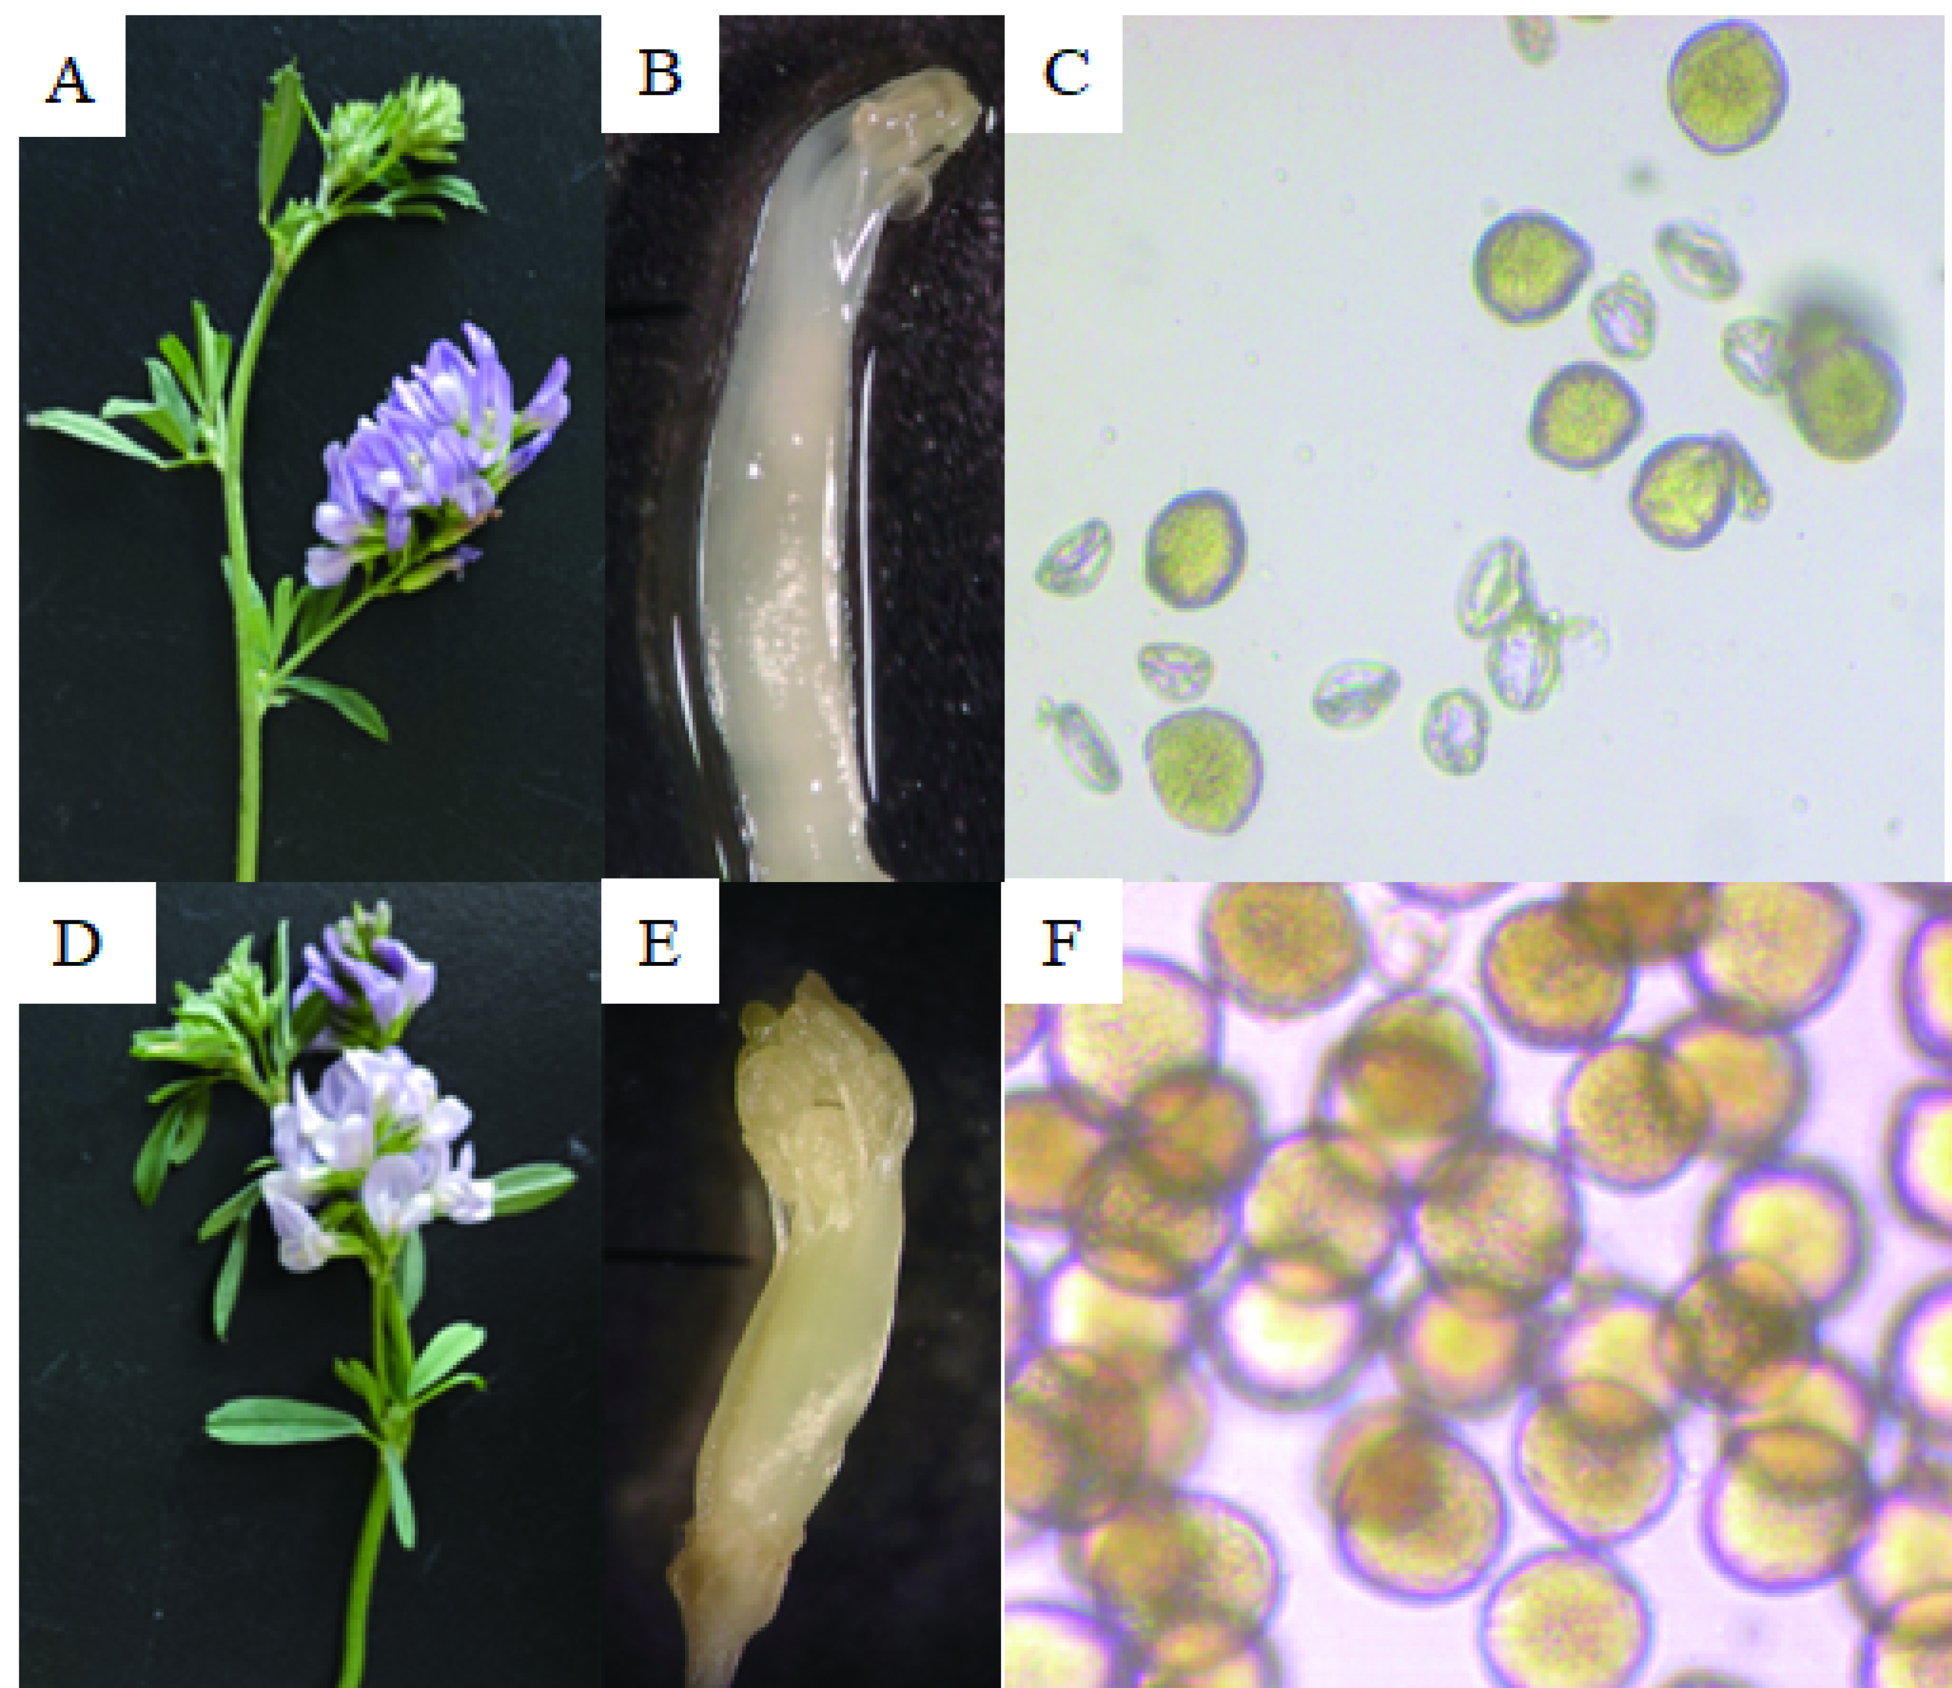
Supplementary Figure 1. Cytoplasmic male sterile lines and maintainer lines of alfalfa (Medicago sativa L.); (A-C) are sterile lines plants, stamens, and pollen, respectively. (D-F) are maintainer lines plants, stamens, and pollen, respectively.

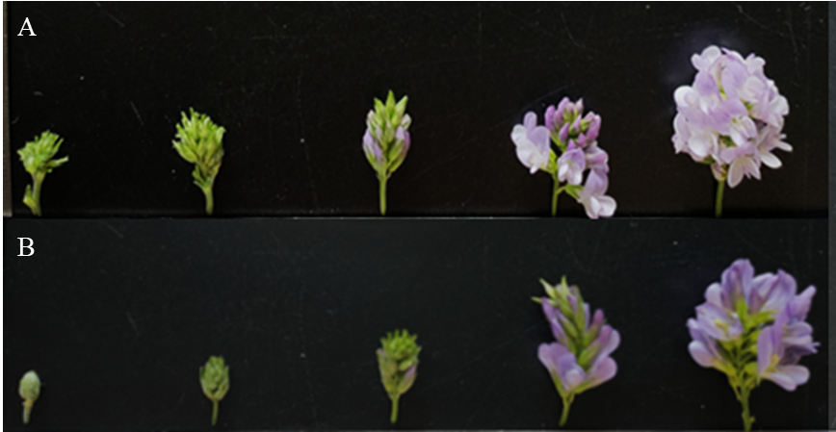
Supplementary Figure 2. (A) (MSJN1A) and (B) (MSJN1B) are the five periods of anther development from left to right, respectively.

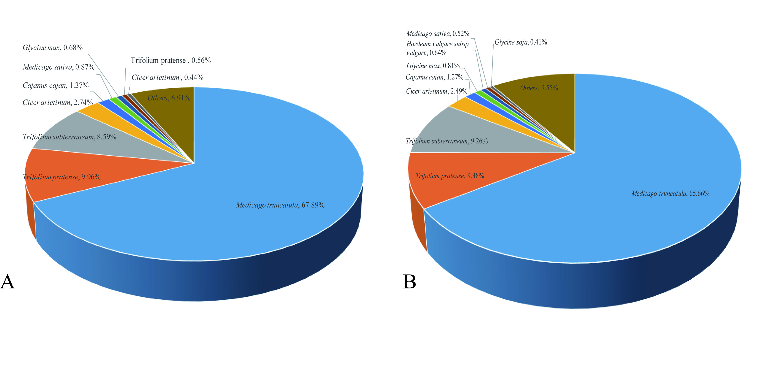
Supplementary Figure 3. (A) (MSJN1A) and (B) (MSJN1B) Nr function annotation for unigenes.

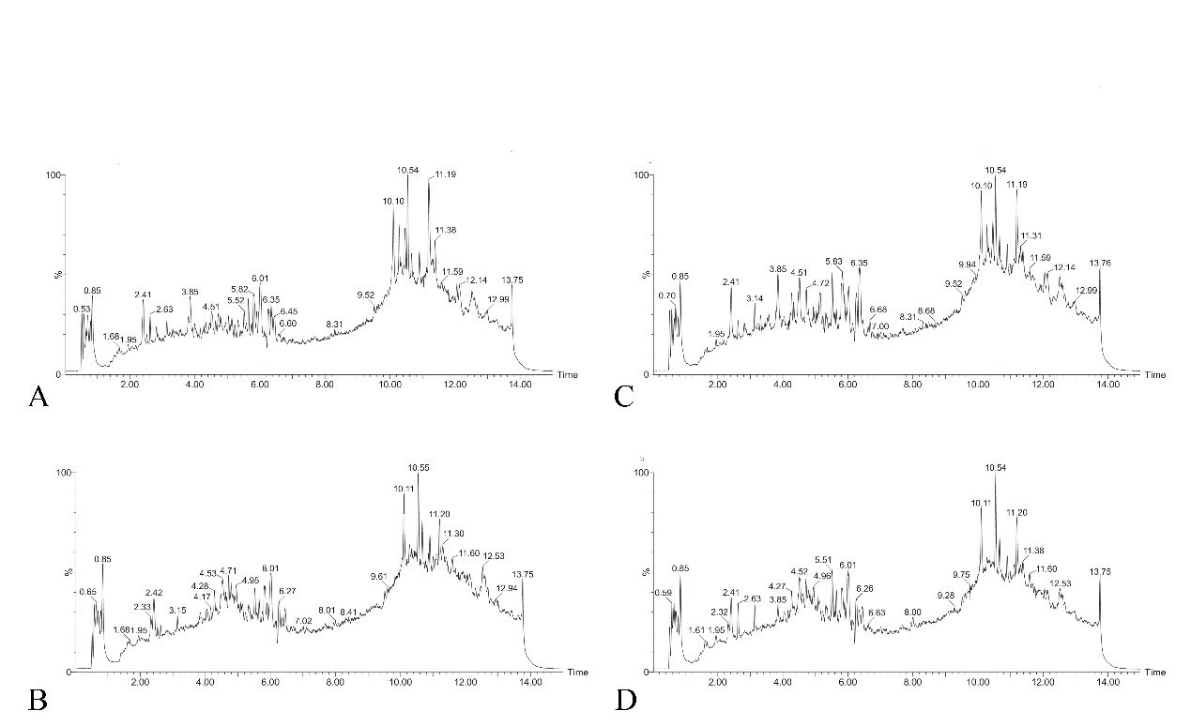Supplementary Figure 4. Chromatogram of late tetrad and early mononuclear anthers of sterile and maintenance. (A): late sterile line tetrad, (B): early mononuclear stage of sterile line, (C): late retention line tetrad, (D): early retention line mononuclear.
Supplementary Figure 5. PCA. (A): Late tetrad; (B): Early mononuclear stage; (C): Monokaryon stage; (D): Dikaryon stage; (E): Mature stage

