Table S1. Information on the insects that are included in the phylogenetic analysis.
Order | Species | GenBank No.
sNPF | Coccinella septempunctata | This study
 | Harmonia axyridis | XP_045470701.1
 | Tribolium castaneum | XP_008198705.1
 | Culex quinquefasciatus | EDS32331.1
 | Nilaparvata lugens | XP_022184541.1
FMRF | Coccinella septempunctata | This study
 | Aethina tumida | XP_019869081.1
 | Anoplophora glabripennis | XP_023310731.1
 | Tribolium madens | XP_044254202.1
 | Tribolium castaneum | XP_008191572.1
PBAN | Coccinella septempunctata | This study
 | Nicrophorus vespilloides | XP_017786058.1
 | Diorhabda sublineata | XP_056645980.1
 | Diorhabda carinulata | XP_057657574.1
 | Aethina tumida | XP_019871287.1
Tachykinin | Coccinella septempunctata | This study
 | Harmonia axyridis | XP_045478364.1
 | Tribolium castaneum | KYB25860.1
 | Dendroctonus ponderosae | XP_019770548.1
 | Tribolium madens | XP_044272560.1
 | Aethina tumida | XP_019880636.2
 | Anthonomus grandis grandis | XP_050299773.1
PTTH | Coccinella septempunctata | This study
 | Harmonia axyridis | XP_045479904.1
 | Tribolium madens | XP_044254998.1
 | Cylas formicarius | XP_060531974.1
 | Diorhabda carinulata | XP_057655514.1
 | Leptinotarsa decemlineata | XP_023026695.1
 | Aethina tumida | XP_019869567.2
AKH | Coccinella septempunctata | This study
 | Asbolus verrucosus | RZB41086.1
 | Tenebrio molitor | UXO98184.1
 | Tribolium castaneum | NP_001107818.1
 | Nilaparvata lugens | AFN26934.1
 | Coptotermes formosanus | AML80822.1
 | Coptotermes gestroi | AML80828.1
 | Zootermopsis nevadensis | AML80834.1
 | Neotermes castaneus | AML80825.1
 | Nasutitermes takasagoensis | AML80829.1
CCAP | Coccinella septempunctata | This study
 | Diorhabda sublineata | XP_056637896.1
 | Diabrotica virgifera virgifera | XP_028132314.1
 | Anoplophora glabripennis | XP_018571850.1
 | Anthonomus grandis grandis | XP_050299286.1
 | Aethina tumida | XP_019874422.1
 | Dendroctonus ponderosae | XP_019766469.1
 | Sitophilus oryzae | XP_030753057.1
 | Leptinotarsa decemlineata | XP_023012719.1
 | Cylas formicarius | XP_060524530.1
 | Tribolium madens | XP_044258689.1
SIFamide | Coccinella septempunctata | This study
 | Harmonia axyridis | XP_045483513.1
 | Tribolium madens | XP_044265653.1
 | Aethina tumida | XP_019881334.1
 | Nicrophorus vespilloides | XP_017769590.1
 | Anoplophora glabripennis | XP_018576888.1
 | Stomoxys calcitrans | XP_013114449.1
DH | Coccinella septempunctata | This study
 | Tribolium castaneum | NP_001164096.1
 | Dendroctonus ponderosae | XP_048520904.1
 | Anoplophora glabripennis | XP_018579740.1
 | Cylas formicarius | XP_060518868.1
ITP | Coccinella septempunctata | This study
 | Harmonia axyridis | XP_045478547.1
 | Asbolus verrucosus | RZC33292.1
 | Anoplophora glabripennis | XP_018574385.1
 | Tribolium castaneum | XP_044263512.1
 | Aethina tumida | XP_019869750.1
 | Tribolium madens | XP_044263512.1
Bursicon | Coccinella septempunctata | This study
 | Henosepilachna vigintioctomaculata | KAK9888420.1
 | Aethina tumida | XP_019870760.1
 | Sitophilus oryzae | XP_030754853.1
 | Leptinotarsa decemlineata | XP_023014168.1
 | Tribolium madens | XP_044267372.1
 | Tribolium castaneum | NP_001107779.1
 | Nicrophorus vespilloides | XP_017771075.1
 | Dendroctonus ponderosae | XP_019755391.2
 | Photinus pyralis | XP_031343673.1

Table S2. Information on the insects that are included in the phylogenetic analysis and amino acid sequence alignment.
Order | Species | GenBank No.
CAPA receptor | Coccinella septempunctata | This study
 | Harmonia axyridis | XP_045464272.1
 | Harmonia axyridis | XP_045464273.1
 | Harmonia axyridis | XP_045464274.1
 | Photinus pyralis | XP_031346676.1
 | Photinus pyralis | XP_031347093.1
SP receptor | Coccinella septempunctata | This study
 | Harmonia axyridis | XP_045464657.1
 | Zophobas morio | XP_063920165.1
 | Tribolium madens | XP_044269980.1
 | Tribolium castaneum | NP_001106940.1
 | Anoplophora glabripennis | XP_018562967.1
Trissin receptor | Coccinella septempunctata | This study
 | Harmonia axyridis | XP_045470325.1
 | Sitophilus oryzae | XP_030767837.1
 | Tribolium madens | XP_044268302.1
 | Zophobas morio | XP_063918045.1
Tachykinin receptor | Coccinella septempunctata | This study
 | Harmonia axyridis | XP_045475839.1
 | Camponotus floridanus | EFN69306.1
 | Apis mellifera carnica | KAG9428468.1
 | Habropoda laboriosa | KOC65718.1
CCHamide receptor | Coccinella septempunctata | This study
 | Coccinella septempunctata | This study
 | Harmonia axyridis | XP_045476917.1
 | Harmonia axyridis | XP_045476918.1
 | Harmonia axyridis | XP_045476923.1
 | Anoplophora glabripennis | XP_023313148.1
 | Aethina tumida | XP_049817471.1
 | Zophobas morio | XP_063916239.1
 | Zophobas morio | XP_063916241.1
 | Tribolium madens | XP_044252528.1
SIFamide receptor | Coccinella septempunctata | This study
 | Harmonia axyridis | XP_045465407.1
 | Onthophagus taurus | XP_022919670.1
 | Photinus pyralis | XP_031335264.1
 | Aethina tumida | XP_049820106.1
 | Zophobas morio | XP_063906474.1
ILP receptor | Coccinella septempunctata | This study
 | Coccinella septempunctata | This study
 | Harmonia axyridis | XP_045479040.1
 | Harmonia axyridis | XP_045479042.1
 | Harmonia axyridis | XP_045482517.1
 | Harmonia axyridis | XP_045482518.1
 | Agrilus planipennis | XP_018329959.1
 | Agrilus planipennis | XP_018329960.1
 | Colaphellus bowringi | WML96173.1
 | Gnatocerus cornutus | BBI47313.1
DH receptor | Coccinella septempunctata | This study
 | Harmonia axyridis | XP_045474413.1
 | Harmonia axyridis | XP_045474415.1
 | Harmonia axyridis | XP_045474416.1
 | Zophobas morio | XP_063931808.1
 | Diorhabda carinulata | XP_057668155.1
RYamide receptor | Coccinella septempunctata | This study
 | Coccinella septempunctata | This study
 | Harmonia axyridis | XP_045468643.1
 | Tribolium madens | XP_044259449.1
 | Tribolium madens | XP_044259454.1
 | Euwallacea fornicatus | XP_066147090.1
 | Tribolium castaneum | XP_008201193.2
 | Tribolium castaneum | XP_064212083.1

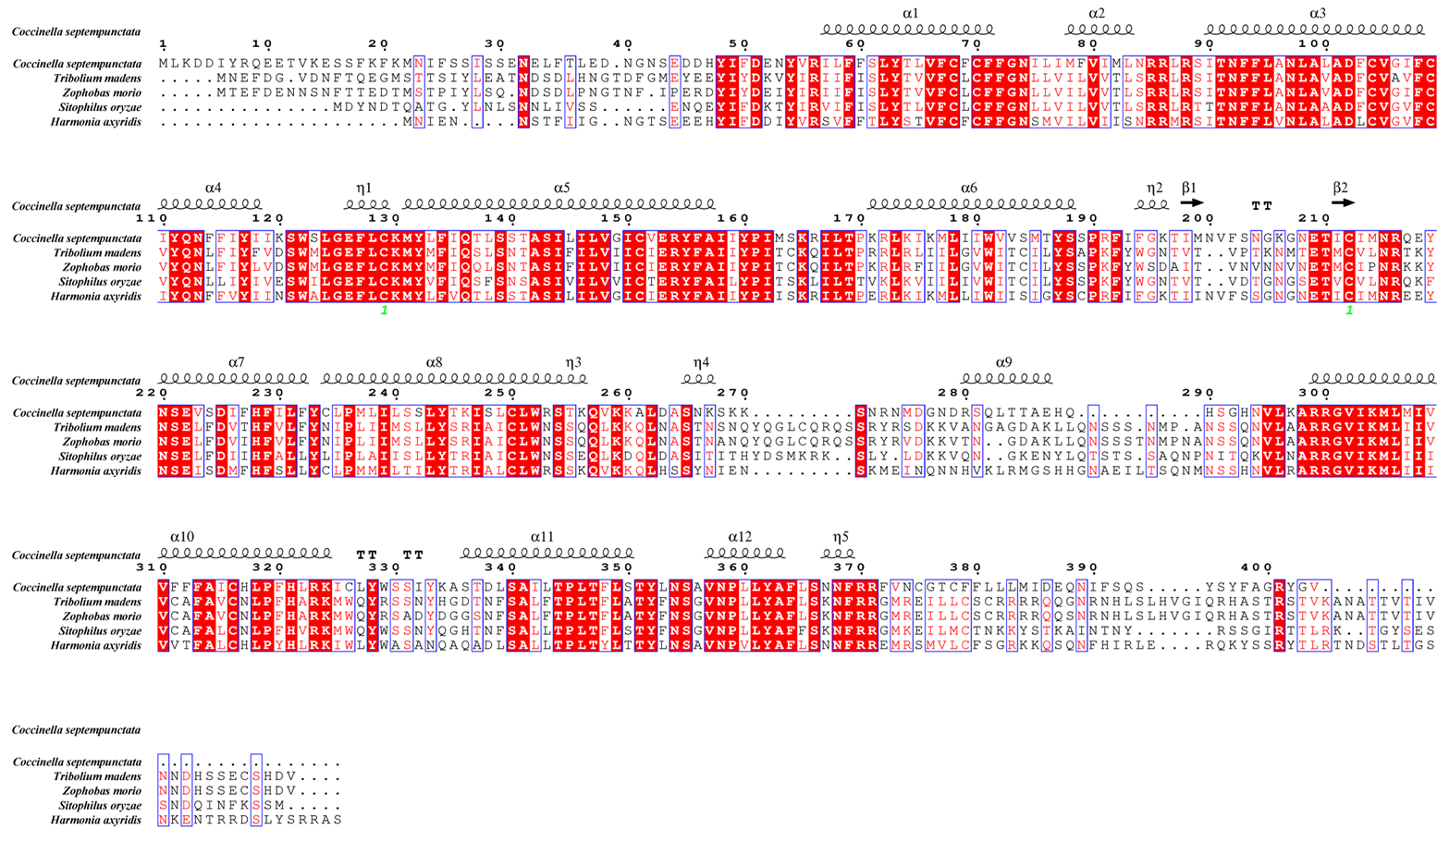
Figure S1： The amino acid sequence alignment of trissin receptor in C. septempunctata

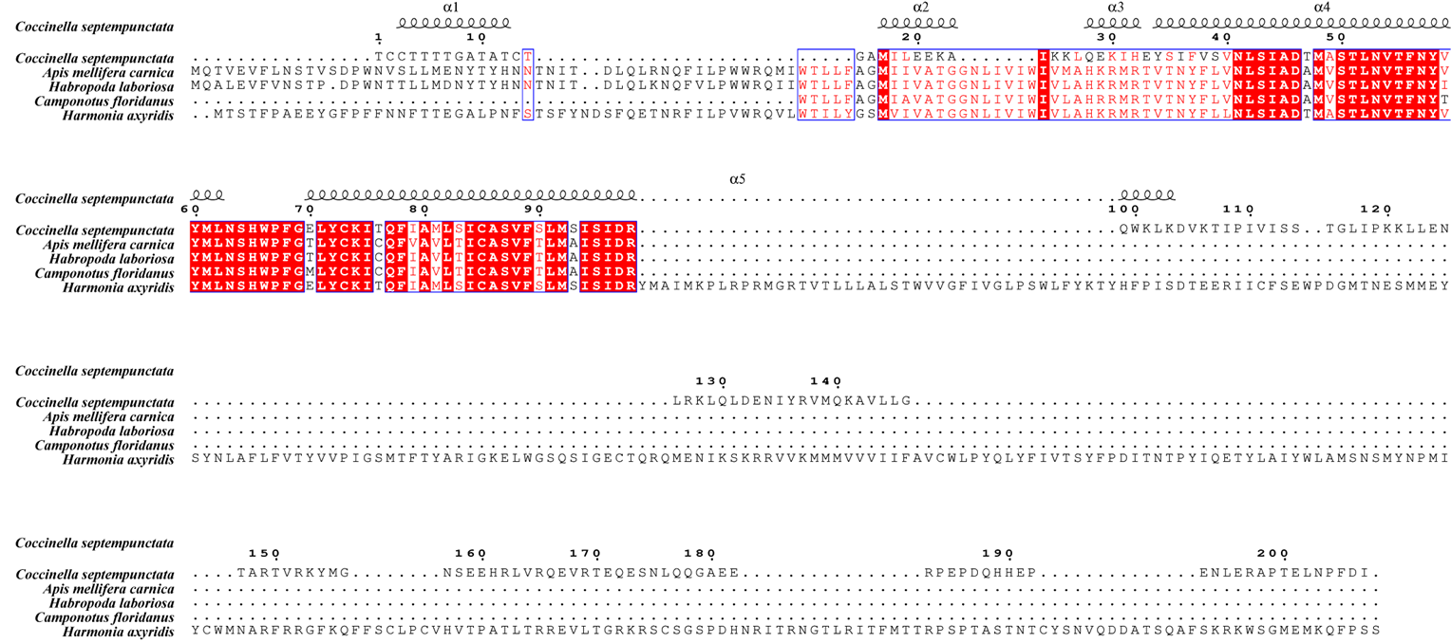
Figure S2： The amino acid sequence alignment of tachykinin receptor in C. septempunctata

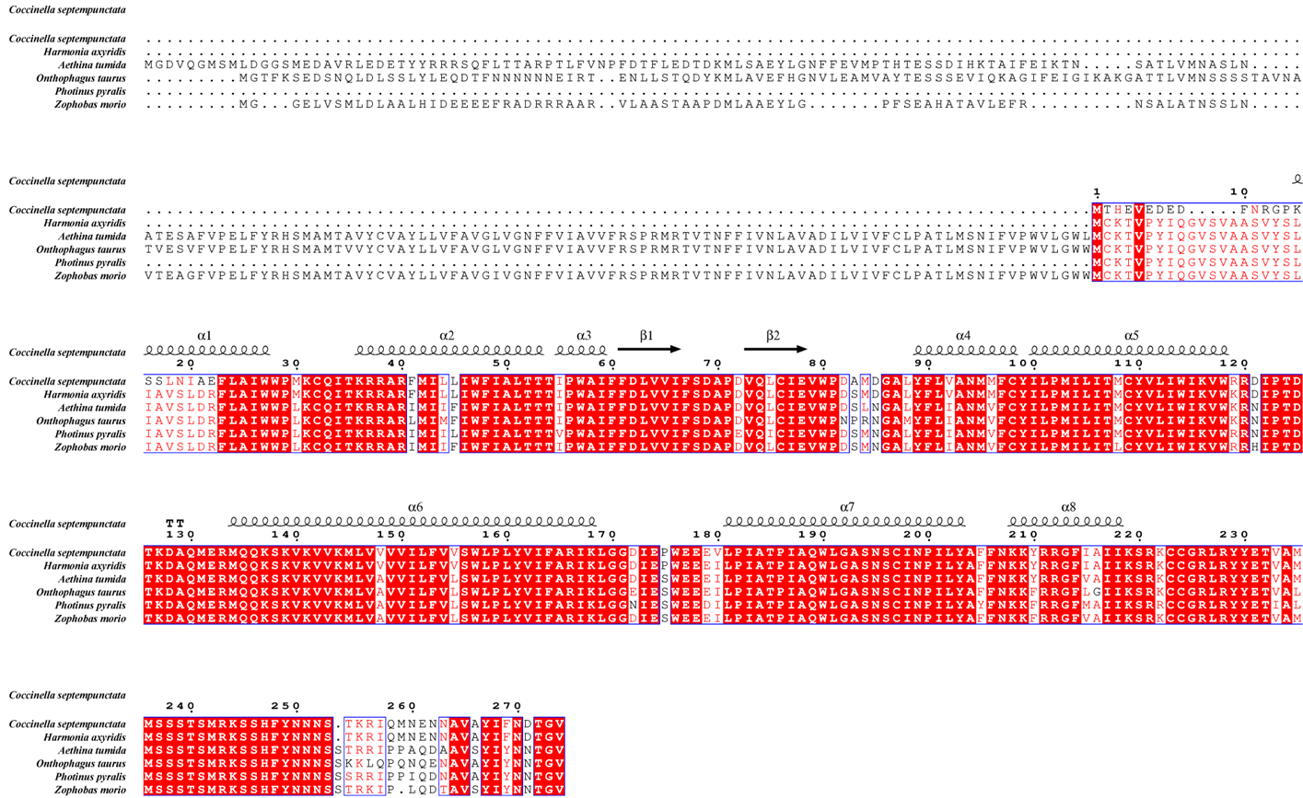
Figure S3： The amino acid sequence alignment of SIFamide receptor in C. septempunctata

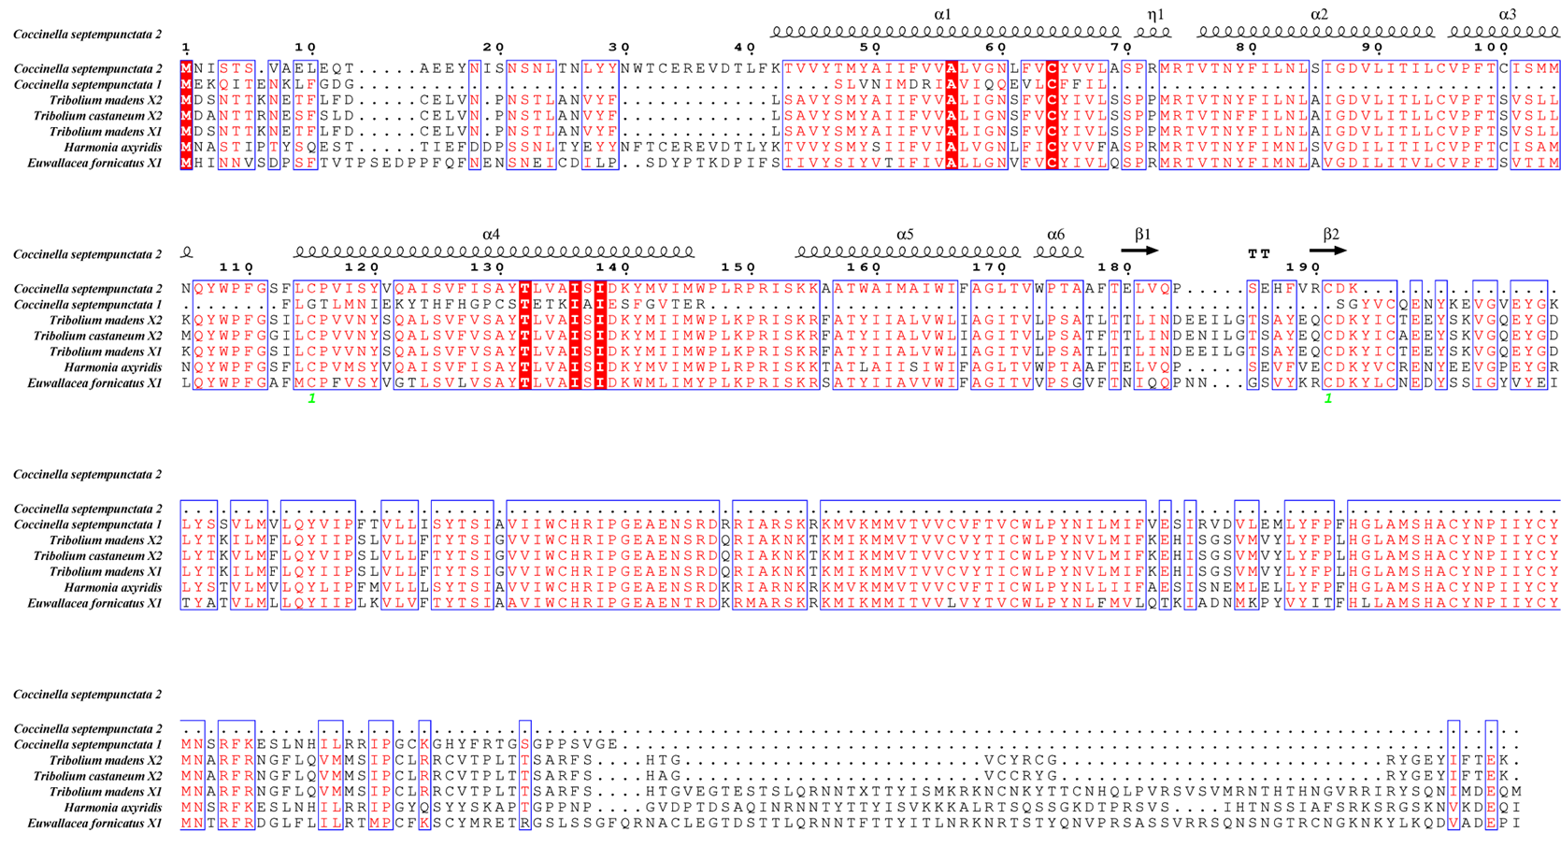
Figure S4： The amino acid sequence alignment of RYamide receptor in C. septempunctata

Figure S5： The amino acid sequence alignment of ILP receptor in C. septempunctata

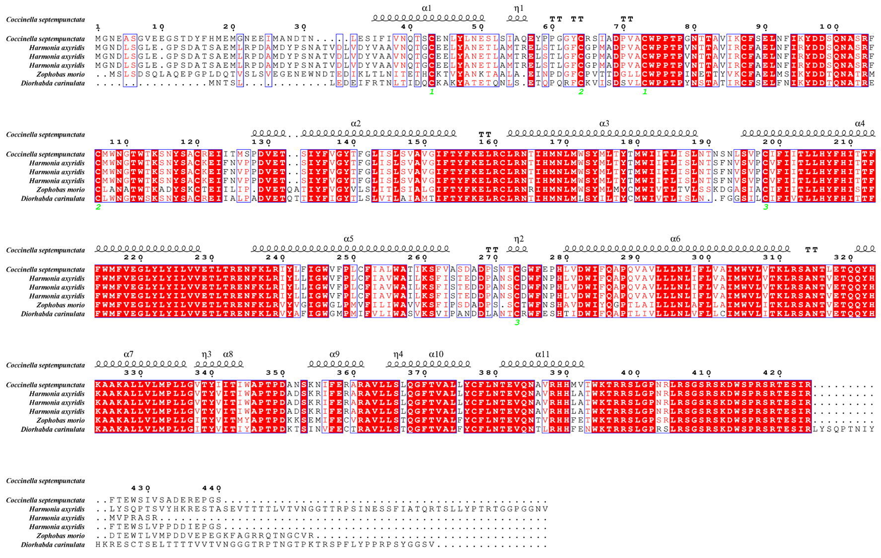
Figure S6： The amino acid sequence alignment of DH receptor in C. septempunctata

Figure S7： The amino acid sequence alignment of CCHamide receptor in C. septempunctata
Figure S8： The amino acid sequence alignment of CAPA receptor in C. septempunctata

Figure S9： The amino acid sequence alignment of SP receptor in C. septempunctata

