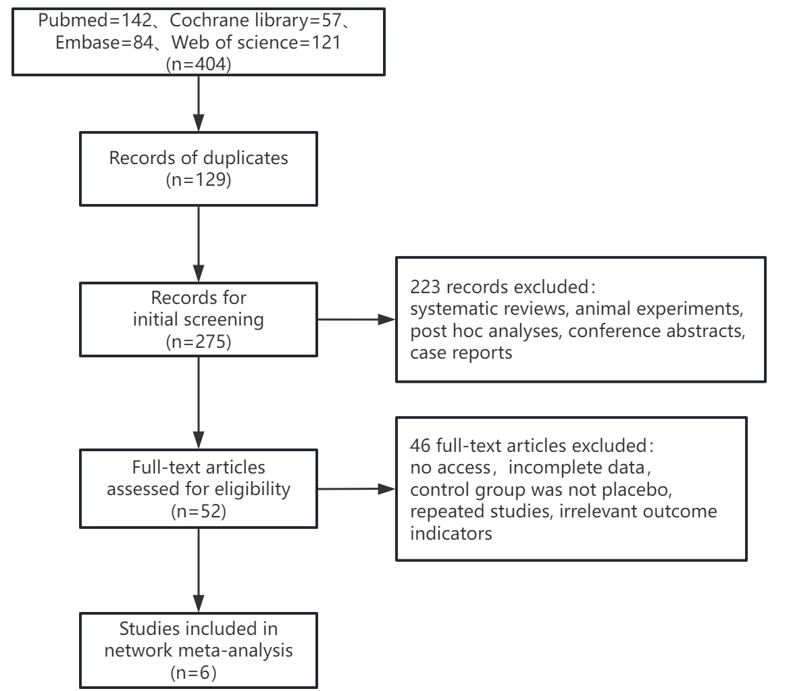
Figure 1 Flow diagram of the selection process of literature.

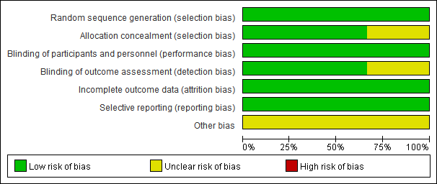
Figure 2 Risk of bias graph for all included studies.

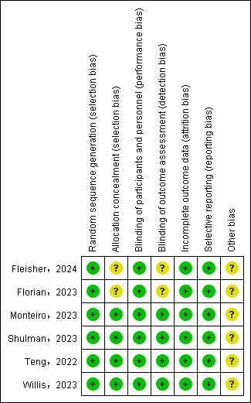
Figure 3 Risk of bias summary for all included study.

a
b
c
d
Figure 4 Network evidence plots of efficacy indicators.
Change in the Mini Mental State Examination (MMSE) from baseline (a); Change in Clinical Dementia Rating Scale Sum of Boxes (CDR-SB) from baseline (b); Change in Alzheimer's Disease Assessment Scale-Cognitive (ADAS-Cog) from baseline (c); Change in Alzheimer's Disease Cooperative Study-Activities of Daily Living Scale (ADCS-ADL) from baseline (d).

a
b
c
d
Figure 5 Network evidence plots of safety indicators.
adverse events (AE) (a); serious adverse events (SAE) (a); fall (a); urinary tract infection (a); infusion-related reaction (b); amyloid-related imaging abnormalities with edema or effusions (ARIA-E) (c); amyloid-related imaging abnormalities with hemosiderin deposits (ARIA-H) (d).
a
b
c
d
Figure 6 Funnel plots of efficacy indicators.
Change in the Mini Mental State Examination (MMSE) from baseline (a); Change in Clinical Dementia Rating Scale Sum of Boxes (CDR-SB) from baseline (b); Change in Alzheimer's Disease Assessment Scale-Cognitive (ADAS-Cog) from baseline (c); Change in Alzheimer's Disease Cooperative Study-Activities of Daily Living Scale (ADCS-ADL) from baseline (d).
a
b
c
d
e
f
g
Figure 7 Funnel plots of safety indicators.
adverse events (AE) (a); serious adverse events (SAE) (b); fall (c); urinary tract infection (d); infusion-related reaction (e); amyloid-related imaging abnormalities with edema or effusions (ARIA-E) (f); amyloid-related imaging abnormalities with hemosiderin deposits (ARIA-H) (g).

