FIGURE S1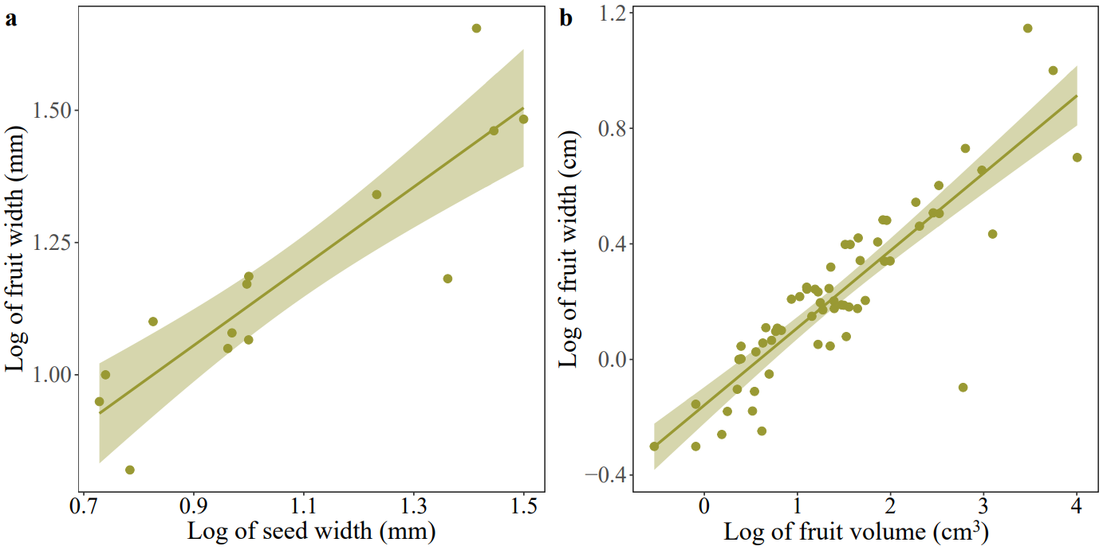

**FIGURE S1 Correlation of fruit width with seed width (a) and fruit volume (b) of palms. Log transformation was performed on the data.**