**Supplementary material S2.** Leaves (1) and roots (2) of lettuce plants treated with water (A), AP1OD formulation (B) and *Agaricus bisporus* WWE (C) and HWE (D).

1)

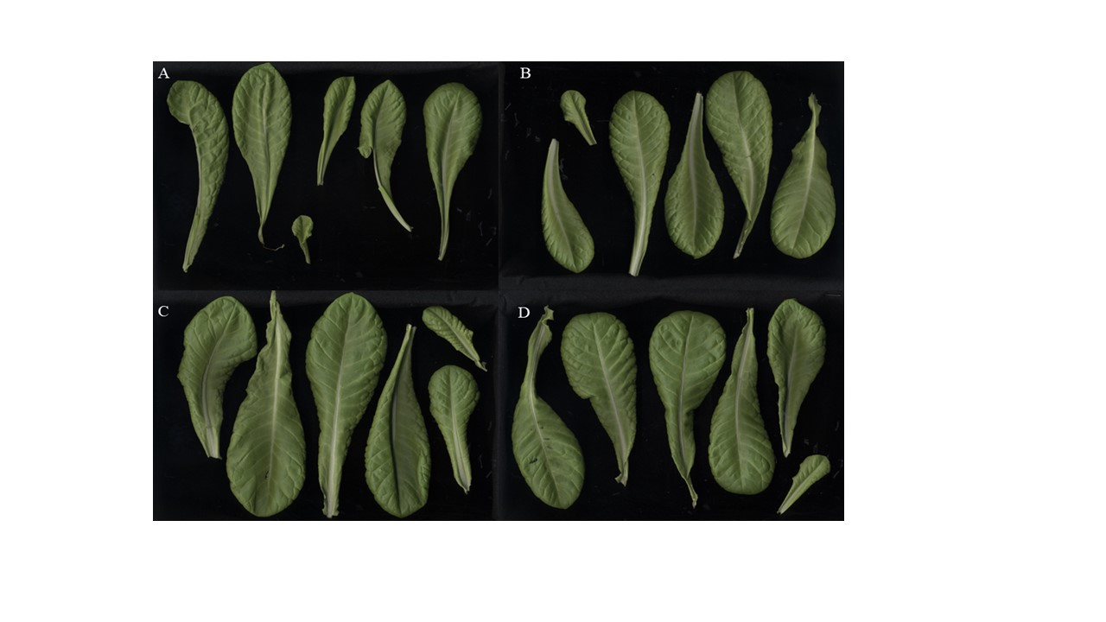

2)

